**Functions:**

**Function is a set of code**

* A function is a collection of instructions, or a collection of code.
* Try the code below and run.

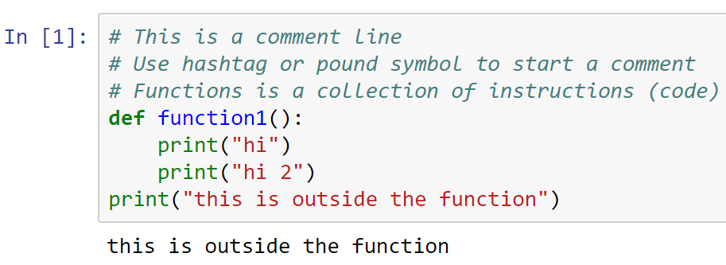

* function1() was defined, but it did not execute because it wasn’t called yet.
* To use (or call) this function

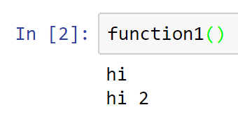

**Function is a mapping**

* A function is also a “mapping”
* A function “maps” an argument to the return value
* In the function below, we are mapping the input argument x to its output of twice x

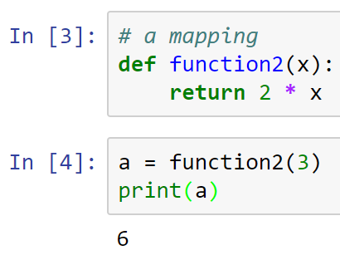

* Calling a function with no argument (or mismatched input) will throw an error. Try!

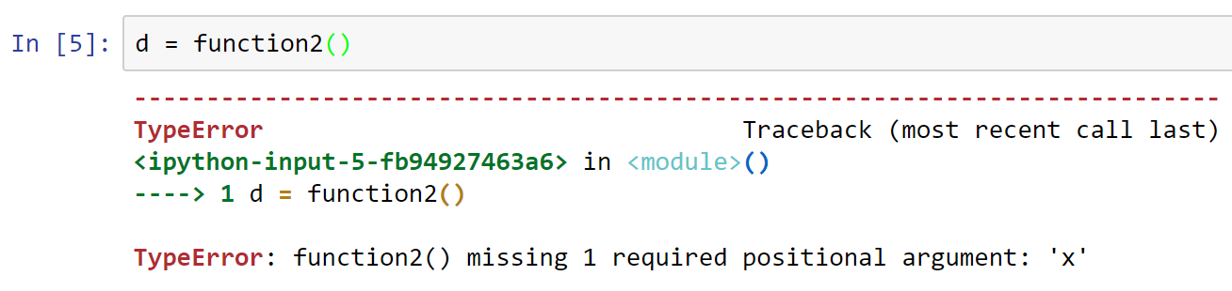

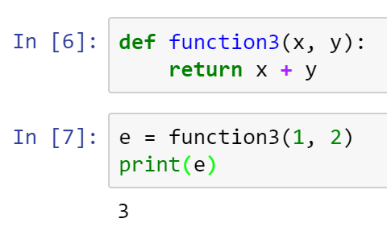

* Functions may not have a return value.

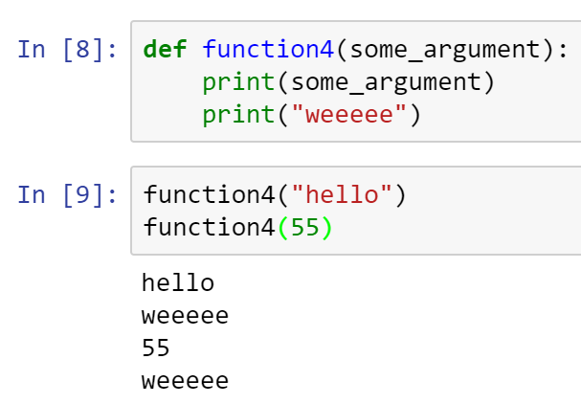

* Now, let’s make a BMI calculator as a function.

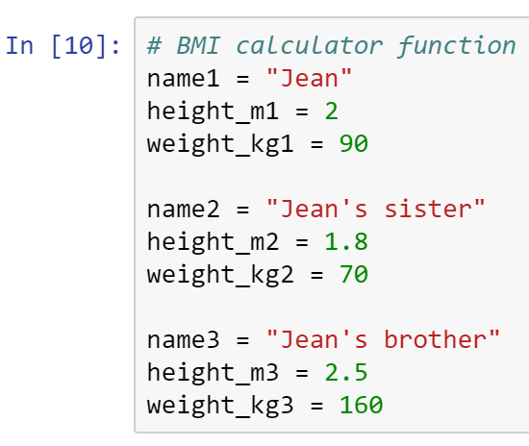

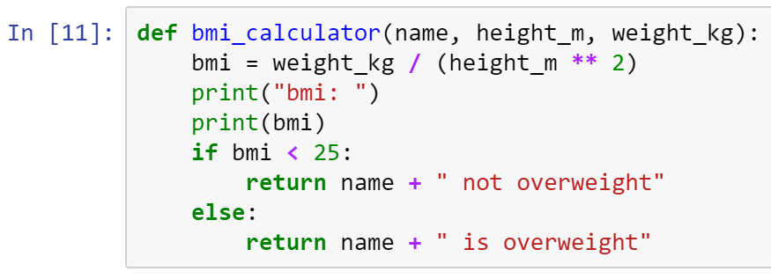

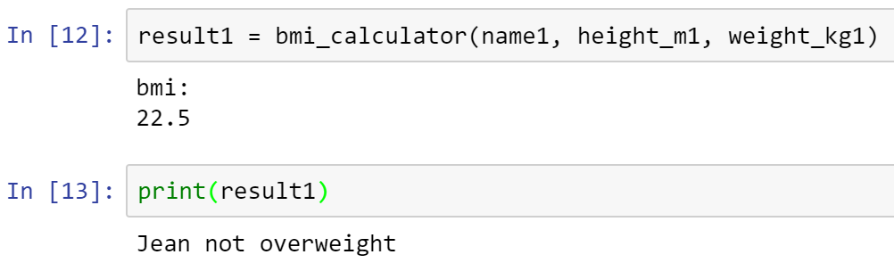

* Check also Jean’s sister and brother results. Who is overweight?
* Your turn: Create a function that converts miles to km.
* The function signature should look like this: km = convert(miles)
* Where: km = 1.6 * miles
* Place your answer here below:

def convert(miles):

return 1.6*miles

convert(2)

____________________________________________________________________________

* Copy all your code into a Word doc, place your name on it, and submit in Canvas.