Exercise 1:
1 & 2:
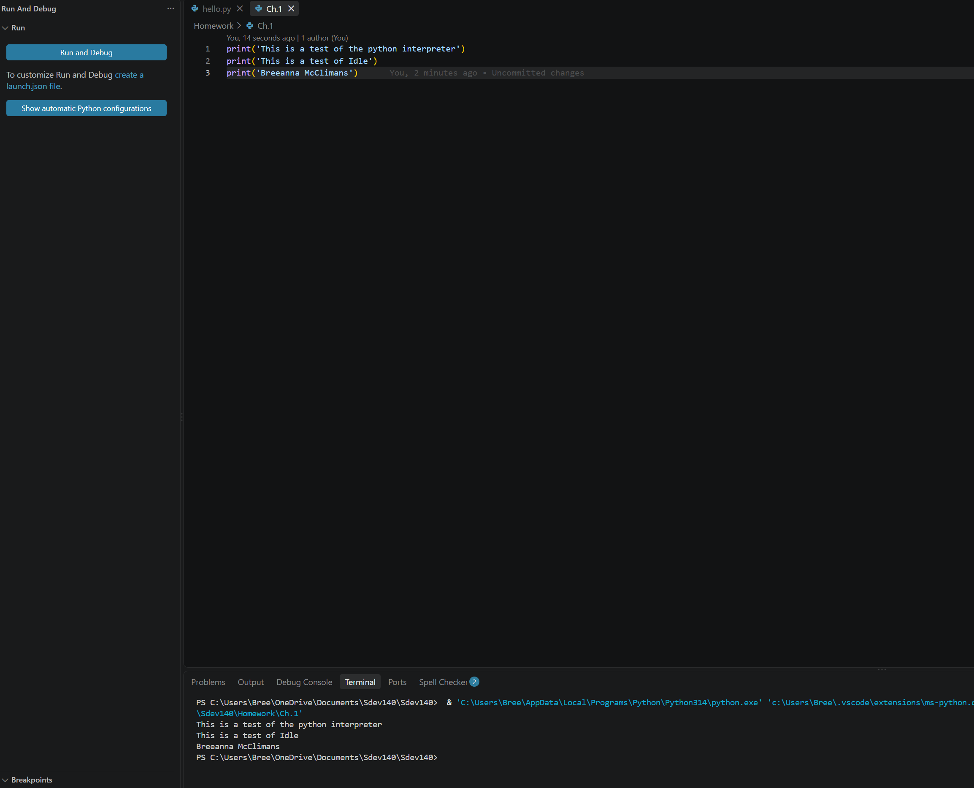
Exercise 2:
3: 1011, 1000001, 1100100, 11111111
4: 13, 8, 43
5. B- 66 r- 114 e- 101 e- 101 a- 97 n- 110 n- 110 a- 97
6. Guido van Rossum is the creator of Python.
Python was created in December 1989 and released in February 1991.
Guido is referred to as the “BDFL” or the “Benevolent Dictator for Life” because he was the final say in all decisions made in Python development.

