M02 Ch3 Ex12
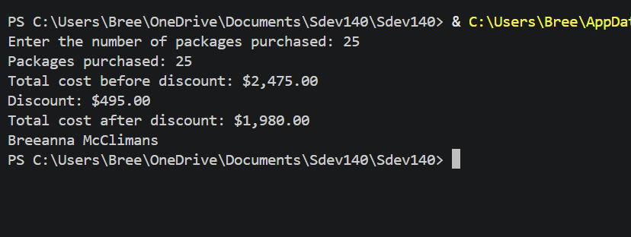
M02 Ch3 Ex16
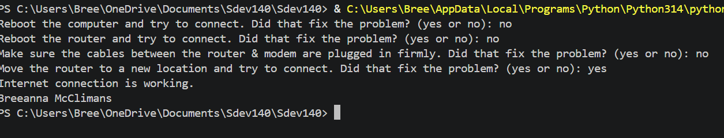
M02 Ch3 Ex17
