Ch. 6 Screenshots
Ex. 6 & 9
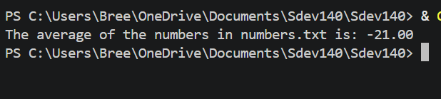
Ex. 7 & 8
