https://metalpriceapi.com

https://www.freegoldprice.org/home.cfm

<https://goldenmark.com/pl/mysaver/ceny-zlota/?gclid=Cj0KCQjw2qKmBhCfARIsAFy8buIsYHZofYVMghLGerXwsm3GdB30SkDc0DuVbB56hvuh_JnS51kG1cgaAqYfEALw_wcB&gclsrc=aw.ds>

beautiful soup

>selenium

Pobieranie kursu:

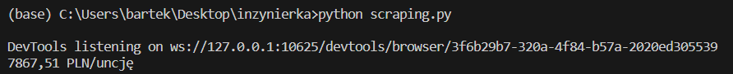

Pobieranie kursu z konkretnej daty:

>RSI (Relative Strenght Index)

https://upstox.com/knowledge-base/rsi-indicator/

>>Calculation

The average time period we use for the RSI is the 14 period average. Let’s say in the last 14 days, there were 10 up days and 4 down days. We will take the average gain on the 10 days and divide it by 14 – then use the average loss of 4 days and divide it by 14. The RSI index assumes that bulls won on the day the stock closed green (closed up) and bearish when it closes down.

>>RSI Useful as Over-Sold & Over-Bought Indicators

The RSI is said to be overbought when over the 70 zone and oversold when under the 30 level. Now one idea to generate a buy signal is to wait for the RSI to dip below 30 and then buy when the RSI breaks above the 30 line. This means that price was significantly oversold and is likely to bounce as the RSI sees strength returning to the market in the form of a move above the 30 area. Here are a few examples of this technique in action on the daily charts!

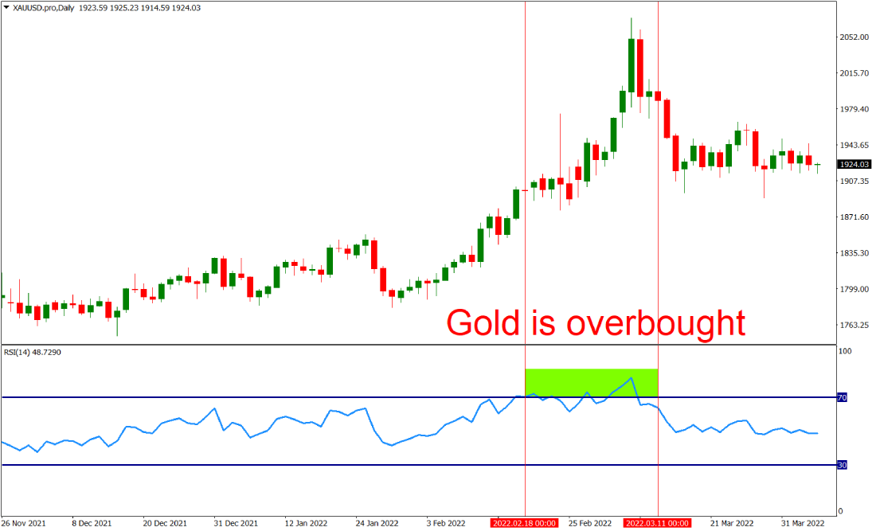

>Moving Average (MA)

https://www.investopedia.com/terms/m/movingaverage.asp

>>What are moving averages

Moving averages are calculated to identify the trend direction of a stock or to determine its support and resistance levels. It is a trend-following or lagging, indicator because it is based on past prices.

The longer the period for the moving average, the greater the lag. A 200-day moving average will have a much greater degree of lag than a 20-day MA because it contains prices for the past 200 days. 50-day and 200-day moving average figures are widely followed by investors and traders and are considered to be important trading signals.

In addition to that, they can be used as indicators that generate entry/exit signals. For example, you could plot a fast-moving (10) and a slow-moving (20) MA on the hourly chart. Once the 10 MA crosses above the 20 MA, it would generate a buy signal. If the 10 MA crosses below the 20 MA, it would create a sell signal.

>>Types of Moving Averages

>>>Simple Moving Average

A simple moving average (SMA), is calculated by taking the arithmetic mean of a given set of values over a specified period. A set of numbers, or prices of stocks, are added together and then divided by the number of prices in the set. The formula for calculating the simple moving average of a security is as follows:

\*A1 is the current day/time period and then next An’s are next days/time periods

Charting stock prices over 50 days using a simple moving average may look like this:

>>>Exponential Moving Average (EMA)

The exponential moving average gives more weight to recent prices in an attempt to make them more responsive to new information. To calculate an EMA, the simple moving average (SMA) over a particular period is calculated first.

Then calculate the multiplier for weighting the EMA, known as the "smoothing factor," which typically follows the formula: [2/(selected time period + 1)].

For a 20-day moving average, the multiplier would be [2/(20+1)]= 0.0952. The smoothing factor is combined with the previous EMA to arrive at the current value. The EMA thus gives a higher weighting to recent prices, while the SMA assigns an equal weighting to all values.

> Bollinger Bands

https://www.fidelity.com/learning-center/trading-investing/technical-analysis/technical-indicator-guide/bollinger-bands

Bollinger Bands are a type of price envelope developed by John BollingerOpens in a new window. (Price envelopes define upper and lower price range levels.) Bollinger Bands are envelopes plotted at a standard deviation level above and below a simple moving average of the price. Because the distance of the bands is based on standard deviation, they adjust to volatility swings in the underlying price.

Bollinger Bands use 2 parameters, Period and Standard Deviations, StdDev. The default values are 20 for period, and 2 for standard deviations, although you may customize the combinations.

Bollinger bands help determine whether prices are high or low on a relative basis. They are used in pairs, both upper and lower bands and in conjunction with a moving average. Further, the pair of bands is not intended to be used on its own. Use the pair to confirm signals given with other indicators.

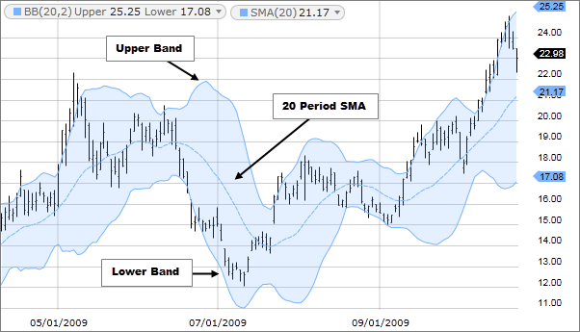

>>How this indicator works

* When the bands tighten during a period of low volatility, it raises the likelihood of a sharp price move in either direction. This may begin a trending move. Watch out for a false move in opposite direction which reverses before the proper trend begins.
* When the bands separate by an unusual large amount, volatility increases and any existing trend may be ending.
* Prices have a tendency to bounce within the bands' envelope, touching one band then moving to the other band. You can use these swings to help identify potential profit targets. For example, if a price bounces off the lower band and then crosses above the moving average, the upper band then becomes the profit target.
* Price can exceed or hug a band envelope for prolonged periods during strong trends. On divergence with a momentum oscillator, you may want to do additional research to determine if taking additional profits is appropriate for you.
* A strong trend continuation can be expected when the price moves out of the bands. However, if prices move immediately back inside the band, then the suggested strength is negated.

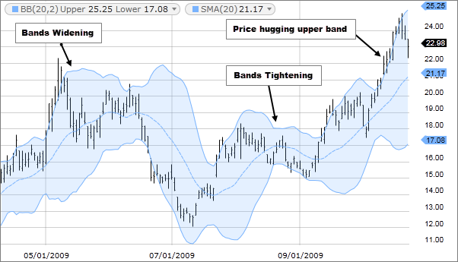

>>Calculation

First, calculate a simple moving average. Next, calculate the standard deviation over the same number of periods as the simple moving average. For the upper band, add the standard deviation to the moving average. For the lower band, subtract the standard deviation from the moving average.

Typical values used:

Short term: 10 day moving average, bands at 1.5 standard deviations. (1.5 times the standard dev. +/- the SMA)

Medium term: 20 day moving average, bands at 2 standard deviations.

Long term: 50 day moving average, bands at 2.5 standard deviations.

<https://youtu.be/MfpoN03k_yg?si=s-jO3FsWzOeSuZ9m>

ogarnac Lucid app dla studentow