**ASSIGNMENT 2 FRONT SHEET**

|  |  |  |  |
| --- | --- | --- | --- |
| **Qualification** | **BTEC Level 5 HND Diploma in Computing** | | |
| **Unit number and title** | Unit 14: Business Intelligence | | |
| **Submission date** |  | **Date Received 1st submission** |  |
| **Re-submission Date** |  | **Date Received 2nd submission** |  |
| **Student Name** | Bui Quang Minh | **Student ID** | GCD210325 |
| **Class** | GCD1104 | **Assessor name** | Phan Thanh Tra |
| **Student declaration**  I certify that the assignment submission is entirely my own work and I fully understand the consequences of plagiarism. I understand that making a false declaration is a form of malpractice. | | | |
|  |  | **Student’s signature** |  |

**Grading grid**

|  |  |  |  |  |  |  |  |
| --- | --- | --- | --- | --- | --- | --- | --- |
| **P3** | **P4** | **P5** | **P6** | **M3** | **M4** | **D3** | **D4** |
|  |  |  |  |  |  |  |  |

|  |  |  |
| --- | --- | --- |
| **❒ Summative Feedback: ❒ Resubmission Feedback:** | | |
| **Grade:** | **Assessor Signature:** | **Date:** |
| **Internal Verifier’s Comments:** | | |
| **IV Signature:** | | |

THE USE OF BUSINESS INTELLIGENCE TOOLS

AND TECHNOLOGIES

## I. Determining Business Intelligence and Associated Tools and Techniques (P3)

### 1.1 Introduction to Business Intelligence

#### 1.1.1 What is Business Intelligence

Business intelligence blends various techniques like business analysis, data exploration, visual representation of data, data management tools, and established methods to assist companies in making decisions based on data. In practical terms, you know your business has embraced modern intelligence when you have a complete understanding of your company's data and utilize it to initiate changes, remove inefficiencies, and swiftly adjust to market or supply alterations. Contemporary BI solutions focus on providing flexible self-service analysis, ensuring data integrity on reliable platforms, empowering business users, and delivering quick insights.

#### 1.1.2 How business intelligence works

Businesses and organizations seek answers to specific questions and strive to achieve particular goals. To achieve this, they collect relevant data, analyze it, and formulate actions to progress towards their objectives.

From a technical perspective, data is initially gathered from various business systems. This raw data undergoes processing and is subsequently stored in data warehouses, cloud platforms, applications, or files. Once stored, users can access this data, initiating the analytical process to address business inquiries.

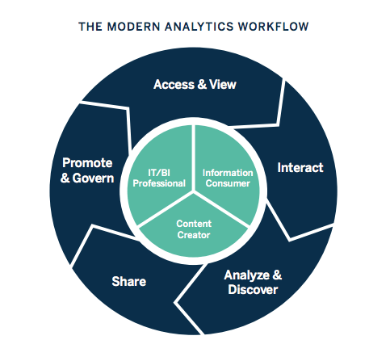

Figure . The Modern Analytics Workflow

### 1.2 Overview of BI Tools and Techniques

#### 1.2.1 BI methods

Business intelligence encompasses the methods and procedures involved in gathering, storing, and analyzing data from business activities to enhance performance. These elements converge to offer a holistic perspective of a business, aiding in making informed decisions. In recent years, business intelligence has expanded to include additional processes and tasks aimed at enhancing performance. These include:

* **Data mining**: Employing databases, statistical methods, and machine learning to uncover patterns in extensive datasets.
* **Reporting**: Disseminating data analysis findings to stakeholders for drawing conclusions and decision-making.
* **Performance metrics and benchmarking**: Comparing current performance data with historical data to monitor progress against objectives, often utilizing personalized dashboards.
* **Descriptive analytics**: Conducting initial data analysis to understand past events.
* **Querying**: Directly asking the data specific questions, with BI systems retrieving answers from datasets.
* **Statistical analysis**: Utilizing results from descriptive analytics to delve deeper into the data using statistical methods to understand trends and reasons behind them.
* **Data visualization**: Transforming data analysis outcomes into visual formats like charts, graphs, and histograms for easier comprehension.
* **Visual analysis**: Investigating data through visual storytelling to convey insights quickly and remain engaged in the analysis process.
* **Data preparation**: Aggregating multiple data sources, identifying dimensions and metrics, and organizing data for analysis purposes.

#### 1.2.2 BI Tools

Today, there is a plenty of BI tools to choose from. To identify the top five, I've compiled the most commonly mentioned ones based on rankings from various websites:

**Microsoft Power BI:**

Offered by Microsoft, Power BI is a widely used BI tool available as downloadable software. It enables users to perform analytics either on the cloud or on a reporting server. Integration with platforms like Facebook and Oracle allows for quick report and dashboard generation. The tool boasts built-in AI capabilities, Excel integration, and various data connectors. Additionally, it ensures end-to-end data encryption and real-time access monitoring.

**Tableau:**

Tableau is renowned for its user-friendly data visualization features, but it offers more than just aesthetically pleasing charts. With live visual analytics and an intuitive interface allowing for quick trend-spotting through drag-and-drop functionality, Tableau supports various data sources including Microsoft Excel, Box, PDF files, and Google Analytics. It also seamlessly connects with most databases.



Figure . Tableau logo

**QlikSense:**

QlikSense adopts a self-service approach to BI, accommodating diverse analytics use cases ranging from guided apps and dashboards to custom and embedded analytics. It features a touchscreen-optimized interface, advanced AI, and high-performance cloud support. Its Search & Conversational Analytics feature enables users to ask questions and derive actionable insights, facilitating enhanced data literacy among BI tool novices.



Figure . Qlik logo

**Dundas BI:**

With a 25-year history, Dundas BI is a browser-based BI tool offering drag-and-drop functionality akin to Tableau. It empowers users to analyze data independently without IT involvement. Known for its simplicity and flexibility, Dundas BI provides interactive dashboards, reports, and visual analytics. Originally a data visualization tool, it has evolved into a comprehensive analytics platform capable of competing with newer BI tools.



Figure . Dundas BI logo

**Sisense:**

Sisense stands out for its user-friendly and streamlined approach to BI. It allows users to export data from sources like Google Analytics and Salesforce. Utilizing in-chip technology, Sisense ensures faster data processing compared to other tools. Notable features include white-label analytics embedding for customizable services, drag-and-drop functionality, and the ability to share reports and dashboards internally and externally.



Figure . Sisense logo

### 1.3 Examples of Business Intelligence in Practice

**HelloFresh**

* **Challenge**: HelloFresh, a meal kit company, faced time-consuming and inefficient digital marketing reporting processes.
* **Solution**: Implementing a centralized business intelligence solution streamlined reporting, saving the marketing analytics team 10-20 hours daily. It enabled the team to create regional, personalized digital marketing campaigns based on aggregated customer behavior analysis, leading to increased conversion rates and improved customer retention. Real-time data visibility facilitated prompt reactions to customer behaviors and campaign optimization.

**REI**

* **Challenge**: Outdoor retail co-op REI encountered difficulties in tracking membership metrics due to vast amounts of data—over 90 terabytes.
* **Solution**: Utilizing a business intelligence platform, REI analyzed co-op membership data to enhance acquisition, retention, and reactivation strategies. Insights derived from data analysis informed decisions on resource allocation between brick-and-mortar and digital retail, resulting in improved customer satisfaction and brand perception. The BI platform also facilitated customer segmentation analysis, guiding decisions on shipping methods, member lifecycle management, and product assortments.

**Coca-Cola Bottling Company (CCBC)**

* **Challenge**: Manual reporting processes hindered access to real-time sales and operations data at CCBC, Coca Cola’s largest independent bottling partner.
* **Solution**: CCBC's business intelligence team automated manual reporting processes, saving over 260 hours annually. Integration with enterprise systems enabled sales teams to access CRM data through mobile dashboards, providing timely insights for operational decision-making and enhancing competitive advantage. The implementation of self-service BI promoted effective collaboration between IT and business users, allowing focus on strategic initiatives and innovation rather than manual tasks.



Figure . BI Application illustration

## II. Designing a Business Intelligence Tool or Application (P4)

### 2.1 Dataset Overview

The dataset used for this analysis was obtained from Maven Analytics Data Playground. It comprises transactional data from a coffee shop, encompassing various aspects such as products, categories, types, and stores. Each row in the dataset represents a unique transaction within the coffee shop.

**Structure of the Dataset:**

The dataset consists of multiple columns, including but not limited to:

* Table Transaction: Represents the transactional identifier associated with each table within the coffee shop.
* Category and Type: Classify the products sold within the coffee shop into distinct categories and types.
* Product: Indicates the specific product purchased during the transaction.
* Store: Identifies the store location where the transaction took place.

**Significance for the Coffee Shop**:

* This dataset holds significant value for the coffee shop as it provides invaluable insights into customer behavior, popular products, and store performance.
* By analyzing this data, the coffee shop can make informed decisions to enhance its operations, optimize product offerings, and improve customer satisfaction.

**Objectives of the Analysis**:

* The primary objectives of this analysis include:
* Understanding customer preferences and purchasing patterns.
* Identifying top-selling products and product categories.
* Evaluating the performance of different stores within the coffee shop chain.
* Extracting actionable insights to enhance business strategies and drive growth.

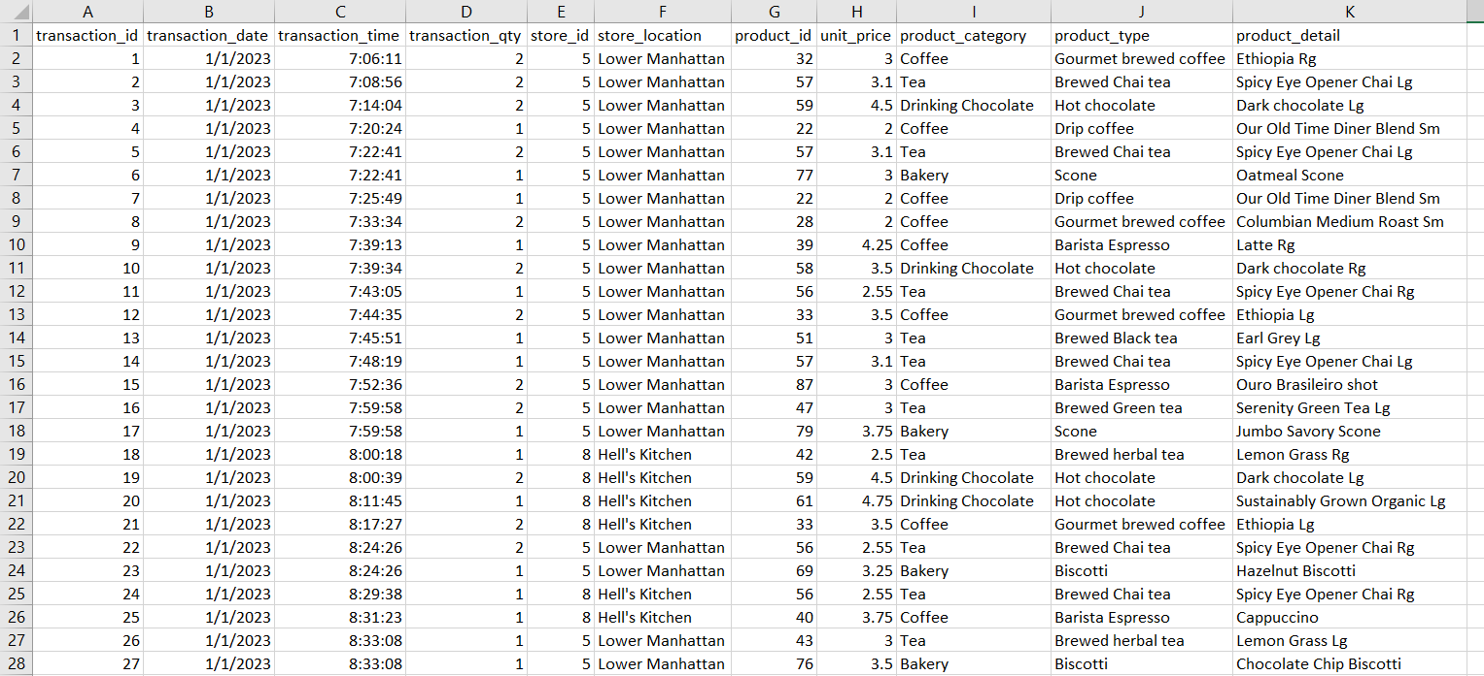

Figure . Data Sample

### 2.2 Data Cleaning and Preparation

Upon initial inspection of the dataset, it was observed that the transactional data was consolidated into a single table, lacking distinct tables for categories, products, types, and stores. In order to facilitate efficient analysis and establish relational integrity, several preprocessing steps were undertaken.

**1. Separation of Data into Distinct Tables:**

Using Excel, the transactional data was separated into distinct tables for categories, products, types, and stores. This involved creating new sheets and employing Excel's "Remove Duplicates" tool to extract unique entries for each table. For example, I removed duplicate values for table Category and I would do the same for other tables.

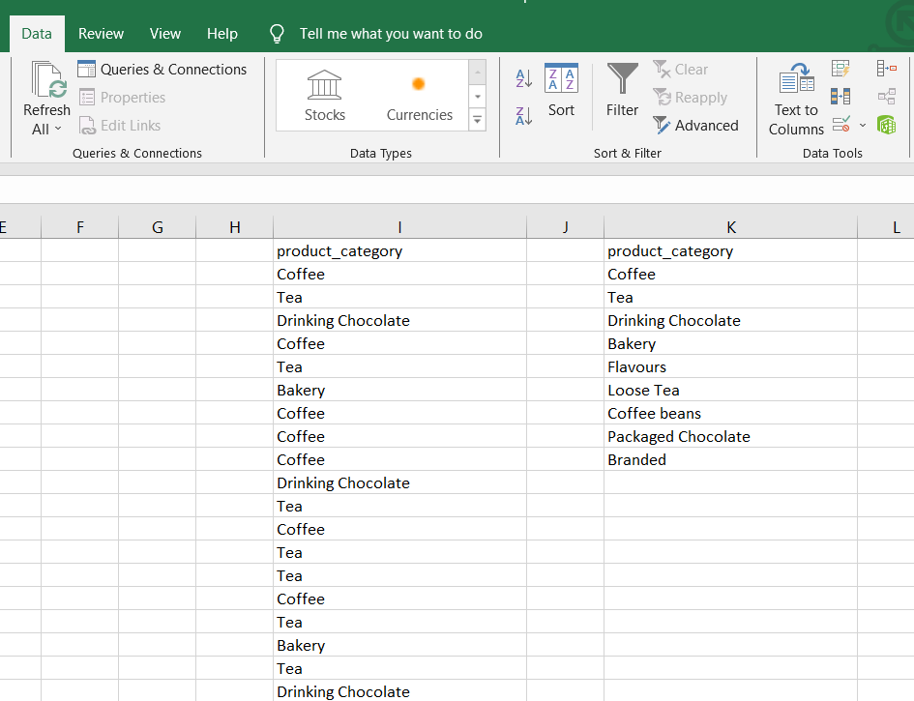

Figure . Duplicate Removing phase



Figure . Tables after seperating

**2. Adding Identifiers (IDs) for Each Row:**

To uniquely identify each entry in the newly created tables, an ID column was added to each sheet. These IDs serve as primary keys, facilitating data retrieval and relational operations.

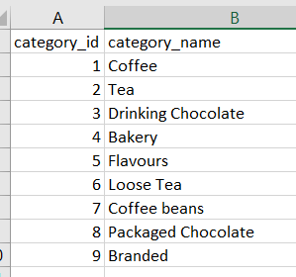

Figure . Example of Adding IDs

**3. Establishing Relationships:**

Excel's VLOOKUP function was utilized to establish relationships between the tables by adding foreign key columns.

* For the Category table: Each row in the Type table was assigned a category_id using VLOOKUP to indicate its corresponding category.
* For the Type table: Each row in the Product table was assigned a type_id using VLOOKUP to denote its associated type.
* For the Store table: Each row in the Transaction table was assigned a store_id using VLOOKUP to link it to the corresponding store.

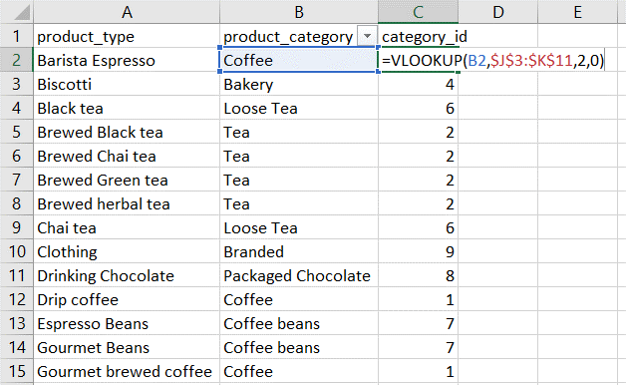

Figure . VLookup example

**4. Addressing Product Naming Issues with Python:**

Upon further examination of the Product table, it was discovered that several products shared identical names, leading to ambiguity in distinguishing between them. To resolve this issue and ensure clarity in product identification, Python was utilized to implement a systematic approach.

* Identifying Differentiating Factors:
  + Initially, the primary concern was to identify the factors that distinguish between products with identical names. It was found that these products differed in their unit prices, indicating potential variations in size or other attributes.

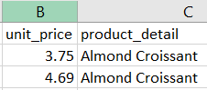

Figure . Example of duplicating names

* Determining Naming Convention:
  + To maintain consistency and avoid arbitrary renaming, a systematic naming convention needed to be established. After thorough analysis, it was observed that certain products were differentiated by the inclusion of additional descriptors such as "Rg" (regular) and "Lg" (large) at the end of their names.

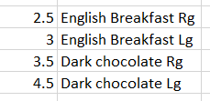

Figure . Example of naming convention

* Implementing Python Script:
  + I have used python to automate the process of appending descriptors to product names based on predefined rules. This script iterated through the Product table, identified products with identical names, and appended appropriate descriptors to differentiate between them. For products with identical names but different unit prices, the script added "Rg" to denote the regular variant and "Lg" for the larger variant with a higher unit price.

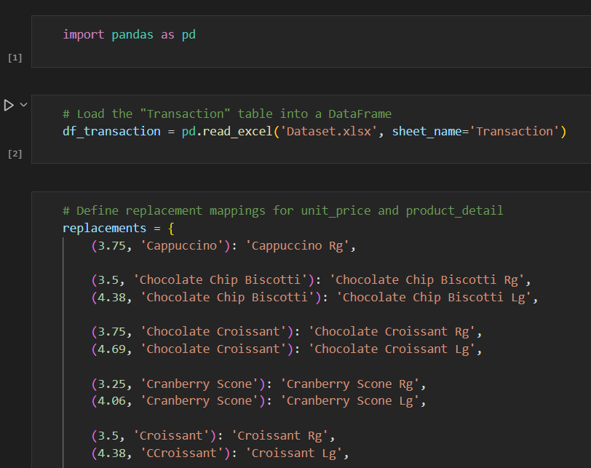

Figure . Python code (1)

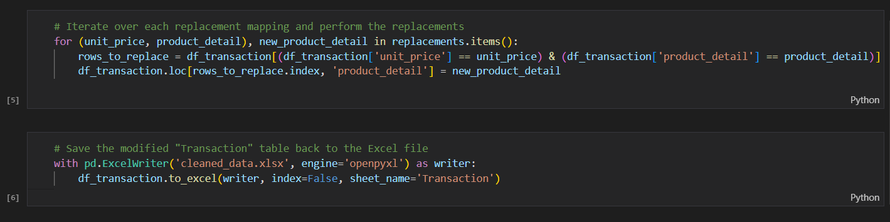

Figure . Python code (2)

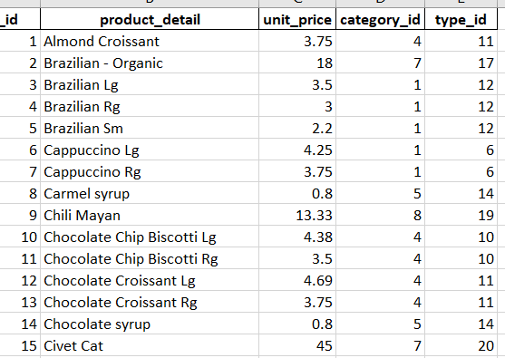

Figure . Data after cleaning

### 2.3 Data Visualization and Analysis

The relatively consistent total sales across all three stores indicate that each location is performing well and meeting the key performance indicators (KPIs) effectively. This suggests that the staff and operational characteristics of the coffee shop, such as product quality, customer service, and store management, are well-established and effective across all locations.

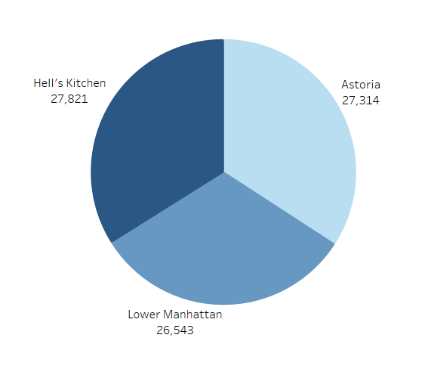

Figure . Sales per Store

**Coffee** emerges as the best-selling category, with 6,791 items sold and total sales exceeding $30,000. This highlights the enduring popularity of coffee among customers and underscores its status as a cornerstone product for the coffee shop.

**Tea and bakery** products follow closely behind coffee in terms of sales volume and revenue generation. Tea sales amount to 5,258 items, contributing $22,622 in sales, while bakery sales total 2,643 items, generating nearly $10,000 in revenue.

This expansion into tea and bakery products showcases the coffee shop's commitment to catering to diverse customer preferences and enhancing its product offerings beyond traditional coffee offerings.

While certain categories such as **Coffee**, **Tea**, and **Bakery** demonstrate strong sales performance, others like **Branded** (clothes), **Loose** **Tea**, **Flavors** (added to drinks), and **Packaged** **Chocolate** are behind in sales volume.

This presents both challenges and opportunities for the coffee shop to reassess its product mix, optimize inventory management, and potentially explore strategies to boost sales in underperforming categories.

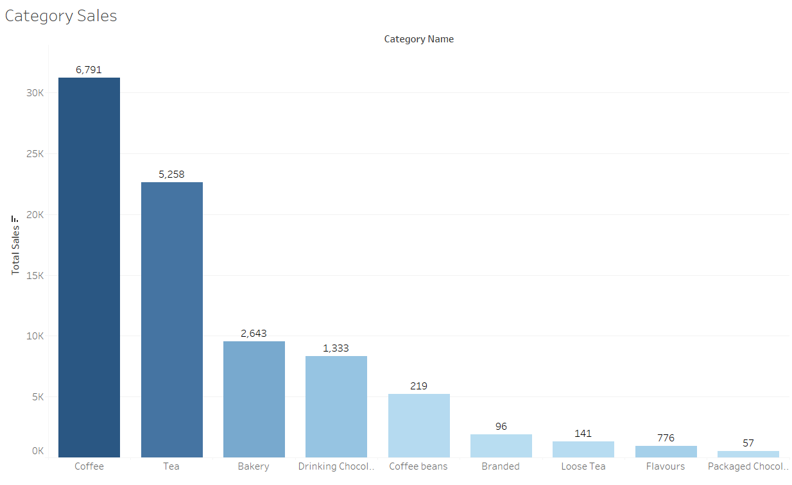

Figure . Category Sales

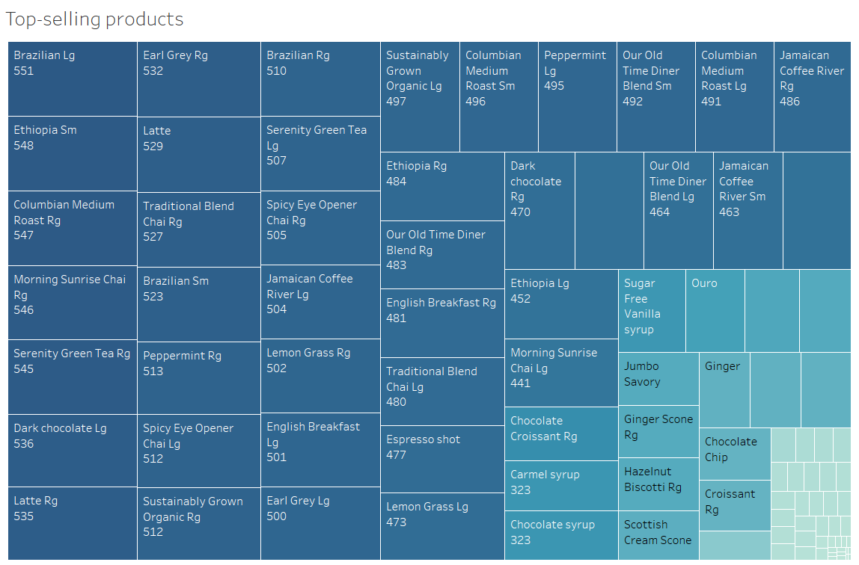

Figure . Top-selling products

Overall, the coffee shop experiences relatively consistent sales throughout the week, peaking on Tuesday with $13,740 in sales. However, sales see a noticeable decline starting on Wednesday, with sales dropping to $10,358, and remaining relatively stable through the end of the week.

This mid-week dip suggests a potential slowdown in customer traffic or spending patterns during the middle of the week.

Despite the mid-week dip, sales rebound slightly towards the end of the week, with Friday and Saturday recording sales figures around $10,600 each. While the weekend sales are relatively stable, they do not surpass the sales figures seen earlier in the week.

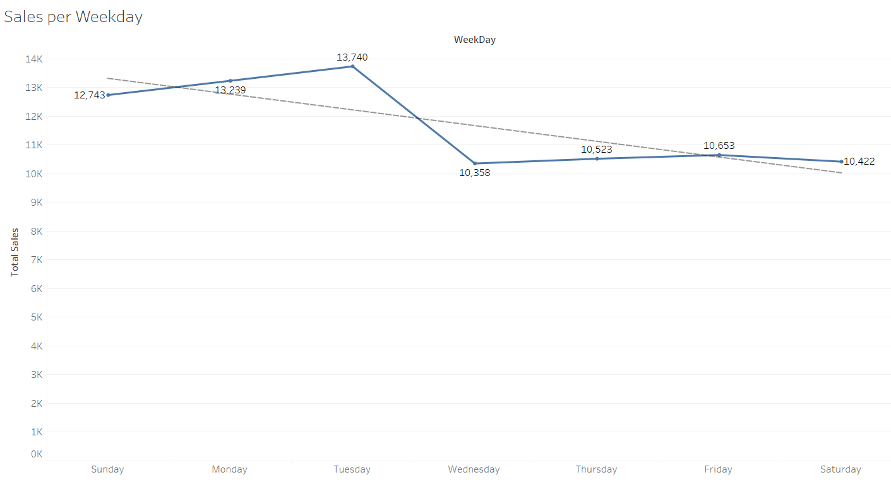

Figure . Sales per Weekday

Sales begin to increase gradually during the early morning hours, with a significant increase starting at 7 AM. The peak operating hours occur between 8 AM and 10 AM, with sales reaching their highest levels during this time period. This suggests that mornings are the busiest time for the coffee shop, likely driven by customers seeking their morning coffee fix and breakfast items.

Sales remain relatively stable throughout the late morning and early afternoon, with slight fluctuations. While sales decrease slightly after the peak hours, they remain relatively consistent from 11 AM to 5 PM, indicating sustained customer traffic during this time.

However, sales begin to decline gradually after 5 PM, with a noticeable decrease in sales during the late afternoon and evening hours. The decline continues into the evening, with sales dropping significantly after 6 PM, suggesting a decrease in customer traffic and spending during these hours.

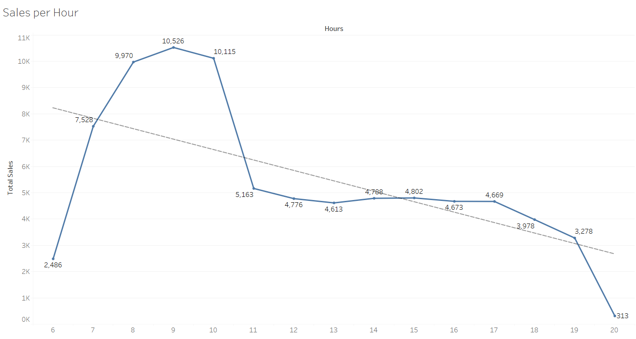

Figure . Sales per Hour

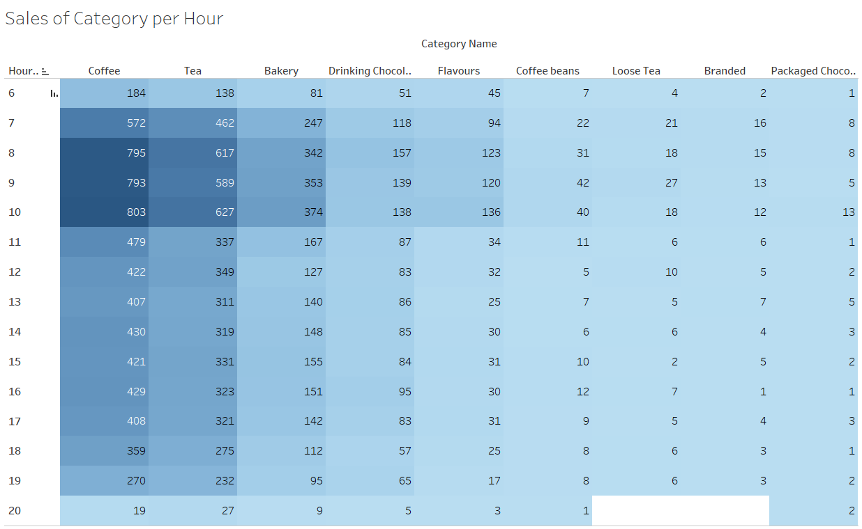

Figure . Category Sales per Hour

### 2.4 Insights and Recommendations

#### 2.4.1 Specific solutions

The analysis of category sales data reveals several key insights into the performance of different product categories within the coffee shop. While coffee remains the best-selling category, with strong sales volume and revenue, tea and bakery products also demonstrate significant popularity among customers. However, certain categories such as Branded (clothes), Loose Tea, Flavors, and Packaged Chocolate lag behind in sales volume.

To address the challenges posed by underperforming categories and capitalize on opportunities for growth, the coffee shop can implement the following recommendations:

* **Highlight less popular categories** prominently in marketing materials, menus, and displays to increase visibility and customer awareness. This can include featuring these products in prominent locations within the store and showcasing them in eye-catching displays.
* **Implement targeted promotional campaigns or special offers** to incentivize customers to try products from less popular categories. This could include offering discounts, bundle deals, or loyalty rewards specifically for products in underperforming categories to encourage customer engagement and trial.

The analysis of sales data throughout the week reveals consistent sales patterns, with sales peaking on Tuesday before experiencing a noticeable decline starting on Wednesday. Despite this mid-week dip, sales rebound slightly towards the end of the week, with Friday and Saturday recording relatively stable sales figures.

To address the potential slowdown in customer traffic or spending patterns during the middle of the week and increase sales during this period, the coffee shop can implement the following recommendations:

* **Implement targeted promotions and discounts** specifically for mid-week days, such as Wednesday and Thursday, to incentivize customers to visit the coffee shop during these slower periods. This can include offering special discounts on certain products or menu items, creating mid-week happy hour specials, or introducing loyalty rewards for mid-week visits.
* **Organize special events or activities** during mid-week days to attract customers and drive foot traffic to the coffee shop. This could include hosting themed events, live music performances, or interactive workshops that appeal to the target audience and encourage customers to visit the coffee shop during off-peak times.

The analysis of sales data per hour reveals distinct patterns in customer traffic and spending throughout the day. Sales gradually increase during the early morning hours, peaking between 8 AM and 10 AM, indicating that mornings are the busiest time for the coffee shop. Sales remain relatively stable throughout the late morning and early afternoon, with sustained customer traffic from 11 AM to 5 PM. However, sales begin to decline gradually after 5 PM, with a noticeable decrease in sales during the late afternoon and evening hours. This decline continues into the evening, with sales dropping significantly after 6 PM, suggesting a decrease in customer traffic and spending during these hours.

To optimize sales performance and enhance the overall customer experience throughout the day, the coffee shop can implement the following recommendations:

* **Allocate additional staff and resources during peak operating hours** between 8 AM and 10 AM to ensure efficient service and minimize wait times for customers. This can help capitalize on the morning rush and maximize sales during this busy period.
* **Host evening events or activities** to create a lively atmosphere and attract customers during off-peak hours. This could include live music performances, open mic nights, trivia nights, or themed events. By offering engaging experiences, the coffee shop can draw in customers looking for entertainment and socializing opportunities in the evening.
* **Introduce a specialty evening menu** featuring unique or indulgent items specifically designed for the evening crowd. This could include artisanal cocktails, dessert specials, or savory snacks that pair well with evening beverages. By offering distinctive offerings, the coffee shop can appeal to customers seeking a memorable dining experience in the evening.

#### 2.4.2 Generic solutions

**Collaborations and Partnerships:**

* Objective: Increase customer traffic during the off-peak hours.
* Solution: Collaborate with local theaters, galleries, or fitness studios to host joint events or promotions. Offer special discounts or promotions for customers who visit both establishments, encouraging them to stop by the coffee shop before or after their activities. This partnership not only drives traffic to the coffee shop but also enhances the overall experience for customers seeking entertainment or leisure activities in the evening.

**Community Engagement:**

* Objective: Foster a sense of community and social connection.
* Solution: Host fundraisers, charity events, or community gatherings in collaboration with local organizations or charities. Position the coffee shop as a hub for community engagement by providing a space for residents to come together, socialize, and support meaningful causes. By actively engaging with the local community, the coffee shop strengthens its ties and attracts customers who value supporting businesses that contribute positively to their community.

**Digital Marketing and Social Media Campaigns:**

* Objective: Promote evening offerings and events to potential customers.
* Solution: Launch targeted digital marketing and social media campaigns specifically focused on promoting evening specials and events. Utilize platforms like Facebook, Instagram, and Twitter to showcase enticing evening menus, highlight upcoming events, and engage with customers in real-time. Incorporate visually appealing content, such as photos or videos, to build excitement and anticipation among followers and encourage them to visit the coffee shop during the evening hours.

**Membership Card:**

* Objective: Encourage repeat visits and foster customer loyalty.
* Solution: Introduce a membership card program that offers exclusive benefits and rewards for customers who frequent the coffee shop during the evening hours. Provide incentives such as discounts on evening purchases, special access to evening events, or bonus points for evening visits. This encourages customers to become regular patrons of the coffee shop and strengthens their loyalty by rewarding their evening patronage.



Figure . Marketing illustration

## III. Customizing Design for User-Friendliness (M3)

### 3.1 Customization for User-Friendliness

In consideration of user-friendliness, the Tableau dashboard has been meticulously customized to cater to both teacher and student users. The following aspects have been addressed to enhance usability:

**Intuitive Layout**: The dashboard layout has been organized in a user-friendly manner, ensuring that teachers and students can easily navigate between different sections and find relevant information without confusion.

**Clear Labels and Descriptions**: All visual elements, including charts and data metrics, are accompanied by clear labels. This enables users to understand the purpose and context of each component at a glance.

**Consistent Visual Language**: A consistent visual language has been adopted throughout the dashboard, with the primary color scheme being blue. This consistent use of color helps to maintain coherence and reinforces brand identity, contributing to a cohesive and visually appealing user interface.

**Simplified Navigation**: Navigation controls have been simplified to streamline the user experience. Users can effortlessly switch between different views and access detailed information without encountering unnecessary complexity.

**Interactive Features**: Interactive features such as filters and parameters have been integrated to empower users with control over the displayed data. Teachers and students can dynamically adjust settings to focus on specific stores, categories, or products of interest.

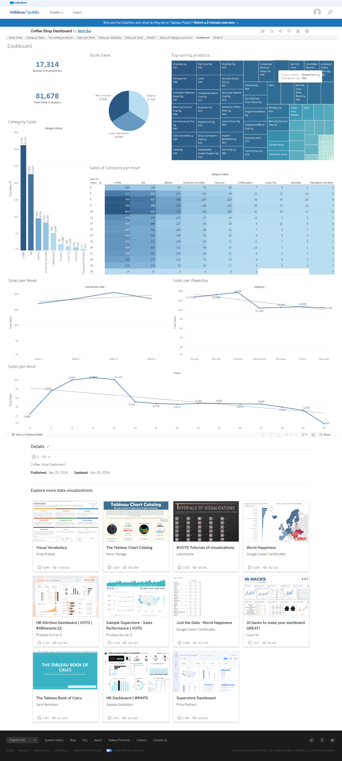

Figure . Beautiful Dashboard

### 3.2 Functional Interface Design Considerations

Functional interface design considerations have been incorporated to ensure that the dashboard not only looks visually appealing but also delivers meaningful insights and supports effective decision-making. The following design principles have guided the development of the dashboard interface:

**Relevant Metrics and Visualizations**: The dashboard includes a curated selection of key metrics and visualizations relevant to the needs of teachers and students. Metrics such as total sales and total transactions provide high-level summaries, while charts such as sales per store, category sales, and top-selling products offer deeper insights into sales performance trends.

**Data** **Granularity**: The dashboard allows users to analyze sales data at different levels of granularity, from overall trends to more granular insights such as sales per weekday and hour. This granularity enables users to identify patterns and correlations that may not be immediately apparent at a higher level of aggregation.

**Visualization Effectiveness**: Charts and visualizations have been carefully chosen and designed to effectively communicate insights from the data. Attention has been paid to factors such as chart type selection, labeling, and color palettes to ensure clarity and interpretability of the visualizations.

**User Feedback Integration**: Feedback mechanisms have been implemented to solicit input from users and gather insights into their preferences and usage patterns. This feedback loop enables continuous improvement of the dashboard interface based on user input, ensuring that it remains responsive to evolving user needs and expectations.

## IV. Critical Review of the Design (D3)

### 4.1 Evaluation of Design Against User/Business Requirements

The Tableau dashboard design has undergone a thorough evaluation against the user and business requirements to gauge its effectiveness in meeting the intended objectives. The evaluation encompasses the following key aspects:

**Alignment with User Needs**: The dashboard design has been meticulously assessed to ensure alignment with the specific needs and preferences of both teachers and students. Feedback collected from user testing sessions and stakeholder consultations has been instrumental in identifying areas where the dashboard design successfully addresses user requirements and where enhancements may be warranted.

**Relevance of Metrics and Visualizations**: The dashboard's inclusion of metrics and visualizations has been scrutinized in light of the identified user and business requirements. Key performance indicators (KPIs) such as total sales and total transactions have been evaluated for their capacity to deliver actionable insights and facilitate decision-making processes for teachers and students.

**Usability and Accessibility**: Usability and accessibility considerations have been central to the evaluation of the Tableau dashboard interface. Factors such as the clarity of labeling, the intuitiveness of navigation features, and adherence to accessibility standards have been carefully examined to ensure that the dashboard is user-friendly and accessible to individuals with diverse abilities and technical proficiencies.

**Performance** **and** **Scalability**: The performance and scalability of the Tableau dashboard have been rigorously assessed to ascertain its suitability for handling large volumes of data and accommodating future growth and expansion. Performance testing has been conducted to identify any potential performance bottlenecks or limitations that may impede the dashboard's ability to deliver timely and responsive insights to users.

### 4.2 Identification of Customizations Integrated into the Design

Several customizations have been integrated into the Tableau dashboard design to augment its usability, functionality, and visual appeal. These customizations include:

**Tailored Visualizations**: Visualizations have been customized to present data in a visually compelling and easily interpretable manner. Customizations such as color palettes, chart types have been employed to optimize readability and facilitate data comprehension.

**Responsive** **Layout**: The layout of the Tableau dashboard has been customized to ensure responsiveness across various devices and screen sizes. Customizations to the layout have been implemented to optimize the arrangement of visualizations and controls, thereby enhancing usability and accessibility across different viewing contexts.

**Theming**: Customizations to professional elements such as color schemes and typography have been applied to maintain visual consistency with organizational branding guidelines. These customizations contribute to reinforcing brand identity and fostering a cohesive user experience.

DISCUSSION ON THE IMPACT OF BUSINESS INTELLIGENCE TOOLS AND TECHNOLOGIES

## I. Discussing Contribution to Effective Decision-Making (P5)

### 1.1 Contribution of Business Intelligence Tools to Decision-Making

Different types of data, like integers (int), decimal numbers (float, double), and long numbers, are built into programming. We can do basic math with them, like adding, subtracting, dividing, and multiplying. But sometimes, we want to work with our own special data types and do operations specific to them. In such cases, we need to define these operations ourselves.

### 1.2 Case Studies and Examples

Different types of data, like integers (int), decimal numbers (float, double), and long numbers, are built into programming. We can do basic math with them, like adding, subtracting, dividing, and multiplying. But sometimes, we want to work with our own special data types and do operations specific to them. In such cases, we need to define these operations ourselves.

## II. Exploring Legal Issues (P6)

### 2.1 Legal and Regulatory Context of Business Intelligence

Different types of data, like integers (int), decimal numbers (float, double), and long numbers, are built into programming. We can do basic math with them, like adding, subtracting, dividing, and multiplying. But sometimes, we want to work with our own special data types and do operations specific to them. In such cases, we need to define these operations ourselves.

### 2.2 Security and Privacy Considerations

Different types of data, like integers (int), decimal numbers (float, double), and long numbers, are built into programming. We can do basic math with them, like adding, subtracting, dividing, and multiplying. But sometimes, we want to work with our own special data types and do operations specific to them. In such cases, we need to define these operations ourselves.

## III. Research on Organizational Examples (M4)

### 3.1 Research Methodology

Different types of data, like integers (int), decimal numbers (float, double), and long numbers, are built into programming. We can do basic math with them, like adding, subtracting, dividing, and multiplying. But sometimes, we want to work with our own special data types and do operations specific to them. In such cases, we need to define these operations ourselves.

### 3.2 Case Studies of Organizations Using Business Intelligence Tools

Different types of data, like integers (int), decimal numbers (float, double), and long numbers, are built into programming. We can do basic math with them, like adding, subtracting, dividing, and multiplying. But sometimes, we want to work with our own special data types and do operations specific to them. In such cases, we need to define these operations ourselves.

## IV. Evaluating Organizational Use and Competitiveness (D4)

### 4.1 Assessment of Extending Target Audience

Different types of data, like integers (int), decimal numbers (float, double), and long numbers, are built into programming. We can do basic math with them, like adding, subtracting, dividing, and multiplying. But sometimes, we want to work with our own special data types and do operations specific to them. In such cases, we need to define these operations ourselves.

### 4.2 Considerations of Security Legislation and Compliance

Different types of data, like integers (int), decimal numbers (float, double), and long numbers, are built into programming. We can do basic math with them, like adding, subtracting, dividing, and multiplying. But sometimes, we want to work with our own special data types and do operations specific to them. In such cases, we need to define these operations ourselves.

Table of Figures

Reference List

Anon (n.d.) Business intelligence: A complete overview, *Tableau*, [online] Available at: https://www.tableau.com/learn/articles/business-intelligence (Accessed 23 April 2024).

Anon (n.d.) 5 business intelligence tools you need to know, *Coursera*, [online] Available at: https://www.coursera.org/articles/bi-tools (Accessed 23 April 2024a).

Appendix

Tableu Link: <https://public.tableau.com/app/profile/minh.bui8303/viz/CoffeeShopDashboard_17138810961380/Dashboard?publish=yes>