HSS 404: Globalization and Medicine
Burhnauddin Mogul

IoT and Blockchain technologies for a globalized healthcare system.

Abstract
With an increasingly digital and globalized world, critical challenges in managing patient records have arisen. Lack of standardized data formats, incompatible healthcare systems, and incomplete records make it difficult for medical professionals to do a proper job. As telemedicine now accounts of 20% of patient appointments [7] and millions of people in the U.S. alone seek international treatments [9], having complete and robust records become more and more difficult. This paper aims to explore the utilization of technologies such as Internet of Things (IoT) and Blockchain within the global healthcare system, specifically within the realm of patient health records. The two technologies have their own advantages separately, but their synergy allows for a healthcare system that has a foothold in data security and integrity, real time data monitoring, and patient data ownership. These key aspects have the ability to allow patients to obtain medical treatment or assistance from across the globe by easily sharing these records from a distributed system. Through analysis of current solutions and more theoretical ones, the paper explores some existing technical and regulatory challenges with integrating such a system on a global scale.

Introduction
There has been an evident shift in how medical treatment is recorded with the rapid development of computing technologies and the information highway that is the internet. Patients have the ability to access portals that have electronic health records (EHR) of all their medical documents. This technology has given patients a lot more power with how they can manage their personal records, but they still remain reliant on both the providers of the EHR systems and the vendors who develop them when it comes to their data. When there are security breaches to either the vendor or the providers, patient privacy is threatened and there exists a possible leak of data without patient consent [12]. Another issue that plagues current records is the reliance on manual data entry and inaccuracies being present within the records [12]. One of the biggest issues with existing EHR systems is that “Patients do not have direct access to their EHR but will be provided part of the information in the form of lab reports and discharge summary” [13]. With the quick advancements of technology, the world has become evidently globalized which is reflected in how patients are able to travel the world to receive medical attention [8]. Having patients able to get medical attention from different regions does help them get the best care possible within their parameters, but issues arise with interoperability of EHR systems and incomplete records from different regions. Even without dealing with cross border sharing of data, records are easily scattered when a patient decides to change hospitals within the same region [13]. The current system in place does have evident benefits, but there are existing technologies that can help supplement the weak points of these systems. One such technology is Blockchain technology, a decentralized distributed ledger that keeps records of transaction of data across multiple computers such that these records cannot be altered after they have been created. Another very powerful technology that can help with accurate EHR and patient monitoring are IoT or Internet of Things devices, small microcontrollers that have the ability to send data across the internet. Blockchain has the ability to give full and true ownership of health records to patients, not the providers or vendors of EHR systems, and IoT devices can allow for powerful and accurate health data monitoring remotely. Both of these technologies have the ability to work together to create a more robust system for patient data records and remote treatments plans, but there still do exist challenges that need to be addressed when implementing these tools. Challenges such as data privacy, scalability, and interoperability of systems across nations.

Section I: Current state of EHR systems
Current EHR systems are based on a central system and database handled by two parties, vendors and providers. The vendors are responsible for creating and developing a system to be used by health care professionals for managing EHR’s and providers are normally the group that implements this system and provides it to the patients. The goal is for having digital records that replace paper-based records so that these records can easily be transferred and viewed over the internet.
Having access to health records over the internet allows doctors to treat their patients to the best of their ability. Getting a comprehensive health history and record can be difficult, especially when a patient has multiple doctors, but with EHR’s, “the system can check to see if there are any interdependencies with other treatments” and then “give appropriate warning” [13]. This empowers health care providers with more information and to better treat their patients. One thing to keep in mind is that whenever data is sent or viewed over the internet, there are various different security risks that are involved, and patient privacy is a major concern. For vendors in particular, “Security and privacy concerns [are] consistently higher than system integration issues” [11]. It should be noted that privacy is not the primary concern, but it is a major one. Health data can be considered very sensitive, and it takes a level of trust for patients to have their data being handled by an independent third party. The article by Palvia also highlights that vendors don’t always prioritize system integration with other vendors. This can become a major issue when patients have multiple doctors from different practices or even different regions all together. Different “EHR providers are using different standards” creating interoperability issues [13]. So if a patient needs urgent care but are being treated with doctors who have to pull their data from a different system, extra overhead is taken so that their system can understand the patients' data.
Going back to patient data privacy, having data stored on the internet makes it vulnerable to being intercepted or accessed by unwanted parties. There are various tools in place to keep data confidential and safe, “Cloud storage, password protection, and encryption” are all simple but powerful ways providers are able to make EHR’s more secure [12]. Cloud storage allows for data to be kept safe and backed up so that there is no single point of failure that could result in loss of data. Password protection and encryption are two methods to ensure only those who are authorized to view data can. Other security measures are in place such as the utilization of firewalls and antivirus software to ensure that patient data has not been tampered with [12]. But even with these pre-cautions these systems can be compromised and patient data can be leaked. Many physicians use their personal mobile devices for communication about work [14]. It isn’t too difficult for malicious actors to steal or gain access to these mobile devices as they don’t tend to have the same level of protection that servers with patient data do. Not only this but having a vendor responsible for handling the patient data create another avenue of risk for patient data to be leaked.

Section II: Blockchain Technology
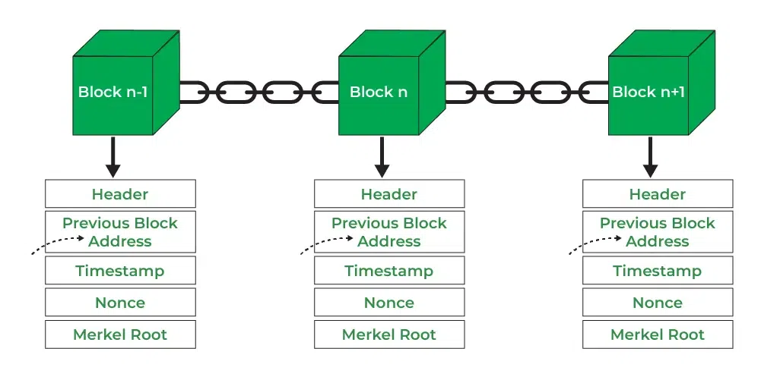Figure 1: Showing how blocks of data are connected in a blockchain structure and how blocks are structered. [15] Geeks for Geeks https://www.geeksforgeeks.org/blockchain-structure/

As mentioned earlier in the introduction, Blockchain is a distributed ledger where data is stored in connected blocks on a peer to peer network. Blockchain provides a few key features that can be utilized in the context of EHR. Decentralization, distributed ledger, and immutability are some of the most important that make it a powerful tool that gives ownership of patient data back to the patients. Based on the work of Hölbl et al [1], I’ll summarize how this technology works to better explain how it can be intergraded for EHR.
Blockchain is a technology that consists of blocks of data that are chained together, thus the name. As seen in Figure 1, each block consists of a few key data points, a header, the address of the previous block, a timestamp that indicates when it was created, a nonce that is used in different consensus algorithms to validate the data, and finally a data structure that holds a list of all the transactions related to the block (a Merkel root ). One of the algorithms that allow for the immutability and integrity of the blocks are hashes. A hash function is a one-way function, meaning given f(x) there is no efficient way of finding x. Specifically hash functions such as SHA256, which outputs a 256 bit string given an input, is normally used to connect blocks [16] (https://nvlpubs.nist.gov/nistpubs/FIPS/NIST.FIPS.180-4.pdf). The content of one block will be passed through the hash function and the output will be passed as the address in the next block, thus connecting the two blocks. Another technology used in Blockchain is asymmetric encryption, using a public and a private key to encrypt and decrypt data. This technology is what allows for only authorized individuals to access the content of a block within the Blockchain, as only the correct combination of public and private keys will allow for the encrypted message to be decrypted. Whenever someone, a node, wants to read or write to a block, or perform a transaction, a digital signature using the private key of the node is used to sign the transaction. By using the private key, each transaction can be traced back to the node responsible, allowing for non-repudability and integrity of the transaction.
Since the Blockchain is decentralized, meaning there is no central point where data is stored but rather distributed along a network of peers, there must be a way to verify if a block is authentic and to ensure the integrity of the entire chain. This is where consensus algorithms come into the picture. The type of consensus algorithm used is dependent on the purpose of the blockchain and the nodes (computers that are connecting to the Blockchain) that are in place. Some common consensus algorithms are proof-of-work (PoW), proof-of-stake (PoS), delegate-proof-of-stake (DpoS), proof-of-importance (PoI), and proof-of-deposit (PoD) [1]. Going over how these consensus algorithms are beyond the scope of my research, but their purpose is to have the peers of the network “to agree on a certain state of the distributed ledge and on a way for packing data into blocks” [1]. In terms of an EHR system, PoS seems to be favored over PoW due to its scalability and faster transactions [17].
There are three major types of Blockchain solutions, “public permissionless, consortium (public permissioned), private” [1]. A public permissionless blockchain allows anyone to join the blockchain without approval [1]. The major downside when it comes to implementing in the context of EHRs is that “users do not have total privacy and anonymity” [2]. This would mean that anyone would be able to see every transaction, so if a patient need to go to a certain specialist and needs to share their data with them, anyone would be able to see this. The private Blockchain is a sort of centralized decentralized network where only specified nodes are allowed to join and only specified nodes can perform transactions [1]. Private chains are only “intedned for use inside corpoarte settings” which limits its scope [2]. There would be a needed trusted third party that sets permissions for nodes and allows patients or hospitals to join. This can become an issue with interoperability between different healthcare providers and patient data ownership. The third major blockchain type is the consortium blockchain, which is a “permission blockchain that is managed by a group of businesses” [2]. These blockchains are open for public use, yet also having a center of trust distributed among the groups maintaining it [1]. There exists another blockchain mentioned by Sanjay Kumar Jena, Ram Chandra Brik, and Rojalina Priadarshini, a hybrid between public and private, “combining the most advantageous features of public and private blockchain protocols” [2]. This hybrid blockchain allows for all participants to perform transactions while keeping confidentiality for the transactions. In terms of healthcare usage, either a private or a hybrid blockchain is preferred [2]. But when we look at having a global system, a consortium may be preferred as nations would be able to better work together for patients that travel the globe for treatments.
What makes Blockchain very suitable for patient EHRs is that it provides data security and immutability, patient data control, interoperability, and eliminating on singular point of failure. When it comes to data security, the nature of transactions “ensures that ledger data cannot be manipulated without discovery” [3]. Any change made will be kept track of, from the change itself and who was responsible for the change. Using the various cryptographic principles that make up the Blockcahin described by Hölbl, data immutability is ensured [1]. Data cannot be altered once on the chain, meaning the integrity of the patients records are ensured. Patient data control is ensured, once again due to the way Blockchain works. By having each block being signed by the owners private key, only the owner can decrypt the data [1], and having “Blockchain-based Identity management solutions” can allow for patients to “[give] access to healthcare practitioners and researches as needed while maintaining privacy and permission” [3]. Interoperability can be obtained through Blockchain solutions with the use of smart-contracts built into the chain to automate and secure the data sharing process between stakeholders [2]. As mentioned earlier in the paper, Blockchain is decentralized, data is stored and shard on a network of peers instead of one singular server prone to attacks. The decentralized nature eliminates one point of failure, so if one node goes down, the entire infrastructure will not fail.

Section III: IoT integration
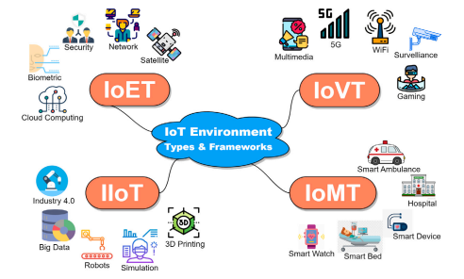Figure 2: IoT environemnt presneted in [2] with IoET (Internet of Everything), IoVT (Internet of Video Things), IIoT (Internet of Industrial Things), and IoMT (Internet of Medical Things)
Internet of Things, or IoT, is a term coined for describing the network that is formed with all the smart devices that are currently available on the consumer market. This includes smartphones, smartwatches, smart fridges, and any other device with an embedded computer that can connect to the internet. The paper “IoT-based eHealth using blockchain technology: a survey” by Aya H. Allam, Ibrahi Gomaa, Hala H. Zayed, and Mohamed Taha, indicates that the estimated number of IoT devices in 2025 will be around 75 billion and the revenue in the IoT industry is to reach $4 trillion [4]. IoT devices can be very significant when it comes to generating EHRs as they allow for patient data monitoring and gathering remotely using the sensors on the devices. As seen in figure 2, Sanjay Kumar Jena et al show an illustration of the IoT environment and some smaller environments that make up the larger one. The primary focus of this paper is on the Internet of Medical Things (IoMT) which consists of IoT devices that have the purpose of gathering medical data.
IoMT devices have the ability to “[automate] data collection and analysis”, thus “[improving] accuracy and speed of healthcare delivery” [4]. The use of these devices has increase substantially since COVID-19, allowing for remote patient monitoring [5]. IoMT consists of various devices that are able to collect patient data such as “body temperature, oxygen levels, and electrical activity” from devices located on the patients body or even in the patients house [4]. These devices have the ability to send data directly to healthcare providers, so they can monitor and provide treatment plans remotely if necessary, or even call for help in the case of emergencies. This also allows for more data on how a patients vitals are while in their normal environment, giving healthcare workers better insight and assistance in diagnosing patients.
Beyond simply recording data and monitoring patient vitals, IoMT devices can allow for disease prediction and patient tracking.
Section IV: Digital Identity
A subset of blockchain technology that can help manage EHRs is digital identity or DId. DId is a way to uniquely identify an individual on the digital landscape that is the internet. There exists a current scheme of DId, where someone can be identified by their IP addresses, browsing habits, geolocation, operating system, etc.. The main issue with current state of DId is that all this personal data is managed and stored by various different organizations that manage web applications where these DId’s are generated and stored. Unlike a physical ID card, or a social security number, people do not have a hold on their own DId [2].

Section V: Existing and Theoretical solutions
Both Blockchain and IoT devices have the ability to enhance the healthcare industry globally,
Healthdote

Section VI: Challenges that exist
Section VII: Conclusion

