GGC Maps Intellectual Property (IP) Contract
Course: ITEC 4860 – Software Development Project II
Project: GGC Maps Revamp
Date: November 16, 2025

1. Purpose
This Intellectual Property (IP) Agreement defines the ownership, usage, and distribution rights of all software, designs, assets, and documentation developed by Team Lost during the creation of the GGC Maps Revamp project during the Fall 2025 semester.
This document is for class assignment purposes only and is not legally binding.

2. Scope
The project rebuilds the existing campus mapping system at Georgia Gwinnett College using a modern modular web framework (Next.js / React).
It reuses campus SVG and JSON assets originally created by prior GGC student teams.

3. Intellectual Property Terms
- All existing SVG maps and JSON data remain the property of their original owners.
- All new React, JavaScript, and CSS code created by Team Lost is co-owned collectively by the current project contributors (Team Lost). Each contributor retains proportional ownership according to the table below.
- All contributors grant Dr. Cengiz Gunay and future student teams a non-exclusive license to use, adapt, and improve the project for educational or research purposes.
- The project may not be sold or published commercially without written permission from all owners.
- All work is released under the GNU General Public License v3.0 (GPL-3.0), in alignment with the licensing model of the parent GGC Maps project. Attribution should include: “Developed by Team Lost – Fall 2025.”
- This document represents a good-faith intellectual property agreement among Team Lost contributors and their client, Dr. Cengiz Gunay, outlining ownership and licensing terms for the GGC Maps Revamp project.

4. Project Stakeholders and Ownership Table
Name | Role | Percent Ownership | Signature
Brendan Morrissey | Lead Developer / Architect | 23% | ________________ ____
Justin McCabe | Team Manager / UI/UX Designer / Developer | 23% | ___________ _____ ____
William Stein | Data Modeler / Documentation Lead / Developer | 23% | _____________ ___
Karen Armendariz | Client Liaison / Lead Tester / Programmer | 23%
Dr. Cengiz Gunay | Client / Institutional Representative | 8% | 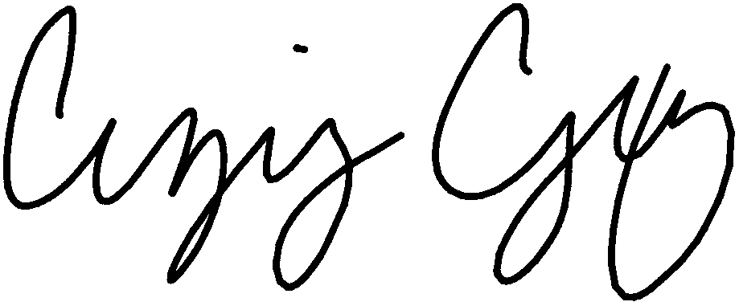  ________ ___________
Total Ownership: 100%

This document is for academic submission only and does not constitute a legal contract.

