Support Vector Machine
A support vector machine (SVM) is a type of supervised machine learning classification algorithm which outputs an optimal hyperplane that categorizes new examples given labeled training data [15]. SVMs were introduced initially in 1960s and were later refined in 1990s. However, it is only now that they are becoming very popular, owing to their ability to achieve outstanding results.
Simple SVM: In case of linearly separable data in two dimensions, as shown in Figure 2.6, a typical machine learning algorithm tries to find a boundary that divides the data in such a way that the misclassification error can be minimized. If you closely look at Figure 2.6, there can be several boundaries that correctly divide the data points. The two dashed lines as well as one solid line classify the data correctly.

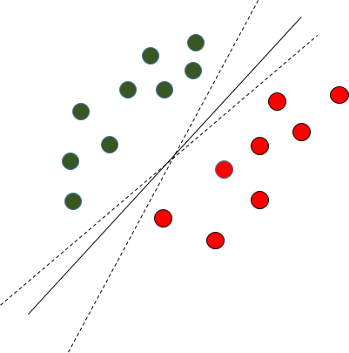

Fig. 2.6 Multiple Decision Boundaries

SVM differs from the other classification algorithms in the way that it chooses the decision boundary that maximizes the distance from the nearest data points of all the classes. An SVM doesn’t merely find a decision boundary; it finds the most optimal decision boundary. The most optimal decision boundary is the one which has maximum margin from the nearest points of all the classes. The nearest points from the decision boundary that maximize the distance between the decision boundary and the points are called support vectors as seen in Figure¬2.7. The decision boundary in case of support vector machines is called the maximum margin classifier, or the maximum margin hyper plane.
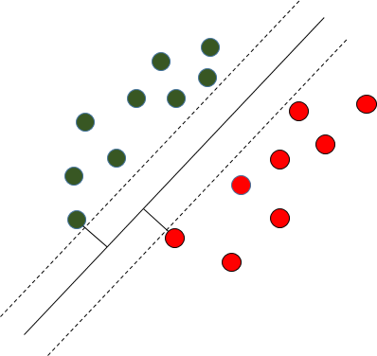
Fig. 2.7 Decision Boundary with Support Vectors

Kernel SVM: In the previous two figures Figure 2.6 and Figure 2.7 it was shown how the simple SVM algorithm can be used to find decision boundary for linearly separable data. However, in the case of non-linearly separable data, such as the one shown in Figure 2.8, a straight line cannot be used as a decision boundary.
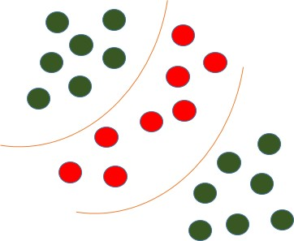
Fig. 2.8 Non-linearly Separable Data

In case of non-linearly separable data, the simple SVM algorithm cannot be used. Rather, a modified version of SVM, called Kernel SVM, is used. Basically, the kernel SVM projects the non-linearly separable data lower dimensions to linearly separable data in higher dimen- sions in such a way that data points belonging to different classes are allocated to different dimensions.

Process Of algorithm:

Dataset:
In this stage data set is prepared which has metoo tweets and sentiment for tweets, these are used as features and labels for the project. Input data is given for preprocessing stage.

Preprocessing:
Data is preprocessed by converting tweets using natural language processing tweets are cleaned and these details are used for training algorithm.

Split Dataset:
Dataset is split in to train data and test data , train data is used for training and test data is used for testing.
Train Algorithm:
Using SVM algorithm data is trained by taking input as x train and y

Train as input and prediction is performed.

Prediction:
For predicting sentiment of women safety tweets train data is taken a input and sentiment is calculated.

