**INSTAGRAM USER ANALYTICS**

**Project Description:**

Performing User analysis which involves analyzing user interactions and engagement with the Instagram app to provide answers to primary and secondary stakeholder’s questions and also to provide valuable insights for taking well-informed decisions about the future direction of one of the world’s most popular social media platforms.

By using Data analytics process, I will Ask questions to define the problem, Prepare the data, Process it by cleaning the data, Analyze the data using MySQL workbench, Share it with the stakeholders and provide meaningful insights to the team for making Data-Driven Decisions.

**Approach:**

***Ask:*** I will first define the questions to solve, these questions are regarding marketing analysis and investor metrics

* Marketing Analysis

1. Identifying the loyal users to reward them. Loyal users are the oldest users on Instagram.
2. Identifying inactive users, who have not posted a single photo.
3. Contest winner who have the most likes on their photo.
4. Identifying top 5 most used hashtags and suggest them to the partner brand to use in their Instagram posts.
5. Providing insights to the team about scheduling the ad campaign by identifying which day the traffic in the application will be more

* Investor metrics:

1. Here investor wants to know the usage of the application by knowing the average posts per user.
2. How many bots and fakes accounts does Instagram have?

***Prepare:*** Collect the required data from the management and create a database called “**ig_clone**” in MySQL workbench to store the data, I will then insert the data in a tabular format by creating various tables with their respective rows and columns. Each table will have primary key as well as foreign key connecting all these tables to one another. The tables in this ig_clone database will be,

* users
* photos
* comments
* likes
* follows
* tags
* photo_tags

***Process:*** Checking for any duplicates and any NULL values in the tables. As the data is directly from primary data source and manually created the chance for errors in data is low.

***Analyze:*** Finally, the data is ready for analyzing and answering the marketing, investor questions. Here we will analyze the data for any trends or relations between the data to provide data-driven insights for our stakeholders.

For this we use MySQL workbench,

To remind the workbench we are using the “ig_clone” database, we have to revoke the database by using the following syntax,

**USE** ig_clone;

# now SQL will know to use this database for the future queries until the end of the session

**Marketing Analysis:**

* **Loyal User Reward:** Here the marketing team wants to identify the 5 oldest users on Instagram to reward their loyalty,

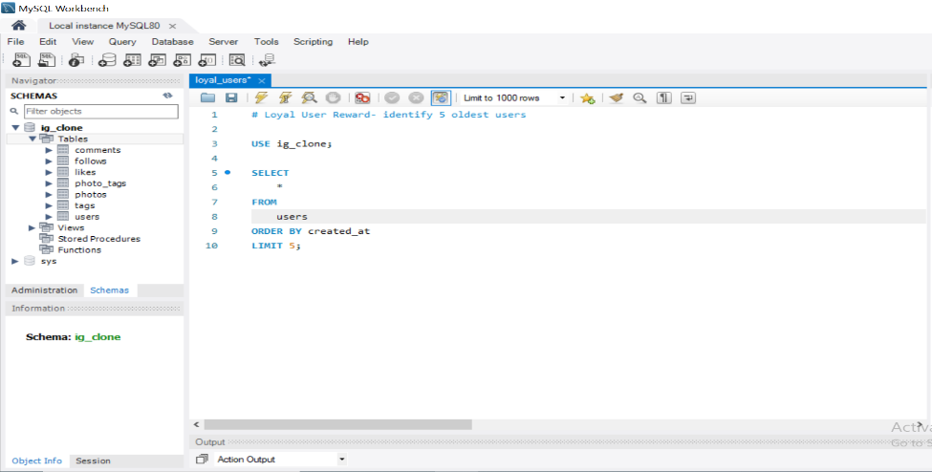

***Output*:** 5 oldest users on Instagram

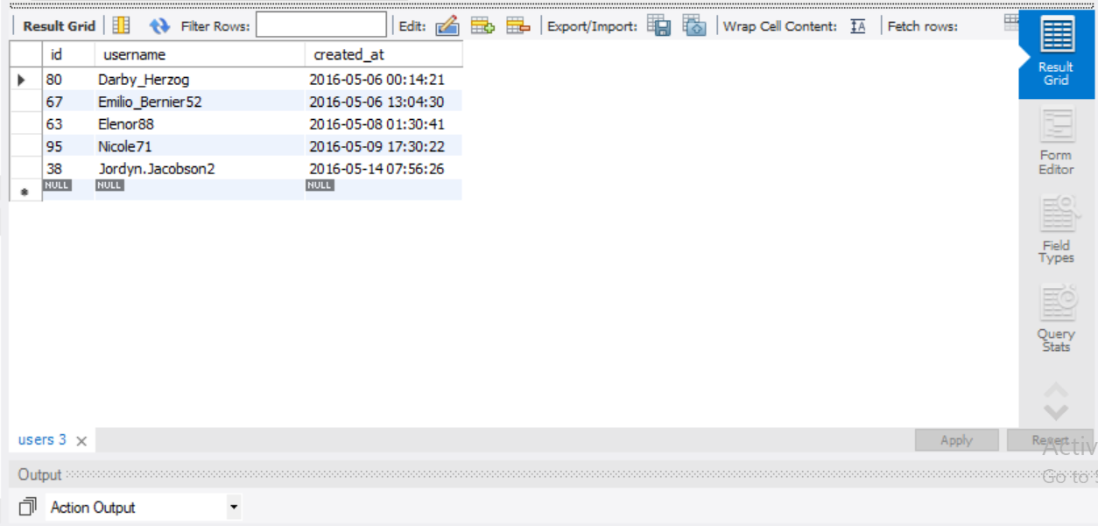

* **Inactive User Engagement:** Marketing team wants to identify users who have never posted a single photo on Instagram to send them promotional emails,

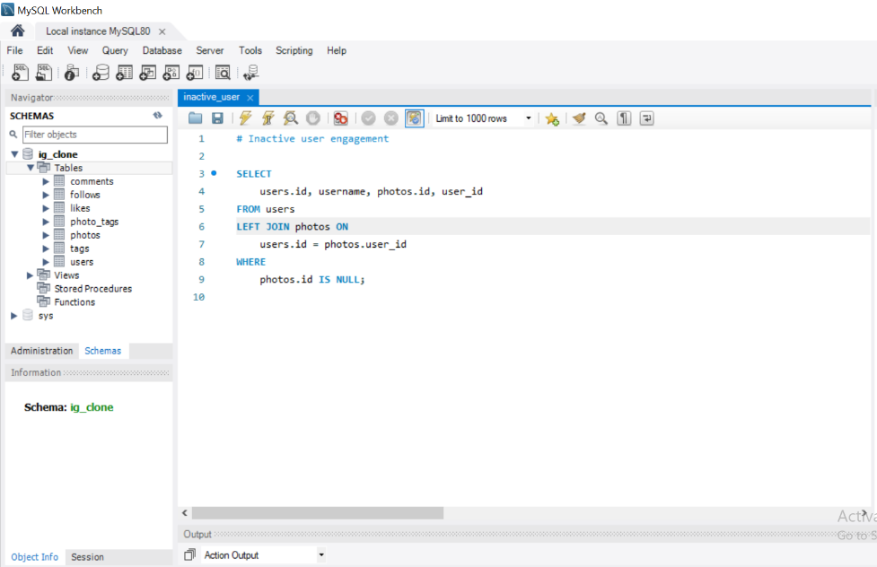

***Output:*** The list of all inactive users to whom marketing team should send promotional E-Mails.

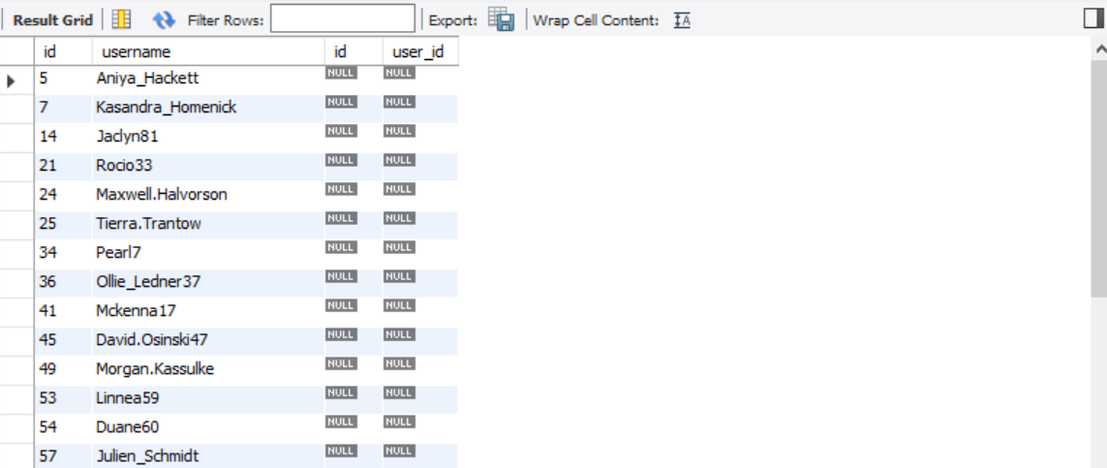

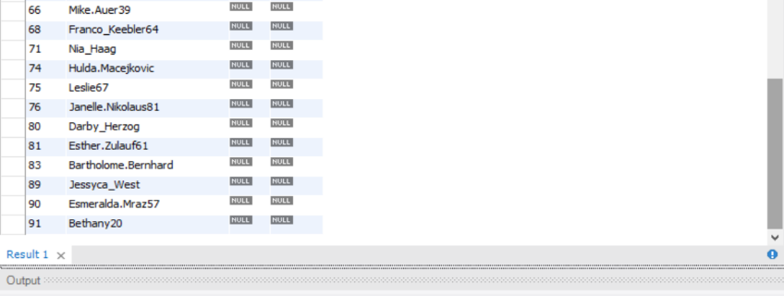

* **Contest Winner Declaration:** Marketing team want to know who got most likes on their photo to declare a winner of the contest.

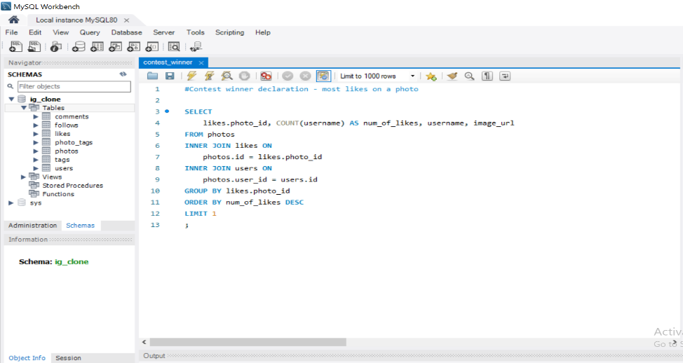

***Output:*** So, username Zack_Kemmer93 with user id 52 and photo id 145 have most number of likes from all the other photos.

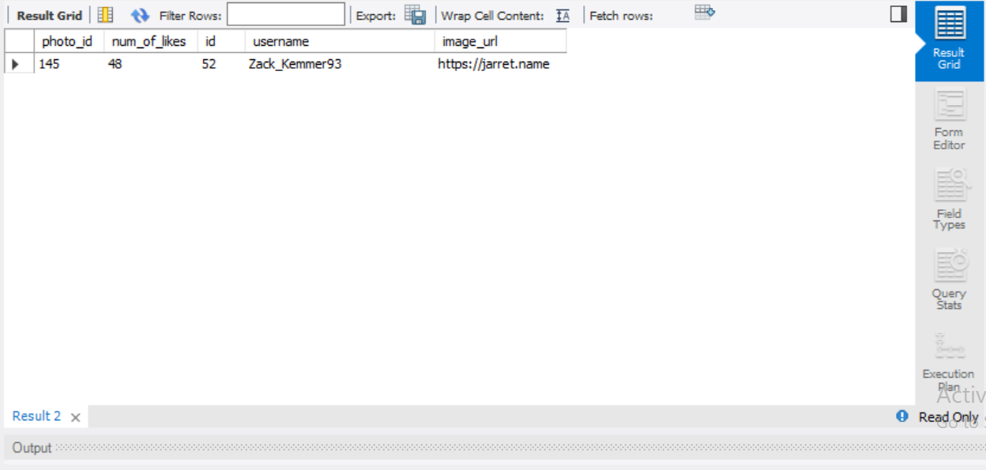

* **Hashtag Research:** Partner brand wants to know the top 5 most commonly used hashtags on the platform,

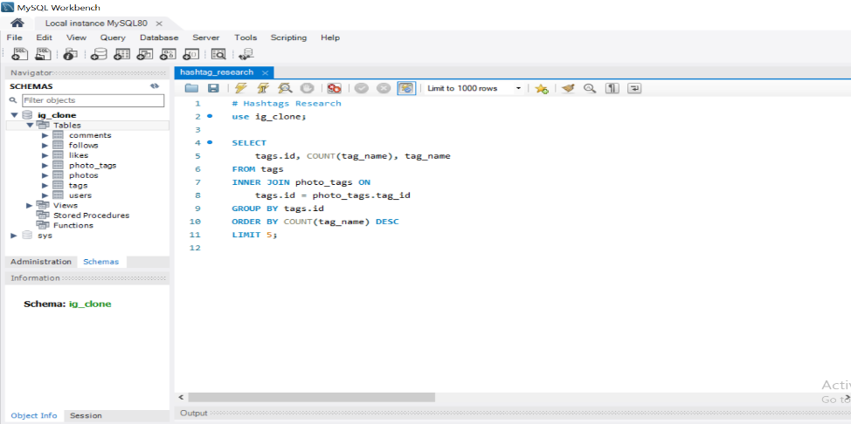

***Output:*** Here are 5 most used hashtags used in the post on Instagram,

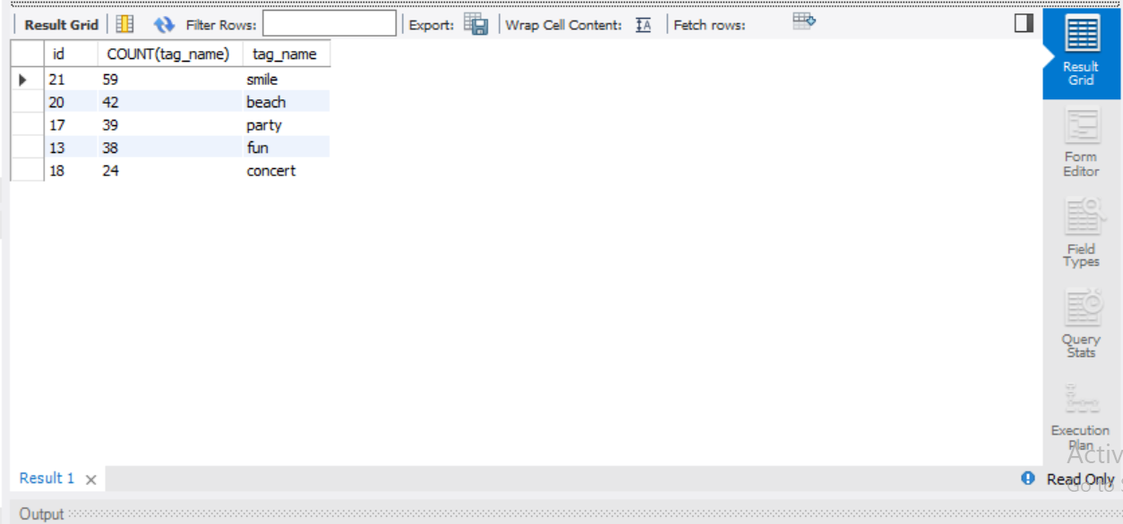

* **Ad Campaign Launch:** Our team wants to learn the best day of the week to schedule an ad campaign when most users will come to register on Instagram,

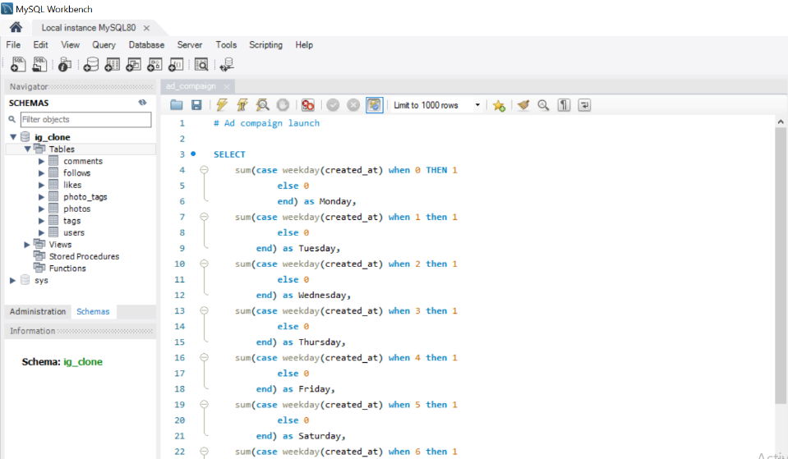

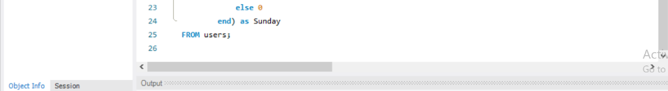

***Output:*** Here, we will find that Thursday is a day which most users register on Instagram.

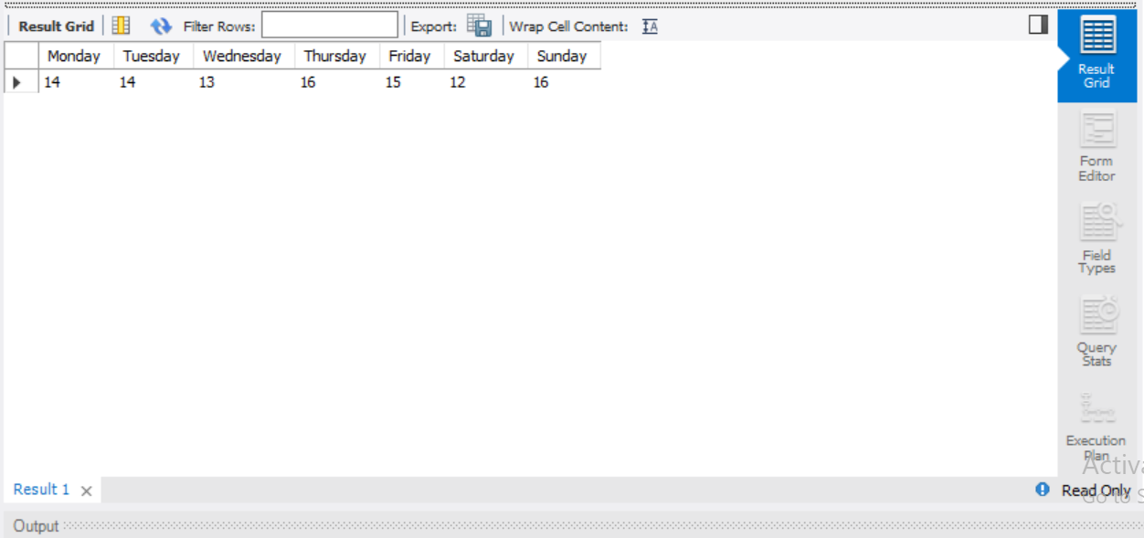

**Investor metrics:**

* **User Engagement:** Investors wants to know average photos per user to know if users are still active on Instagram,

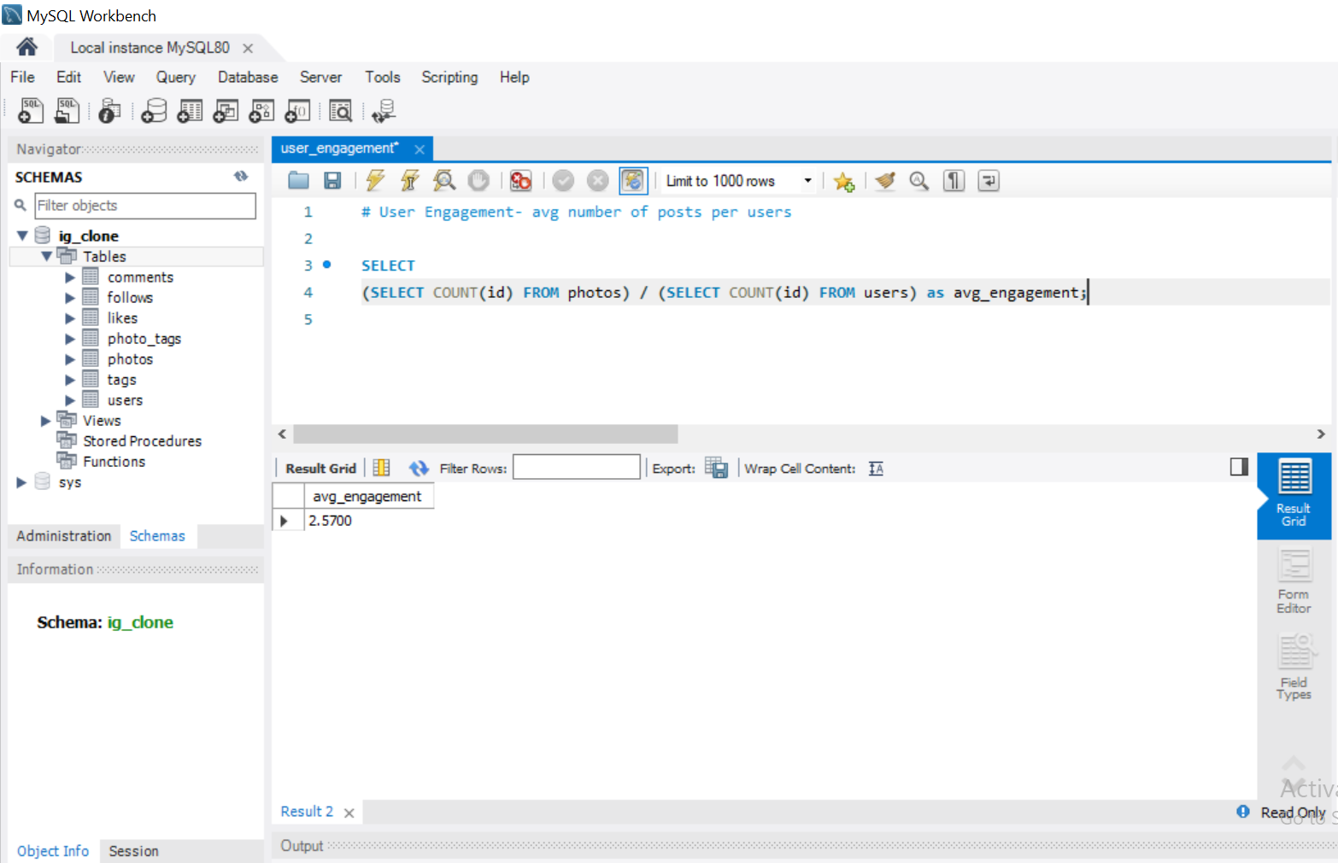

***Output:*** The average engagement per user is 2.57as shown in the above figure.

* **Bots & Fake Account:** Investors want to know if the platform is crowded with fake and dummy account by finding which users liked each and every photo in Instagram,

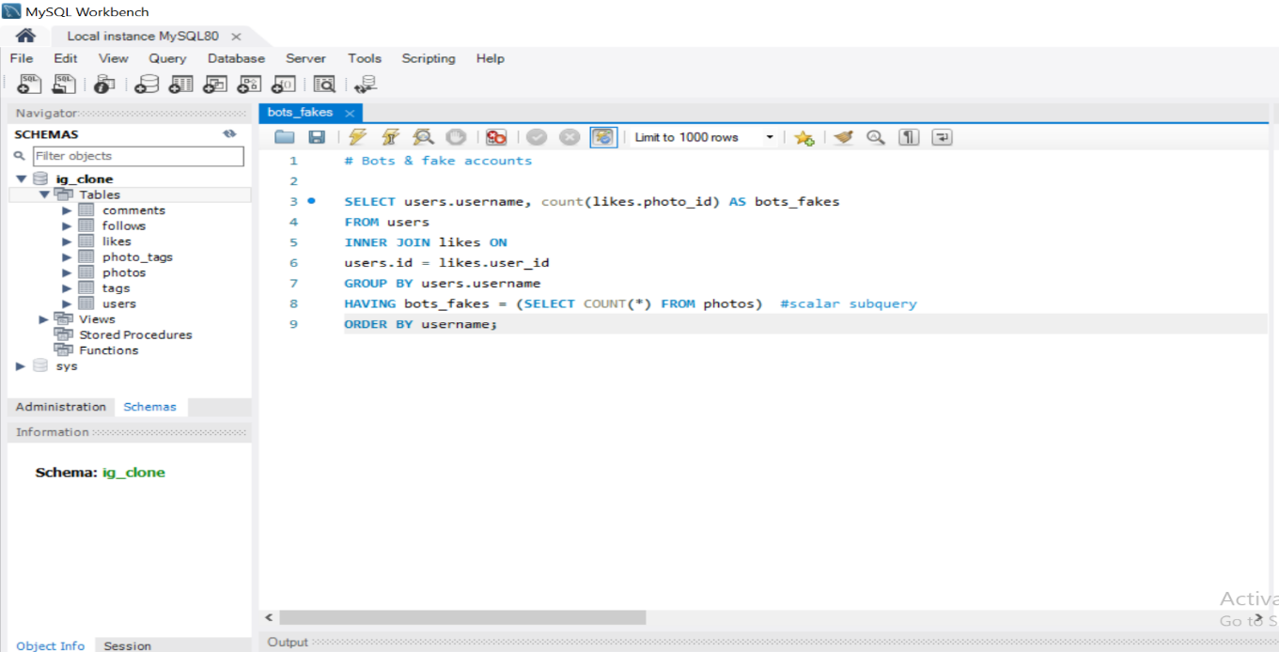

***Output:*** This query will return 13rows which consists of bots and fake accounts.

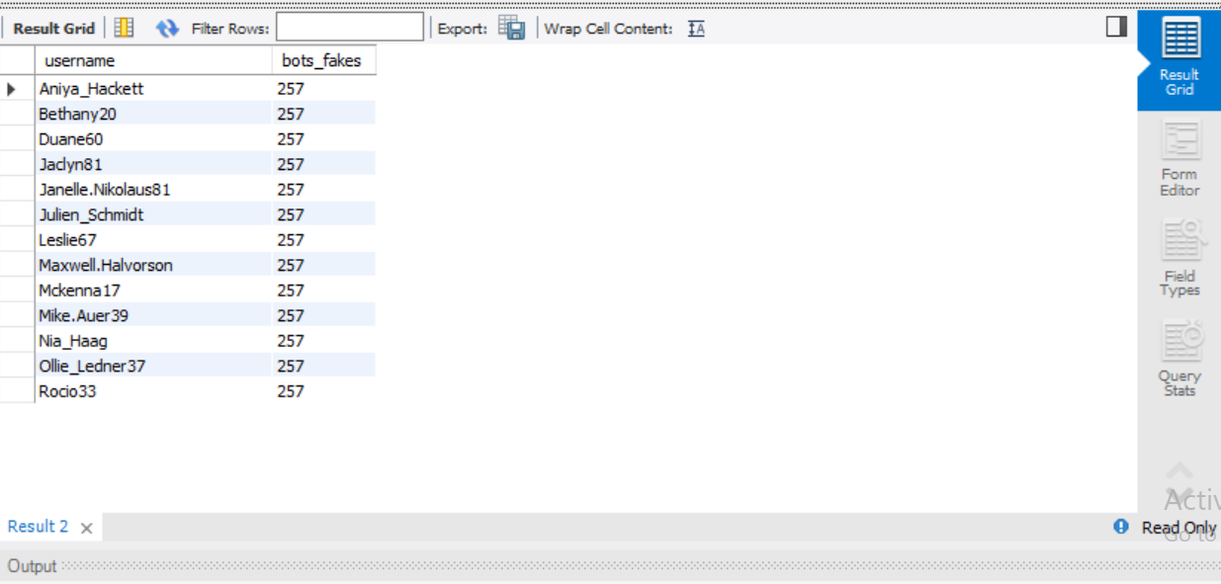

Thus, conclude our analysis.

**Tech-Stack used:**

The Tech-stack used is MySQL workbench 8.0 CE to perform analysis and execute the queries for obtaining meaningful insights.

**Insights:**

***Share & Act:*** After analyzing the data, in MySQL workbench we have to share out insights with the primary stakeholders i.e., marketing managers, investors and secondary stakeholders (Team members). So, that data-driven decisions are taken for the success of the program.

My insights are as follows,

* From the ad campaign query, we concluded that the most users register accounts on “Thursday” and also “Sunday”. The marketing team should schedule their ad campaign on “Thursday” as their will be a possibility that more number of users will see the ad rather than in other days. As more people will see the ad, it will be reach more people by the word of the mouth.
* List of Inactive users should be persuaded to return to the platform by sending new promotional E-Mails.
* Partner brand can use these 5 most popular hashtags in their posts to increase their engagement:

smile, beach, party, fun and concert

* Rewards should be given to both loyal users as well as the contest winner as it will increase the user engagement on the platform too.
* Preventive measures should be taken to take down all the bots and fake accounts in order to optimization the security measures of the users.

**Result:**

Instagram is running with moderate success but by increasing the promotional and advertising campaigns, rewarding the loyalty, measures to increase the security of the platform leads to future success of the platform.