**CIS200 – Introduction to Object-Oriented Programming**



**Laboratory Report**

**Name:** Andrea Beam **BlazerID**: APBEAM

**Lab***:* Assignment 8 **Date submitted***:* 26 Jan 15

**Introduction**

The overall goal for this lab assignment is to be able to begin developing programs that are centered around the concept of Object-Oriented Programming. You will manipulate strings and objects such as pictures. You will be able to manipulate the color in pictures at the end of this lab.

To make sure that the right response (output) is received the student must make sure to set the path (can be unique to different computers) to the java compiler before attempting to run any program in the terminal window. The terminal window is also known as the command prompt which can be accessed via the Start Menu, then typing cmd into Run or Find. Once the path has been set the programs can be compiled then ran in the Terminal Window.

**Methods**

When first attempting to create the Picture program where you manipulate the color pigmentation, I created a main method that would call the Picture class to be able to get the original color of the picture. I made sure to import java.awt.color so that the program could find the colors. I then began to figure out how to find only the red, green, or blue colors; printing a seperate picture of each. Within each method I created, one for each color, I made a for loop that would search the whole picture to find the colors. Then I changed the settings of the picture to make it so that only one color was being found. Then I made the main method print out each newly formed picture along with the original so that you can see the difference.

I created the String Manipulation program next by creating a main method that would take an input of a string of any length. I then utilized the StdIn libraries to change the String to all capital letters, to reverse the order of the String, and to count the number of e's in the String. After I did this I tidied up the program and had it print out the results.

The next program, Extension, takes a file name as the command argument then separates it so that the end result prints out the beginning part of the file name and then the extension. I used the decimal that separates the two parts as the reference point then after declaring the two separate parts had it print them.

I was unable to finish the last program however I want to try to figure out how to write it so I will continue to work on this program.

**Results**

StringManipulation:

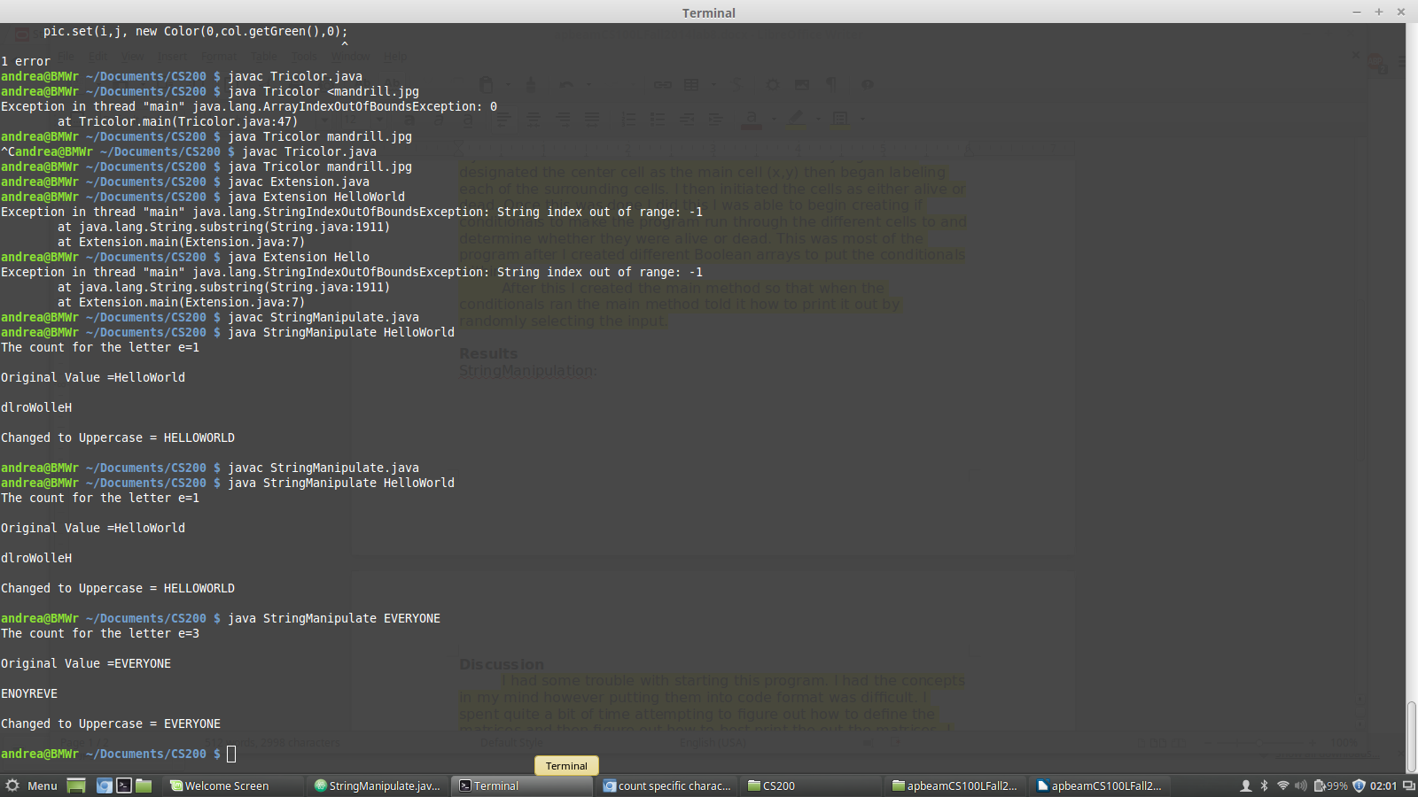

Extension:

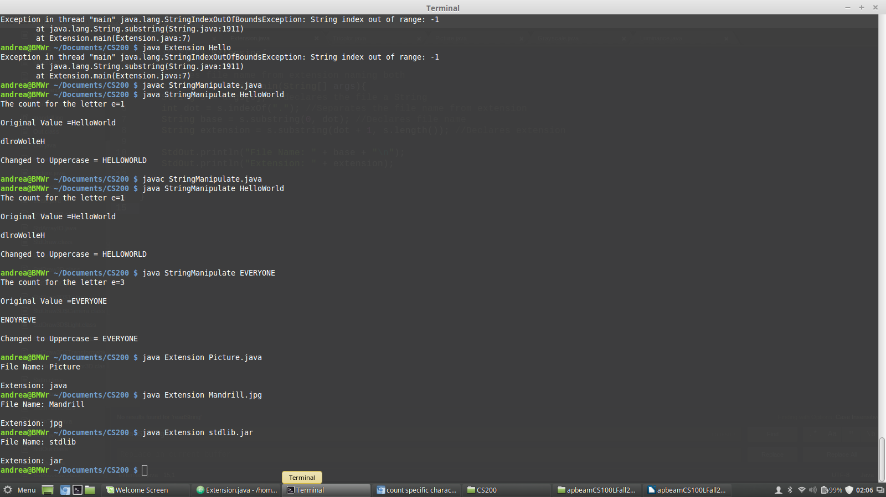

Tricolor:

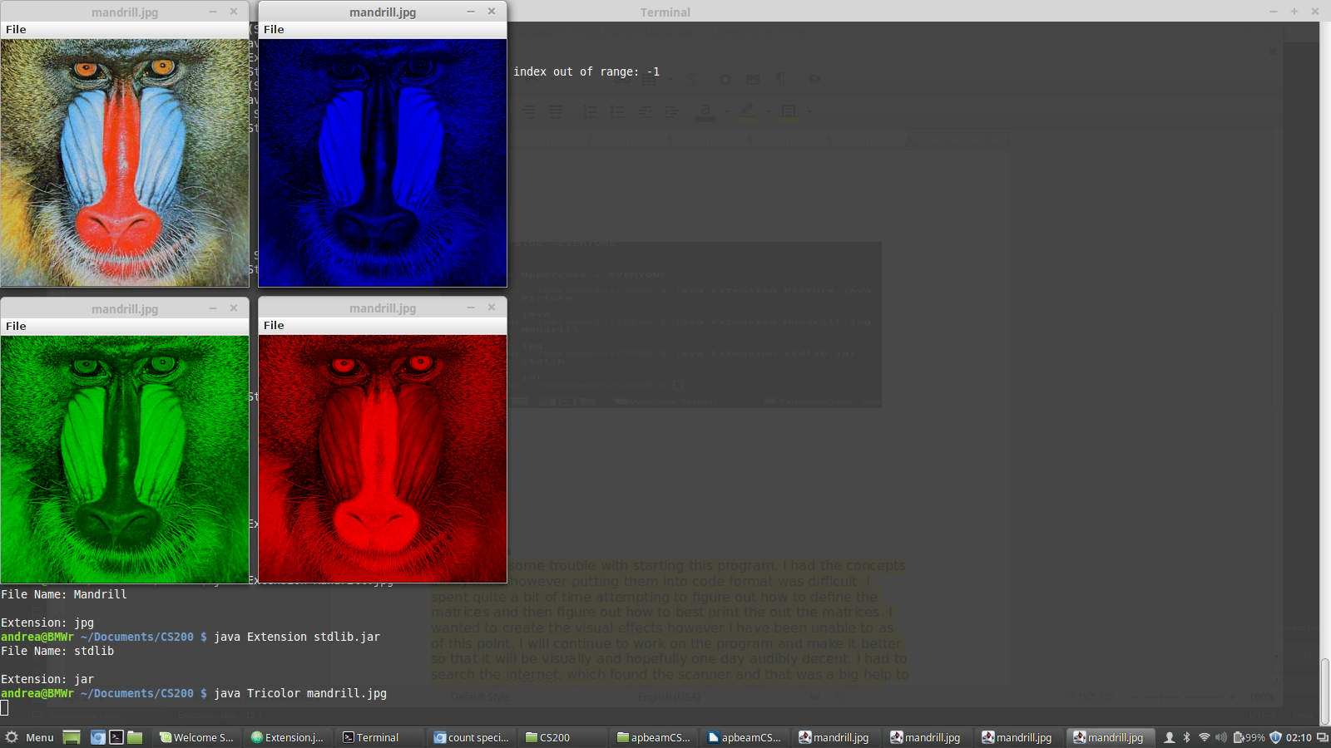

**Discussion**

Most of these programs were very simple. The Extension program and the String Manipulation programs were the two that I found extremely simple. I spent most of the time when writing these programs making the output respectable and neat. However, the TriColor program gave me quite a bit of trouble. I knew in the beginning that I would need 3 separate methods one for each color and then also a main method. I first wrote the main method, what I had at the time, and then proceeded to write rest. I would work on one method mainly since I knew in the end they would all be almost identical. At first I did not realize that I would need a for loop to scan the whole picture to find the colors. This took a bit of time attempting to figure out. After I figured this out I had several errors that took time understanding what was wrong. Once I did see the mistakes, I made sure that I double checked all of the basic things in the program such as declaring variables integers and such.

I tried to begin on the last step of the assignment but was unable to truly understand what was needed to get the end result. I will continue to work on this program as I was unable to finish it.

**Conclusion**

In conclusion, I know that I need to be more careful when writing my programs as most of my errors were simple ones that caused most of my debugging time. I know that practicing writing and reading programs is the only way to improve so I will continue to do this. I want to finish the 5th step of the assignment so I will continue to work on that program.

**References**

Sedgewick, Robert and Kevin Wayne. Introduction to Programming in Java. New

York:Pearson Education, Inc, 2008. Print

**Appendices**

Picture.java

Luminance.java

Extension.java

StringManipulate.java

Tricolor.java