**CIS200 – Introduction to Object-Oriented Programming**

**Laboratory Report**

**Name:** Andrea Beam **BlazerID**: APBEAM

**Lab***:* Assignment 9 **Date submitted***:* 9 Feb 15

**Introduction**

The overall goal for this lab assignment is to be able to begin developing programs that are centered around the concept of Object-Oriented Programming. You will manipulate strings and objects such as pictures.

To make sure that the right response (output) is received you must make sure to set the path (can be unique to different computers) to the java compiler before attempting to run any program in the terminal window. The terminal window is also known as the command prompt which can be accessed via the Start Menu, then typing cmd into Run or Find. Once the path has been set the programs can be compiled then ran in the Terminal Window.

**Methods**

The first step in the lab was to finish off a rectangle API by setting the methods for formulating the area and perimeter of a rectangle plus a methods for drawing the any rectangles that the client wants. I also created a method that would compare 2 rectangles created and determine whether they intersected each other. I used StdDraw functions to create the rectangles visually and just used the formulas for area and perimeter to calculate those two functions. After this I wrote a separate program to call the functions. I began by initializing the arguments for width, height, and the x and y coordinates where the rectangles begin. Once this was done I created print line statements that would call the different functions from the original rectangle program. I also added two lines that would draw each rectangle.

I copied the turtle program from the book as directed then I just multiplied the angle by 2 to create the star effect.

The last thing that I did was copy the Stopwatch program from the book also as directed. I then determined that main method was not needed so I deleted that out. I then created a new method that would stop the program, and another one after that to restart the program. Once this was done I began working on the main method I created three print line statements that would run immediately to tell the user how to start, stop, and restart the stopwatch. I then initialized the stopwatch to “null”. Once this was done I wrote a while statement including three separate functions that told the program to run until the user input certain integers. Within each if statement depending on the specific function I called the corresponding method.

**Results**

RectangleTest:

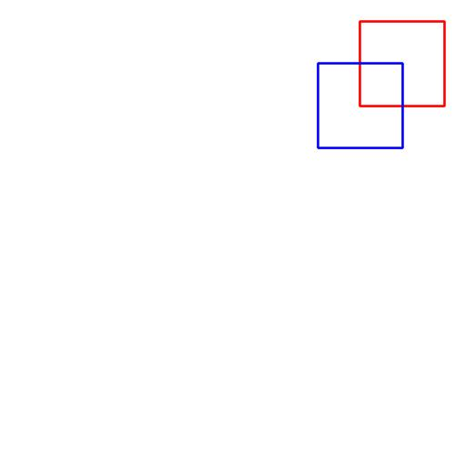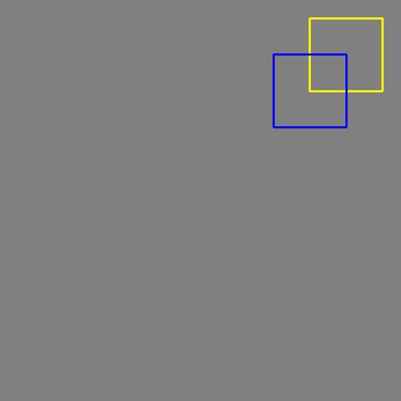

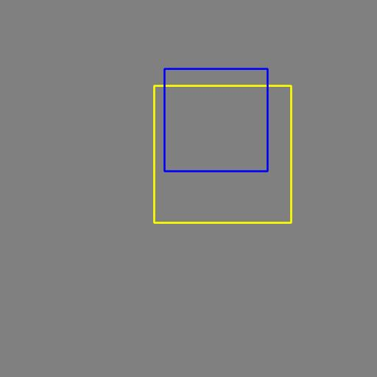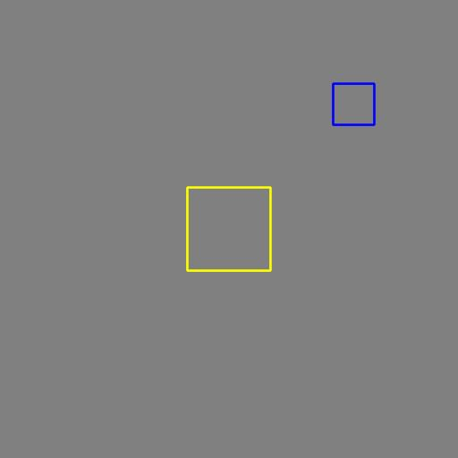

java RectangleTest 200 200 100 100 150 150 100 100

The area of Rectangle a is 10000.0

The perimeter of Rectangle a is 400.0

The area of Rectangle b is 10000.0

The perimeter of Rectangle b is 400.0

Do the 2 rectangles intersect? true

java RectangleTest 50 50 200 200 40 100 150 150

The area of Rectangle a is 40000.0

The perimeter of Rectangle a is 800.0

The area of Rectangle b is 22500.0

The perimeter of Rectangle b is 600.0

Do the 2 rectangles intersect? true

java RectangleTest 0 0 100 100 150 150 50 50

The area of Rectangle a is 10000.0

The perimeter of Rectangle a is 400.0

The area of Rectangle b is 2500.0

The perimeter of Rectangle b is 200.0

Do the 2 rectangles intersect? false

Turlte:

java Turtle 5



java Turtle 7

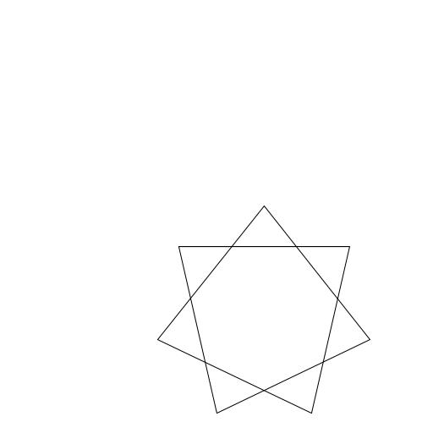

java Turtle 9

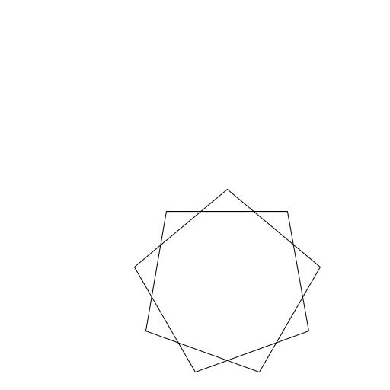

Stopwatch:

java Stopwatch

Type 1 to begin the Stopwatch.

Type 0 to stop the Stopwatch.

Type -1 to restart the Stopwatch.

1

Starting Stopwatch.

Stopwatch@2721e92

0

Stopping Stopwatch.

4.813

-1

Restarting Stopwatch.

Stopwatch@2721e92

0

Stopping Stopwatch.

9.227

java Stopwatch

Type 1 to begin the Stopwatch.

Type 0 to stop the Stopwatch.

Type -1 to restart the Stopwatch.

1

Starting Stopwatch.

Stopwatch@1235047f

0

Stopping Stopwatch.

2.062

-1

Restarting Stopwatch.

Stopwatch@1235047f

0

Stopping Stopwatch.

9.078

**Discussion**

For the most part the programs were fairly simple. I had some trouble with determining the function to figure out if the 2 separate rectangles intersected in the Rectangle.java program. Once that was done getting the program to run was not too difficult. I did have some difficulty getting the rectangles to draw because I forgot to set the x and y scales for the window. I looked back on some old programs after not being able to figure out what I was doing wrong when I noticed that was what I was missing. In the Turtle program I had no problem. It was a matter of knowing how the program worked when drawing the lines and then adding in a multplication to double the effect to make the stars appear. The stopwatch program at first I thought would be difficult when I received the lab assignment however when I reached the program to work on it I found it pretty easy. The hardest part for me was determining how I was going to have the user start, stop and restart the program. Once I decided to have numbers be the arguments it was a matter of determining whether to use a for or while statement. I chose a while(true) statement so that the program was continually running and the user had the choice when to change that setting.

**Conclusion**

In conclusion, I know that I need to be more cognizant when writing my programs as most of my errors were simple ones that caused most of my debugging time. I also need to try and revert back to my old programs to see if there are any simple mistakes that I may have made as I would have saved a ample amount of time had I check the old programs for the StdDraw issues that I was having. I know that practicing writing and reading programs is the only way to improve so I will continue to do this. I want to continue to work on the stopwatch program so that maybe I'll be able to one day have a window appear with the stopwatch time running and have actual buttons for the Stop, Start, and Restart functions. I would also like to maybe add in a Reset function.

**References**

Sedgewick, Robert and Kevin Wayne. Introduction to Programming in Java. New

York:Pearson Education, Inc, 2008. Print

**Appendices**

Turtle.java

Stopwatch.java

StdDraw.java

StdOut.java

StdIn.java