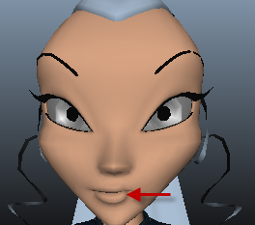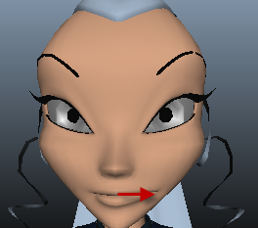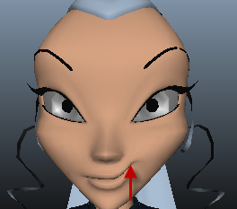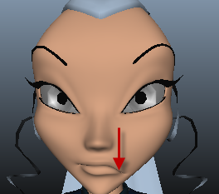
嘴巴： Lf_Mouth_LF Lf_Mouth_RT Lf_Mouth_UP Lf_Mouth_DN

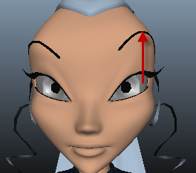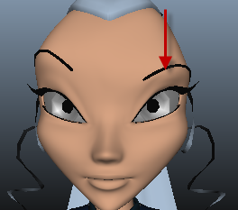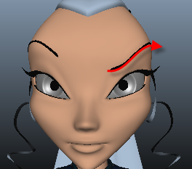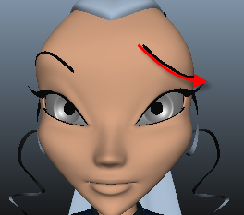
Lf_ SuperciliaryArch _UP Lf_ SuperciliaryArch _DN Lf_ SuperciliaryArch _LF Lf_ SuperciliaryArch _RT
眉毛： Lf_ Eyebrow _UP Lf_ Eyebrow _DN Lf_ Eyebrow _LF Lf_ Eyebrow _RT

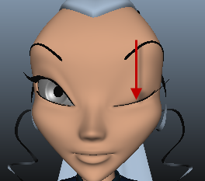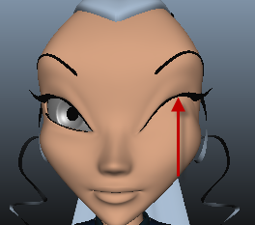
Lf_EyeClose_UP Lf_EyeClose_DN
睫毛： Lf_ LashUp_UP Lf_ LashDn_DN

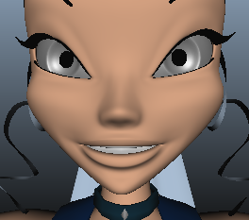
Mouth_A Mouth_E Mouth_O Mouth_U

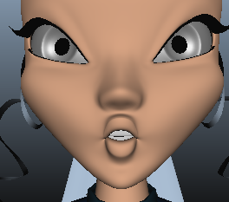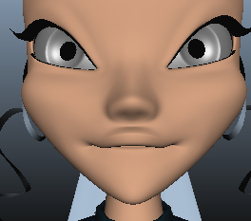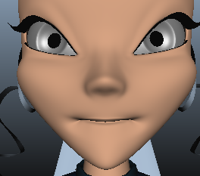
Mouth_S Mouth_F Mouth_BM

如果有中间过渡目标体。命名方法为：原来目标体名称+目标体过渡数值。例如：Lf_EyeClose_UP_0_5,_0_5表示过渡值为0.5.

