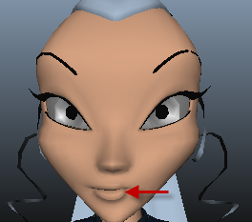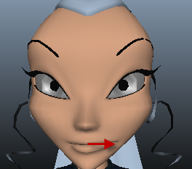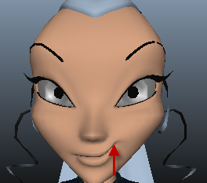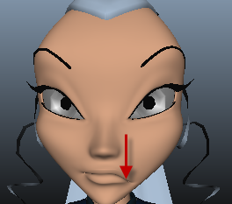
嘴巴： Lf_Mouth_LF Lf_Mouth_RT Lf_Mouth_UP Lf_Mouth_DN
Rt_Mouth_LF Rt_Mouth_RT Rt_Mouth_UP Rt_Mouth_DN

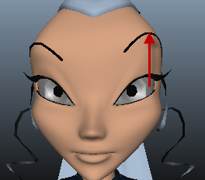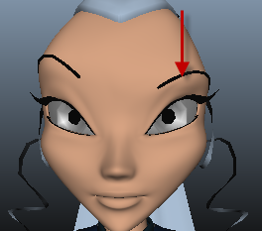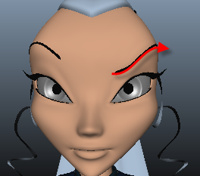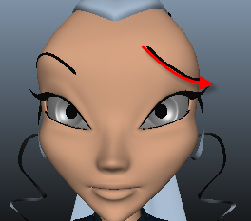
嘴巴：Lf_SuperciliaryArch_UP Lf_SuperciliaryArch_DN Lf_SuperciliaryArch_LF Lf_SuperciliaryArch_RT
Rt_SuperciliaryArch_UP Rt_SuperciliaryArch_DN Rt_SuperciliaryArch_LF Rt_SuperciliaryArch_RT
眉毛： Lf_Eyebrow_UP Lf_Eyebrow_DN Lf_Eyebrow_LF Lf_Eyebrow_RT
Rt_Eyebrow_UP Rt_Eyebrow_DN Rt_Eyebrow_LF Rt_Eyebrow_RT
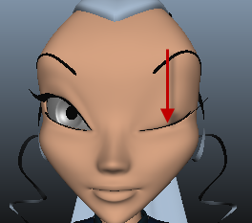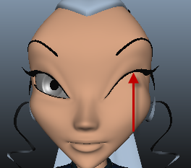
嘴巴： Lf_EyeClose_UP Lf_EyeClose_DN
Rt_EyeClose_UP Rt_EyeClose_DN
睫毛： Lf_LashUp_UP Lf_LashDn_DN
Rt_LashUp_UP Rt_LashDn_DN
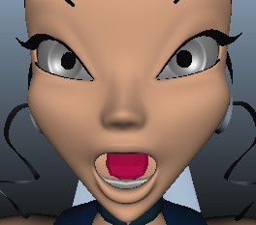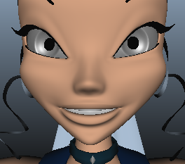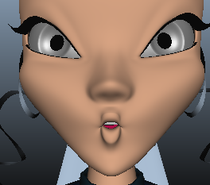
Mouth_A Mouth_E Mouth_O Mouth_U

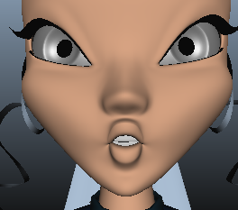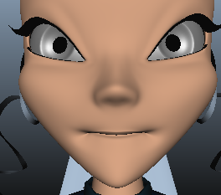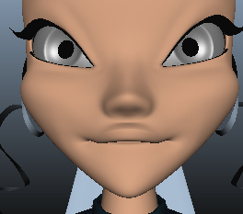
Mouth_S Mouth_F Mouth_BM

如果有中间过渡目标体。命名方法为：原来目标体名称+目标体过渡数值。例如：Lf_EyeClose_UP_0_5,_0_5表示过渡值为0.5.

