파티션 실습하기

- emp_salary를 파티션으로 분할하기

**# 1년 단위**

**alter table partitioned_emp_salary partition by range(YEAR(from_date)) (**

**partition p1985 values less than(1985),**

**partition p1986 values less than(1986),**

**partition p1987 values less than(1987),**

**partition p1988 values less than(1988),**

**partition p1989 values less than(1989),**

**partition p1990 values less than(1990),**

**partition p1991 values less than(1991),**

**partition p1992 values less than(1992),**

**partition p1993 values less than(1993),**

**partition p1994 values less than(1994),**

**partition p1995 values less than(1995),**

**partition p1996 values less than(1996),**

**partition p1997 values less than(1997),**

**partition p1998 values less than(1998),**

**partition p1999 values less than(1999),**

**partition p2000 values less than(2000),**

**partition p2001 values less than(2001),**

**partition p2002 values less than(2002),**

**partition pmax values less than maxvalue**

**);**

- 테이블이름은 partitioned_emp_salary

**create table partitioned_emp_salary**

**select * from emp_salary; # 2844047 개**

- from_date를 조사하여 파티션 갯수를 정하십시오.(일년단위, 십년단위....)

**1년 단위 분류 총 18개** group, 월별은 212 개

- emp_salary에 저장된 데이터를 파티션으로 저장함

- 각 파티션에 저장된 row수 등의 현황을 조회하여 붙여넣기

**select PARTITION_NAME, PARTITION_ORDINAL_POSITION, PARTITION_DESCRIPTION, TABLE_ROWS, AVG_ROW_LENGTH, DATA_LENGTH from information_schema.PARTITIONS where table_name = 'partitioned_emp_salary';**

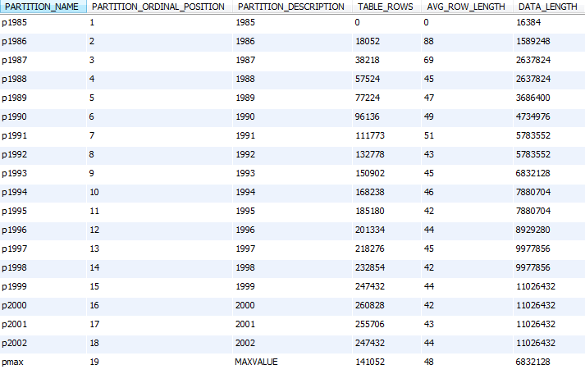

- 테이블 파티션 현황 조회 캡쳐

**위와 같음**

- 통계정보를 생성 조회 캡처

**analyze table partitioned_emp_salary;**

**C:\SQL\day3-work1-analyze.PNG**

- 두 테이블의 데이터를 일치여부를 체크합니다.

**checksum table emp_salary, partitioned_emp_salary;**

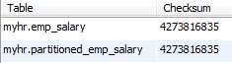

**전체 쿼리**

**use myhr;**

**create table partitioned_emp_salary**

**select * from emp_salary; # 2844047 개**

**select from_date from partitioned_emp_salary order by from_date;**

**select DATE_FORMAT(from_date,'%Y-%m') m from partitioned_emp_salary group by m; # 월별 분류 시 212 개**

**select DATE_FORMAT(from_date,'%Y') y from partitioned_emp_salary group by y; # 년별 분류 시 18 개**

**select count(*), DATE_FORMAT(from_date,'%Y') y from partitioned_emp_salary group by y; # 년별 분류 시 각 행 수**

**select min(from_date) from partitioned_emp_salary; # 1985-01-01**

**select max(from_date) from partitioned_emp_salary; # 2002-08-01**

**# 1년 단위**

**alter table partitioned_emp_salary partition by range(YEAR(from_date)) (**

**partition p1985 values less than(1985),**

**partition p1986 values less than(1986),**

**partition p1987 values less than(1987),**

**partition p1988 values less than(1988),**

**partition p1989 values less than(1989),**

**partition p1990 values less than(1990),**

**partition p1991 values less than(1991),**

**partition p1992 values less than(1992),**

**partition p1993 values less than(1993),**

**partition p1994 values less than(1994),**

**partition p1995 values less than(1995),**

**partition p1996 values less than(1996),**

**partition p1997 values less than(1997),**

**partition p1998 values less than(1998),**

**partition p1999 values less than(1999),**

**partition p2000 values less than(2000),**

**partition p2001 values less than(2001),**

**partition p2002 values less than(2002),**

**partition pmax values less than maxvalue**

**);**

**select PARTITION_NAME, PARTITION_ORDINAL_POSITION, PARTITION_DESCRIPTION, TABLE_ROWS, AVG_ROW_LENGTH, DATA_LENGTH**

**from information_schema.PARTITIONS where table_name = 'partitioned_emp_salary'; #파티션 주요 현황**

**analyze table partitioned_emp_salary; # 통계 정보**

**checksum table emp_salary, partitioned_emp_salary; # 체크 섬**