International Debt Analysis System
Exploratory Data Analysis (EDA) Report

1. Objective
This report summarizes the structure, quality, coverage, and initial patterns in the International Debt Statistics country-series dataset used by the project. The analysis uses the supplied raw CSV and country metadata.

2. Dataset Overview
Rows in raw dataset | 62,983
Columns in raw dataset | 39
Distinct country codes | 134
Distinct series/indicator codes | 576
Year range in file | 2000–2032
Exact duplicate rows found | 2
Rows missing one or more key identifiers | 5
Non-missing annual data cells | 1,345,046
Missing annual data cells | 733,393
The file contains country/series identifiers followed by annual value columns. The cleaning script converts this wide structure into long format with one row per country, indicator, and year observation.

3. Data Quality Findings
The raw file contains 2 exact duplicate rows and 5 rows with at least one missing key identifier. Across the annual columns, 733,393 cells are missing and 1,345,046 contain values. Missing annual cells are expected in a dataset where indicators have different reporting coverage; they should not be treated as zero.
The current cleaning workflow trims text, standardizes blank text as missing, removes exact duplicates, saves rows with missing identifiers for review, converts annual columns to numeric values, reshapes the data to long format, and excludes missing debt-value observations while retaining zero values.

4. Yearly Data Coverage
Annual data coverage is not uniform. The source includes columns from 2000 through 2032, but the number of populated values falls sharply from 2025 onward. These future years should not automatically be labelled as forecasts without confirmation from the source documentation. For historical comparisons in this report, the country ranking below is limited to observations through 2024.
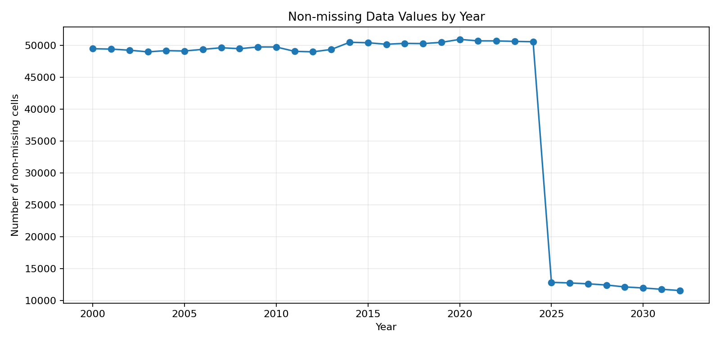

5. Indicator Coverage
The following indicators have the largest total number of non-missing annual values in the raw file. This is a coverage ranking, not a ranking of the largest debt amounts.
Indicator code | Indicator name | Non-missing annual values
DT.TDS.DIMF.CD | IMF repurchases and charges (TDS, current US$) | 4,348
DT.INT.DIMF.CD | IMF credit and SDR allocations, charges (INT, current US$) | 4,348
DT.TDS.DECT.CD | Debt service on external debt, total (TDS, current US$) | 4,341
DT.INT.DLXF.CD | Interest payments on external debt, long-term (INT, current US$) | 4,326
DT.TDS.DLXF.CD | Debt service on external debt, long-term (TDS, current US$) | 4,326
DT.INT.DEPS.CD | Interest payments on external debt, public sector (PPG) (INT, current US$) | 4,325
DT.INT.DPPG.CD | Interest payments on external debt, public and publicly guaranteed (PPG) (INT, current US$) | 4,325
DT.TDS.DPPG.CD | Debt service on external debt, public and publicly guaranteed (PPG) (TDS, current US$) | 4,325
DT.AMT.DLXF.CD | Principal repayments on external debt, long-term (AMT, current US$) | 4,325
DT.TDS.DEPS.CD | Debt service on external debt, public sector (PPG) (TDS, current US$) | 4,325

6. External Debt Stock: Initial Country Comparison
For an initial comparable country-level view, the analysis uses indicator DT.DOD.DECT.CD (External debt stocks, total, current US$), and selects each country's latest non-missing value through 2024. Aggregate groups are excluded when country metadata identifies them through a blank region.
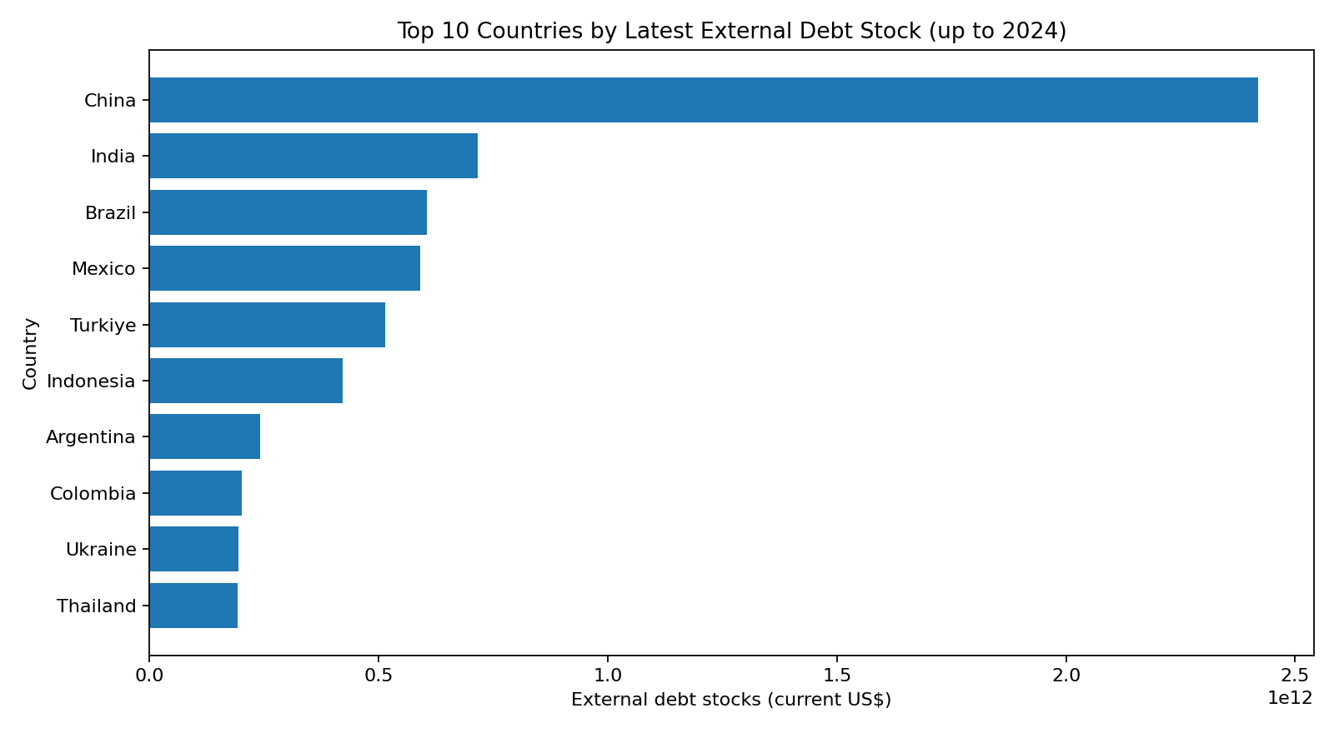
Country | Year of value | Debt value (current US$)
China | 2024 | 2,420,000,000,000
India | 2024 | 716,000,000,000
Brazil | 2024 | 605,000,000,000
Mexico | 2024 | 591,000,000,000
Turkiye | 2024 | 515,000,000,000
Indonesia | 2024 | 421,000,000,000
Argentina | 2024 | 242,000,000,000
Colombia | 2024 | 202,000,000,000
Ukraine | 2024 | 193,000,000,000
Thailand | 2024 | 192,000,000,000
Important limitation: country values may be from different latest years because reporting coverage differs. This is a latest-available-through-2024 ranking, not a strict same-year comparison. Use a single fixed year for a like-for-like comparison when enough country observations are available.

7. Cleaning and Analysis Recommendations
- Keep the original raw CSV unchanged and retain cleaning audit files.
- Check the exact duplicate rows and repeated country-indicator-year keys before final submission.
- Treat missing values as missing rather than replacing them with zero.
- Document the year range used for each chart and SQL analysis.
- Avoid summing values across different indicators or years as if they represented one comparable debt total.
- Use indicator definitions and source notes to determine whether values after 2024 are reported, estimated, or projected.
- For comparisons between countries, use the same indicator and preferably the same year.

8. Conclusion
The dataset provides a broad set of country-level debt indicators across 2000–2032, with uneven observation coverage and a large number of missing annual cells. The cleaning pipeline is designed to reshape and validate the data rather than invent values. The next project tasks are to verify the 30 SQL queries against the assignment, validate dashboard outputs, and finish final project documentation.

