**Final Research Paper**

Binita Khanal

Colorado State University Global

Course number: MIS581-1

Dr. Morad

10/01/2023

**Table of Contents**

**Abstract** 3

**Introduction** 4

**Objectives** 4

**Overview of the Study** 5

**Research Questions and Hypothesis** 6

**Literature Review** 8

**Research Design** 11

**Methodology** 11

**Methods** 11

**Limitations** 12

**Ethical considerations** 12

**Findings** 13

**Conclusions** 16

**Recommendations** 17

**References** 18

# 

# **Abstract**

The objective of this research is to analyze the comparison between the two big school systems in the United States, which are the public school system and the private school system. Normally people enquire about the school rating system and the cost involved in their area, but not entirely sure about how to choose between them when they plan to send the kids to school. So, it is helpful for parents to know the result of the research which includes statistical results which is visually represented. The two questions in this research are, what is the pupil/teacher ratio in public schools and private schools in various years? Which school system has the better ratio and how the quality of education is related to the pupil/teacher ratio? Another question is, which school system has a better number of FTEs (Full-time equivalent), is it public schools and private schools in various years? How the quality of education is related to the number of FTEs? To accomplish this research, the quantitative methodology was used, by using two datasets. All these statistical tests were done by using SAS studio with occasional use of SQL server. Descriptive statistics was used to find mean and bar graphs as required by the research. The research expresses that the pupil-teacher ratio is better in private schools as compared to private schools. On the other side, the FTE is higher in public schools as compared to private schools, higher FTE is considered better. So, to conclude, one entity is better in public schools and another entity is better in private schools, so the score is 1:1. This research requires further research between private, public, and even chartered schools and finding out which is better and which is lacking in some areas so that there is a place to improve and also parents can make an informed decision before sending their kids to school for a better future.

*Keywords*: Private School, Public School, FTE (Full Time Equivalent), PTR (pupil-teacher ratio)

# **Introduction**

Education is a journey from unknowingness to knowingness and from darkness to brightness. Education is considered more vital in developing countries since it is the key to awareness, health, wealth, socio-economic status, and others. The definition of education, according to Market Business News (MBN, n.d.), education is the process of learning or teaching, acquiring or gaining knowledge, which includes preparing children for a mature life. In a country like the USA where education is tested and considered good, there are still multiple options for parents such as, where to send their children either to a private school public school, or chartered schools. Also, there is an option to homeschool. So, in this research, we are going to analyze the similarities, and differences between the two big entities which are the public school system and private school system. Normally people know the school rating system in their area, and the cost, but not entirely sure and have all the answers to choose between these two. According to (Diffeen, n.d.), A private school is independent and produces its funding through its sources such as student tuition, private grants, and endowments. A public school is government funded and all students attend free of cost.

# **Objectives**

When a kid turns 5 and it is time to decide where to send the kid to get elementary-level education, a parent has a dilemma since they do not have enough information about the pros and cons of different school systems available. Some parents are originally from the United States, and they generally understand the school system clearly because they were part of it, still most of them are exposed to only one school system, either private or public, and few of them might be from chartered school and some of them also homeschooled. This group of people has most of the understanding but still, they need more statistical results, similarities, and differences to make an informed decision as to where to send their student. On the other hand, so many people come to the United States as it is a melting pot from all over the world. When they come here, they learn various new things, one of the things to learn and understand is about the school system to provide suitable education for their child. And this might be a challenge to them since they don’t have first-hand experience in attending the school here. This research will help them make informed decisions. There are mainly two school systems to choose from in the USA, which are a private school and a public school, and when trying to find knowledge about it from some parents, neighbors, YouTube, and Google, it looks like both have their pros and cons. Also, the rating of the public system is different in every city or state and it is not clear to parents why there are different school ratings how and why that was given, and how often they change that rating. So, the purpose of this research is to analyze the data in a way that will be helpful to the parents to make an informed decision.

# **Overview of the Study**

This research aims to perform data analytics by using appropriate statistical methods, such as finding correlations, summarizations, identifying patterns, and presenting appropriate statistical test results, such as box plots, line charts, histograms, bar charts, graphs, and tables. To complete the analytics, I am planning to use data sets which is not summarized and have almost complete and varied information. The methodology used in this research is quantitative analytics, as quantitative data is represented through numbers and analyzed through statistics (O’Leary, n.d.). Also, quantitative data are analyzed numerically to develop a statistical picture of a trend. Such statistical results may shed light on cause-and-effect relationships. They may either confirm or disprove the study’s original hypothesis. Whether positive or negative, the outcome can spark awareness and action (Hoover, 2021).

# **Research Questions and Hypothesis**

This research started with the idea of helping parents to make informed decisions while they have to send their kids to school. There are multiple options for schools in the USA such as private school, private school, charter school, and homeschooling. In this research though, we are going to compare only private and public schools since they are the main entities among them. There are two different datasets that I am going to analyze in the capstone project, one is for private and one for public schools. Private school vs. public school. This research starts with the question of which school system is better in the USA with different matrices, though due to unavailability of data, I am going to compare based on two matrices which are, pupil/teacher ratio and number of full-time teachers.

The pupil-teacher ratio abbreviated as PTR, is a metric used in the education system to find out the relation between the number of teachers and the number of students in a classroom. It is the ratio where the number of pupils is in the numerator and the number of teachers is in the denominator.

PTR= total number of pupils/total number of teachers

The lower PTR ratio indicates the class size is small and a higher PTR ratio indicates the class size is big, normally small class six means the student got more attention and a better learning environment. In contrast, if the PTR ratio is high that means it is more challenging for a teacher to give attention and enough time to each student. It is a good metric to compare the quality of education in private and public schools.

The number of full-time equivalent teachers which is abbreviated as FTE, is a system employed in school districts across America. At its root, full time equivalency reflects the total amount of work that a teacher does during the school day. This figure is calculated using the number of hours a teacher works, or how many classes they have, and dividing it by the possible hours in the school year (Brandt, October 2021). FTE is important for resource allocation, budgeting, and class size management.

The **research questions** are,

1. What is the pupil/teacher ratio in public schools and private schools in various years? Which school system has the better ratio and how the quality of education is related to the pupil/teacher ratio?
2. Which school system has a better number of FTEs, is it public schools and private schools in various years? How the quality of education is related to the number of FTEs?

The **null and alternative hypotheses**,

1. For pupil-teacher ratio,

H0: The average ratio of pupil-teacher is equal in private and public schools.

Ha: The average ratio of pupil-teacher is not equal in private and public schools.

1. For FTE,

H0: The average number of FTE is equal in private and public schools.

Ha: The average number of FTE is not equal in private and public schools.

# **Literature Review**

We started this research to find out which school system is better whether it's a private school or public school by comparing the quality of both school systems. Education is one of the most important things in people’s lives since it’s a journey from unknowingness to knowingness and from darkness to brightness. Education is considered more vital in developing countries since it is the key to awareness, health, wealth, socio-economic status, and others. In a country like the USA where education is tested and considered good, there are still multiple options for parents such as, where to send their children either to a private school public school, or chartered schools. Also, there is an option to homeschool. So, in this research, we are going to analyze the similarities, and differences between the two big entities which are the public school system and private school system. Normally people know the school rating system in their area, and the cost, but not entirely sure and have all the answers to choose between these two. A private school is independent and produces its funding through its sources such as student tuition, private grants, and endowments. A public school is government funded and all students attend free of cost. So, the purpose of this research is to analyze the data in a way that will be helpful to the parents to make an informed decision. The measure of the successful high school student is, how well they do after leaving high school, and the quality of schools in different areas. To understand more about the related topic and the analysis process, various existing literature has been analyzed. Some of them are explained below.

The first research that is going to be reviewed is about the **comparison between creativity in public and private** schools. Creativity is an important aspect for any student, and the most important for young learners so it is a must to provide a creative environment for kids in the school. The researcher mentioned that early childhood students should not be seen as empty vessels to fill but as individuals with creative potential to be nurtured (Eason et al., 2009). The school environment should be creative and inventive and that is only possible by the encouragement from their teachers as they spend a huge amount of time with them. One of the questions this research, answers is, if the teacher’s perspective of student’s creativity is important. To do this survey 24 public schools and 24 private schools were included with students from kindergarten, one, two, and third grade with the age of five to nine.

To complete this survey the Early Childhood Creativity Rating Scale (ECCRS) developed by Kay Bennett Shanahan at the University of Tennessee was used. This scale had 12 questions, and the teacher had to circle the options, those were ‘almost never’, ‘very rarely’, ‘rarely’, ‘sometimes’, ‘often’, ‘very often’, and ‘almost-always’. To analyze, the mean value was calculated and a two-way analysis of variance (ANOVA) was used to find the differences in rating by teachers. This analysis showed that private school has a higher mean on creativity ratings than public schools, though this difference was only slight. While doing this research, the researcher observed that teachers in the public schools seemed much more loaded with paperwork, record keeping, and most importantly, the safety and welfare of every student. It looked like the public-school teacher had too much work and pressure related to tests and other things. On the other hand, private schools thought of ECCRS as an important ant and made it a higher priority.

This second research which is going to be reviewed, **tries to find the difference between private and public education on college performance.** To complete this research 15,270 participants were taken from Ball State University who were doing their undergrad in 2002. These students came from various public and private schools. To do this analysis, they collected SAT, ACT, and GPA and did the descriptive analysis. This research found that those who go to religious high schools did better performance than their public-school counterparts however, as the students proceed through college this pattern lessened and completely disappears by the time student reach junior and senior years (Horowitz & Spector, 2005).

The third research is about doing **the comparison of the prevalence of asthma and severity in public vs. private schools in New Orleans, LA**. The health of the kids is a very important factor as when their health is good then students can be more creative and focused on the class. To find the comparison of asthma and asthma-related symptoms in private and public schools in New Orleans. While doing the analytics they did some statistics analysis by finding standard deviation and p values. The Results showed, that students in public schools had more reports of wheezing and undiagnosed for asthma. Among them, public schools with lower socio-economic status were more likely to report wheezing every 12-month to wheeze after exercise compared to students of the same socio-economic status in private schools. Though the researcher does not mention the reason behind that, it might be the opportunity to do more research (Alawad & Moore, 2004).

The Fourth researchthat is going to be reviewed is from an article that argues about **public schools vs. private schools**. This article starts with the concept that[public schools](https://go-gale-com.csuglobal.idm.oclc.org/ps/retrieve.do?tabID=News&resultListType=RESULT_LIST&searchResultsType=MultiTab&retrievalId=adff3959-b331-4723-b872-4142de75842a&hitCount=1&searchType=AdvancedSearchForm&currentPosition=1&docId=GALE%7CA148339822&docType=Brief+article%2C+Editorial&sort=Relevance&contentSegment=ZXAA-MOD1&prodId=UHIC&pageNum=1&contentSet=GALE%7CA148339822&searchId=R2&userGroupName=colstglobal&inPS=true) are in a very bad situation and cannot be fixed and that all students should get vouchers to attend private or religious schools with public funding. Amid these assumptions, the [United States](https://go-gale-com.csuglobal.idm.oclc.org/ps/retrieve.do?tabID=News&resultListType=RESULT_LIST&searchResultsType=MultiTab&retrievalId=adff3959-b331-4723-b872-4142de75842a&hitCount=1&searchType=AdvancedSearchForm&currentPosition=1&docId=GALE%7CA148339822&docType=Brief+article%2C+Editorial&sort=Relevance&contentSegment=ZXAA-MOD1&prodId=UHIC&pageNum=1&contentSet=GALE%7CA148339822&searchId=R2&userGroupName=colstglobal&inPS=true) Education Department released a report that compared private and public schools in terms of student achievement on federal math and reading tests known as the National Assessment of Educational [Progress](https://go-gale-com.csuglobal.idm.oclc.org/ps/retrieve.do?tabID=News&resultListType=RESULT_LIST&searchResultsType=MultiTab&retrievalId=adff3959-b331-4723-b872-4142de75842a&hitCount=1&searchType=AdvancedSearchForm&currentPosition=1&docId=GALE%7CA148339822&docType=Brief+article%2C+Editorial&sort=Relevance&contentSegment=ZXAA-MOD1&prodId=UHIC&pageNum=1&contentSet=GALE%7CA148339822&searchId=R2&userGroupName=colstglobal&inPS=true). This study helped to debunk the widely believed concept that public schools are lesser than private schools. Also, this article says that all school systems suffer from inconsistencies in their quality and effectiveness. In conclusion, instead of disagreeing about which school is better, the country should stay focused on the main problem which is on average, American schoolchildren are performing at mediocre levels in reading, math, and science wherever they attend school (The New York Times, 2006).

# **Research Design**

## **Methodology**

The research method to be used in this research is quantitative methodology since its research approach is highly reliant on quantified data (numerical data as well as concepts we code with numbers) (O’Leary, n.d.). Also, regression mode can be used, such as how the school district numbers can depend on these two matrices. If the pupil/teacher ratio is low, does that mean the school district is a better -number, and if the FTE is good then does that mean the number -school district is good?

## **Methods**

I am using two datasets with multiple years of data, after cleaning the data. I will perform descriptive statistics to describe the basic features of a dataset and to summarize variables. (O’Leary, n.d.). Descriptive statistics includes measuring dispersion, measuring central tendency by finding mean, median, and mode. The dispersion such as finding range, quartiles, and variances. Also finding the standard deviation, inferential statistics. Also, to find statistical significance. All these statistical tests will be done by using SAS. Also, I will be using multiple graphs such as bar graphs, pie graphs, line graphs, histograms, etc. as required by the research.

## **Limitations**

The main limitation of this data is the data unavailability, the research started with questions about comparing various test scores from public and private schools, comparing employment rate and salary, and entrance rate in tired universities. But, due to the unavailability of those data to analyze, now question was changed to compare full-time equivalent teachers (FTE) numbers and pupil/teacher ratio based on the available data the

## **Ethical considerations**

The data which is used in this research is secondary datasince I was not involved in creating data. It was already created by NCES for their purpose, and it is accessed from their website to analyze for this research. The dataset is valid and reliable since it is taken from the government website. Central to research integrity is ethics. (O’Leary, n.d.). Regarding ethical considerations, there are two different datasets that I am going to analyze in the capstone project, one is for private and one for public schools. The source of this dataset is the National Center for Education Statistics which is the primary statistical agency of the US Department of Education. These organization collects, compile, process, and analyze this information for statistical purposes. It says we can use the data Access IPEDS data submitted to NCES through our data tools or download the data to conduct our research and analysis (NCES, n.d.).

So, in this week 5 various components of research design are included, some components were included for the previous module’s work and some were new. To guide this page the project write-up document is used. Now, that all the theoretical learning is done, the next step is to create the findings by including charts, graphs, and tables of this research using analytics tools. By using that the null hypothesis will be accepted or rejected.

**Findings**

**Figure 1**

*SAS codes to display bar plots*

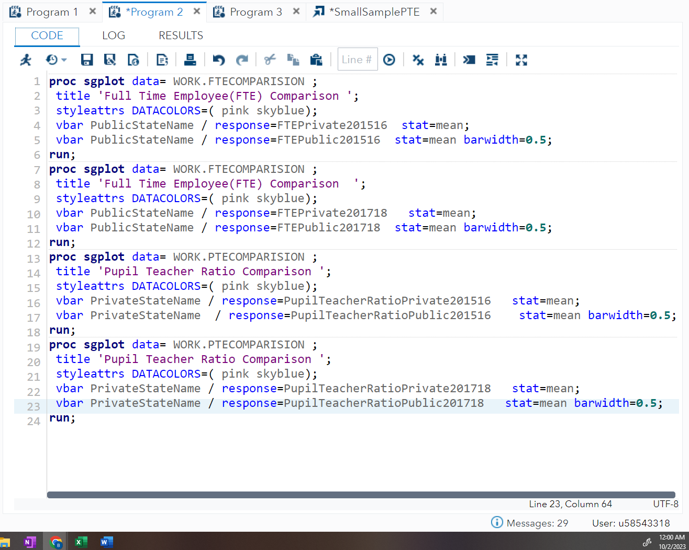

*Note*. Created using SAS studio

**Figure 2**

*Full-time equivalent (FTE) comparison between private and public schools 2015-2016, 2017-2018*

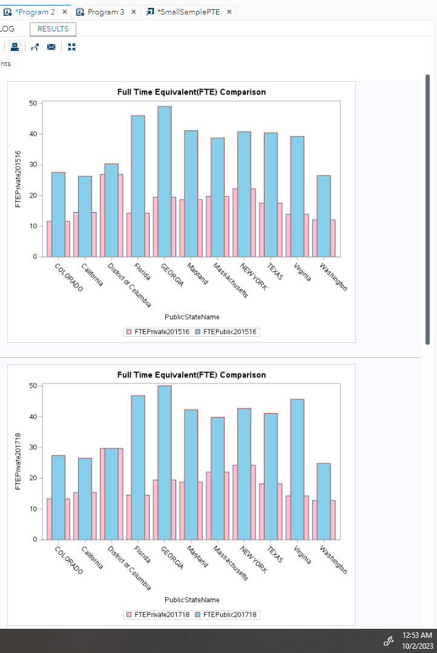

*Note*. Created using SAS studio

**Figure 3**

*Pupil Teacher Ratio (PTE) comparison between private and public schools 2015-2016, 2017-2018*

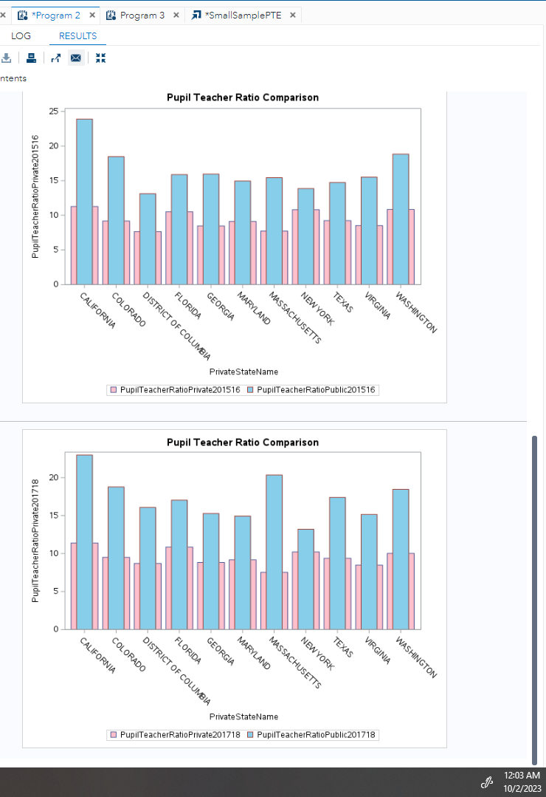

*Note*. Created using SAS studio

Figure 1 shows the code used to create graphs to compare FTE and PTE between private and public schools. The code uses the sgplot procedure which connects with the dataset and gets input variables and creates bar charts. Figure 2, full-time equivalent (FTE) comparison bar charts show that, in both years public schools have higher average FTE value than the public schools. Similarly, in Figure 2, Pupil Teacher Ratio (PTE) is higher in public schools as compared to private schools.

# **Conclusions**

From this result from the data analytics, for both pupil-teacher ratio and FTE, the null hypothesis is rejected, which means the average ratio of pupil-teacher is not equal in private and public schools and the average number of FTE is not equal in private and public schools. To be precise the pupil-teacher ratio is better in private schools. On the other side, higher FTE is considered better which is high in the public schools. This leads to more precise research between private, public, and even chartered schools and finding out which is better and which is lacking in some areas so that there is a place to improve and also parents can make an informed decision before sending their kids to school for a better future.

# 

**Recommendations**

The above research can be more specific and valuable if we can find the datasets related to the academic performance of students, in terms of GPA, SAT score, and GRE score in public school versus private school, also finding suitable datasets which have the rate of employment and the range of salary for students who passed out from public school versus private school and the rate of entering high-tiered universities by public versus private schools’ students. Once there are suitable datasets descriptive, statistics analysis and appropriate visualizations can be done.

# 

**References**

Alawad, G., Moore, C. (2004), Comparison of the prevalence of asthma and severity in public vs. private schools in New Orleans, LA, Journal of Allergy and Clinical Immunology, Volume 113, Issue 2, Supplement, 2004, Page S273, ISSN 0091-6749, <https://doi.org/10.1016/j.jaci.2004.01.454>. (<https://www.sciencedirect.com/science/article/pii/S0091674904004580>)

Brandt, W. (2021). *Full-time equivalency and its place in a post-pandemic world*.<https://nafme.org/blog/full-time-equivalency-and-its-place-in-a-post-pandemic-world/>

Diffen LLC. (n.d.). *Private School vs Public School.* <https://www.diffen.com/difference/Private_School_vs_Public_School>

Eason, R., Giannangelo, D. M., Franceschini, L.A. (2009) . A look at creativity in public and private schools, Thinking Skills and Creativity, Volume 4, Issue 2, 2009, Pages 130-137, ISSN 1871-1871, <https://doi.org/10.1016/j.tsc.2009.04.001>. (https://www.sciencedirect.com/science/article/pii/S1871187109000212)

Hoover, L. (2021, June). *What is qualitative vs. quantitative study?* <https://www.gcu.edu/blog/doctoral-journey/what-qualitative-vs-quantitative-study>

Horowitz, J. B., Spector, L. (2005), Is there a difference between private and public education on college performance? Economics of Education Review, Volume 24, Issue 2, 2005, Pages 189-195, ISSN 0272-7757, https://doi.org/10.1016/j.econedurev.2004.03.007. (https://www.sciencedirect.com/science/article/pii/S0272775704000500)

Market Business News. (n.d.). *What is education?* *Definition and examples*. MBN <https://marketbusinessnews.com/financial-glossary/education-definition/>

NCES. (n.d.). [https://nces.ed.gov/ipeds/use-the-data#](https://nces.ed.gov/ipeds/use-the-data)

O’Leary, Z. (n.d.). The Essential Guide to Doing Your Research Project. Retrieved from <https://platform.virdocs.com/read/1832229/12/#/4/2[s9781529756562.i620]/16[s9781529756562.i685]/6,/1:0,/1:0>

Public vs. Private Schools. (2006, July 19). *New York Times*, A20(L). https://link-gale-com.csuglobal.idm.oclc.org/apps/doc/A148339822/UHIC?u=colstglobal&sid=bookmark-UHIC&xid=a9bf5613