Preliminary Project

Internet Shop

The main idea what Main class this is E-Shop in which contain data about Seller and Customers accounts and list of all Products. E-Shop have method menu in which user chose option Login to account or create account. After logging user see menu but they different for Seller and Customer.

class *E_Shop*

{

private:

    map<*string*, *SellerAccount*> seller_accounts;     // Map of seller accounts with their username as key

    map<*string*, *CustomerAccount*> customer_accounts; // Map of customer accounts with their username as key

    map<*string*, *Product* *> name_products;           // Map of products with their name as key

    map<int, *Product* *> id_products;                // Map of products with their id as key

    void login_seller();                            // Login seller

    void login_customer();                          // Login customer

    void create_seller_account();                   // Create a seller account

    void create_customer_account();                 // Create a new customer account

    void print_products();                          // Prints all products

public:

    E_Shop();

    void enter_menu(); // Main menu

    friend class *SellerAccount*;

    friend class *CustomerAccount*;

};

Class Seller contain data about seller and products of this seller. Seller can add new product, remove his product, update his product, view his products and view all products.

class *SellerAccount*

{

private:

*string* password;                       // Password of the seller account

*string* name;                           // Name of the seller account

*string* email;                          // Email of the seller account

*string* phone;                          // Phone number of the seller account

    map<int, *Product*> products;            // Map of products with their id as key

*E_Shop* *e_shop;                        // Pointer to the e-shop

    void enter_menu();                     // Menu of the seller account

    void change_password();                // Change password of the seller account

    void add_product();                    // Add a new product

    void remove_product();                 // Remove a product

    void update_product();                 // Update a product

    void update_product(*Product* \**product*); // Update a product

    void view_your_products();             // View all products of the seller account

    void view_all_products();              // View all products

public:

    SellerAccount() = default;

    SellerAccount(*string* *name*, *string* *email*, *string* *phone*, *string* *password*, *E_Shop* \**e_shop*);

    bool login(*string* *password*); // Login seller account

};

Class Customer contain data about customer and his cart. Cart contain link to Product and quantity. Customer can view products, view cart, add to cart, remove from cart and buy.

class *CustomerAccount*

{

private:

*string* password;                         // Password of the customer account

*string* name;                             // Name of the customer account

*string* email;                            // Email of the customer account

*string* phone;                            // Phone number of the customer account

    map<*Product* *, int> cart;                // Map of quantity of products with link to product as key

*E_Shop* *e_shop;                          // Pointer to the e-shop

    void enter_menu();                       // Menu of the customer account

    void change_password();                  // Change password of the customer account

    void view_products();                    // View all products

    void view_cart();                        // View cart

    void add_to_cart();                      // Add product to cart

    void add_to_cart(*Product* \**product*);      // Add product to cart

    void remove_from_cart();                 // Remove product from cart

    void remove_from_cart(*Product* \**product*); // Remove product from cart

    void buy();

public:

    CustomerAccount() = default;

    CustomerAccount(*string* *name*, *string* *email*, *string* *phone*, *string* *password*, *E_Shop* \**e_shop*);

    bool login(*string* *password*); // Login customer account

};

Both of this classes can change password of their account.

Class Product contain data about product, price, quantity, link to seller and id which take automatically.

class *Product*

{

private:

    inline static int id_counter = 0;  // Counter for the id of the product

    inline static std::stack<int> ids; // Stack of free ids for the products which are deleted

    int id;                            // Id of the product

*string* name;                       // Name of the product

*string* description;                // Description of the product

    float price;                       // Price of the product

    int quantity;                      // Quantity of the product

*SellerAccount* *seller;             // Seller of the product

    friend class *SellerAccount*;

    Product(*string* *name*, *string* *description*, float *price*, int *quantity*, int *id*, *SellerAccount* \**seller*);

    int new_id(); // Get a new id for the product

public:

    Product() = default;

    void print();        // Prints the product

    int &get_quantity(); // Get quantity of the product

};

**Memory map**

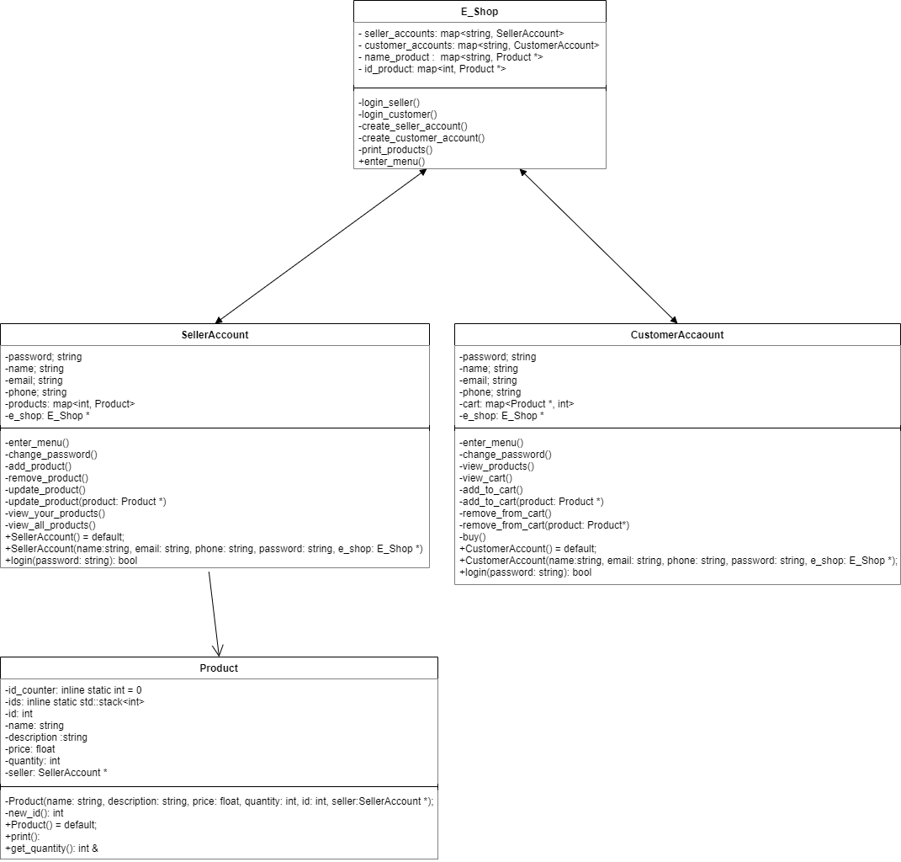

**Tests**

1. Try to enter incorrect username and password in functions: E_Shop::login_seller and E_Shop::login_customer.
2. Try to enter number less than 0 or greater than in menu in functions: E_Shop::enter_menu, SelletAccount::enter_menu, CustomerAccount::enter_menu, SellerAccount::remove_product, SellerAccount::update_product, CustomerAccount::add_to_cart, CustomerAccount::remove_from_cart.
3. Try to enter incorrect quantity in functions CustomerAccount::add_to_cart, CustomerAccount::remove_from_cart.
4. Try to enter name of product which is same with another in functions SellerAccount::add_product and SellerAccount::update_product.