**Engineering design of 1D rod and 2D pin-jointed frame structure driven by reinforcement learning and finite element analysis**

*Georgy Tskhondiya, Gigala (*[*www.facebook.com/GigaTsk/*](http://www.facebook.com/GigaTsk/)*)*

1. **Introduction**

Artificial intelligence is a very powerful tool for inference that is widely used nowadays in many domains of knowledge. One possible application of AI is to engineering design which is a quite tiring process as one needs to make a lot of iterations before resulting in the final design. But this process can be automated by the power of AI. For these models, I combined reinforcement learning with finite element analysis to: (a) optimize cross-sectional area and material in one-dimensional bar, and (b) design pin-jointed frame structure, automatically. Models show some ways on how reinforcement learning can assist in engineering design.

1. **Model**

For reinforcement learning algorithm, the finite element model represents an environment which you apply actions to. The actions, in this case, are (a) altering values of cross-sectional area and Young’s modulus, and (b) moving joint along horizontal axis in the frame. Actions that reduce displacements in a structure, measured by FEA, get rewards. Rewards and FE output then fed to neural network for the next iteration (Figure 1).

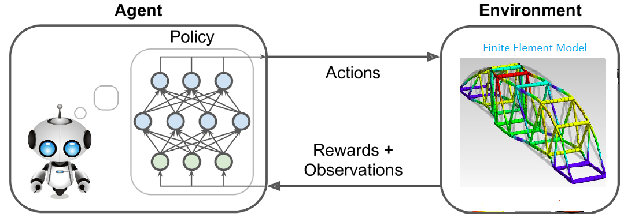

**Figure 1.** Reinforcement learning to FE model interaction

Model (a) is a 1D bar loaded at its tip (Figure 2). AI tries to find optimal cross-sectional area and Young’s modulus, i.e. optimize for geometry and material in the simplest one-dimensional case, in order to have acceptable displacement in tip node (4).

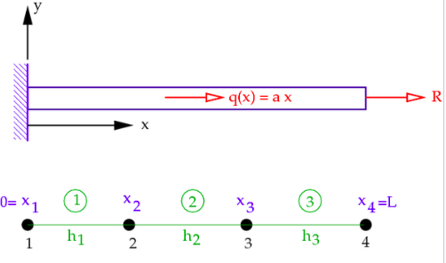

**Figure 2.** FE model for task (a)

Model (b) is a two-dimensional pin-jointed stricture loaded at node (6) as shown in Figure 3. AI tries to optimize the position of element (3)-(5) by allowing its “asynchronized” movement along horizontal axis in order to minimize displacements in the structure.

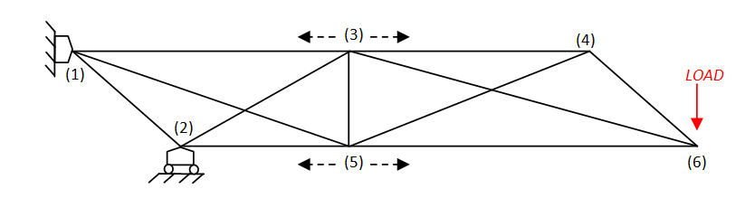

**Figure 3.** FE model for task (b)

Both, model (a) and (b) optimize to reduce displacements in the structure.

The code for reinforcement learning model is taken from [1]. RL model uses neural network policy gradient algorithm. The algorithm optimizes the parameters of a policy by following the gradients toward higher rewards. The end result of the modeling is a design of (a) bar and (b) pin-jointed frame structure that preserves displacements within acceptable limits.

The code for FE model is taken from [2], Program 4.1 and 4.2.

The source code for the model can be found at [3].

1. **Conclusion**

AI in general and reinforcement learning in particular is a powerful tool to support engineering design. For this model, I combined RL with FEA in order to get optimal design of structures. The work shows some ways to combine two fields of knowledge: artificial intelligence and finite element analysis. One can experiment with the code at [3].

If you would like to contact with the author please go at [*www.facebook.com/GigaTsk/*](http://www.facebook.com/GigaTsk/)

1. **References**

[1] Hands-On Machine Learning with Scikit-Learn and TensorFlow, *Aurйlien Gйron*

[2] Programming the finite element method, *I.* *M.* *Smith et al*, 5th edition

[3] <https://github.com/gigatskhondia/Reinforcement_Learning_and_FEA>