Lab 4: Cache Simulator Report

0511097 黃柏豪 0516329 黃昱彰

1. Basic Problems:
2. **Verilog:**

We use .v codes of lab 3 to implement the whole CPU.

* **Changes:** 
  + **In “Instruction_Memory.v”:** Change the size of instruction_file from [0:31] to [0:64], and read input data from lab4_test_data.txt.
  + **In “TestBench.v”:** Change the whole testbench.v code into the testbench.v code that in supplied files.
* **Outcome:** 
  + After simulating the CPU, it writes ICACHE data and DCACHE data into correspond .txt file.

1. **cpp codes:**
2. **direct_mapped_cache.cpp**

* **In function “simulate”:** We add two double type number hit and total to calculate the hits when access data. Therefore, we can know the hit rate and miss rate(1-hit_rate)
* If the cache hit, we add 1 to variable “hit”.

And we add 1 to variable “total” when each time read the input data.

* hit rate = ( hit / total )*100;
* miss rate = (( total – hit ) / total ) *100;
* **In main function:** We use two for loop to run the call function of simulate.
* int i, j;

for(i = 1 ; i < 5 ; i++){

for(j = 0 ; j < 5 ; j++)

simulate(pow(2, i*2) * K, pow(2, j+4));

cout << endl;

}

Because it has to run cache_size in 4K, 16K, 64K, 256K

* They are all 2 to the power of i*2
* 2^(1*2) K, 2^(2*2) K, 2^(3*2) K, 2^(4*2) K

And the block_size are 16 B, 32 B, 64 B, 128 B, 256 B

* They are all 2 to the power of j+4
* 2^(0+4) B, 2^(1+4) B, 2^(2+4) B, 2^(3+4) B, 2^(4+4) B

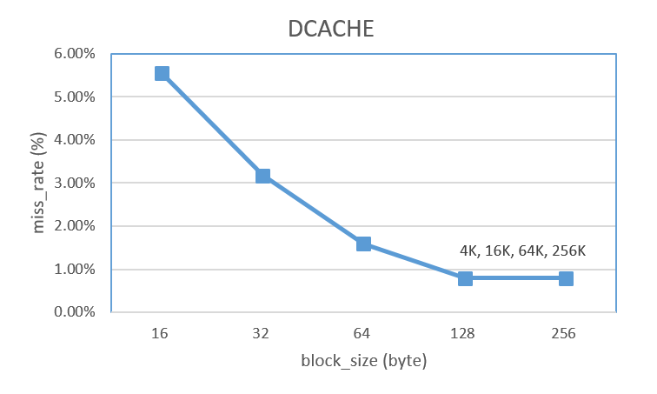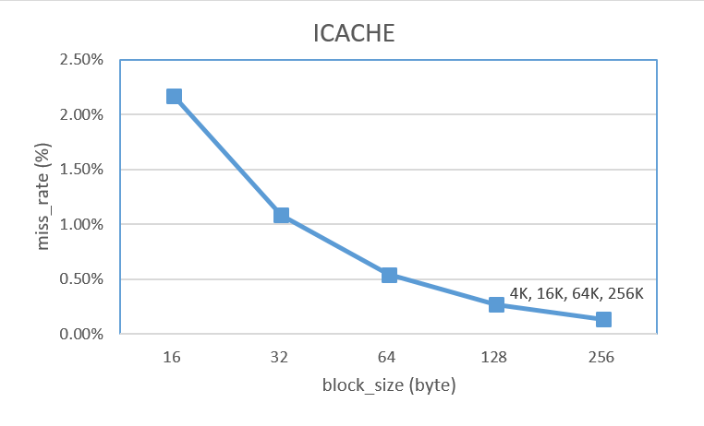

1. **Direct_mapped_cache_LRU.cpp**

* **In struct cache_content:** We add one more integer array called “data” which has size of 16 to save data.
* **In function “simulate”:** We need to add one more parameter when calling the function which is “ways”, so that we can know how many ways does it have now.
* **In main function:** We use two for loop to run the call function of simulate.
* int i, j;

for(i = 0 ; i < 6 ; i++){

for(j = 0 ; j < 4 ; j++)

simulate(pow(2, j), pow(2, i) * K, 64);

cout << endl;

}

Because it has to run 1-way, 2-way, 4-way, 8-way

* They are all 2 to the power of j
* 2^0-way, 2^1-way, 2^2-way, 2^3-way

And cache_size are in 1K, 2K, 4K, 8K, 16K, 32K

* They are all 2 to the power of i
* 2^0 K, 2^1 K, 2^2 K, 2^3 K, 2^4 K, 2^5 K

※If you run the code, it will automatically print out its cache line, cache_size, block_size, miss_rate, and n-way associative.