**\***B is correct. Although A and B numbers calculate correctly, B is correct because the 2nd letter must be the first letter of the provider’s last name.

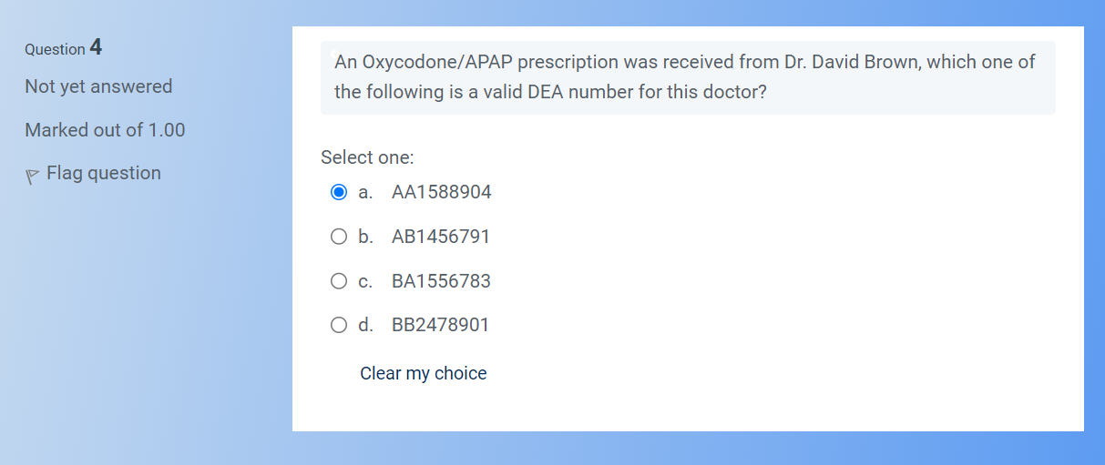

a.

1 5 8 8 9 0 4

1+8+9=18

5+8+0=13

13*2=26

26+18=44

b.

1 4 5 6 7 9 1

1+5+7=13

4+6+9=19

19*2=38

38+13=51

After completing the quiz, it said that choice “a” was incorrect.

**\***The second value in the DEA number must be the first letter of the provider’s last name.

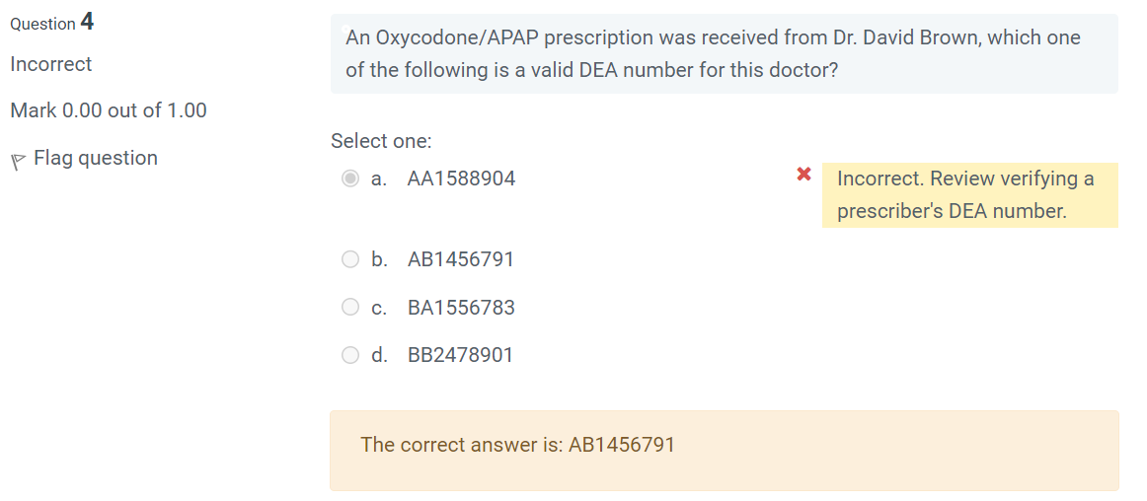

**********************************************************************************************************************

Who regulates the practice of pharmacy?

Select one:

a.

State Board of Pharmacy

Correct! Your State Board of Pharmacy is responsible for the regulation of the practice of pharmacy within your state.

b.

American Pharmacy Association

c.

American Association of Health-System Pharmacists

d.

National Pharmaceutical Association

The correct answer is: State Board of Pharmacy

What is true regarding the consultation requirements of OBRA '90?

Select one:

a.

All patients are offered counseling on every fill of every prescription

Incorrect. All of these are correct.

b.

Pharmacy Technicians cannot offer counseling

c.

Pharmacy Technicians can identify counseling opportunities

d.

All of the Above

The correct answer is: All of the Above

A vincristine vial was found to have been broken and spilled. What should be used to clean up the spill?

Select one:

a.

Chemo Spill Kit

Correct! Since vincristine is a cytotoxic medication, a chemo spill kit should be used to clean.

b.

Warm Water

c.

OSHA

d.

Sterile Towels

The correct answer is: Chemo Spill Kit

A manufacturer recall due to temporary adverse health consequences would be:

Select one:

a.

Class IV

b.

Class III

c.

Class II

Correct! A class II recall is one in which use of, or exposure to, a violative product may cause temporary or medically reversible adverse health consequences or where the probability of serious adverse health consequences is remote.

d.

Class I

The correct answer is: Class II

What is the name of the reporting agency that collects information from both health care professionals and patients during Phase 4 of the Drug Development Process?

Select one:

a.

DEA

b.

WebMD

c.

MedWatch

Correct! MedWatch is used during Phase 4 clinical trials to record any adverse effects of medications after they reach market.

d.

MedTurn

The correct answer is: MedWatch

Which agency or administration regulates prescription and OTC medication and their approval?

Select one:

a.

OSHA

b.

FDA

c.

DEA

Incorrect. The DEA, or Drug Enforcement Administration, are responsible for the regulation of controlled medications.

d.

State Board of Pharmacy

The correct answer is: FDA

Which Act shortened the required text for prescription medication bottles to read "Rx Only"?

Select one:

a.

OBRA

b.

Hatch-Waxman Act

c.

FDA Modernization Act

Correct! The FDA Modernization Act allowed for the shortening of prescription label warnings from "Caution: Federal law prohibits dispensing without prescription" to "Rx only".

d.

HIPAA

The correct answer is: FDA Modernization Act

Which one of these is considered Protected Health Information?

Select one:

a.

Patients Rx #

b.

All of the Answers are Correct

Correct! All of these are Protected Health Information.

c.

Patients name

d.

Patients date of birth

The correct answer is: All of the Answers are Correct

Which one of the following is the best practice to protecting patients PHI?

Select one:

a.

All of the Answers are Correct

b.

Use other methods to verify patients identity at pick up, such as DOB and phone # as opposed to prescription name.

c.

Cover patient's name when placing their prescription in the pick up area.

d.

Shred all papers not in use that has patient prescription information on it.

Incorrect. All of these are best practices.

The correct answer is: All of the Answers are Correct

Which piece of legislation separated medication into two groups, OTC and Legend Drugs?

Select one:

a.

Pure Food and Drug Act

b.

Controlled Substances Act

c.

Durham-Humphrey Amendment

Correct! The Durham-Humphrey Amendment separated drug classes into OTC and legend medications requiring a prescription.

d.

Kefauver-Harris Amendment

The correct answer is: Durham-Humphrey Amendment

SSRIs, or Selective Serotonin Re-uptake Inhibitors, are in what schedule?

Select one:

a.

Non-Controlled Legend Medication

Correct! SSRIs, or Selective Serotonin Re-uptake Inhibitors, are not scheduled by the DEA; therefore, they are considered a non-controlled legend medication.

b.

C-III Medication

c.

C-II Medication

d.

C-IV Medication

The correct answer is: Non-Controlled Legend Medication

If narcotic abuse is suspected, the patient must be searched utilizing the ________ database

Select one:

a.

Prescription Monitoring Program

Correct! The Prescription Monitoring Program, or PMP, can provide pharmacists and pharmacy technicians with valuable information about a patient's narcotic usage.

b.

ISMP

c.

Drug Utilization Review

d.

HIPAA

The correct answer is: Prescription Monitoring Program

Which act allowed for the creation of the DEA?

Select one:

a.

Poison Prevention Act

b.

Drug Listing Act

c.

Controlled Substances Act

Correct! The Controlled Substances Act established the Drug Enforcement Administration, or DEA, which then assigned drugs to appropriate schedules based on their likelihood of dependence or abuse.

d.

Orphan Drug Act

The correct answer is: Controlled Substances Act

The Anabolic Steroid Control Act requires that Anabolic Steroids are in what drug schedule?

Select one:

a.

C-II

b.

C-III

Correct! Anabolic steroids belong to the C-III class due to their potential for abuse.

c.

C-IV

d.

C-V

The correct answer is: C-III

Medications undergo how many test phases before they are FDA approved?

Select one:

a.

3

Correct! In order for a drug to be approved for market it must undergo 3 phases of clinical trials. Phase 1 focuses on the safety profile of the drug and typically only involves 20-80 humans. Phase 2 focuses on the efficacy of the drug and typically involves 100's of humans. Phase 3 focuses on the combined safety and efficacy of the drug, and typically involves 1000's of humans. Should the drug prove to be both safe and efficacious after phase 3, the FDA will then approve the drug to be available on the market.

b.

4

c.

2

d.

1

The correct answer is: 3

What was the first federal law regulating drugs that prevented inaccurately labeled medications from crossing state lines?

Select one:

a.

Kefauver-Harris Amendment

b.

Pure Food and Drug Act

Correct! The Pure Food and Drug Act of 1906 established labeling requirements for medications to help protect the safety of patients.

c.

Durham-Humphrey Amendment

d.

Controlled Substances Act

The correct answer is: Pure Food and Drug Act

**********************************************************************************************************************

Which act allowed for research grants, tax incentives, and market exclusivity for medications that treat rare diseases?

Select one:

a.

Controlled Substances Act

b.

Poison Prevention Act

c.

Orphan Drug Act

Correct! The Orphan Drug Act was established to aid in the development of medications for rare diseases.

d.

Drug Listing Act

The correct answer is: Orphan Drug Act

CEU’s are:

Select one:

a.

required biannually for national certification

b.

a continuing education unit

c.

available at www.powerpak.com

d.

All of the answers are correct

Correct! CEU stands for continuing education unit. In order to renew your national certification, 20 CEUs are required biannually. You can complete these CEUs through various live events, or online at websites similar to powerpak.com. Remember to check with your specific state licensure requirements in order to determine your annual CEU requirements for renewing your license.

The correct answer is: All of the answers are correct

The FDA’s purpose in regard to pharmaceuticals is:

Select one:

a.

all of the answers are correct

b.

to regulate medications ensuring safety and effectiveness

Correct! The FDA is responsible for ensuring the safety and effectiveness of all medications both before they reach the market, and to continue surveillance of medications currently on the market for their safety and efficacy.

c.

to regulate the practice of pharmacy at a state level

d.

to schedule medications based on dependency and abuse factors

The correct answer is: to regulate medications ensuring safety and effectiveness

Which piece of legislation standardized labeling requirements, required package inserts, and a good manufacturing process?

Select one:

a.

Controlled Substances Act

b.

Durham-Humphrey Amendment

c.

Pure Food and Drug Act

d.

Kefauver-Harris Amendment

Correct! In an effort to keep patients safe, the Kefauver-Harris Amendment enacted the above requirements.

The correct answer is: Kefauver-Harris Amendment

Which act allowed for market exclusivity of brand name medications?

Select one:

a.

HIPAA

b.

OBRA

c.

Hatch-Waxman Act

Correct! The Hatch-Waxman Act helped to allow for market exclusivity for brand name medications by changing the approval process for generic medications.

d.

FDA Modernization Act

The correct answer is: Hatch-Waxman Act

Which Act shortened the required text for prescription medication bottles to read "Rx Only"?

Select one:

a.

HIPAA

b.

FDA Modernization Act

Correct! The FDA Modernization Act allowed for the shortening of prescription label warnings from "Caution: Federal law prohibits dispensing without prescription" to "Rx only".

c.

OBRA

d.

Hatch-Waxman Act

The correct answer is: FDA Modernization Act

Who regulates the practice of pharmacy?

Select one:

a.

National Pharmaceutical Association

b.

American Association of Health-System Pharmacists

c.

State Board of Pharmacy

Correct! Your State Board of Pharmacy is responsible for the regulation of the practice of pharmacy within your state.

d.

American Pharmacy Association

The correct answer is: State Board of Pharmacy

A manufacturer recall due to temporary adverse health consequences would be:

Select one:

a.

Class I

b.

Class III

c.

Class II

Correct! A class II recall is one in which use of, or exposure to, a violative product may cause temporary or medically reversible adverse health consequences or where the probability of serious adverse health consequences is remote.

d.

Class IV

The correct answer is: Class II

**********************************************************************************************************************

Top of Form

What is true regarding the consultation requirements of OBRA '90?

Select one:

a.

All patients are offered counseling on every fill of every prescription

b.

Pharmacy Technicians cannot offer counseling

c.

Pharmacy Technicians can identify counseling opportunities

d.

All of the Above

Correct! OBRA made it to where every pharmacist must offer counseling to every patient on every fill of every prescription. As a pharmacy technician you are not legally allowed to counsel patients; however, you can help the pharmacist identify patients that may need counseling, such as new fills, late fills, or patients with many questions.

The correct answer is: All of the Above

The FDA’s purpose in regard to pharmaceuticals is:

Select one:

a.

to schedule medications based on dependency and abuse factors

b.

to regulate the practice of pharmacy at a state level

c.

all of the answers are correct

d.

to regulate medications ensuring safety and effectiveness

Correct! The FDA is responsible for ensuring the safety and effectiveness of all medications both before they reach the market, and to continue surveillance of medications currently on the market for their safety and efficacy.

The correct answer is: to regulate medications ensuring safety and effectiveness

Which piece of legislation separated medication into two groups, OTC and Legend Drugs?

Select one:

a.

Pure Food and Drug Act

b.

Controlled Substances Act

c.

Durham-Humphrey Amendment

Correct! The Durham-Humphrey Amendment separated drug classes into OTC and legend medications requiring a prescription.

d.

Kefauver-Harris Amendment

The correct answer is: Durham-Humphrey Amendment

Which agency or administration regulates prescription and OTC medication and their approval?

Select one:

a.

State Board of Pharmacy

b.

DEA

c.

OSHA

d.

FDA

Correct! The FDA, or Food and Drug Administration, is responsible for regulating the safety and efficacy of both prescription and OTC drugs on the market.

The correct answer is: FDA

Which government agency enforces controlled substance law and regulation?

Select one:

a.

OSHA

b.

DEA

Correct! The DEA, or Drug Enforcement Administration, is responsible for the enforcement of controlled substance laws and regulations.

c.

FDA

d.

BOP

The correct answer is: DEA

CEU’s are:

Select one:

a.

All of the answers are correct

Correct! CEU stands for continuing education unit. In order to renew your national certification, 20 CEUs are required biannually. You can complete these CEUs through various live events, or online at websites similar to powerpak.com. Remember to check with your specific state licensure requirements in order to determine your annual CEU requirements for renewing your license.

b.

available at www.powerpak.com

c.

required biannually for national certification

d.

a continuing education unit

The correct answer is: All of the answers are correct

Which act allowed for market exclusivity of brand name medications?

Select one:

a.

Hatch-Waxman Act

Correct! The Hatch-Waxman Act helped to allow for market exclusivity for brand name medications by changing the approval process for generic medications.

b.

HIPAA

c.

FDA Modernization Act

d.

OBRA

The correct answer is: Hatch-Waxman ActBottom of Form

**********************************************************************************************************************

**********************************************************************************************************************

**********************************************************************************************************************

**********************************************************************************************************************

**********************************************************************************************************************

**********************************************************************************************************************

**********************************************************************************************************************

**********************************************************************************************************************

**********************************************************************************************************************

**********************************************************************************************************************

**********************************************************************************************************************