
AMERICAN INTERNATIONAL UNIVERSITY-BANGLADESH
Faculty of Science and Technology
Department of Computer Science
CSC 3215: Web Technologies

Semester: Summer 2025-26 | Group No: |  | Section:

Group Members:
SL. | Student ID | Name | Role | Signature
1 |  |  | Group Leader
2 |  |  | Member
3 |  |  | Member
4 |  |  | Member
Project Title
InkWell: A Role-Based Online Article Publishing and Marketplace System
Short Description
InkWell is a role-based web platform where authors publish and price their own articles, readers discover, read, and purchase them, and an administrator oversees accounts, spending limits, and sales performance. The system is built with plain PHP (MVC, no OOP), MySQL, and vanilla HTML/CSS/JavaScript, and demonstrates full CRUD, session-based authentication, AJAX-driven search, and standard web-security practices across three distinct user roles.
Introduction
Independent writers increasingly look for simple ways to publish their work and earn from it directly, without relying on a large third-party platform. InkWell is a small-scale article publishing and marketplace system built to explore that idea in a classroom setting. It supports three roles Reader, Author, and Admin each with its own dashboard, its own CRUD entity, and three features unique to that role. Authors write and price articles, choosing to keep them as drafts or publish them; readers browse, search, like, comment on, rate, and purchase published articles within a spending limit; and the admin manages accounts, sets that spending limit per reader, gives feedback to authors, and monitors sales and profit/loss. The goal of the project is to practice the full stack of a session-authenticated, database backed web application from prepared-statement SQL and CSRF-protected forms to AJAX-driven live search using only plain PHP, MySQL, and vanilla JavaScript.
Background Study
Existing platforms such as Medium, Substack, and Wattpad already let authors publish content and, in some cases, monetize it directly, while readers browse, follow, and engage with what they read. These platforms are large, closed-source commercial systems with far more infrastructure (payment gateways, recommendation engines, email delivery, mobile apps) than a course project can reasonably reproduce. InkWell borrows the core idea — authors publish and price content, readers discover and buy it — and scales it down to a size appropriate for learning MVC architecture, authentication, and basic web security in PHP: one users table for all three roles, prepared statements instead of an ORM, and plain server-rendered pages with AJAX enhancements instead of a full single-page application. This keeps the project’s scope realistic for a semester while still covering the same architectural concerns (role separation, ownership checks, session security) that the larger platforms have to solve.
ER Diagram
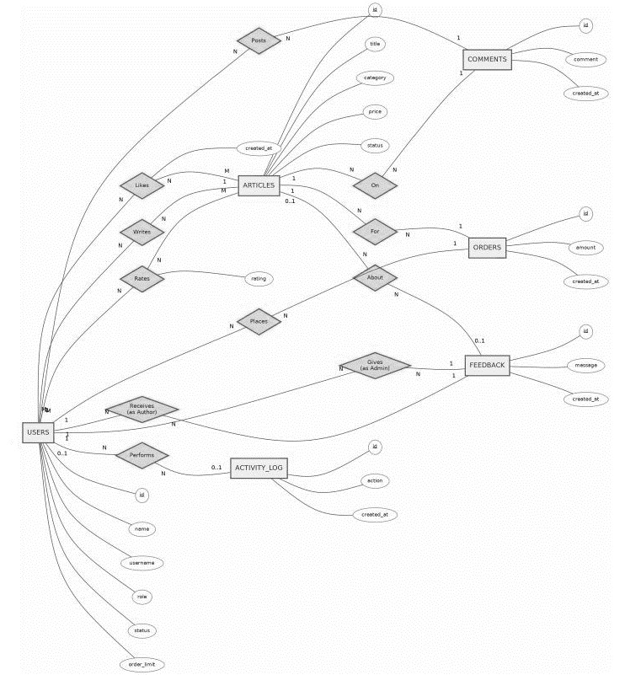
Figure 01: ER Diagram

Use Case Diagram
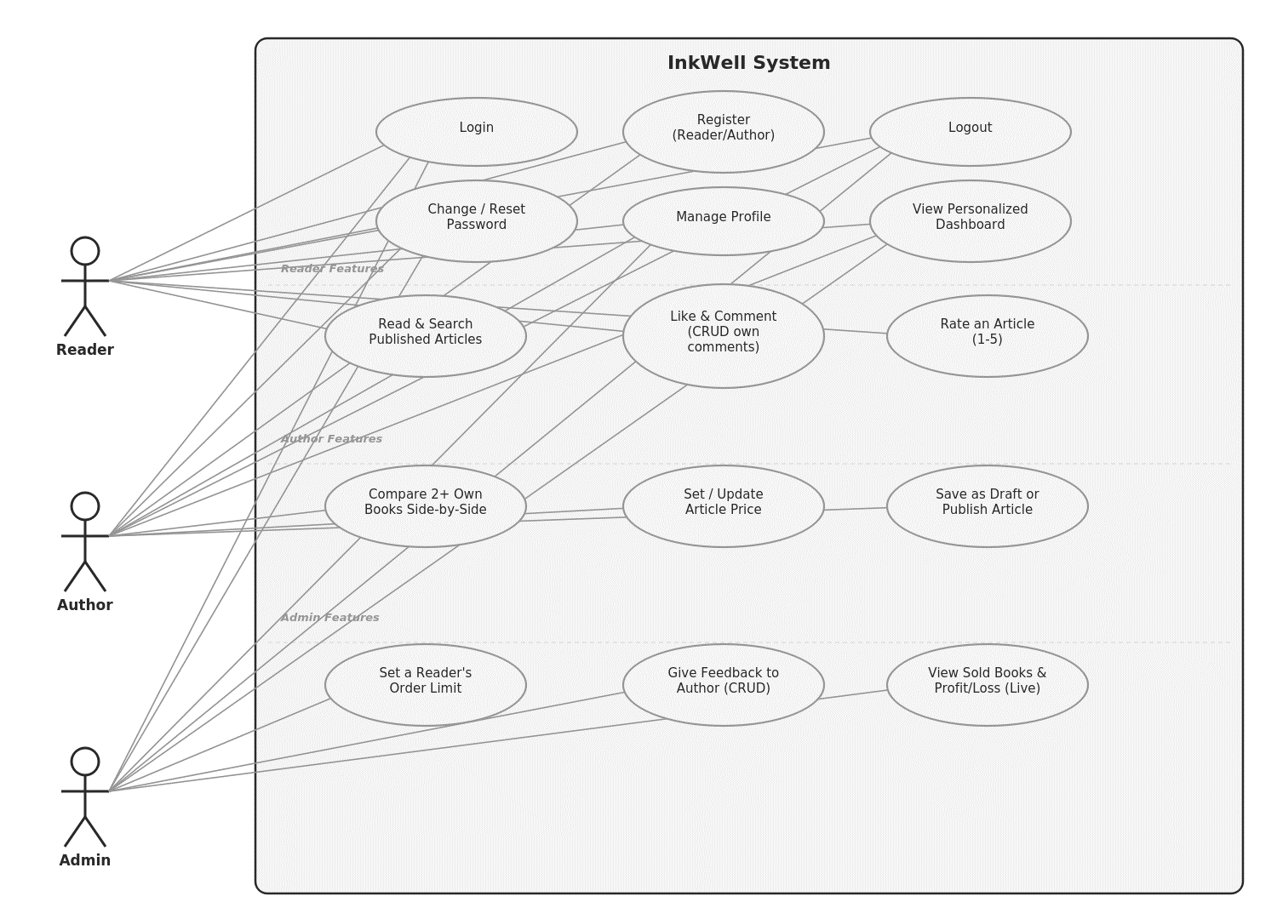
Figure 02: Use Case Diagram
UI (Figma/Sketch)
- Signup
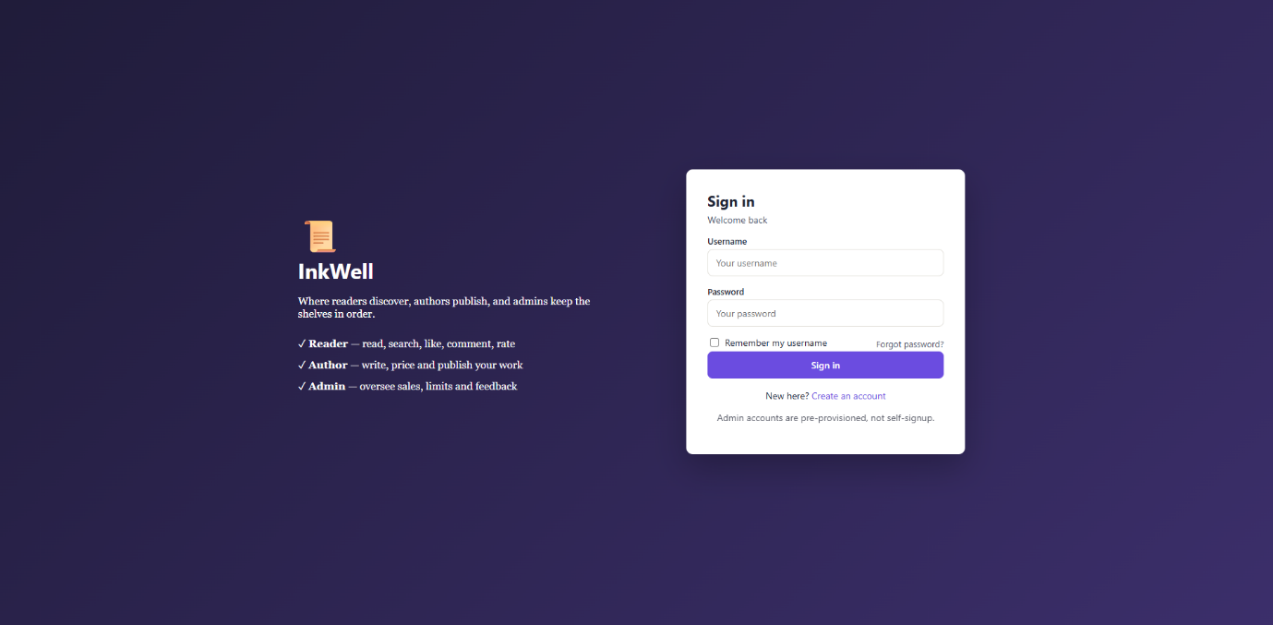
- Register
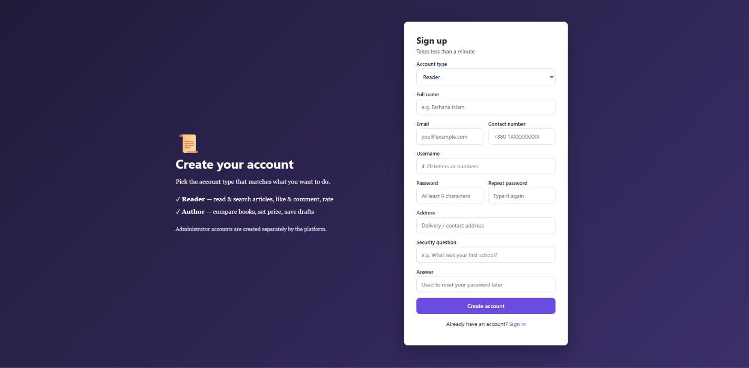
- Forget Password
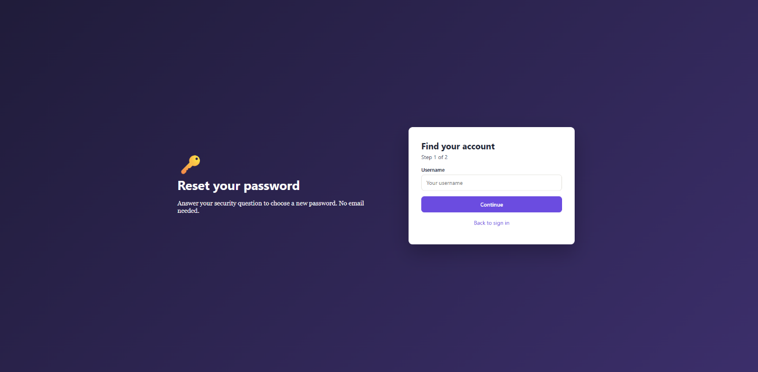
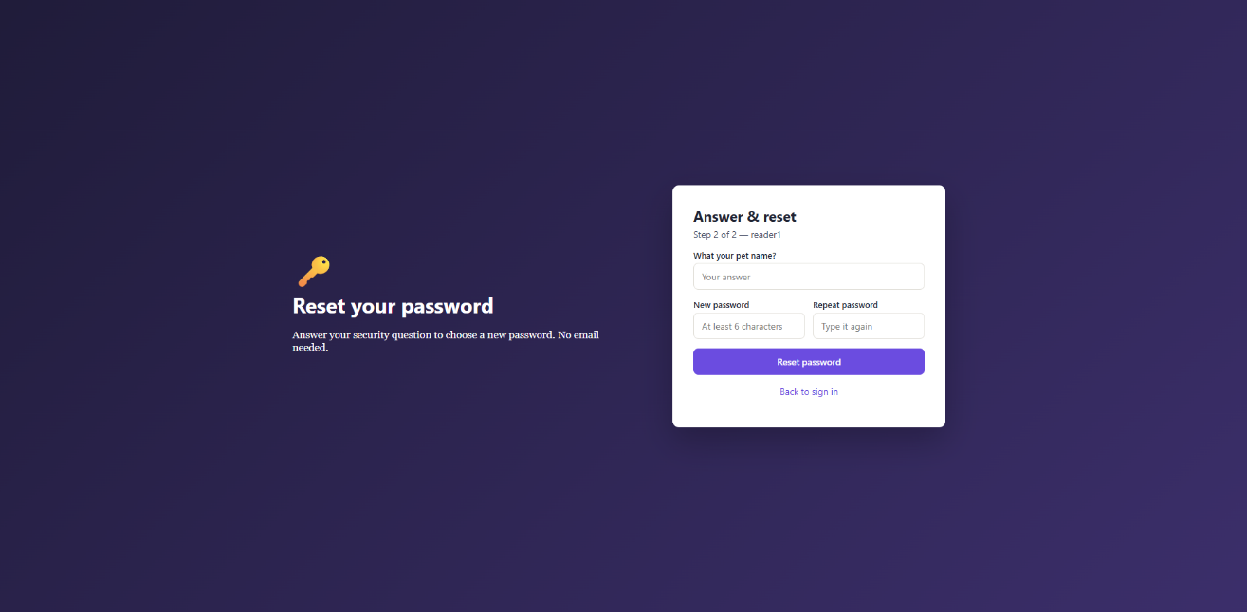
- Author Dashboard
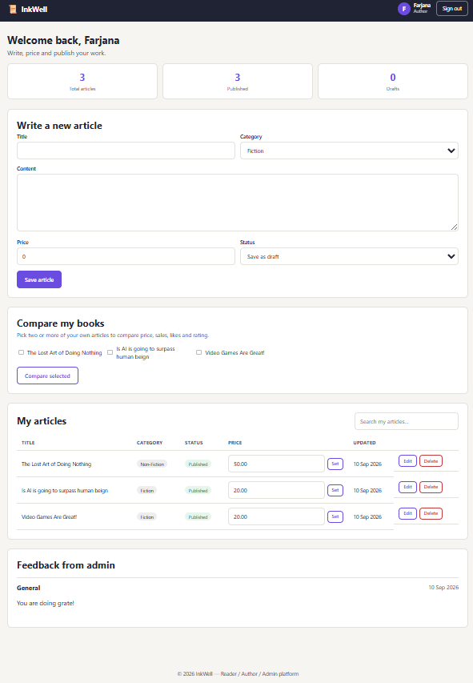

- Reader Dashboard
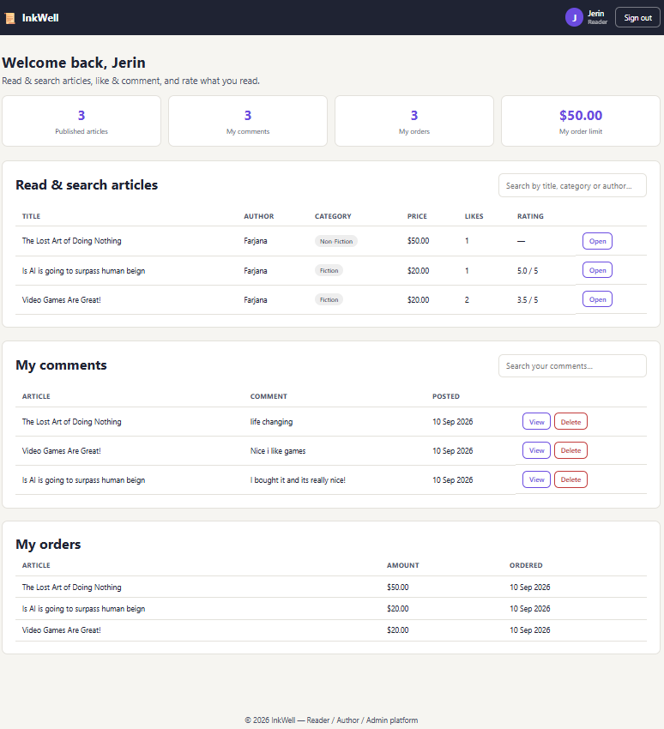

- Admin Dashboard
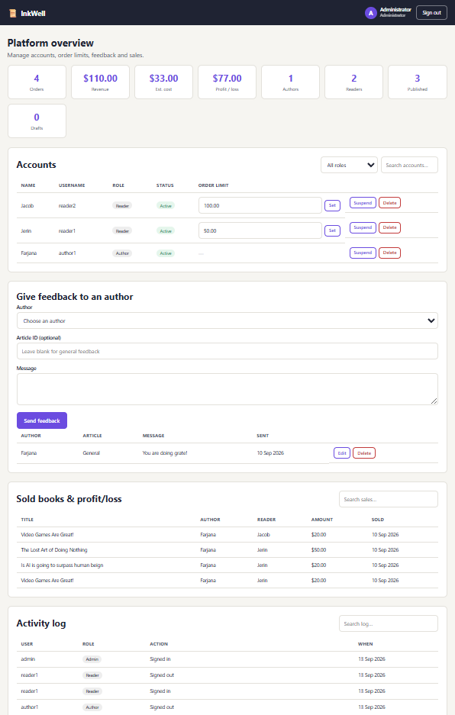
Types of Users: 1. Admin 2. Author 3. Reader
Common Features (Available to All Users)
- Authentication
- Login to the system
- Logout from the system
- User registration
- Account Management
- Change or reset password
- Manage profile information (view, edit, delete)
- Dashboard
- Access a personalized dashboard after login
Specific Features by User Type
- Features of Admin
- Set how much a reader may spend on a single order (spending limit)
- Give feedback to authors on their articles
- View sold articles with revenue and profit/loss, refreshed live via AJAX
- Features of Author
- Compare two or more of their own articles side by side (price, sales, likes, rating)
- Set or update the price of any of their articles
- Save an article as a draft or publish it when ready
- Features of Reader
- Read and search published articles by title, category, or author
- Like an article and manage their own comments (add, edit, delete)
- Rate an article from 1 to 5 stars

N.B: Each user type must have at least 3 distinct features different from the others. Additional features may be added if desired. Proposals with generic, incomplete, or duplicated features across user types will receive reduced marks under the criteria below.

