**Original Process document**

1. **Create a Local txt Document**

Create a txt document on my desktop, named ‘exercise.txt’.

1. **Initialize a Git Repository:**

2.1. Open the Terminal, and Navigate to the directory where "exercise.txt" is located:

Use “cd ~/Desktop” command

then Use “ls”command

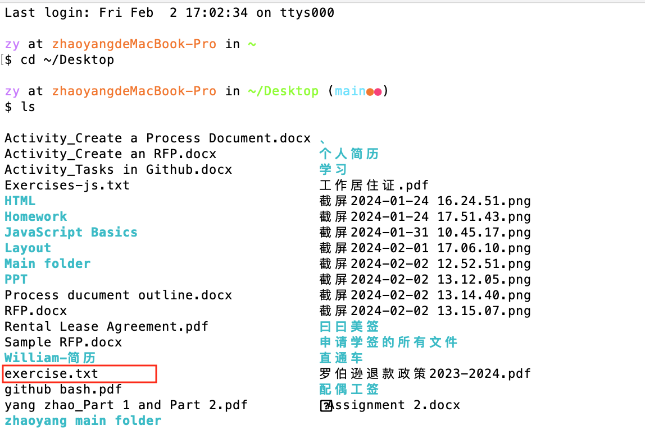

2.2. Initialize the Git repository.

Execute the command :$ git init

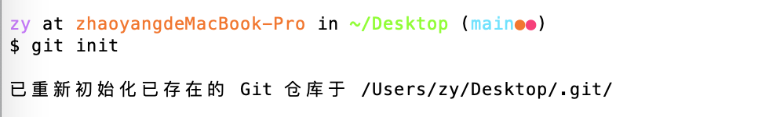

1. **Add some changes in txt.**

Open the txt with VScode, and add some changes

1. **Use Git commands to stage changes**

**Problems encountered：**I stored exercise.txt in desktop, but the terminal showed me the wrong path, it showed the txt was in my ‘JavaScript basics folder. Then I puted it in ‘yang_yang’ folder, and re-executed the command：



1. **Commit changes**

Execute the “git commit -m “ Add exercise.txt” command to commit the changes:

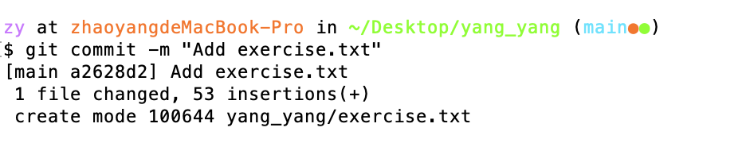

I have successfully committed the changes and created a commit record that contains the addition of "exercise.txt".

1. **Rollback to Initial Snapshot**

Execute the “git log” command to find my initial commit ID:

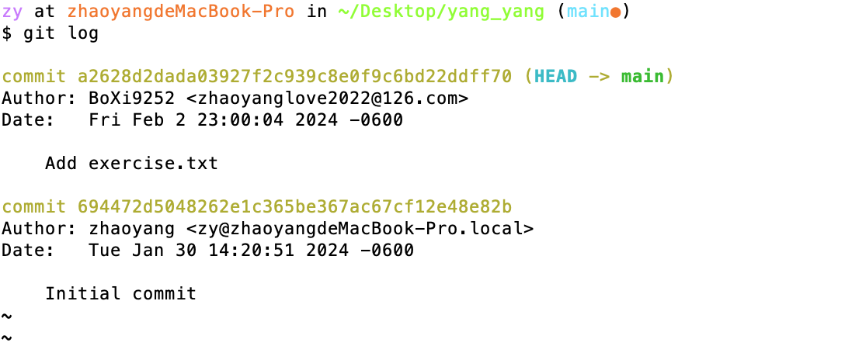

Execute the following command to rollback the initial snapshot:

git checkout <initial commit ID> -- exercise.txt

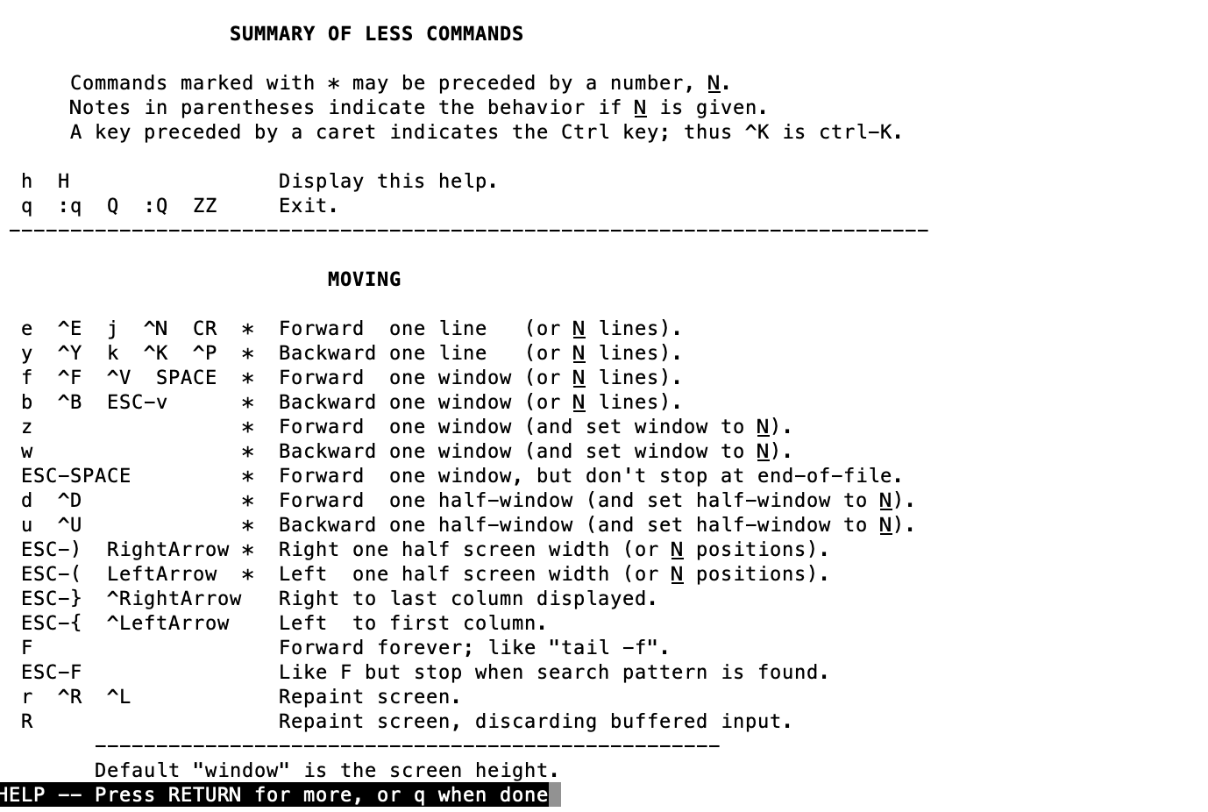

1. **Create a new repository on GitHub**
   1. Log in GitHub , and create a repository



7.2.Link my local Git repository to the GitHub repository:

find the URL in the GitHub repository, and copy the URL to the commit:

git remote add origin +URL



7.3.Push my changes to GitHub:

Create the token on GitHub to meet the User Authentication.

7.4.Push local repository to remote repository on GitHub.

