**Overview**

The objective of our programming system is to provide water for pets and based on this analyses and feedback on the cat's current health status.

**Specification**

Real-time detection of the current amount of water in the cup based on image recognition

The quality of the water provided is set automatically

The cat's health status is displayed in a console based on the cat's water intake.

**SYSTEM ARCHITECTURE DIAGRAM & TECHNOLOGIES USED**

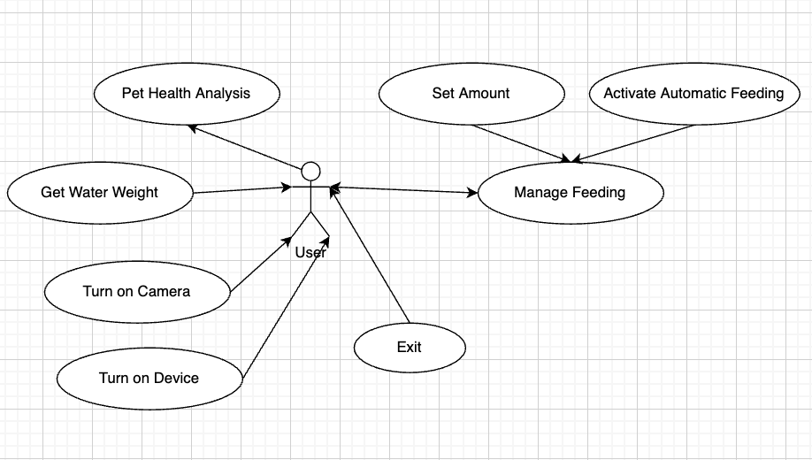

## **Technology to be used**

### **Raspberry Pi (Raspberry Pi 4 Model B)**

Raspberry Pi is a series of single-board computers ranging from $20-$60 CND. The version of Raspberry Pi we are looking at includes 1GB of RAM, ARM compatible CPU, GPU, MicroSDHC memory storage, 4 USB ports, Ethernet port, as well as WiFi and Bluetooth capabilities. The Raspberry Pi uses a Linux-Kernel based OS, Raspbian.

The Raspberry Pi will act as our central processing unit, controlling all other components of the tank itself. The Raspberry Pi does not have a real-time clock built in, and will need to be reset after each power off. Raspberry Pi runs on Python natively, however we would like to use C++ to take advantage of the Automatic Pet Feeding System.

# **Youmile HX711 Weight Sensor**

On-chip power supply regulator for load-cell and ADC analog power supply, On-chip active low noise PGA with selectable gain of 32,64 and 128, Simple digital control and serial interface: pin-driven controls, no programming needed, selectable 10SPS or 80SPS output data rate. Operation supply voltage range: 2.6 ~ 5.5V. Current consumption including on-chip analog power supply regulator: normal operation < 1.5mApower down < 1uA.

**Qt Programming Platform**

Qt is a cross-platform C++ GUI application development framework. It can be used to develop both GUI programs and non-GUI programs such as console tools and servers. qt is an object-oriented framework and using special code generation extensions (called Meta Object Compiler (moc)) and a number of macros, qt is easily extensible and allows true component programming.

#### Use Case Name: Enable pet recognition

**Actor(s)**: User

**Use Case Precondition(s)**:

* Must be connected to the camera.
* Must be turn on the devices.

**Use Case Successful post condition(s)**:

* Automatic feeding is enabled

**Applicable Business Rules:**

* Pet can be recognized

**Use Case Specifications**

**Main Flow:**

|  |  |  |
| --- | --- | --- |
|  | Actor(s): *User* | System (App) |
| 1 | Enable the camera | System checks if the object is a pet or not and show the recall on consoles. |

**Test Cases**

A. Test case Summary

|  |  |
| --- | --- |
| Scenario Name | Scenario Description |
| Main: Imaging recognition is turned on | Camera is turned on, and will start recognizing the Pet during the scheduled times. |

B. Test Case Details

|  |  |  |  |
| --- | --- | --- | --- |
| Test Case | Scenario | Data values / conditions being tested | Expected Result |
|  | Main: Camera is enabled. | Image features of pets are already created. | Pet will be recognized during scheduled times. |

#### Use Case Name: Enable pet feeding

**Actor(s)**: User

**Use Case Precondition(s)**:

* Must be turn on the devices.

**Use Case Successful post condition(s)**:

* Automatic feeding is enabled.

**Applicable Business Rules:**

* Pet can be fed.

**Use Case Specifications**

**Main Flow:**

|  |  |  |
| --- | --- | --- |
|  | Actor(s): *User* | System (App) |
| 1 | Enable the devices | System checks if any water is available, checks if pets have been fed once in a day. If all checks passed, Pets are fed. Time of feeding logged. |

**Test Cases**

A. Test case Summary

|  |  |
| --- | --- |
| Scenario Name | Scenario Description |
| Main: Automatic feeding | Devices are turned on, and will start if there is no more water during the scheduled times. |

B. Test Case Details

|  |  |  |  |
| --- | --- | --- | --- |
| Test Case | Scenario | Data values / conditions being tested | Expected Result |
|  | Main: Devices are enabled. | Valid schedule is already created. | Pets are fed, water amount decreased. Time of feeding logged. |