**Project Ⅱ**

**Link**

**Name: 黃柏喻**

**Student ID: N16064674**

**Department: Mechanical Engineering**

1. **Implementation detail**

First of all, loading file is necessary. Then, I create a class named “Link”. There are three attributes: item name, item children (nodes which item points to) and item parent (nodes which point to item). Next, create a subgraph to store all those information within the big dictionary.

* 1. **HITS**

In the beginning, set the authority and hub value by 1. If parent and children of each item exist, new value will be calculated. Otherwise, it will be set to zero. After each iteration, normalization will be implemented. The stopping value is determined by adding absolute value of both hub and authority.

* 1. **PageRank**

In the beginning, set the PageRank value to 1 divided by number of total node. The value will be re-calculated using equation (1), which I set d value to 0.15 and n equals to the number of total node. The stopping value is determined by adding absolute value of current and previous PageRank value.

 …….Eq (1)

Figure 1.1 shows the IBM data I chose in HITS and PageRank algorithm. Node 6 is the center of the graph, which means it points to every other node. However, there is no connection between other nodes.

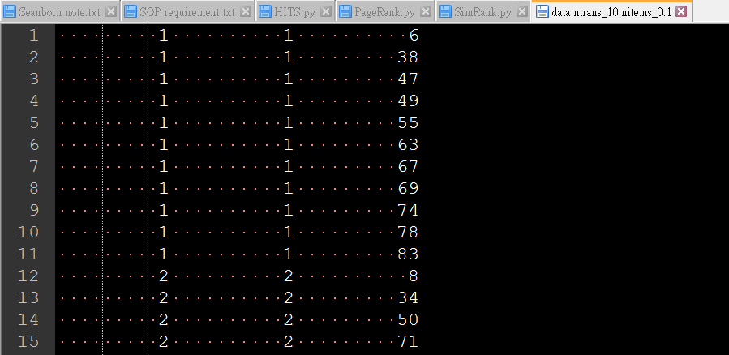

**Figure 1.1 IBM data selection**

* 1. **SimRank**

In the beginning, set original matrix to be identity matrix. Then renew the value through iteration. In equation 2, if a = b, S(a,b) equals 1. Also, if in-neighbors of a or b are None, S(a,b) equals 0.

 ……Eq(2)

1. **Result analysis and discussion**
2. **Grpah_1**

In this simple graph, the result show in Table 2.1. Since the graph is basically a straight line but not circular, I found out that hub and authority value are exactly the same.

Table 2.1 HITS and PageRank result of graph 1

|  |  |  |
| --- | --- | --- |
|  | HITS | PageRank |
| Hub | 5: 0.348 | X |
| Authority | 6: 0.348 | X |
| PageRank | X | 6: 0.103  5: 0.0927 |

The result of SimRank remain identity matrix.

1. **Grpah_2**

This graph is basically a circle and it might cause problems in certain method. The HITS method didn’t converge while PageRank immediately converge after two iteration. The results of PageRank are all 0.2.

Table 2.2 HITS and PageRank result of graph 2

|  |  |  |
| --- | --- | --- |
|  | HITS | PageRank |
| Hub | 4: 0.334 | X |
| Authority | 1: 0.269 | X |
| PageRank | X | ALL: 0.2 |

The result of SimRank remain identity matrix.

1. **Grpah_3**

This result is shown in Table 2.3. This graph is basically a symmetrical pattern which node 1 and node 2 are on the right side, and node 3 and node 4 are on the left side.

Table 2.3 HITS and PageRank result of graph 3

|  |  |  |
| --- | --- | --- |
|  | HITS | PageRank |
| Hub | 3: 0.414 | X |
| Authority | 3: 0.414 | X |
| PageRank | X | 2: 0.324 3: 0.324 |

The result of SimRank is shown in Table 2.4. Obviously, pair (1, 3) and pair (2, 4) bear the same idea.

Table 2.4 SimRank result of graph 3

|  |  |  |  |  |
| --- | --- | --- | --- | --- |
|  | 1 | 2 | 3 | 4 |
| 1 | 1.0 | 0 | 0.818 | 0 |
| 2 | 0 | 1.0 | 0 | 0.818 |
| 3 | 0.818 | 0 | 1.0 | 0 |
| 4 | 0 | 0.818 | 0 | 1.0 |

1. **Grpah_4**

This result is shown in Table 2.5. It is abnormal to see node 5 being the top value in both hub and authority but not the top value in PageRank. I personally think that PageRank method is slightly leaning toward Hub value in HITS method. Because node 2 which has a rather good authority value is pointed by node 1. It will definitely affect the PageRank value of node 1. Also, node 5 is benefited by node 1 too.

Table 2.5 HITS and PageRank result of graph 4

|  |  |  |
| --- | --- | --- |
|  | HITS | PageRank |
| Hub | 5: 0.445 | X |
| Authority | 5: 0.31 | X |
| PageRank | X | 1: 0.28 5: 0.184 |

The result of SimRank is shown in Table 2.6. I found out node 4 and node 7 are both pointed by node 1 and pointing to node 5. Moreover, node 4 and node 6 are both pointed by node 5 and pointing to node 5. Maybe it is the reason why they have the highest value.

Table 2.6 SimRank result of graph 4

|  |  |  |  |  |  |  |  |
| --- | --- | --- | --- | --- | --- | --- | --- |
|  | 1 | 2 | 3 | 4 | 5 | 6 | 7 |
| 1 | 1 | 0.52 | 0.51 | 0.51 | 0.5 | 0.566 | 0.46 |
| 2 | 0.52 | 1 | 0.56 | 0.526 | 0.568 | 0.45 | 0.6 |
| 3 | 0.51 | 0.56 | 1 | 0.59 | 0.545 | 0.59 | 0.596 |
| 4 | 0.51 | 0.526 | 0.59 | 1 | 0.5 | 0.67 | 0.67 |
| 5 | 0.5 | 0.568 | 0.545 | 0.5 | 1 | 0.44 | 0.56 |
| 6 | 0.566 | 0.45 | 0.59 | 0.67 | 0.44 | 1 | 0.44 |
| 7 | 0.46 | 0.6 | 0.596 | 0.67 | 0.56 | 0.44 | 1 |

1. **Grpah_5**

This result is shown in Table 2.7. Clearly, the result is diversified.

Table 2.7 HITS and PageRank result of graph 5

|  |  |  |
| --- | --- | --- |
|  | HITS | PageRank |
| Hub | 468 : 0.704 | X |
| Authority | 461: 0.209 | X |
| PageRank | X | 61: 0.00287 122: 0.00283 |

The result of SimRank is shown in SimRank_Link.html file.

1. **Grpah_6**

This result is shown in Table 2.8. Clearly, the result is diversified.

Table 2.8 HITS and PageRank result of graph 6

|  |  |  |
| --- | --- | --- |
|  | HITS | PageRank |
| Hub | 1183: 0.459 | X |
| Authority | 709: 0.195 | X |
| PageRank | X | 1052: 0.0007 761: 0.000565 |

1. **IBM**

This graph demonstrate how a center node can be look like. The result is shown in Table 2.7. Apparently, node 6 is the center and it has the highest hub value. However, authority value is weird since every node other than node 6 should have the same value. Instead, node 83, which is the last link mentioned in the txt file, has the highest authority value. This flaw can be solved in PageRank method, the value of node 6 is 0, but the other node values are all the same.

Table 2.9 HITS and PageRank result of IBM transaction

|  |  |  |
| --- | --- | --- |
|  | HITS | PageRank |
| Hub | 6: 1 | X |
| Authority | 83: 0.3898 | X |
| PageRank | X | ALL(no node 6): 0.01479 |

1. **Computation performance analysis**

**3.1 Computation time**

In HITS algorithm, I set the stopping value, ɛ to 0.0001.

In PageRank algorithm, I set the stopping value, ɛ to 0.0001

**Table 3.1 Time used and iteration count by each method**

|  |  |  |  |  |  |  |  |
| --- | --- | --- | --- | --- | --- | --- | --- |
| Method | graph1 | graph2 | graph3 | graph4 | graph5 | graph6 | IBM |
| **HITS(s)** | **0.001** | **0.004** | **0.001** | **0.001** | **0.088** | **0.8** | **0.001** |
| **HITS_iter** | **9** | **99** | **20** | **18** | **39** | **64** | **2** |
| **PageRank(s)** | **0.0** | **0.0** | **0.0** | **0.001** | **0.006** | **0.014** | **0.001** |
| **PR_iter** | **7** | **1** | **10** | **11** | **8** | **6** | **3** |
| **SImRank (s)** | **0.001** | **0.001** | **0.001** | **0.003** | **9.64** | **X** | **X** |
| **SR_iter** | **10** | **10** | **10** | **10** | **10** | **X** | **X** |

**3.2 Algorithm Complexity**

|  |  |  |  |
| --- | --- | --- | --- |
|  | **HITS** | **PageRank** | **SimRank** |
| **Time complexity** | **O(n2)** | **O(n2)** | **O(n3)** |
| **Space complexity** | **O(n)** | **O(n)** | **O(n)** |

1. **Discussion**

Those three methods are easy to implement. I have learned how to utilized identity matrix to calculate SimRank value easily. I did not use recursive, instead, I used “break” and “continue” inside “if” loop to better understand the method. In terms of first two algorithms, they are relatively simple and I just created a class for me to access the subgraph of each node.

I think that SimRank method is difficult to understand and the material in the handout is too little. Fully understanding of each method is the top priority before actually programming.