Kyle Rollins & Amy Higgs

Weber State University | 3848 Harrison Blvd, Ogden

Chi Tester User’s Guide

Table of Contents

Table of Contents i

Table of Figures iv

Proctor Set-Up 1

A. Find an Approved Proctor on the Map 4

B. Search Existing Proctors 6

C. Create a New Proctor 7

Request a Test from a Proctor 10

Take a Test 13

Review a Test 15

Frequently Asked Questions 16

Other Helpful Information 17

Appendix 18

**Note:** *If you find you’ve strayed from the steps in a section, it is easier to start back at step 1.* ***Do not*** *try to back track and* ***do not*** *hit the back button option on your browser as you may be logged out of Chi Tester.*

Table of Figures

*Figure 1.1………………………………………………………………………………………………………………………………………………… 3*

*Figure 1. 1………………………………………………………………………………………………………………………………………………… 3*

*Figure 1 2………………………………………………………………………………………………………………………………………………… 4*

*Figure 1.3………………………………………………………………………………………………………………………………………………… 4*

*Figure 1.4………………………………………………………………………………………………………………………………………………… 5*

*Figure a.1…………………………………………………………………………………………………………………………………………….. 6*

*Figure a.2…………………………………………………………………………………………………………………………………………….. 6*

*Figure a.3…………………………………………………………………………………………………………………………………………….. 7*

*Figure b.1 …………………………………………………………………………………………………………………………………………….. 8*

*Figure c1. …………………………………………………………………………………………………………………………………………….. 9*

*Figure c.2…………………………………………………………………………………………………………………………………………….. 10*

*Figure c.3…………………………………………………………………………………………………………………………………………….. 10*

*Figure c.4 …………………………………………………………………………………………………………………………………………….. 11*

*Figure 2.1………………………………………………………………………………………………………………………………………………… 12*

*Figure 2.2 ………………………………………………………………………………………………………………………………………………… 12*

*Figure 2.4………………………………………………………………………………………………………………………………………………… 13*

*Figure 2.3………………………………………………………………………………………………………………………………………………… 13*

*Figure 2.5………………………………………………………………………………………………………………………………………………… 14*

*Figure 2.6……………………………………………………………………………………………………………………………………………………14*

*Figure 3.1………………………………………………………………………………………………………………………………………………… 15*

*Figure 3.2………………………………………………………………………………………………………………………………………………… 15*

*Figure 3.3………………………………………………………………………………………………………………………………………………… 16*

*Figure 4.1………………………………………………………………………………………………………………………………………………… 17*

*Figure 4.2………………………………………………………………………………………………………………………………………………… 17*

Proctor Set-Up

After logging in to Chi Tester, follow the steps below to set up a proctor.

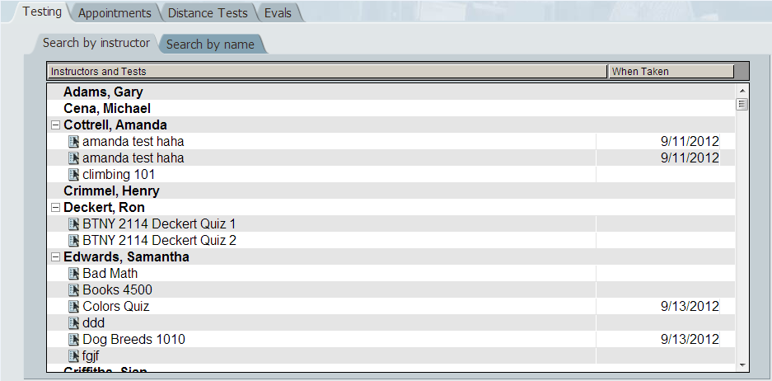Step 1: Click **Distance Tests**

Figure 1.1

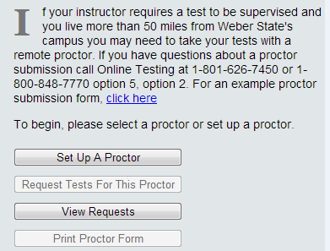Step 2: Click **Set Up a Proctor**

MC900391170[1]**** This hypertext will link you to an example of a proctor submission form. This submission form is also located in Appendix A.

Figure 1. 1

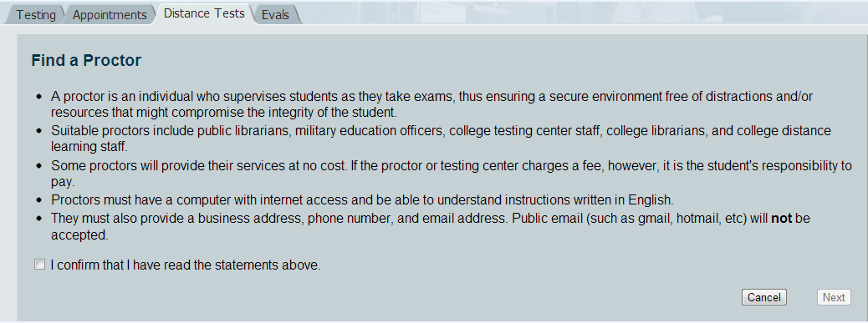Step 3: Read the instructions

and click the box next to

**I confirm that I have read the statement above.**

Figure 1 2

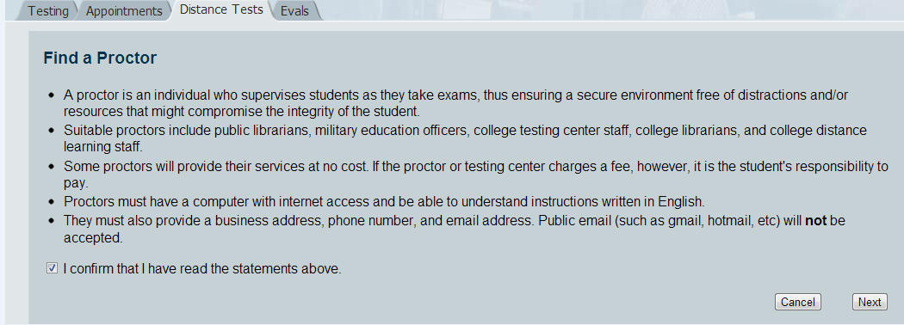

Step 4: Click **Next**

Figure 1.3

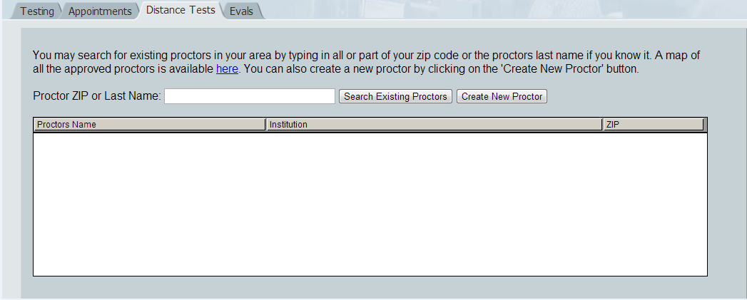Step 5: Read the instructions provided and select an option that best suits your situation.

Figure 1.4

1. This h This hypertext will open up a window to a map of approved proctors all over the world. This map is listed in Appendix A2. Use this option if you do not already have a name of a proctor you would like to use.



1. Use this tab if you kno Use this tab if you know the name of an approved proctor you would like to use.



1. Use this tab if you Use this tab if you have met someone you would like to use as your

# A. Find an Approved Proctor on the Map

If you selected this option, follow the steps below. Otherwise, proceed to the next option.

Figure a.1

Step 1: Click **here**

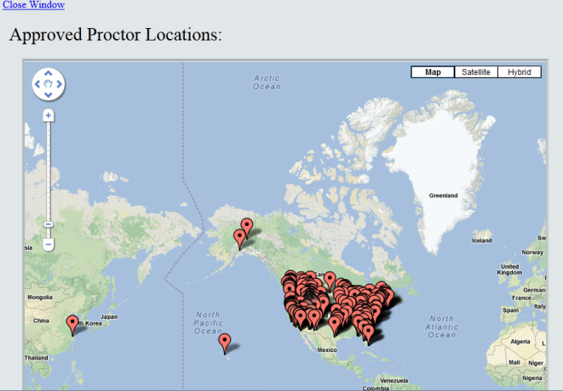Step 2: **Find your location on the map.**

MC900391170[1]The map functions like Google Maps. Use zoom in/out functions and satellite/street view functions to assist your search.

Figure a.2

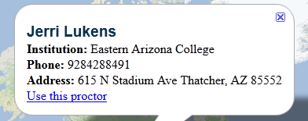Step 3: Click the red flag closest to your location. The proctor’s name and location will appear.

Step 4: Click **Use this proctor**

Figure a.3

Step 5:Follow the steps under **Create a New Proctor** to fill out and submit the proctor approval form.

# B. Search Existing Proctors

If you know a proctor exists in your area, or you know the name of a proctor, you can search the proctor using these steps.



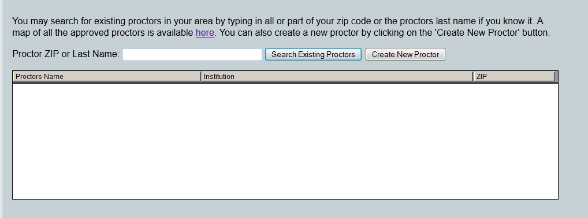

Step 1: Enter a proctor’s ZIP code or last name in **Proctor ZIP or Last Name** box.

Step 2: Click **Search existing proctors**

Figure b.1

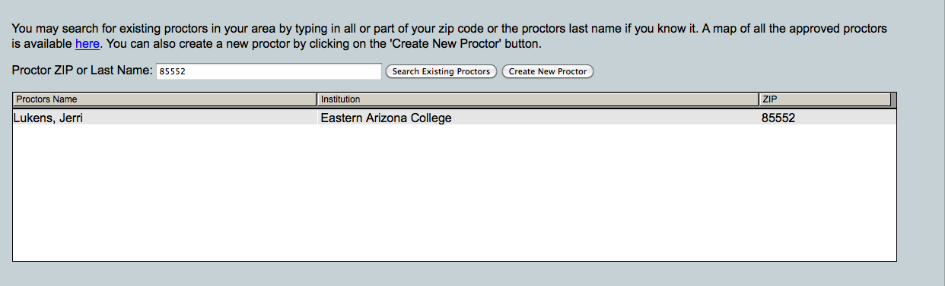Step 3: Choose a proctor from the list and select their name.

Figure b.2

Step 4: Follow the steps under **Create a New Proctor** to fill out and submit the proctor approval form.

# C. Create a New Proctor

If you selected this option, follow the instructions below.



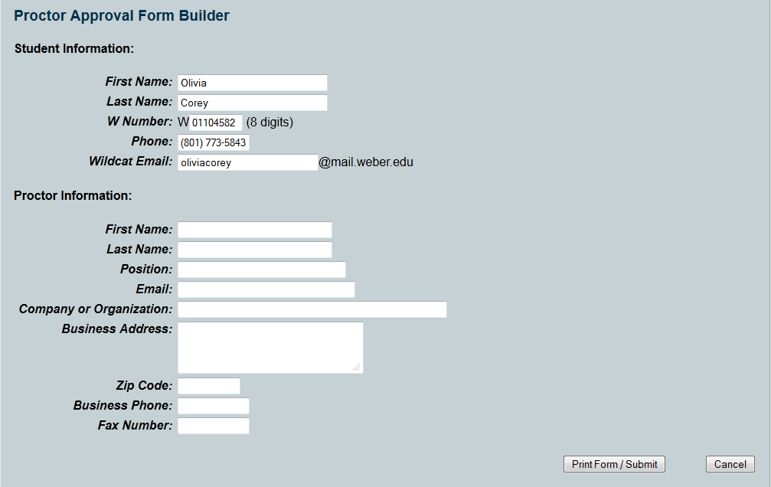

Step 1: After clicking **Create New Proctor**a form will appear called **Proctor Approval Form Builder.** Fill out the form and click **Print Form/Submit.**

Figure c.1

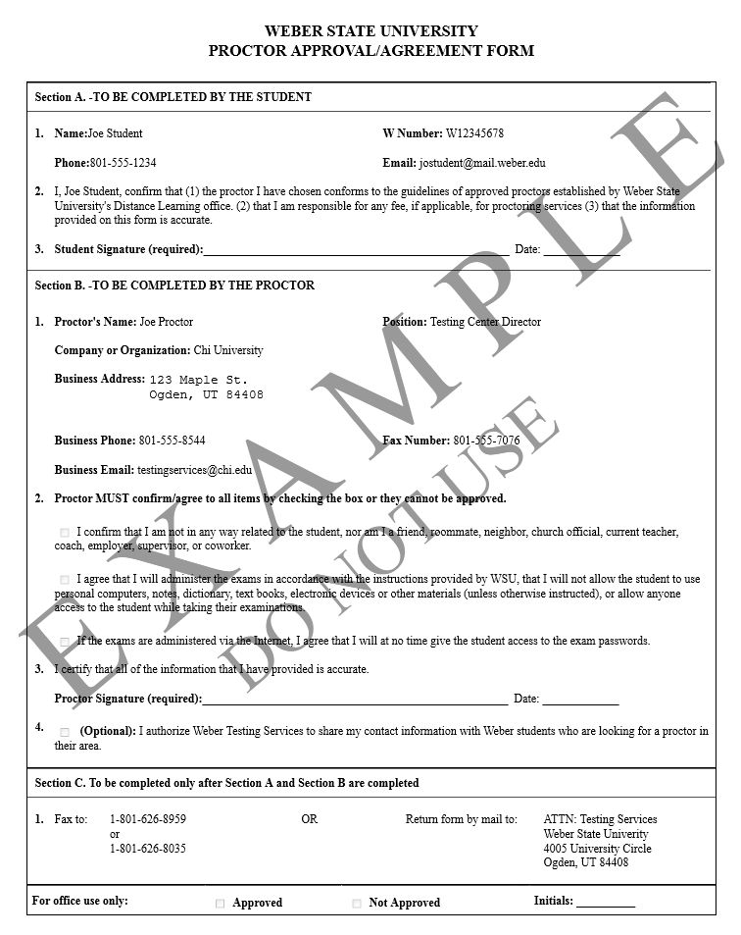

Step 2: Chi-Tester will automatically fill your information into the form and bring up print screen. **Print** the form.

Step 3: Both you and your proctor should **sign** the form.

Figure c.2

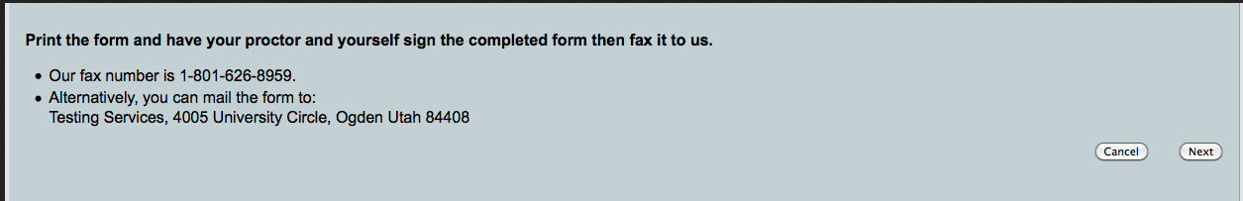

Step 4: Fax the form to Weber State University (1-801-626-8959) and then click **Next.**

MC900391170[1]If your proctor is approved, you will receive an email within 3 days.

Figure c.3

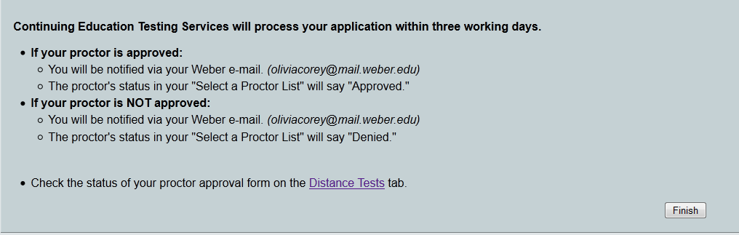Step 5**:** Read the proctor approval information and click **Finish.**

MC900391170[1]If your proctor is approved, you will receive an email within 3 days.

Figure c.4

To take a test, you must first request the test from your approved proctor.

Request a Test from a Proctor

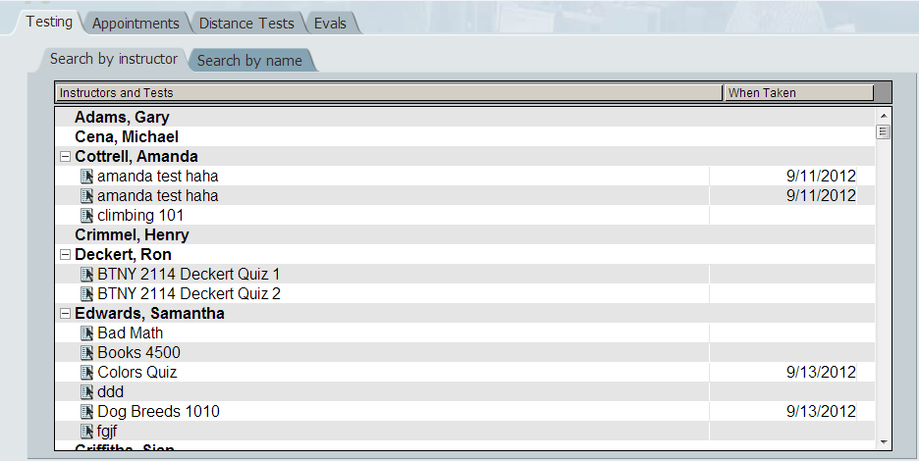Step 1: Click **Distance Tests**

Figure 2.1

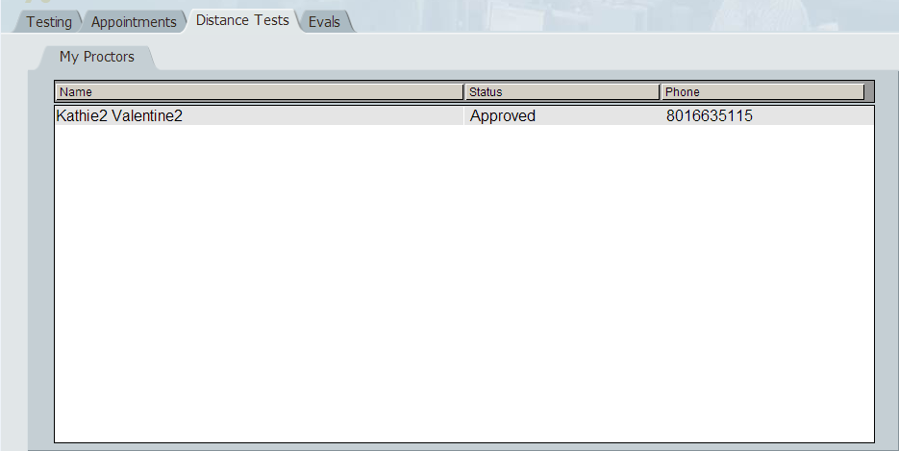Step 2: Select your proctor’s name

MC900391170[1]Notice the status will say “**Approved**” if the proctor has been approved. A phone number is also available for you to contact your proctor to coordinate test times.



Figure 2.2

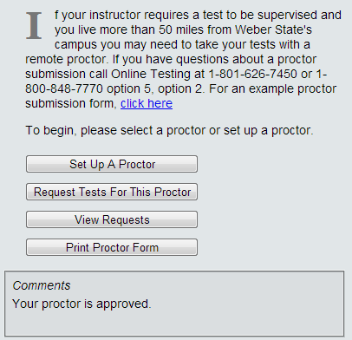Step 3: Click **Request Test for This Proctor**

MC900391170[1]Comments: This box will inform you of any problems. (Ex: proctor not approved.)

MC900391170[1]

This tab will allow you to see all the exams you have requested.

Figure 2.3

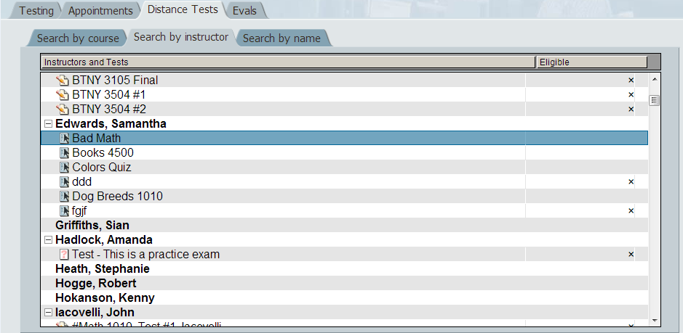

Figure 2.4

Step 4: Select your test

MC900391170[1]**Search by course**: You can find your course by the course name and number: for example, BTNY 3504.

MC900391170[1]**Search by instructor:** Search by your instructor’s name.MC900391170[1]**Search by name:** Search by the name of the test.

--

--

Step 5: Click **Request Proctor Test**

Step 6: Make sure the test you have requested is listed. Click **Done.**

MC900391170[1]If your test is not on the list please refer to troubleshooting.

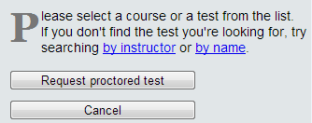

--

Figure 2.5

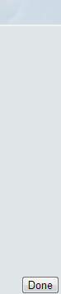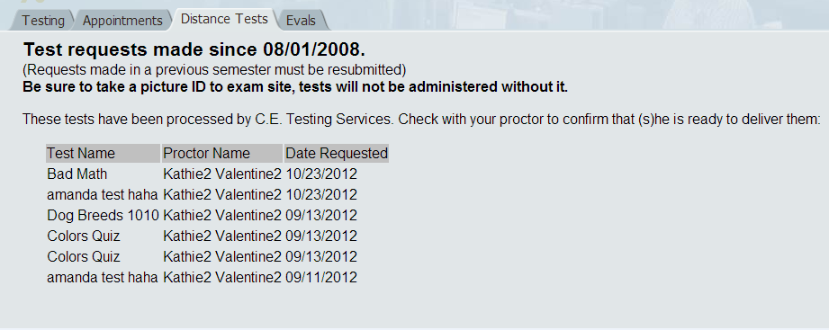

--

Figure 2.6

Take a Test

After logging into Chi Tester, follow the steps below to take your Test.

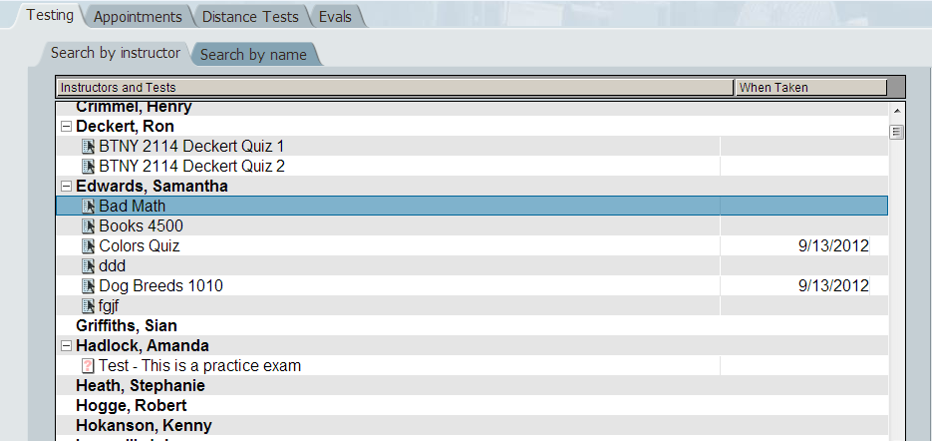Step 1: Under the **Testing** tab find your Test and select it.

*C:\Users\Sean\AppData\Local\Microsoft\Windows\Temporary Internet Files\Content.IE5\5IYHWS2Y\MC900391170[1].wmf* **Search by instructor:** scroll through your instructors and click on the name of your Test.

*C:\Users\Sean\AppData\Local\Microsoft\Windows\Temporary Internet Files\Content.IE5\5IYHWS2Y\MC900391170[1].wmf***Search by name:** searches by the last name of your instructor or the name of the test.

Figure 3.1

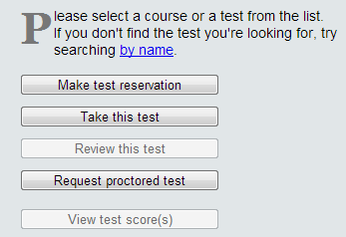Step 2: Click **Take this Test**

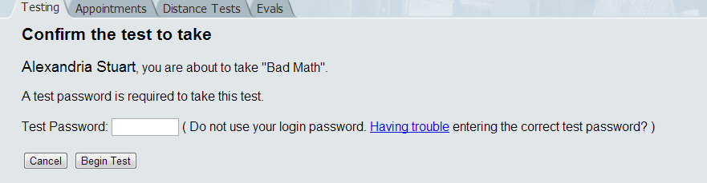Step 3: Have your proctor enter the test password then click **Begin Test**.

Figure 3.2

*C:\Users\Sean\AppData\Local\Microsoft\Windows\Temporary Internet Files\Content.IE5\5IYHWS2Y\MC900391170[1].wmf*Click this hypertext if there is a problem entering the correct test password.

Figure 3.3

Review a Test

To review your test, you must complete the following steps.

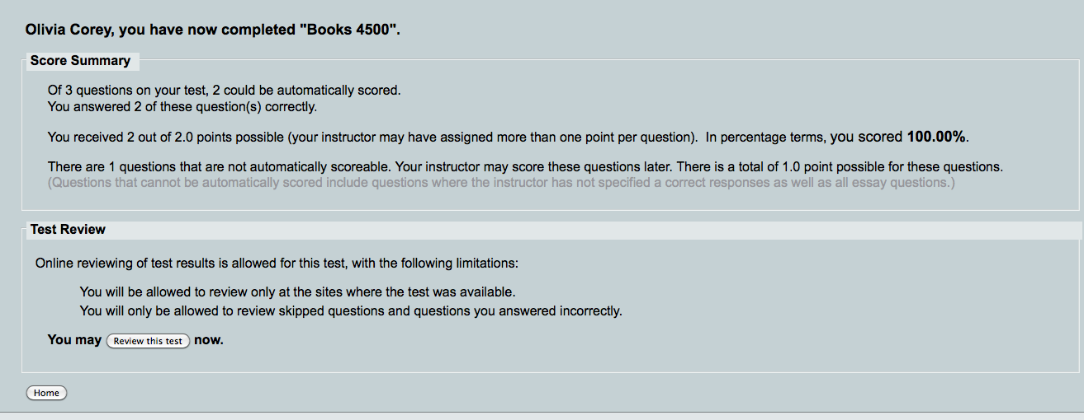Step 1: After completing your test, the following screen will appear displaying your score. If your professor has allowed reviewing for your test, click **Review this test.**

Figure 4.1

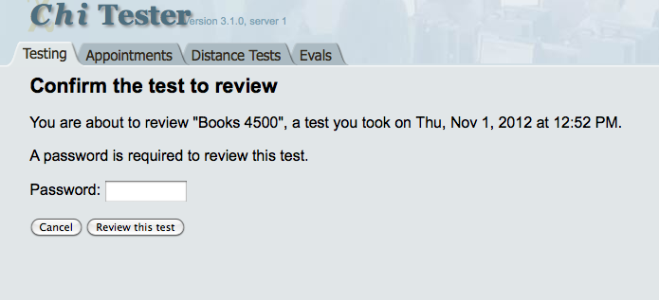

Step 2: Have your proctor type the same password used to begin your test. Click **Review this test.**

Figure 4.2

Frequently Asked Questions

The following section illustrates frequently asked questions concerning the processes discussed in this document.

**1-**What do I do if the proctor’s test code does not work?

-Your proctor has been given instructions in order to fix this complication.

**2-**The comment box says my test is no longer available, what do I do?

-Contact your professor as soon as possible.

**3-**My proctor did not show up for my exam, what do I do?

-Your proctor should have provided you with contact information. Inform your professor immediately if this problem occurs.

**4-**How long will it take for my proctor to be approved?

-An email should be sent to you within three days of proctor request.

**5-** Who do I contact for problems with Chi Tester?

-Chi Tester Support can help you resolve any issues.

-Phone: (801) 626-6477

-Email: chitester@weber.edu

**6-**Who do I contact for problems regarding proctor setup?

-Proctor Support should be your first stop for help.

-Phone: (801) 626-7450

-Email: onlinetesting@weber.edu

Other Helpful Information

This section will provide you with further information on the topics discussed in this document.

* Contact information for problems with Chi Tester/Proctor Setup
  + Chi Tester Support Phone: (801) 626-6477
    - Email: chitester@weber.edu
  + Proctor Support Phone: (801) 626-7450
    - Email: onlinetesting@weber.edu
* Websites with further instruction on Chi Tester:
  + http://departments.weber.edu/ce/distancelearning/testing.aspx

Appendix