Name: Robert Loth Class: COMSC 200-1369 Lab:2 Due Date: 2/22/2019

Problem-1
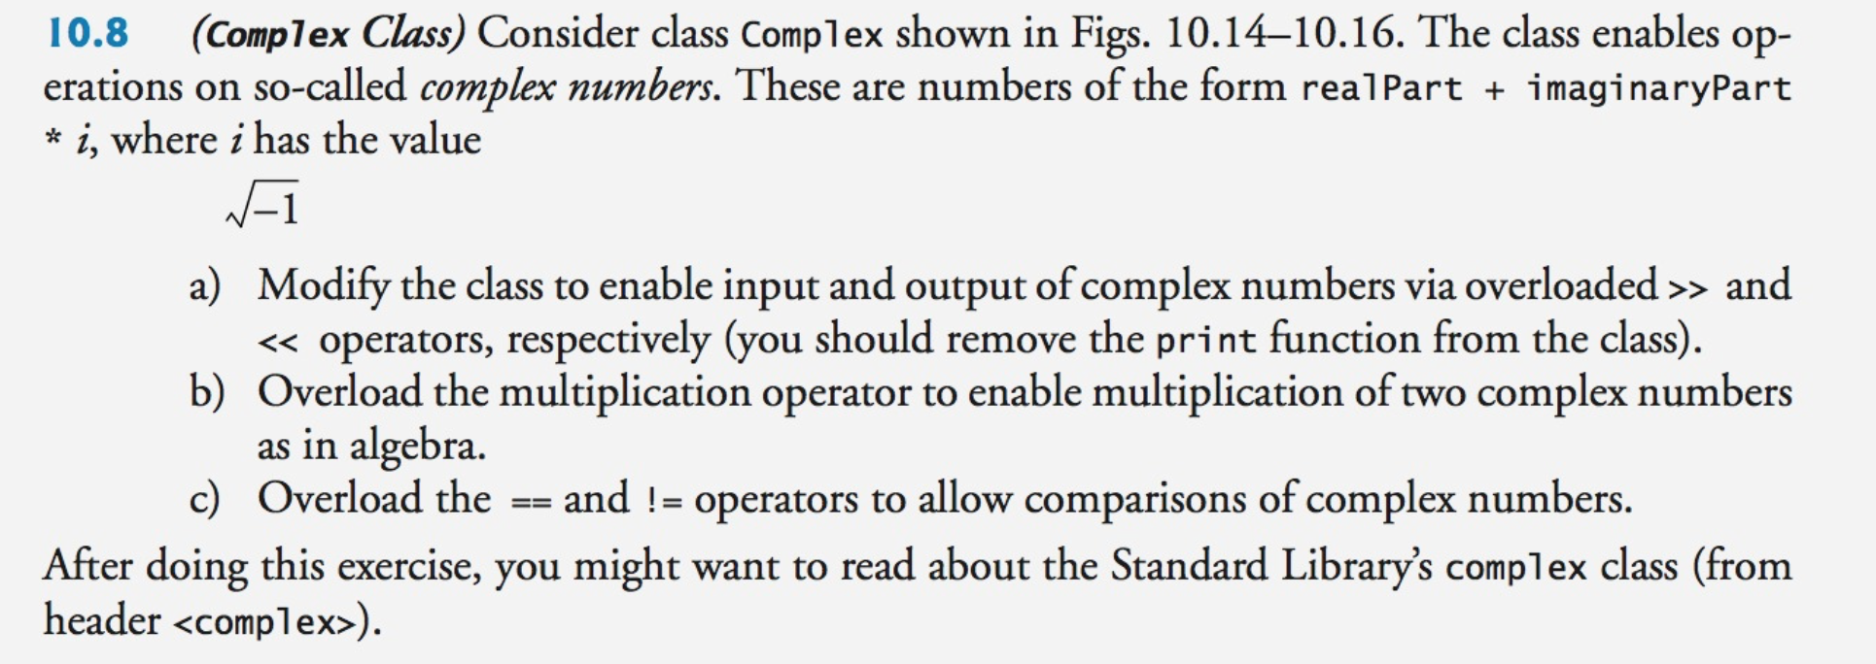

ANSWER:

Complex.h:
#ifndef COMPLEX_H
#define COMPLEX_H

#include <iostream> //cout
#include <string> //string literals in PrintComplexNumber

class Complex
{
public:
Complex();
Complex(double real, double imaginary);
Complex operator+ (Complex c2) const; //performs c1 + c2
Complex operator- (Complex c2) const; //performs c1 - c2
Complex operator* (Complex c2) const; //performs c1 * c2
bool operator== (Complex c2) const;//evaluates c1 == c2, mutually exclusive with !=
bool operator!= (Complex c2) const;//evaluates c1 != c2, if c1 == c2, then false
private:
friend std::ostream& operator<<(std::ostream&, const Complex&);
friend std::istream& operator>>(std::istream&, Complex&);
double realPart;
double imaginaryPart;
};

#endif

Complex.cpp:
#include "Complex.h"

Complex::Complex() {
realPart = 0.0;
imaginaryPart = 0.0;
}

Complex::Complex(double real, double imaginary){
realPart = real;
imaginaryPart = imaginary;
}

Complex Complex::operator+(Complex c2) const{
Complex temp;
temp.realPart = this->realPart + c2.realPart;
temp.imaginaryPart = this->imaginaryPart + c2.imaginaryPart;
return temp;
}

Complex Complex::operator-(Complex c2) const{
Complex temp;
temp.realPart = this->realPart - c2.realPart;
temp.imaginaryPart = this->imaginaryPart - c2.imaginaryPart;
return temp;
}

Complex Complex::operator*(Complex c2) const{
Complex temp;
temp.realPart = (realPart * c2.realPart) - (imaginaryPart * c2.imaginaryPart);
temp.imaginaryPart = (realPart * c2.imaginaryPart) + (imaginaryPart * c2.realPart);
return temp;
}

bool Complex::operator==(Complex c2) const{
if (realPart == c2.realPart && imaginaryPart == c2.imaginaryPart) return true;
else return false;
}

bool Complex::operator!=(Complex c2) const{
if (realPart != c2.realPart || imaginaryPart != c2.imaginaryPart) return true;
else return false;
}

std::ostream & operator<<(std::ostream &output, const Complex& temp){
output << "(" << temp.realPart << ", " << temp.imaginaryPart << ")";
return output;
}

std::istream & operator>>(std::istream &input, Complex &temp){
input >> temp.realPart >> temp.imaginaryPart;
return input;
}

TestComplex.cpp:
#include <iostream>
#include "Complex.h"
using namespace std;
int main()
{
//initialize
Complex InputComp;
Complex Comp2(5, 3);
Complex Comp3(4, 6);

cout << "Please enter the real part and imaginary part of an ";
cout << "imaginary number, separated by a space.";
cin >> InputComp;
cout << endl;
//TestComp.PrintComplexNumber(); old format, new overloaded operators support format below
//cout << endl;

//print all
cout << "You entered " << InputComp << endl;
cout << "Test value 2 is " << Comp2 << endl;
cout << "Test value 3 is " << Comp3 << endl;

//test operator+
Complex TestComp1 = InputComp + Comp3;
cout << "Your value plus value 3 is " << TestComp1 << endl;

//test operator-
Complex TestComp2 = Comp2 - InputComp;
cout << "value 2 minus your value is " << TestComp2 << endl;

//test operator*
Complex TestComp3 = Comp2 * Comp3;
cout << "value 2 multiplied by value 3 is " << TestComp3 << endl;

//test operator==
Complex TestCompEq2(5, 3);
cout << "Equivalency Test Expected value: " << true << endl;
cout << "Equivalency Test for Comp2 == Comp2: " << (Comp2 == TestCompEq2) << endl;

//test operator!=
cout << "Non-Equivalency Test Expected value: " << false << endl;
cout << "Non-Equivalency Test for Comp3 != Comp3: " << (Comp3 != Comp3) << endl;
system("pause");
return 0;
}

Screenshot:
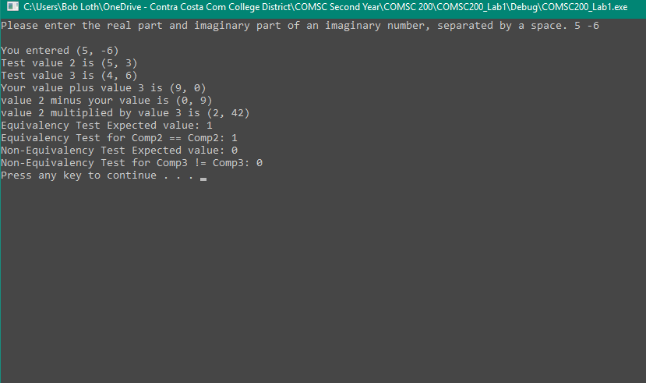
Problem-2 and 3

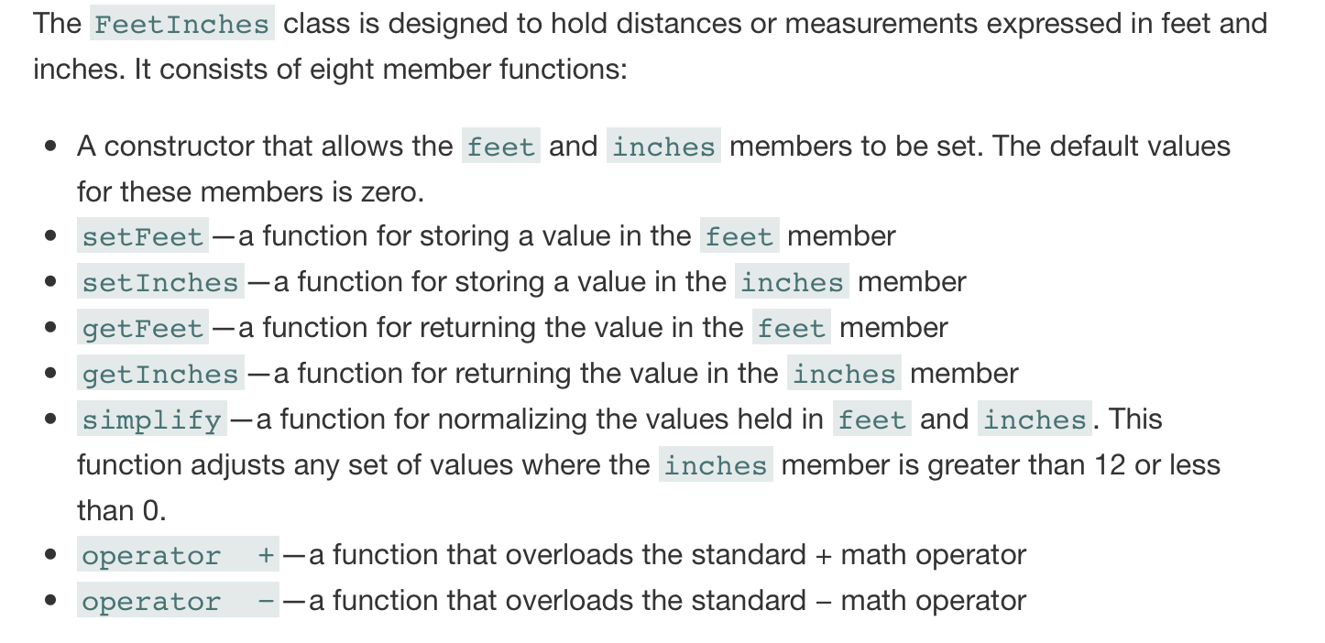
3- Modify the above feet and inches program to include the following operator overloading:
<=
>=
!=
>>
<<
FeetInches.h
#pragma once
#include <stdexcept>
#include <iostream>
class FeetInches
{
public:

FeetInches(int=0, int=0);
void setFeet(int);
void setInches(int);
int getFeet() const;
int getInches() const;
void Simplify();
FeetInches operator+(FeetInches &) const;
FeetInches operator-(FeetInches &) const;
bool operator>=(FeetInches &) const;
bool operator<=(FeetInches &) const;
bool operator!=(FeetInches &) const;
private:
int feet;
int inches;

friend std::ostream & operator<<(std::ostream &, const FeetInches &);
friend std::istream & operator>>(std::istream &, FeetInches &);
};

FeetInches.cpp
#include "FeetInches.h"

FeetInches::FeetInches(int feet, int inches) {
this->feet = feet;
this->inches = inches;
}

void FeetInches::setFeet(int feet) {
this->feet = feet;
}

void FeetInches::setInches(int) {
this->inches = inches;
}

int FeetInches::getFeet() const {
return feet;
}

int FeetInches::getInches() const {
return inches;
}
void FeetInches::Simplify() {

if (inches >= 12) {
feet += (inches / 12);
inches = inches % 12;
}
else if (inches < 0) {
while (inches < 0) {
inches += 12;
feet -= 1;
}
}
if (feet < 0)
throw std::invalid_argument("Distance cannot be negative");
}

FeetInches FeetInches::operator+(FeetInches & arg2) const {
FeetInches temp;
temp.feet = feet + arg2.feet;
temp.inches = inches + arg2.inches;
return temp;
}

FeetInches FeetInches::operator-(FeetInches & arg2) const {
FeetInches temp;
temp.feet = feet - arg2.feet;
temp.inches = inches - arg2.inches;
return temp;
}

bool FeetInches::operator>=(FeetInches & arg2) const {
if (((feet * 12) + inches) >= (arg2.feet * 12) + arg2.inches) {
return true;
}
else return false;
}

bool FeetInches::operator<=(FeetInches & arg2) const {
if (((feet * 12) + inches) <= (arg2.feet * 12) + arg2.inches){
return true;
}
else return false;
}

bool FeetInches::operator!=(FeetInches & arg2) const
{
if (((feet * 12) + inches) != ((arg2.feet * 12) + arg2.inches))
return true;
else return false;
}

std::ostream & operator<<(std::ostream & output, const FeetInches & ftIn)
{
output << ftIn.getFeet() << " ft, " << ftIn.getInches() << " in";
return output;
}

std::istream & operator>>(std::istream & input, FeetInches & ftIn){
input >> ftIn.feet >> ftIn.inches;
return input;
}

FeetInchesTest.cpp
#include "FeetInches.h"
#include <cassert>
#include <iostream>

using namespace std;

int main() {
//test constructors
FeetInches a(5, 17);
assert(a.getFeet() == 5 && a.getInches() == 17);
FeetInches b;
assert(b.getFeet() == 0 && b.getInches() == 0);

//test Simplify
a.Simplify();
assert(a.getFeet() == 6 && a.getInches() == 5); //positive adjustment
b.Simplify();
assert(b.getFeet() == 0 && b.getInches() == 0); //no adjustment needed
FeetInches c(4, -22);
c.Simplify();
assert(c.getFeet() == 2 && c.getInches() == 2); //negative adjustment

//test operators + and -
FeetInches d = a + c;
assert(d.getFeet() == 8 && d.getInches() == 7);
d = a - c;
assert(d.getFeet() == 4 && d.getInches() == 3);

//test operators <=, >= and !=
assert(d <= a);
assert(a <= a);
assert(a >= c);
assert(b >= b);
assert(!(b != b));
assert(c != d);
cout << "All automated function testing passed." << endl;
//test operators >> and <<, and cascading operators
FeetInches e,f;
cout << "Please enter a positive integer for feet, followed by an integer for inches. " << endl;
cout << "Then, do the same thing again: feet, then inches. (total 4 inputs): ";
cin >> e >> f;
cin.ignore();
cout << e << endl;
e.Simplify();
cout << "Otherwise known as " << e << endl;
cout << f << endl;
f.Simplify();
cout << "Otherwise known as " << f << endl;
system("pause");
return 0;
}
Note: problems 2 and 3 were done at the same time.

