COMSC200 LAB5 Due: March-22 Name: Robert Loth

In the following problem, time.h is given to you on Canvas.

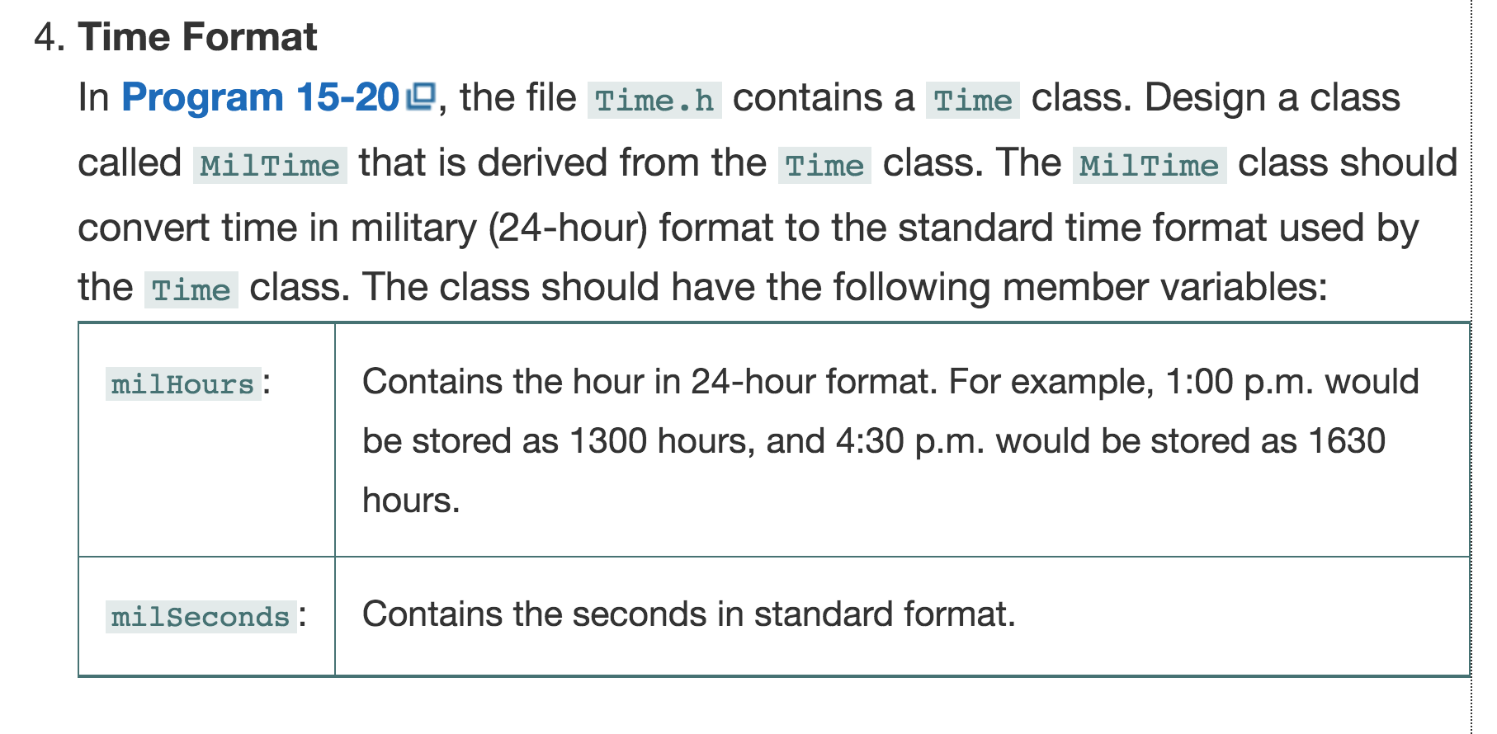

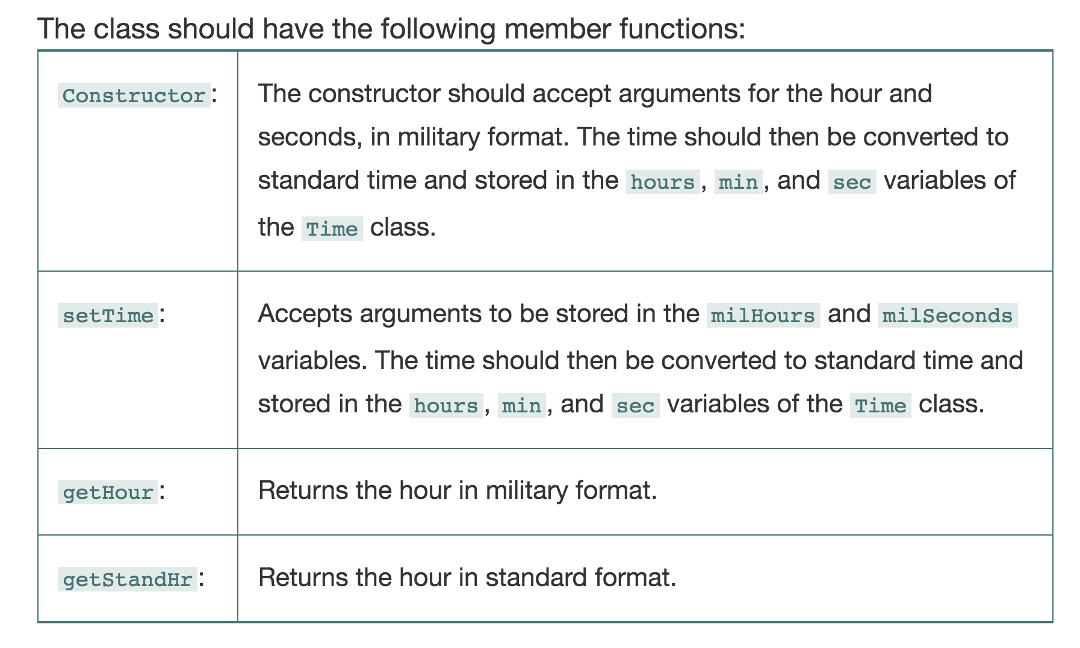

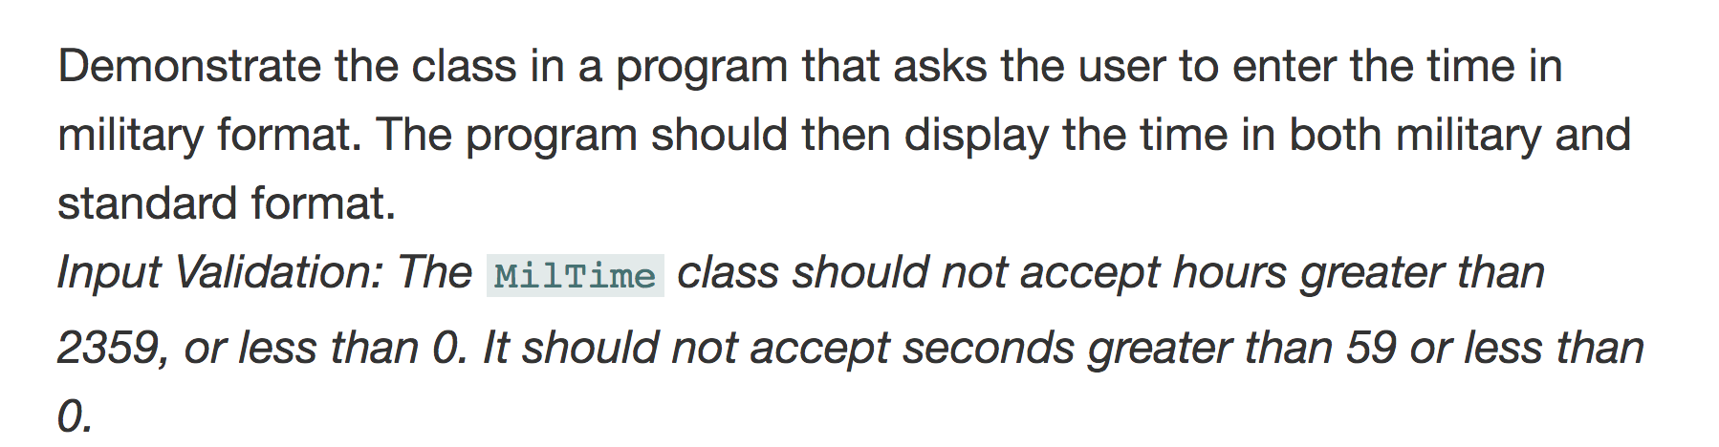

THE FOLLOWING PROBLEM REFERS TO THE ABOVE PROBLEM
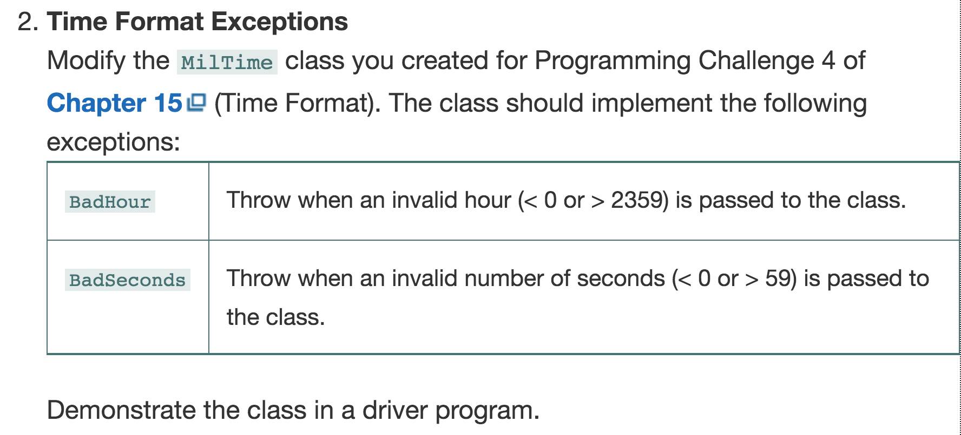

MilTime.h
#ifndef MILTIME_H
#define MILTIME_H
#include "Time.h"

class MilTime : public Time
{
public:
MilTime(int hour, int second);
void setTime(int milHours, int milSeconds);
int getHour();
int getStandHr();
private:
int milHours;
int milSeconds;
};
#endif

MilTime::MilTime(int hour, int second)
{
if (hour < 0 || hour > 2359)
{
throw "Bad Hour";
}
if (second < 0 || second > 59)
throw "Bad Second";
milHours = hour;
min = milHours % 100;
milSeconds = second;
}

inline void MilTime::setTime(int milHours, int milSeconds)
{
if (milHours < 0 || milHours > 2359)
{
throw "Bad Hour";
}
if (milSeconds < 0 || milSeconds > 59)
throw "Bad Second";
this->milHours = milHours;
min = milHours % 100;
this->milSeconds = milSeconds;
}

inline int MilTime::getHour()
{
return milHours;
}

inline int MilTime::getStandHr()
{
if (milHours > 1259)
return (milHours - 1200) / 100;
else
return milHours / 100;
}

MilTimeTestDriver.cpp:
#include "MilTime.h"
#include <iostream>

#include <iomanip>
using namespace std;

int main()
{
int input;
try
{
cout << "Please enter the time in military format ( ex. 2200 for 10PM): ";
cin >> input;
}
catch (const char* exc)
{
cerr << exc << endl;
}
MilTime myTime(input, 0);
//print formatted output
cout << fixed << "Military time: " << setfill('0') << setw(4) << myTime.getHour() << endl;
cout << "Standard time: " << setfill('0') << setw(2) << myTime.getStandHr()
<< ":" << setprecision(2) << myTime.getMin() << endl;

cout << "Testing for exceptions:" << endl;
try
{
myTime.setTime(4300, 0);
}
catch (const char* exc)
{
cerr << exc << endl;
}
try
{
myTime.setTime(400, -9);
}
catch (const char* exc)
{
cerr << exc << endl;
}
system("pause");
return 0;
}

ScreenShot:

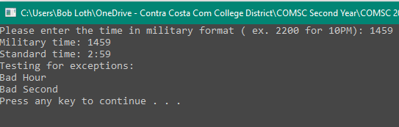

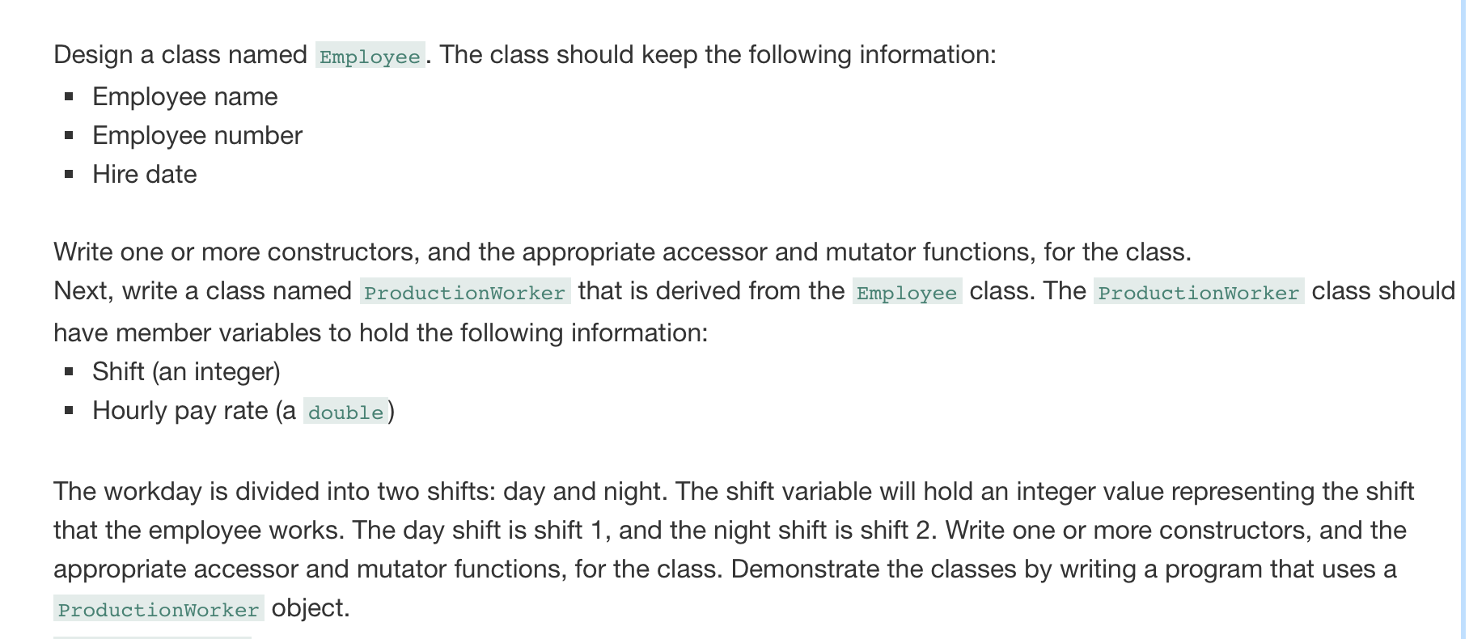

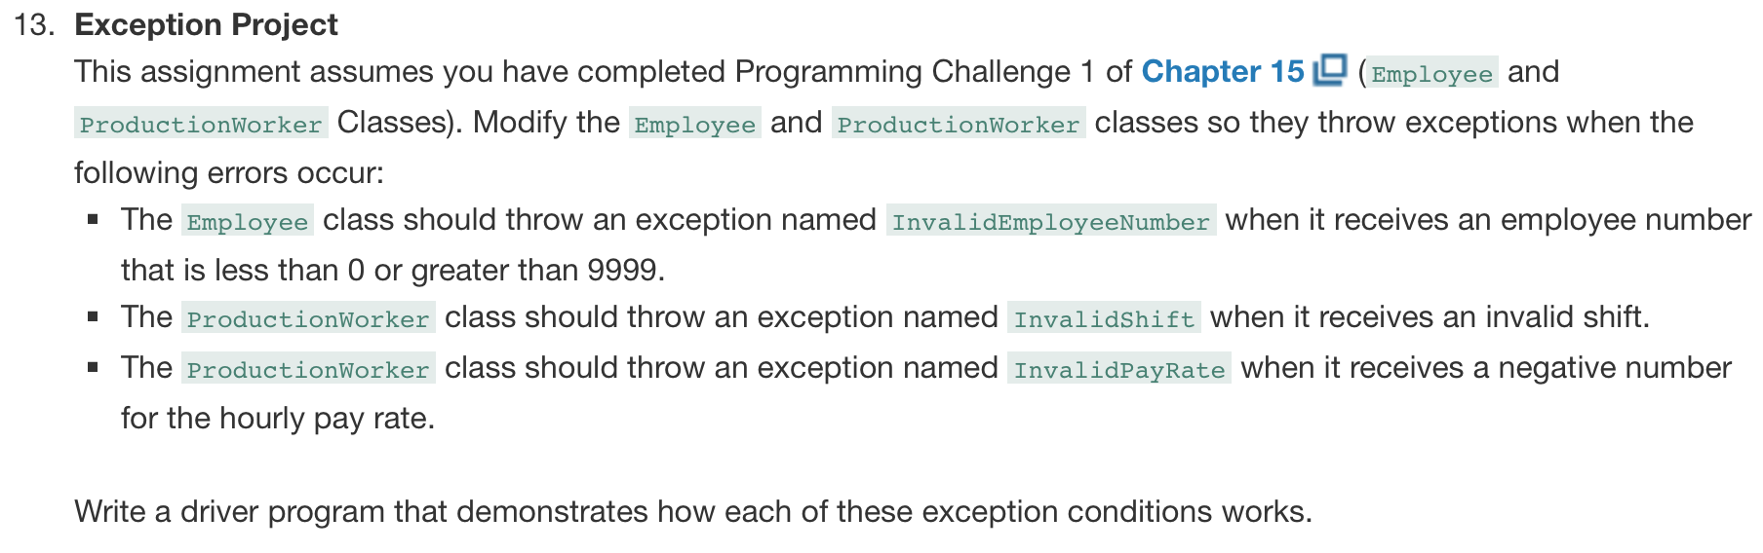

Employee.h:
#ifndef EMPLOYEE_H
#define EMPLOYEE_H
#include <string>
class Employee
{
public:
Employee(std::string name, int number, std::string hireDate);
std::string getName() const;
int getNumber() const;
std::string getHireDate() const;

void setName(std::string name) { this->name = name; }
void setNumber(int number);
void setHireDate(std::string hireDate) { this->hireDate = hireDate; }
protected:
std::string name;
int number;
std::string hireDate;
};
#endif

Employee.cpp:
#include "Employee.h"

Employee::Employee(std::string name, int number, std::string hireDate)
{
this->name = name;
if (number < 0 || number > 9999)
{
throw "Invalid employee number";
}
this->number = number;
this->hireDate = hireDate;
}

std::string Employee::getName() const
{
return name;
}

int Employee::getNumber() const
{
return number;
}

std::string Employee::getHireDate() const
{
return hireDate;
}

void Employee::setNumber(int number)
{
if (number < 0 || number > 9999)
{
throw "Invalid Employee Number";
}
this->number = number;
}

ProductionWorker.h:

#ifndef PRODUCTIONWORKER_H
#define PRODUCTIONWORKER_H
#include "Employee.h"
class ProductionWorker :
public Employee
{
public:
ProductionWorker(std::string name, int number, std::string hireDate, int shift, double hourlyPay);
int getShift() const { return shift; }
double getPay() const { return hourlyPay; }
void setShift(int shift);
void setHourlyPay(double hourlyPay);
private:
int shift;
double hourlyPay;
};
#endif // !PRODUCTIONWORKER_H

ProductionWorker.cpp:
#include "ProductionWorker.h"

ProductionWorker::ProductionWorker(std::string name, int number,
std::string hireDate, int shift, double hourlyPay)
: Employee(name, number, hireDate)
{
if (!(shift == 1 || shift == 2))
{
throw "Invalid shift";
}
if (hourlyPay < 0)
{
throw "Invalid pay rate";
}
this->shift = shift;
this->hourlyPay = hourlyPay;
}

void ProductionWorker::setShift(int shift)
{
if (!(shift == 1 || shift == 2))
{
throw "Invalid shift";
}
this->shift = shift;

}

void ProductionWorker::setHourlyPay(double hourlyPay)
{
if (hourlyPay < 0)
{
throw "Invalid pay rate";
}
this->hourlyPay = hourlyPay;
}

ProductionWorkerTestDriver.cpp:
#include "ProductionWorker.h"
#include <iostream>
#include <iomanip>
using namespace std;
int main()
{
Employee emp1("John", 6446, "03/21/2019");
ProductionWorker Prod1("Jack", 9482, "3/22/2019", 2, 14.50);

cout << emp1.getName() << "\nNumber: " << emp1.getNumber()
<< "\nHired on " << emp1.getHireDate() << endl << endl;

cout << Prod1.getName() << "\nNumber: " << Prod1.getNumber()
<< "\nHired on " << Prod1.getHireDate() << "\nShift Designation: "
<< Prod1.getShift() << "\nHourly Pay: $" << fixed << setprecision(2) << Prod1.getPay() << endl << endl;
cout << "Should see 5 invalid statements." << endl;
try
{
emp1.setNumber(-5);
}
catch (const char* exc)
{
cout << exc << endl;
}
try
{
emp1.setNumber(12000);
}
catch (const char* exc)
{
cout << exc << endl;
}
try
{
Prod1.setNumber(15000);
}
catch (const char* exc)
{
cout << exc << endl;
}
try
{
Prod1.setHourlyPay(-1.5);
}
catch (const char* exc)
{
cout << exc << endl;
}
try
{
Prod1.setShift(3);
}
catch (const char* exc)
{
cout << exc << endl;
}
system("pause");
return 0;
}

ScreenShot:
