COMSC 200 Lab-4 Due: March-8 at 11:59 PM Name: Robert Loth

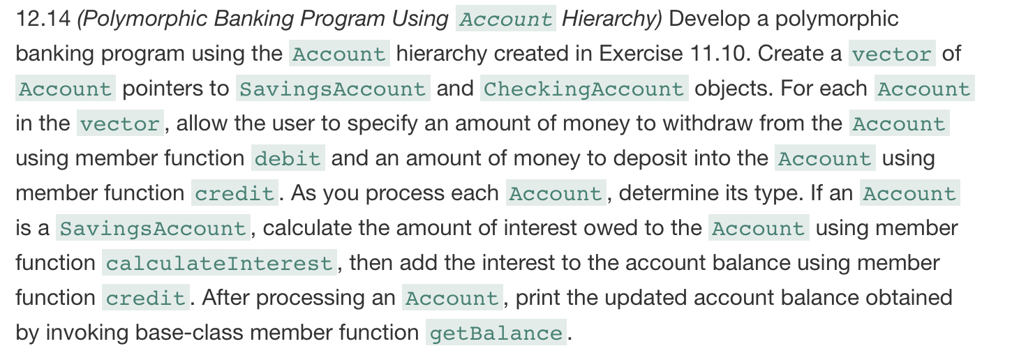

Main.cpp:

#include "Account.h"
#include "CheckingAccount.h"
#include "SavingsAccount.h"
#include <iostream>
#include <vector>
#include <typeinfo>
using namespace std;
int main() {
vector<Account*> accountsList(3);
double tempInput = 0;
accountsList.at(0) = new Account(1200);
accountsList.at(1) = new CheckingAccount(1500, 10);
accountsList.at(2) = new SavingsAccount (9000, .01);
for (int i = 0; i < accountsList.size(); i++) {
SavingsAccount* savingsPtr = dynamic_cast<SavingsAccount*>(accountsList.at(i));
if (savingsPtr != nullptr) {
cout << "\nThis is a savings account, calculating interest on $" << savingsPtr->getBalance() << endl;
savingsPtr->credit(savingsPtr->calculateInterest());
cout << "\nBalance is now $" << savingsPtr->getBalance() << endl;
}
CheckingAccount* checkingPtr = dynamic_cast<CheckingAccount*>(accountsList.at(i));
if (checkingPtr != nullptr) {
cout << "\nThis is a checking account, an amount will be deducted for each transaction.\n";
}
cout << "Account balance: " << accountsList.at(i)->getBalance() << endl;
cout << "Enter an amount to withdraw, or enter 0 to continue: ";
cin >> tempInput;
cin.ignore();
if (tempInput > 0) {
accountsList.at(i)->debit(tempInput);
cout << "\nAmount successfully withdrawn\n";
}
cout << "Account balance: " << accountsList.at(i)->getBalance() << endl;
cout << "Enter an amount to deposit, or enter 0 to continue: ";
cin >> tempInput;
cin.ignore();
if (tempInput > 0) {
accountsList.at(i)->credit(tempInput);
cout << "\nAmount successfully deposited, amount now " << accountsList.at(i)->getBalance() << endl;
}
cout << "deleting object of " << typeid(*accountsList.at(i)).name() << endl;

}
cin.ignore();
return 0;
}

Account.h:
#pragma once
#include <iostream>
class Account
{
public:
Account();
Account(double accBal);
~Account();
double getBalance() const { return accountBal; }
virtual void credit(double depositAmt);
virtual bool debit(double withdrawAmt);
protected:
double accountBal;
};

Account.cpp:
#include "Account.h"

Account::Account()
{
}

Account::Account(double accBal)
{
if (accBal < 0) {
this->accountBal = 0.0;
std::cout << "Account balance invalid, setting account balance to 0.\n";
}
else this->accountBal = accBal;
}

Account::~Account()
{
}

void Account::credit(double depositAmt)
{
accountBal += depositAmt;
}

bool Account::debit(double withdrawAmt)
{
if (withdrawAmt > accountBal) {
std::cout << "Debit amount exceeded account balance." << std::endl;
return false;
}
else {
accountBal -= withdrawAmt;
return true;
}
}

CheckingAccount.h:

#pragma once
#include "Account.h"
class CheckingAccount
: public Account
{
public:
CheckingAccount(double accountBal, double transactFee);
~CheckingAccount();
void credit(double depositAmt);
bool debit(double withdrawAmt);
private:
double transactFee; //flat sum per transaction
};

CheckingAccount.cpp:
#include "CheckingAccount.h"

CheckingAccount::CheckingAccount(double accountBal, double transactFee)
{
this->accountBal = accountBal;
this->transactFee = transactFee;
}

CheckingAccount::~CheckingAccount()
{
}

void CheckingAccount::credit(double depositAmt)
{
accountBal += (depositAmt - transactFee);
}

bool CheckingAccount::debit(double withdrawAmt)
{
if (withdrawAmt > accountBal) {
std::cout << "Debit amount exceeded account balance." << std::endl;
return false;
}
else {
accountBal -= (withdrawAmt + transactFee);
return true;
}
}

SavingsAccount.h:
#pragma once
#include "Account.h"
class SavingsAccount :
public Account
{
public:
SavingsAccount(double accountBal, double interestRate);
~SavingsAccount();
double calculateInterest();
private:
double interestRate; //as percentage
};

SavingsAccount.cpp:
#include "SavingsAccount.h"

SavingsAccount::SavingsAccount(double accountBal, double interestRate)
{
if (accountBal > 0)
this->accountBal = accountBal;
else this->accountBal = 0.0;
if (interestRate > 0)
this->interestRate = interestRate;
else this->interestRate = 0.0;
}

SavingsAccount::~SavingsAccount()
{
}

double SavingsAccount::calculateInterest()
{
return interestRate * accountBal;
}

Screenshot:
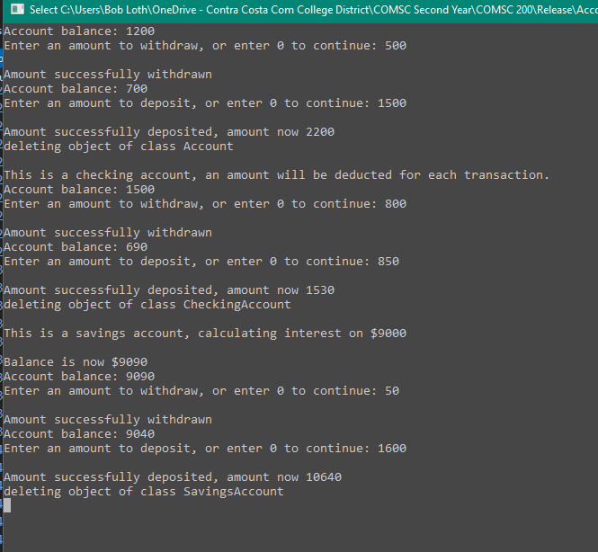

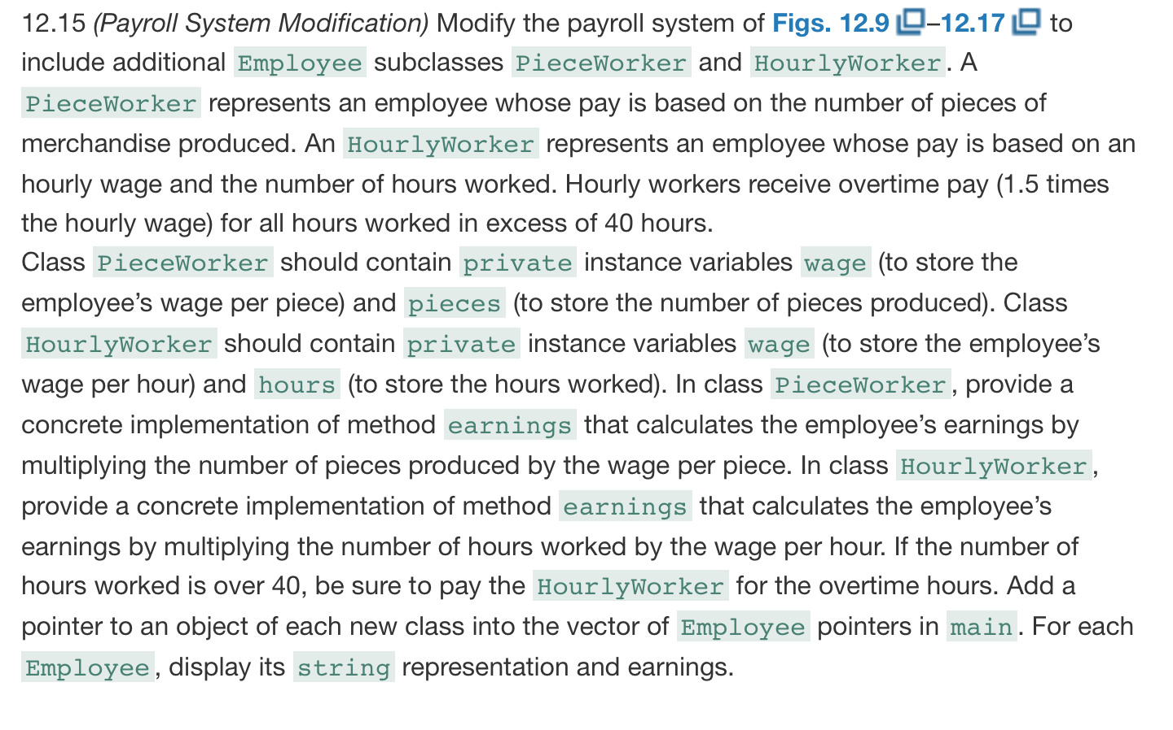

Employee.h:
#pragma once
#include <string>
using namespace std;
class Employee
{
public:
Employee(const string&, const string&, const string&);
virtual ~Employee() = default;

void setFirstName(const string&);
string getFirstName() const;

void setLastName(const string&);
string getLastName() const;

void setSSN(const string&);
string getSSN() const;

virtual double earnings() const = 0;
virtual string toString() const;
private:
string firstName;
string lastName;
string SSN;
};

Employee.cpp:
#include "Employee.h"

Employee::Employee(const string& first, const string& last, const string& SSN) : firstName(first), lastName(last), SSN(SSN){}

void Employee::setFirstName(const string& first)
{
firstName = first;
}
string Employee::getFirstName() const {return firstName;}

void Employee::setLastName(const string & last)
{
lastName = last;
}
string Employee::getLastName() const { return lastName; }

void Employee::setSSN(const string & SSN)
{
this->SSN = SSN;
}
string Employee::getSSN() const { return SSN; }

string Employee::toString() const
{
return getFirstName() + " "s + getLastName() + "\nsocial security number : "s + getSSN();
}

PieceWorker.h:
#pragma once
#include "Employee.h"
using namespace std;
class PieceWorker :
public Employee
{
public:
PieceWorker(const string&, const string&, const string&, double = 0.0, int = 0);
~PieceWorker();
void setWage(double wage) { this->wage = wage; }
double getWage() const { return wage; }
void setPieces(int pieces) { this->pieces = pieces; }
int getPieces() const { return pieces; }
double earnings() const override;
private:
double wage;
int pieces;
};

PieceWorker.cpp:
#include "PieceWorker.h"
PieceWorker::PieceWorker(const string& first, const string& last,
const string& ssn, double wage, int pieces)
:Employee(first, last, ssn)
{
setWage(wage);
setPieces(pieces);
}

PieceWorker::~PieceWorker()
{
}

double PieceWorker::earnings() const
{
return wage * pieces;
}

HourlyWorker.h:
#pragma once
#include "Employee.h"
using namespace std;
class HourlyWorker :
public Employee
{
public:
HourlyWorker(const string&, const string&, const string&,
double = 0.0, double = 0.0);
void setWages(double wages) { this->wages = wages; }
double getWages() const { return wages; }
void setHours(double hours) { this->hours = hours; }
double getHours() const { return hours; }

double earnings() const override;
private:
double wages;
double hours;
};

HourlyWorker.cpp:
#include "HourlyWorker.h"

HourlyWorker::HourlyWorker(const string& first, const string& last,
const string& ssn, double wage, double hours)
:Employee(first, last, ssn)
{
setWages(wage);
setHours(hours);
}

double HourlyWorker::earnings() const
{
if (getHours() > 40.0) {
return (1.5 * getWages() * (getHours() - 40)) + (getWages() * 40); //OT + BASE
}
else return getWages() * getHours();
}

main.cpp:
#include "Employee.h"
#include "PieceWorker.h"
#include "HourlyWorker.h"

#include <iostream>
#include <vector>
#include <typeinfo>

using namespace std;

int main() {
vector<Employee*> employeeList(3);
employeeList.at(0) = new HourlyWorker("John", "Doe", "123456789", 15, 35);
employeeList.at(1) = new PieceWorker("Jane", "Doe", "987654321", 4, 105);

for (int i = 0; i < employeeList.size(); i++) {
HourlyWorker* hourlyPtr = dynamic_cast<HourlyWorker*>(employeeList.at(i));
if (hourlyPtr != nullptr) {
cout << "This is an hourly employee." << endl;
cout << hourlyPtr->toString() << endl;
cout << "Earnings for week: " << hourlyPtr->earnings() << endl << endl;
}
PieceWorker* piecePtr = dynamic_cast<PieceWorker*>(employeeList.at(i));
if (piecePtr != nullptr) {
cout << "This is a paid-by-piece employee." << endl;
cout << piecePtr->toString() << endl;
cout << "Earnings for week: " << piecePtr->earnings() << endl << endl;
}

}
cin.ignore();
return 0;
}

Screenshot:
