10.30 Gilgamesh

1:Highlight some places in the text that tell us about the relationship between Gilgamesh and Enkidu. Use your own words to describe their relationship.

Answer:They have collaborations to slaughter the bull of heaven and kill Humbaba.They are very close friends and even like brothers.

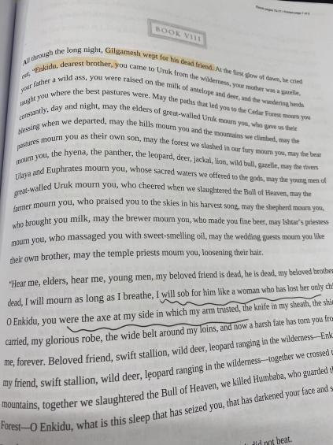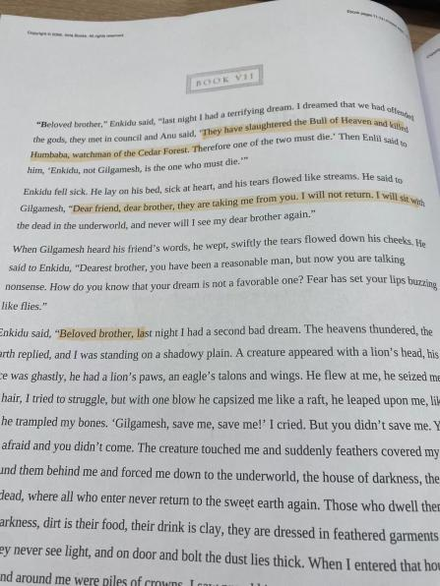

2:Use 4 to 5 sentences to describe Gilgamesh' journey after the death of Enkidu.

Answer:Overwhelmed by grief and the realization of mortality, he becomes obsessed with the quest for immortality. He leaves the city of Uruk and travels in search of Utnapishtim, a wise survivor of the Great Flood who possesses the secret of eternal life. Along the way, he encounters various challenges and trials, such as crossing the Waters of Death and enduring the scorching sun.During this journey, Gilgamesh's character evolves from a brash and self-centered king into a more humble and contemplative figure. He learns valuable lessons about the limitations of human existence and the importance of living a meaningful life. Ultimately, he does not attain physical immortality but gains wisdom and a deeper understanding of the human condition.

3: What is Shiduri's advice to Gilgamesh and what is his reaction? Highlight the section and use 3-4 sentences to describe their conversation in your own words.

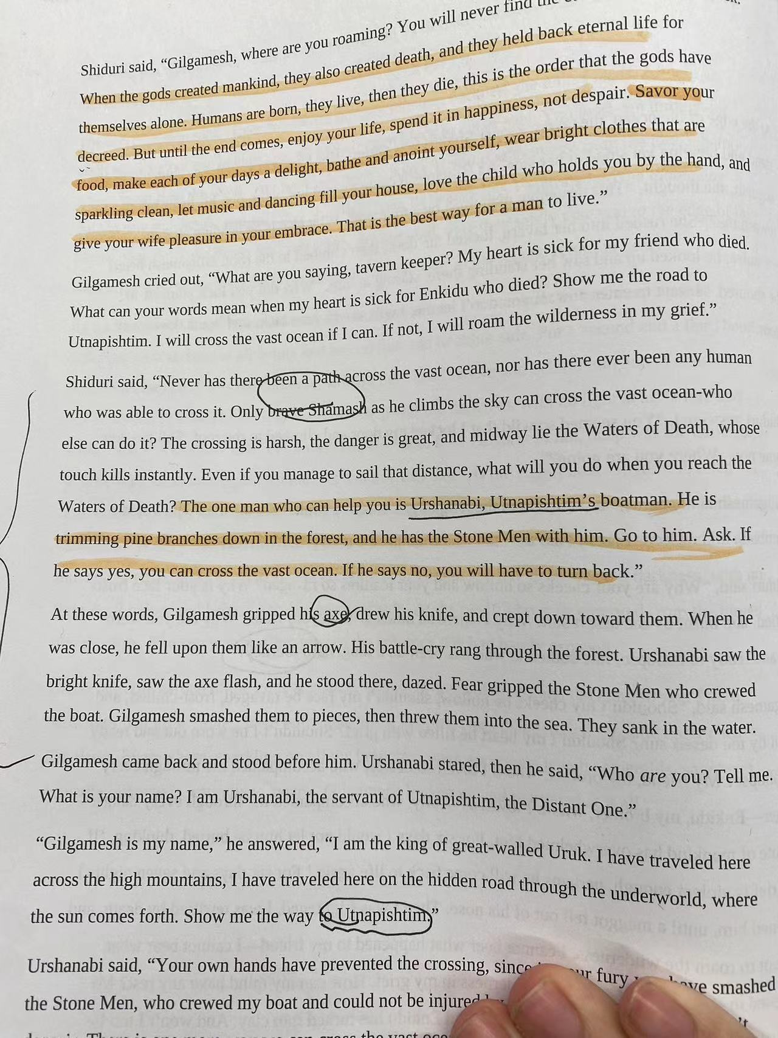

(1:She encourages Gilgamesh to enjoy life's simple pleasures and appreciate the present moment. She advises him to eat, drink, and be merry, for these are the joys of mortal life.

(2:Shiduri suggests that Gilgamesh should not seek immortality because it is beyond the reach of humanity. She explains that the gods have granted humanity a finite existence, and no one can escape the fate of death.

(3:She also tells him to cherish the companionship of friends and loved ones, as human relationships and connections are what truly give life meaning and enduring value.

(4:She also suggest him not across the vast ocean and the Waters of Death but she also give some ways (Urshanabi) to help him.

Gilgamesh's initial reaction to Shiduri's advice is one of frustration and disappointment. He is still grieving the death of Enkidu and remains obsessed with the idea of eternal life. He rejects Shiduri's counsel and continues his quest for immortality, demonstrating his stubbornness and unwillingness to accept the limitations of human existence.

5:List at least 3 similarities between the flood myth as described in Genesis (page 25-29 of the reader) and Gilgamesh.

Answer:

(1:Divine Warning and Construction of an Ark:

In both stories, there is a divine warning of an impending catastrophic flood. In Genesis, God warns Noah, instructing him to build an ark to save himself, his family, and animals. In Gilgamesh, the god Ea (Enki) warns Utnapishtim about the gods' decision to flood the earth, and Utnapishtim is instructed to build a massive boat, essentially an ark, to save living creatures.

(2:Saving Animals and Humanity:

Both Noah and Utnapishtim are tasked with preserving not only their families but also animals and various species. The purpose of the arks in both accounts is to ensure the survival of life on Earth.

3(:Sending Forth Birds to Determine Land:After the floodwaters recede, both Noah and Utnapishtim release birds to determine if the floodwaters have abated and if there is dry land. In Genesis, Noah sends out a raven and then a dove. In the Epic of Gilgamesh, Utnapishtim releases a dove, a swallow, and a raven for the same purpose.

11.1. Commands and Admonitions

1:According to the reading, what are the bad things (e.g. natural disasters) that have happened in history? Highlight at least three occasions where the bad things are being mentioned.

Answer:

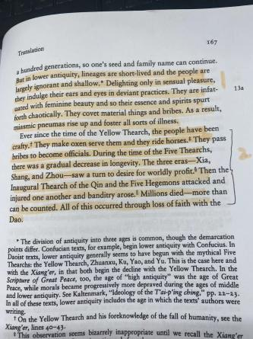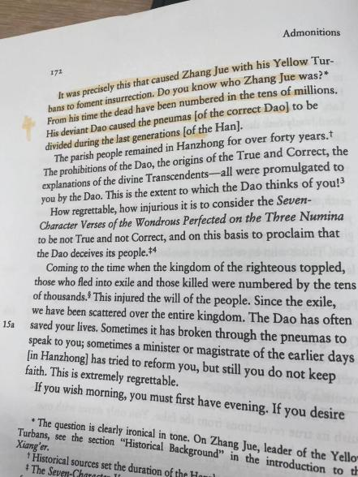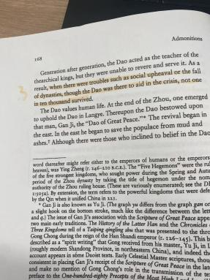

2:What are the causes of the bad things? Explain in three to five sentences citing the relevant page numbers.

The main causes of the bad things is that they don’t reserve or serve the Dao(283),which ich encompasses heaven and earth, is joined 12a with and nourishes all forms of life, and controls the myriad initia-tory mechanisms.(276)Also,In earlier times, ancestral lines were brief, and the populace largely lacked knowledge and depth.(278)What’s more, Those of these final generations are frivolous and lacking in sub-stance. They are not resolute of heart.(284)

3:What term does the text use to refer to the ones who are able to avoid the bad things? Highlight the term in the text and explain in two to three sentences how one could earn the term.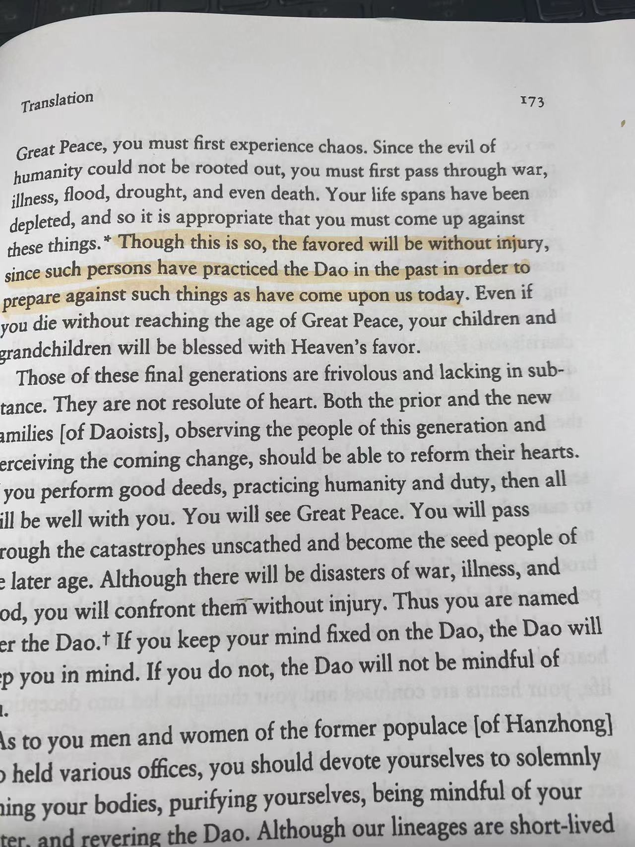

“ "favored" One could earn the term "favored" by practicing the Dao, through good deeds and living according to its teachings. By practicing the Dao in the past, one renders themselves to face difficulties without harm, and thus becomes one of the "favored" who will avoid injury during times of chaos and disasters.

4：What are the similarities and differences between the Way (Dao) in this text and in the Laozi reading? List the similarities and differences, and then elaborate on them in four to six sentences. Please also cite chapter numbers from the Laozi reading as your evidence.

Similarities:

1. :Both are the origin of the universe.From chapter 25,Laozi thinks the way is the mother of Heaven and earth,which also refers to the”Great”.Also ,in the Dao encompasses heaven and earth,which joined with and nourishes all forms of life.(165)
2. Both are hard to recognize.For the Dao,it is without shape or image and undifferentiated and humans cannot put a name for it (165).Also for the Laozi,he donnot know its proper name,he thinks is confused.

Different:

1. :This text describes the Dao generated three pneumas that form heaven, earth, and the Dao itself, whereas the Laozi does not mention pneumas.
2. It includes religious Daoism, which incorporates rituals and deities, whereas the Laozi reading primarily focuses on philosophical way.