Mini project (particles)

When adjusting slightly the coding : (using -5),I found it appear spiraling feature

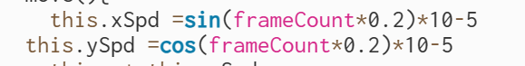

However, it is a little monotonous.And I search from the Internet to check how to add something new,and I found this

.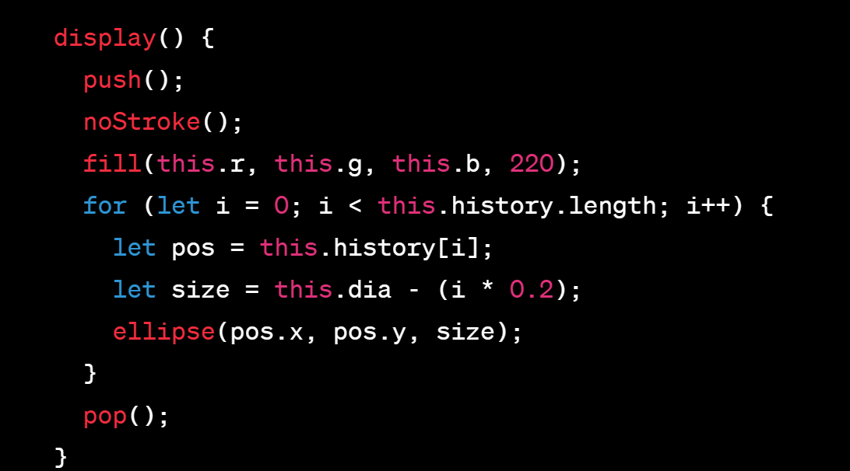

for (let i = 0; i < this.history.length; i++) ： This is a for loop that iterates through the history array of a Particle object. The history array contains the past positions of the particle.

let pos = this.history[i]: In each iteration of the loop, it creates a new variable pos and assigns it the value of the i-th element in the history array. pos is a createVector object containing the x and y coordinates of a past position of the particle.

let size = this.dia - (i \* 0.2): This line calculates the size of the ellipse to be drawn at this historical position. The size is determined based on the particle's original diameter (this.dia) and a decreasing factor. The factor (i \* 0.2) ensures that each subsequent historical position results in a smaller ellipse, creating a fading trail effect.

ellipse(pos.x, pos.y, size);: This is where the ellipse (trail point) is actually drawn on the canvas. pos.x and pos.y are the x and y coordinates of the historical position of the particle, and size is the diameter of the ellipse. This code draws a series of decreasing ellipses at past positions of the particle, forming a trail effect as the particle moves.

Also ,we need to create an new history array to reserve the the ellipse :

And then, it appears cooler! The trail is more obvious and like a snake.

Now ,I want to explore the meteor:

Initially, I just creates several meteors(points) fall from the left corner to the right ,and it will reappear if it rush out of the canvas.However, it seems like not the real.

I also did a lot of survey and finds a way to creates the 3D effect!

Adding this.Z!

this.z is used to represent the depth or Z-axis coordinate of the stars in simulating a 3D effect.

It has these effects.

Controlling the depth of stars: The value of this.z determines the position of the stars along the Z-axis, representing their depth. When this.z has a larger value, stars appear farther from the observer, and when this.z has a smaller value, stars appear closer to the observer.

Mapping X and Y coordinates: The value of this.z is used to map the X and Y coordinates of stars in the show() method to simulate a perspective effect. By dividing the actual X and Y coordinates of stars by this.z, appropriate coordinates on the 2D plane are obtained, creating a perspective effect when observed.

Controlling the size of stars: The value of this.z is also used to calculate the size of stars, making the size of stars change with depth. This is achieved using the map() function, where the size r gradually decreases from large to small based on the value of this.z.

