Lab 8 r13943015 張根齊

1. Take a screenshot of the waveform from Visualize after running the visualize

command. (You can select the useful signals on the right-hand side to inspect the byte_cnt behavior further, as shown in the following figure)

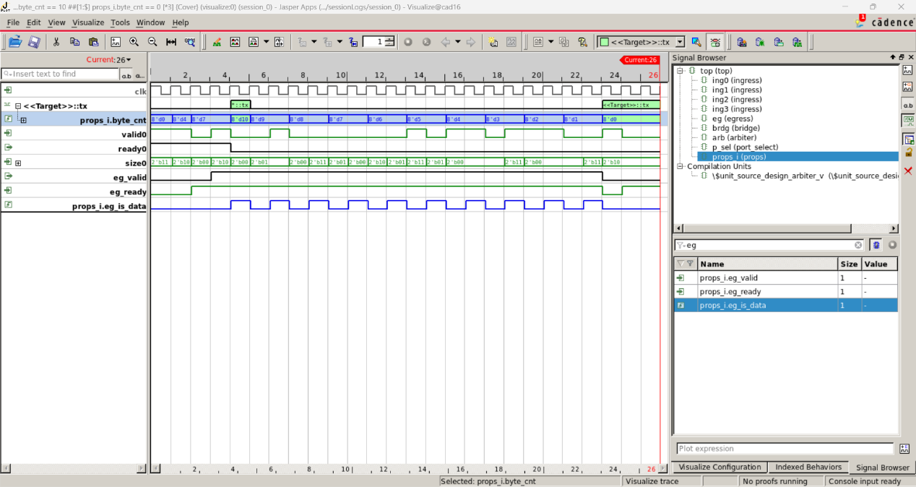

2. Take a screenshot of the comparison between non-quiet (left) and quiet (right)

visualize windows.

3. Take a screenshot of the property table after disabling reads and running a formal proof.

