DSP in VLSI

HW3

電子所ICS組, R13943015, 張根齊

1. (Step 1) Show the output waveform after interpolation using linear interpolator, second-order polynomial interpolator, and piecewise parabolic interpolator to interpolate the sampled waveform in the region of 16 ≤ 𝑚 ≤ 32 with 𝜇 = 0, 1/9 , 2/9 , … 8/9 . In addition, draw the error in the region of 16 ≤ 𝑚 ≤ 32 with 𝜇 = 0, 1/9 , 2/9 , … 8/9 . (30%)

1-1. Linear interpolator output waveform and error

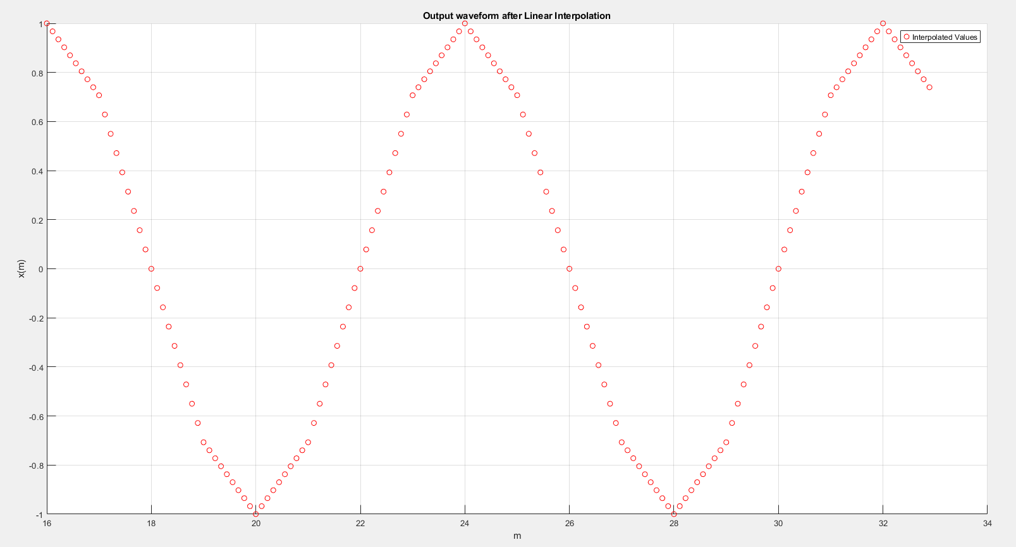

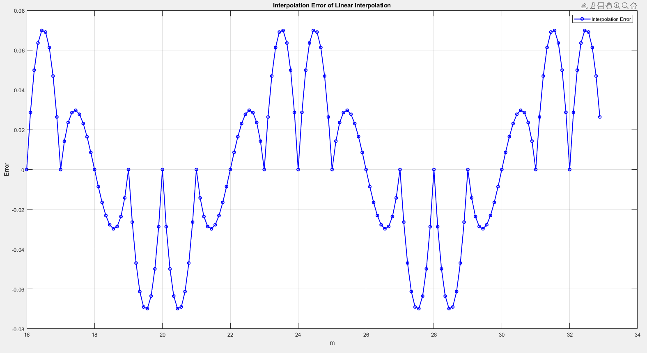

1-2. Second-order polynomial interpolator output waveform and error

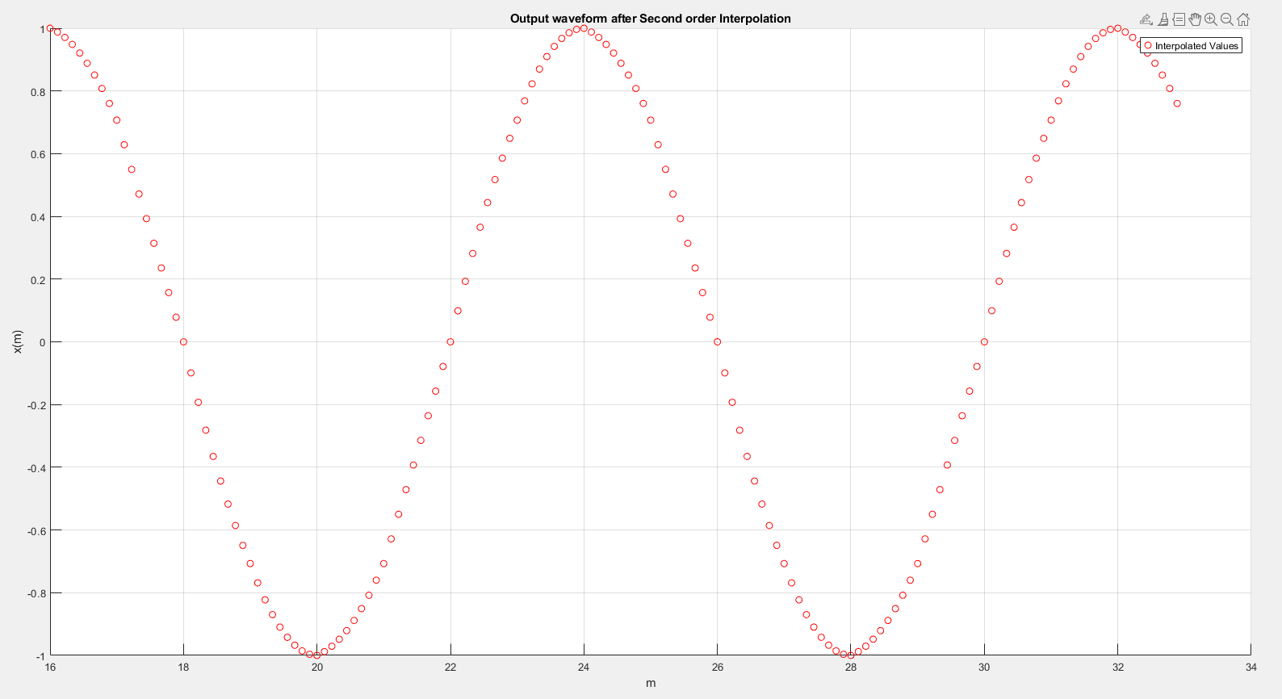

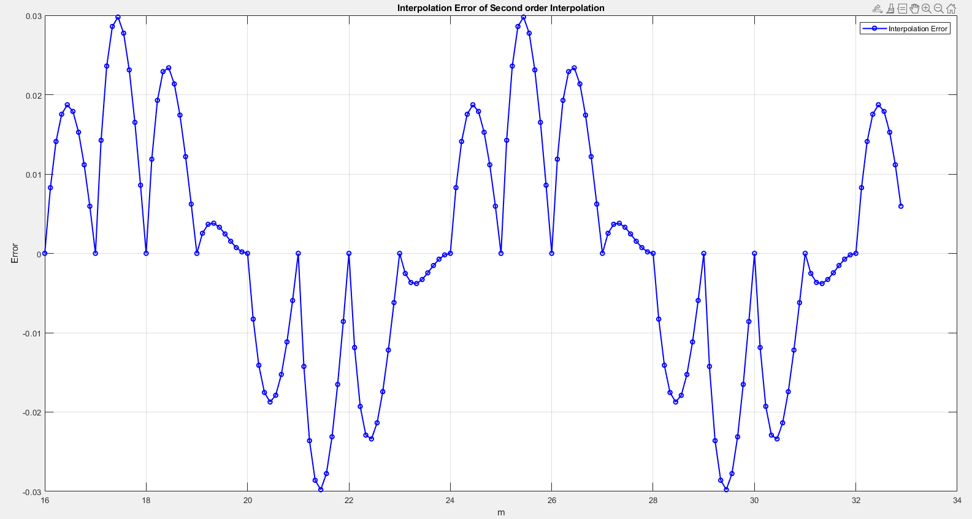

1-3. piecewise parabolic interpolator output waveform and error

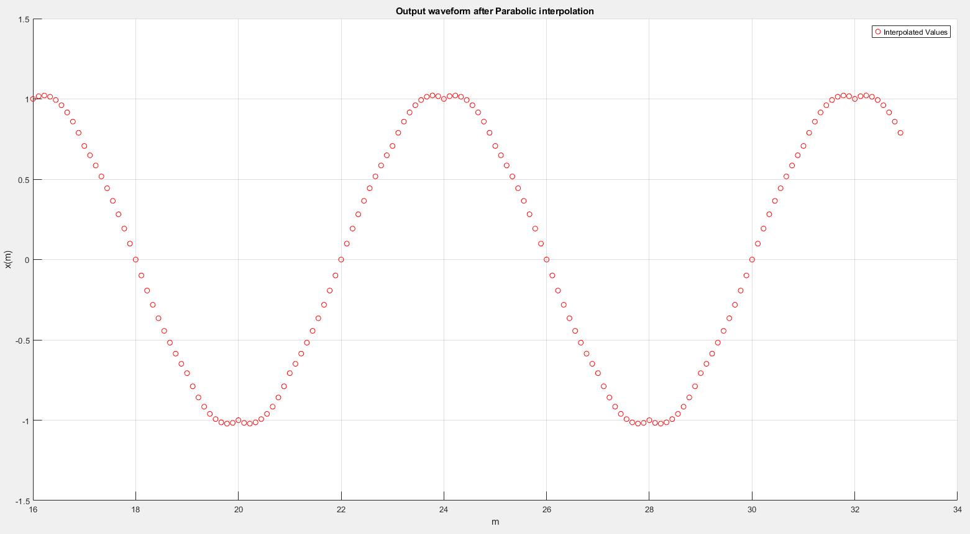

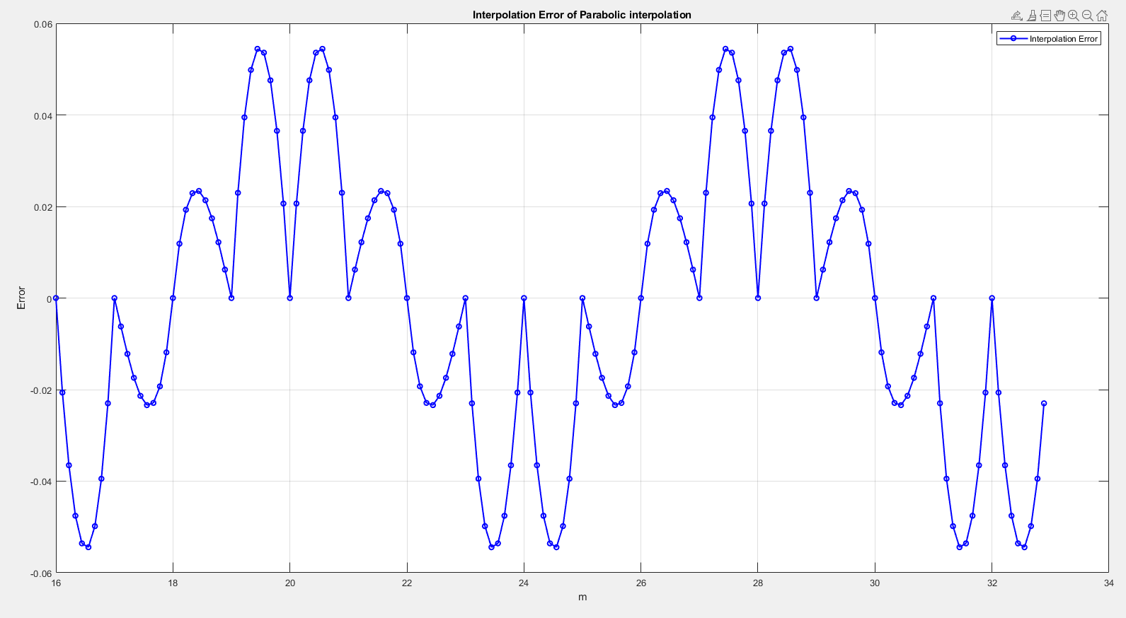

2. (Step 2) Show the output waveform after interpolation using linear interpolator, second-order polynomial interpolator, and piecewise parabolic interpolator to interpolate the sampled waveform in the region of 5 ≤ 𝑚 ≤ 10 with 𝜇 =0, 1/9, 2/9, …8/9. In addition, draw the error in the region of 5 ≤ 𝑚 ≤ 10 with 𝜇 =0, 1/9, 2/9, …8/9.

2-1. Linear interpolator output waveform and error

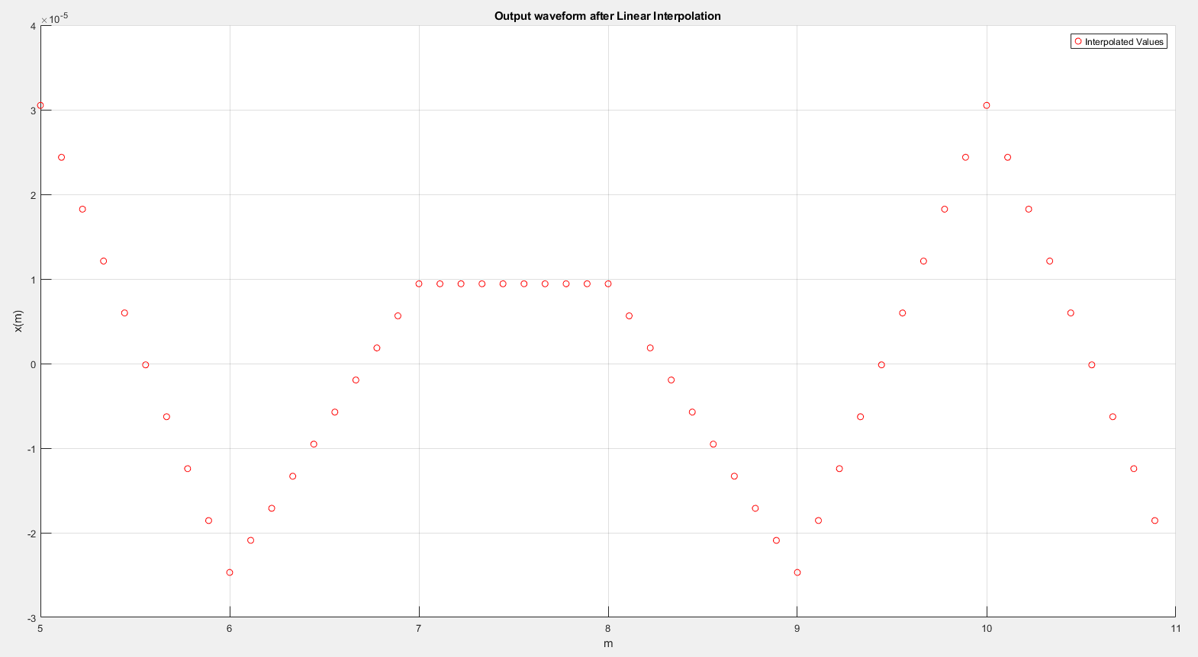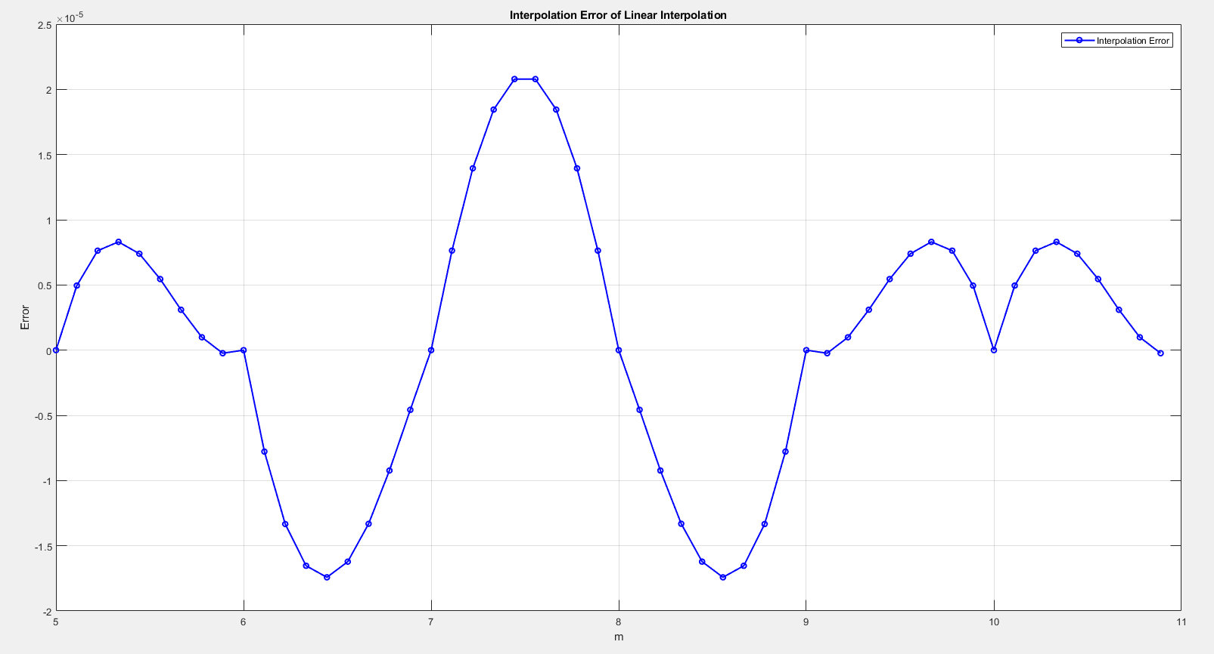

2-2. Second-order polynomial interpolator output waveform and error

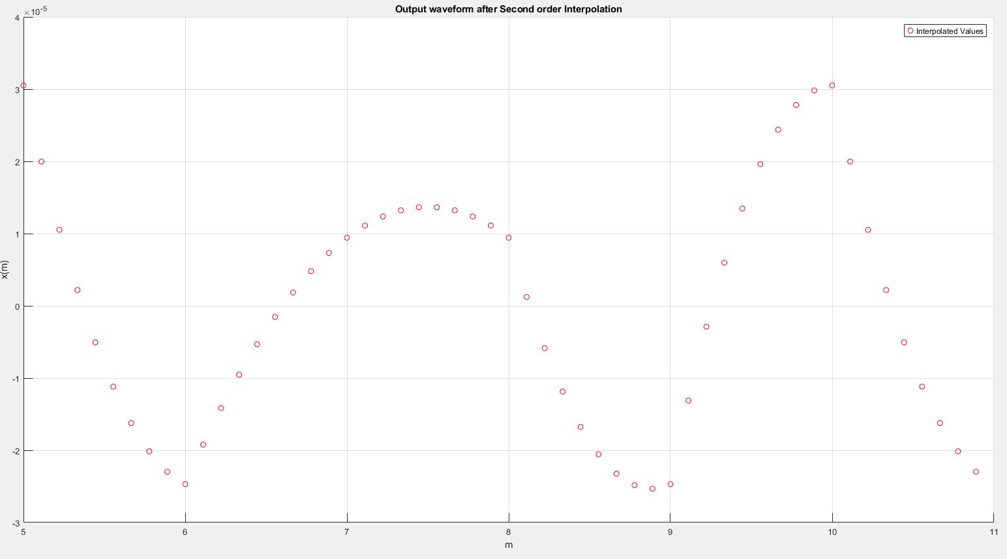

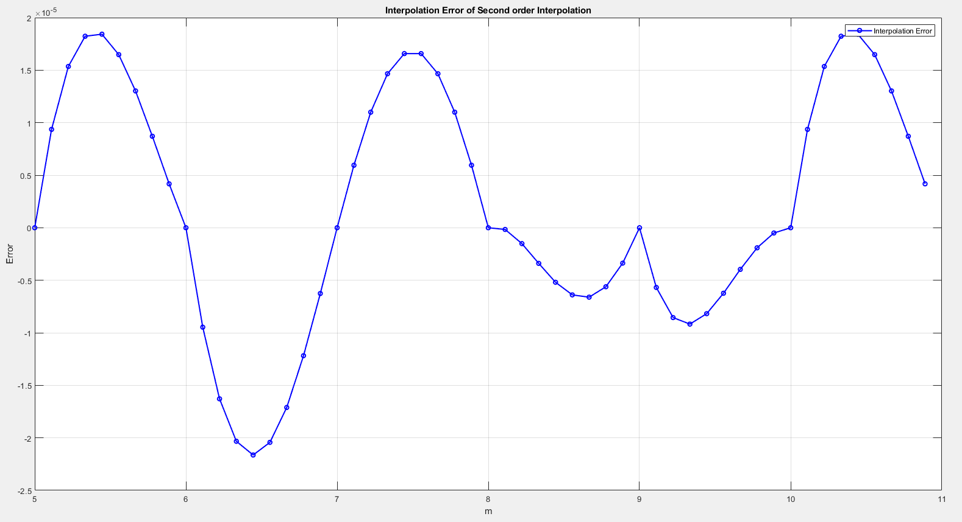

2-3. piecewise parabolic interpolator output waveform and error

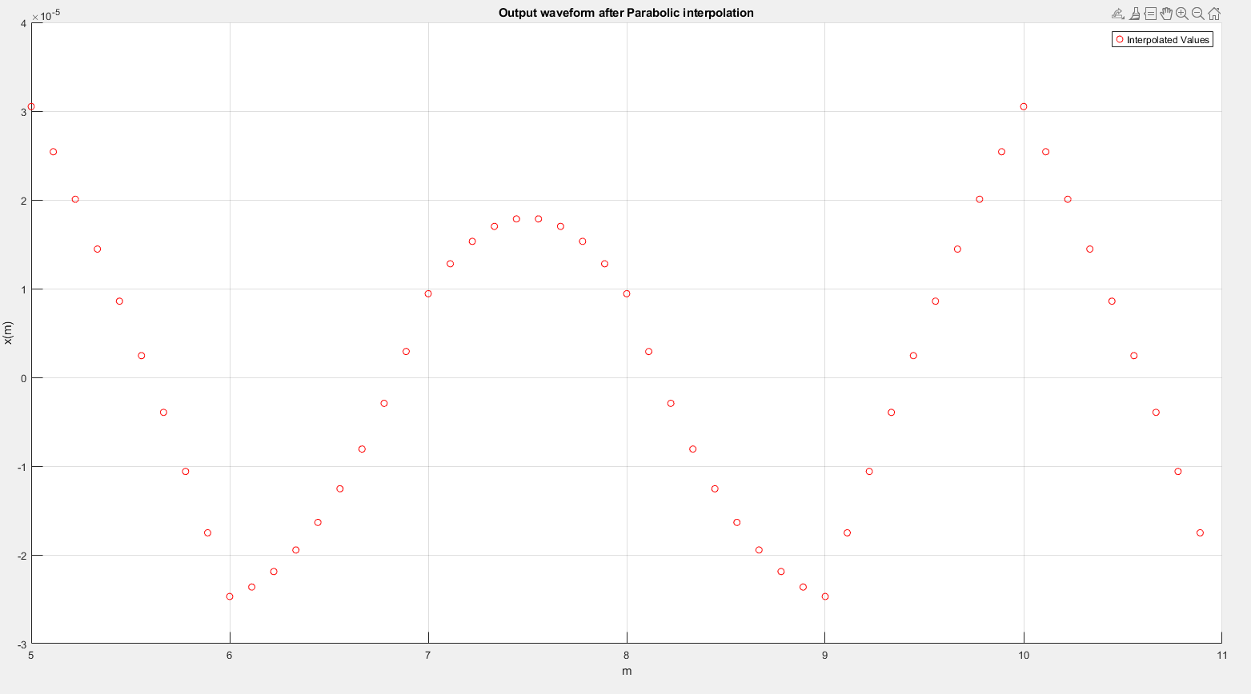

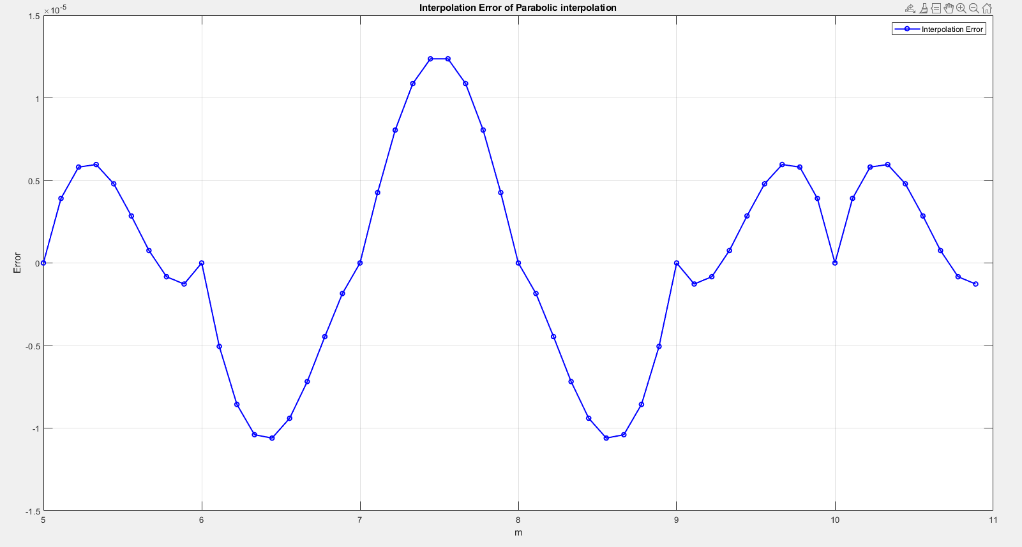

3. (Step 3) Please show the results that are calculated by your bit-true model for the following operands and operators. Express results both in decimal and binary representation. (S, E, F mean the sign bit, exponent field, and fraction field. All are given in binary.)