DSP in VLSI

HW4

電子所ICS組, R13943015, 張根齊

1. (Step 1) Please show how you calculate the scaling factor, write down the 𝑁 value that you use and the result of 𝑆(𝑁).

Scaling factor算式:

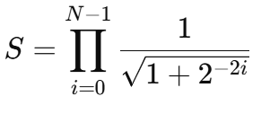

Matlab code:

I use N = 24, result of 𝑆(𝑁) is 0.6072529350.

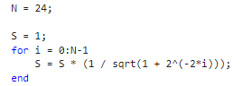

1. (Step 2) Draw the figure of average absolute error versus fractional word-length (10%) to show how you determine the setting of word-length of the fractional part. Write down the integer word-length of 𝑋(𝑖) and 𝑌(𝑖) that you use all the stages. Please explain it. (5%)

2.1 Average absolute error versus fractional word-length: choose w = 11.

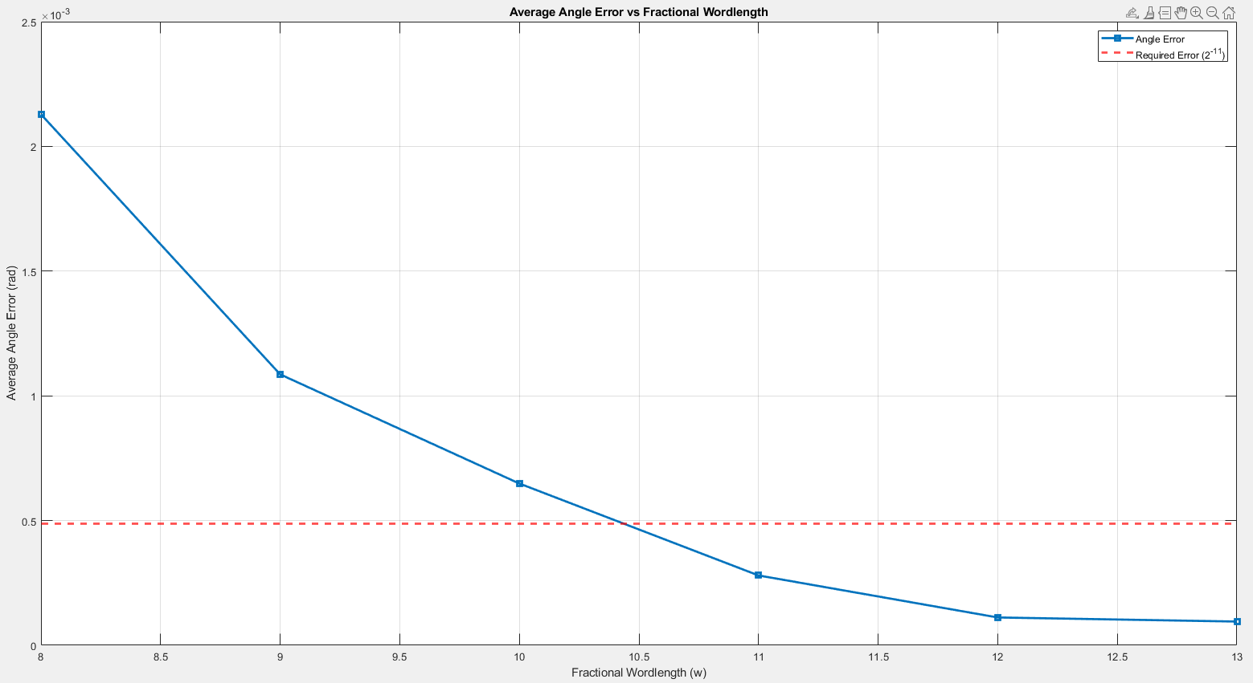

2.2 integer word-length of 𝑋(𝑖) and 𝑌(𝑖) = 3 bits

The integer word length of 𝑋(𝑖) and 𝑌(𝑖) is set to 3 bits to ensure that no overflow occurs during the 𝑁 = 24 stages, which could otherwise lead to errors. I have verified using MATLAB that a 3-bit integer word length is sufficient to prevent overflow.

3. (Step 3) Please draw a figure to denote the average phase errors of 11 quantized input pairs (𝑋, 𝑌) versus different numbers of micro-rotations 𝑁 (10%) and draw a figure to show the resulted phase errors of 11 quantized input pairs versus the word-length of quantized elementary angles (10%). Explain how you determine it. Also list a table of the elementary angles (both in floating-point representation and binary fixed-point representation). (5%) 3.1 Average phase errors of 11 quantized input pairs (𝑋, 𝑌) versus different numbers of micro-rotations 𝑁:

Choose N = 11.

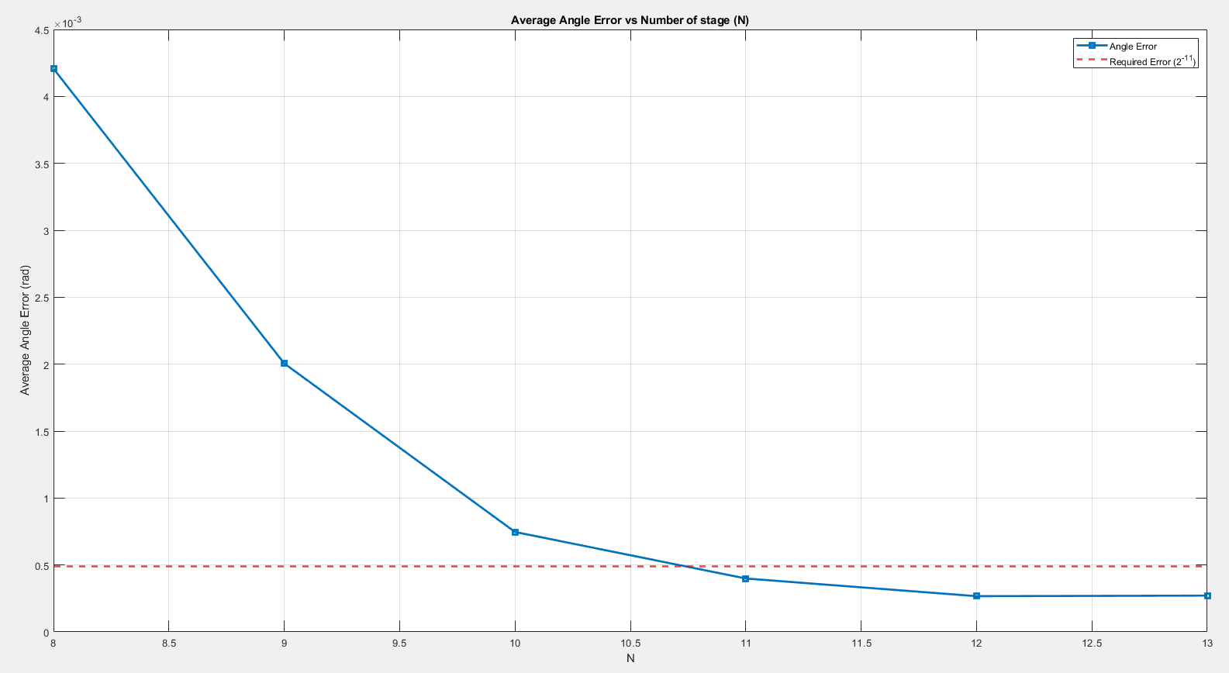

3.2 phase errors of 11 quantized input pairs versus the word-length of quantized elementary angles:

Choose frac word-length of elementary angles = 11. And integer word-length of elementary angles = 3 to ensure that no overflow occurs.

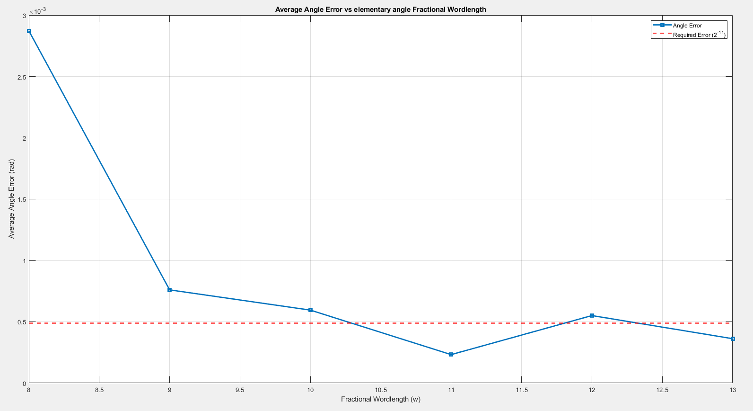

3.3 Table of the elementary angles:

Floating-point representation:

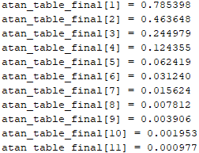

Binary fixed-point representation (3bit int, 11bit frac):

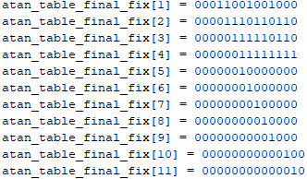

1. (Step 4) Please show how you decide the number of micro-rotations for the magnitude function with error tolerance of 0.1%. (10%)



I use equation 12 to find sufficient N such that magnitude error < 0.1%. Matlab code is shown as below, and the minimum N to meet the requirement is 6.

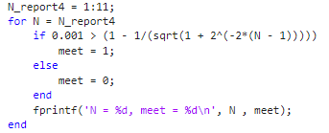

I also draw the figure to verify equation 12.

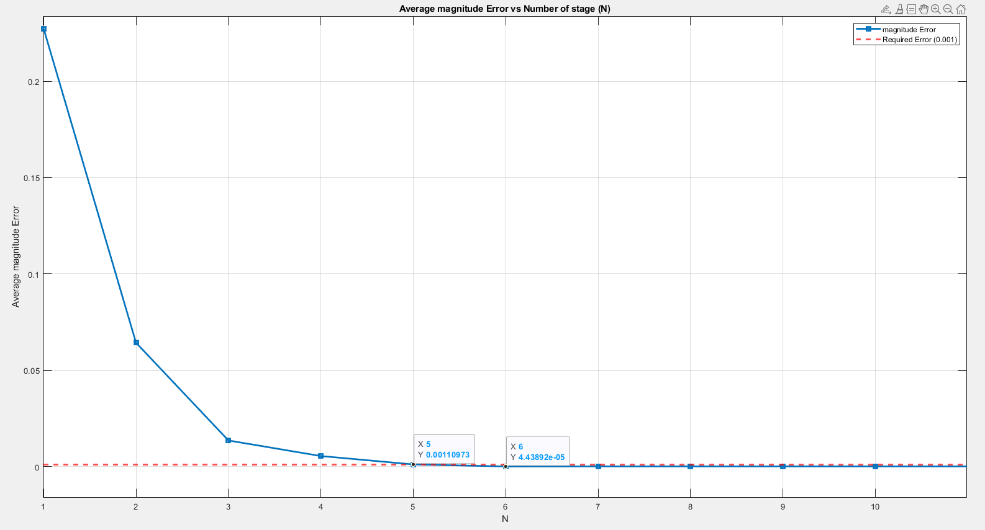

1. (Step 5) Write a program to show the setting of fractional word-length of CSD versus error. Draw the figure. (10%). Depict your design for the shift-and-add block according to your CSD representation. How many adders do you use? (10%)

5.1 fractional word-length of CSD versus magnitude error

Choose CSD frac word-length = 11.

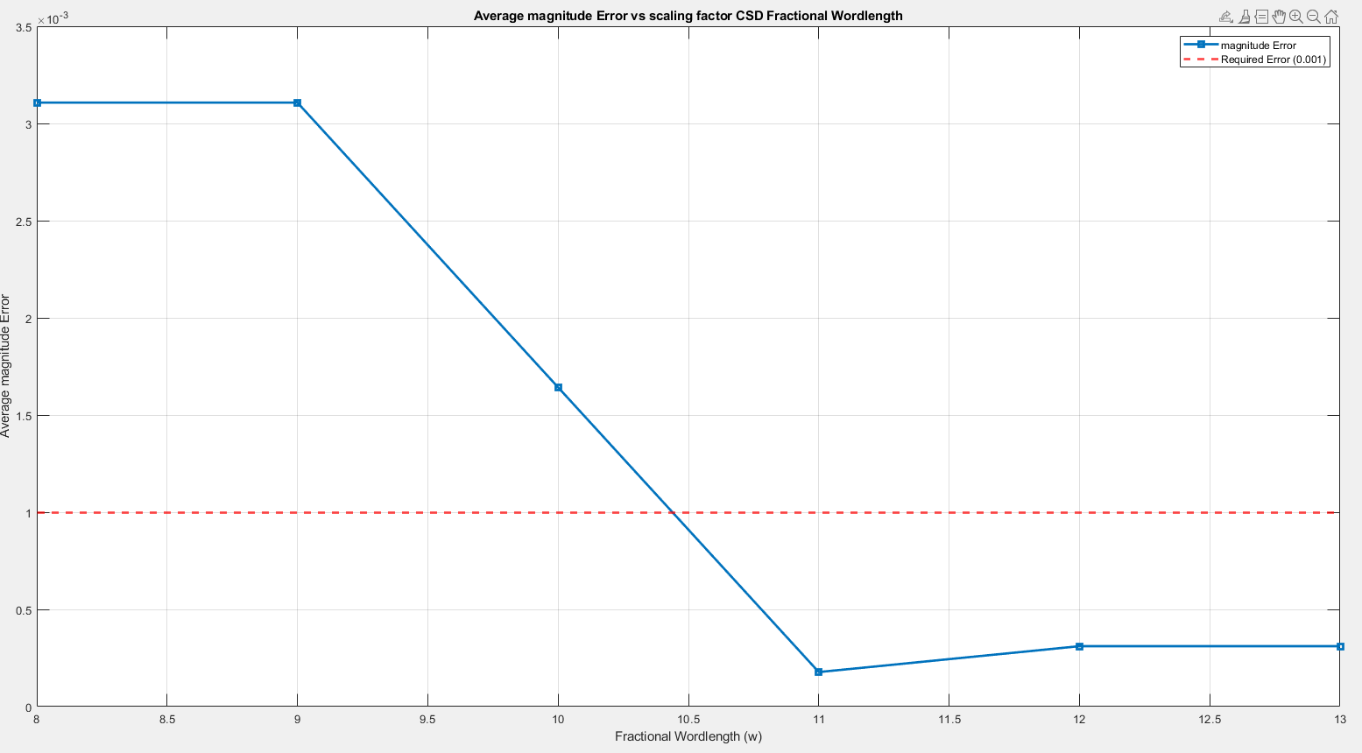

* 1. fractional word-length of CSD versus angle error

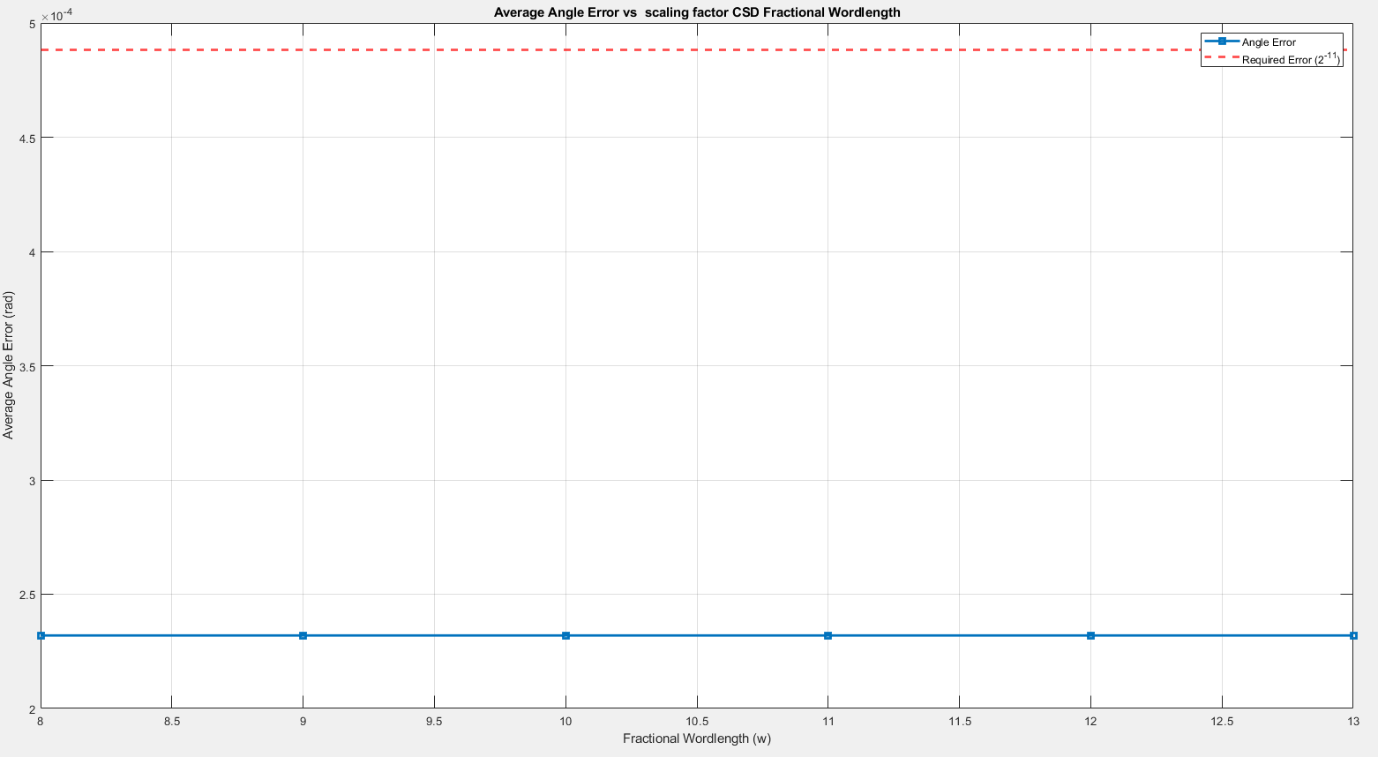

* 1. Shift-and-add block: Total 4 adder (3 add and 1 sub)

CSD block diagram calculate X(N) * Scaling_factor.

