Analytical Report
About tmdb-movies

Prepare by
Abdelrahman Mustafa Abdelazim
Musicmakerjam3@gmail.com
April 1, 2021

Itroduction :
The report used the data and the findings that resulted from This data set contains informationabout 10,000 movies collected fromThe Movie Database (TMDb),including user ratings and revenue
This report shows the result of top rating films based on several points like :
1- highest profits
2- most popularity
3- total profits per year
4- vote average
5- most common genres

And in this report we will explore the following questions :
1- What are films with the highest profits in a short period?
2- What are films that got popular in a short period ?
3- What are top-rated films?
4-What is Most popular genres?

Data Wrangling :
Now that my data is loaded , I’ll make the following changes :
1- drop all missing values
2- make csv file contain top 10 movies groupby highest_profits, reset index and create new column contian total profits per year
3- change release year column with new column called year ago to know how many years passed on movies
3- make csv file contain top 10 movies groupby most_popularity and reset index
4- make csv file contain top 10 movies groupby top_rated and reset index
5- make list with all genres to know which most popular genres

Exploration :

highest profits :
Here we make this graph to make a comparison between top 10 movies that make highest profits to show the differences between them in which makes most profits in a little period
And we got that the top movie that makes the highest profits in just 6 years is Star Wars : The Force Awakens
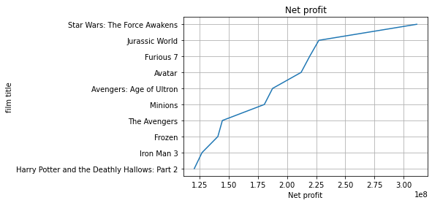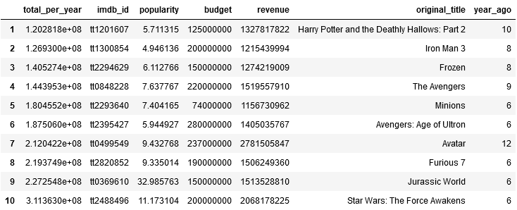

most popularity :
we make the graph here to make comparison between popularity rate in x axis and (genres , director name ) in y axis to show which director gain most popularity rate and which genres they use in there movies to gain it
and we find that colin trevorrow gain the most popularity in just 6 years and he choose Action|Adventure|scince fiction |Thriller genres for his movie
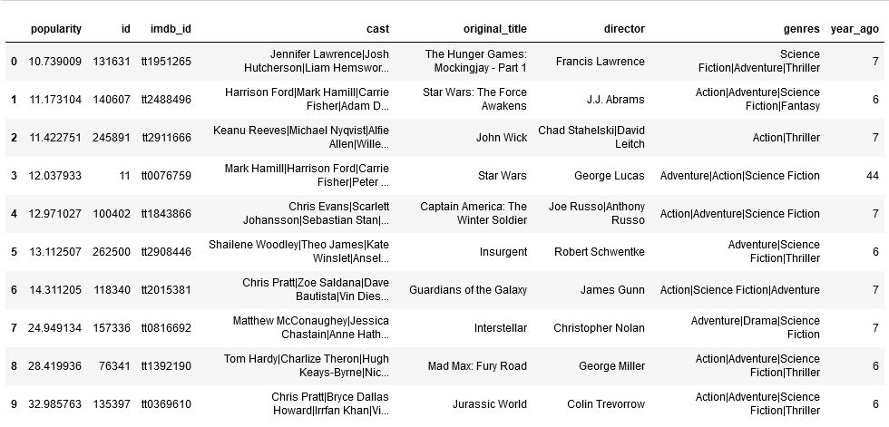
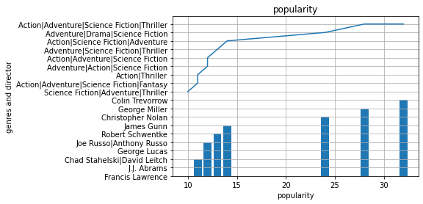

vote average :
here we make this graph to comparison between vote average since release year and between vote average for top 10 movies with their titles
to show the Variation over the years
and we find that The Godfather which released in 1972 gain the most vote average 8.3/10
from about 3970 vote count
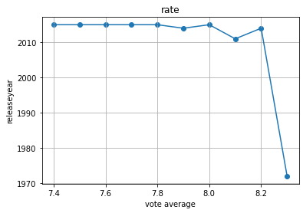
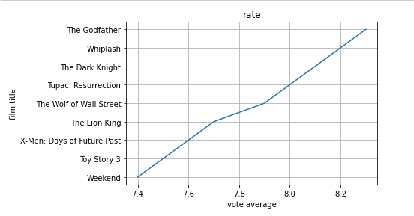
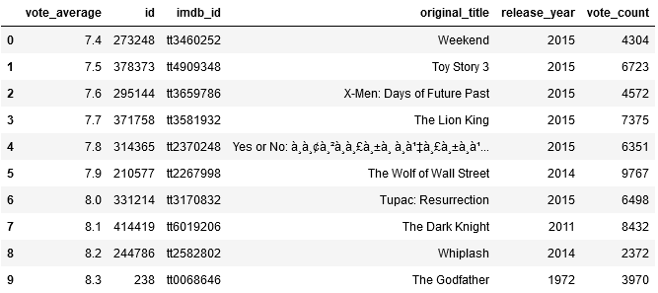

most common genres :

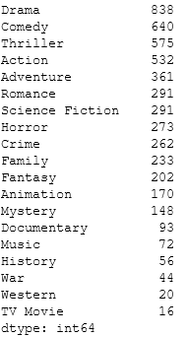

Conclusion :
- We have used TMBD Movies dataset for our analysis and worked with popularity, revenue and runtime. Our analysis is limited to only the provided dataset. For example, the dataset does not confirm that every release of every director is listed.
- There is no normalization or exchange rate or currency conversion is considered during this analysis and our analysis is limited to the numerical values of revenue.
- Dropping missing or Null values from variables of our interest might skew our analysis and could show unintentional bias towards the relationship being analyzed. etc.

Recommendations
1- You can take advantage of people's love for drama in movies and add drama to your works, but to the extent that is likable and not to the extent that is excessive
2- It is very important to focus on choosing the right director for the work, as it is possible for the director's audience to help the work succeed

