

air quality sensing powered by citizen science

**Volunteer’s manual**

1. Turning the sensor on and off

If you are not actively collecting data or if you leave your bike you should turn off your sensor in order to save battery. The switch on the outside of the sensor is marked with a **red dot** which marks its **off position**.

1. Downloading data from the sensor

Open the cover marked with a red dot as indicated in the photo below. You should be able to see the SD card module to pull it out with your finger. Slide out the micro SD card and insert it into your computer. The card should contain .csv files that you can open using Microsoft Excel. **The latest file is the one with the highest number** (sort alphabetically). To easily visualise your data please skip to the “upload” part further down in this manual.

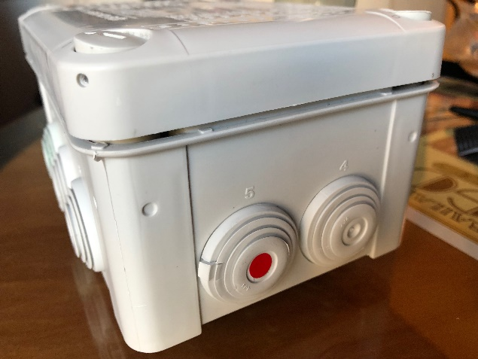 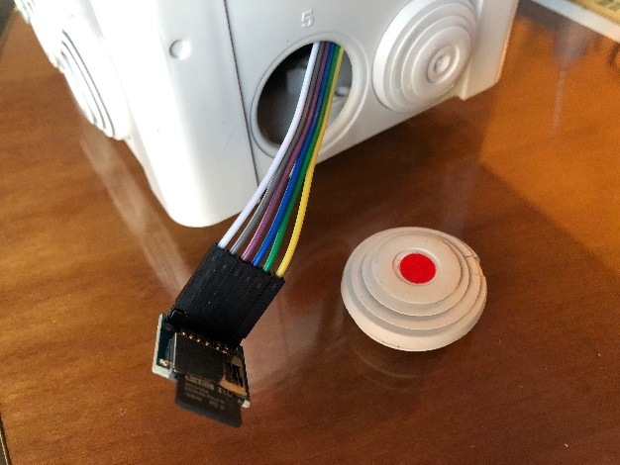

1. Charging the sensor

The sensor has a 10.000mAh power bank included in the case which should last for 5 daysof continuous measurement. If you are only using it for a couple of bike rides per day you can use it for about **a month** before you have to recharge.

After pulling out the SD card you can check the number of blue LEDs lighting up on the power bank to see how much charge is left. 4 means it is full, 1 means you should recharge.

To recharge feed a **micro USB cable** through the hole and plug it into the power bank.

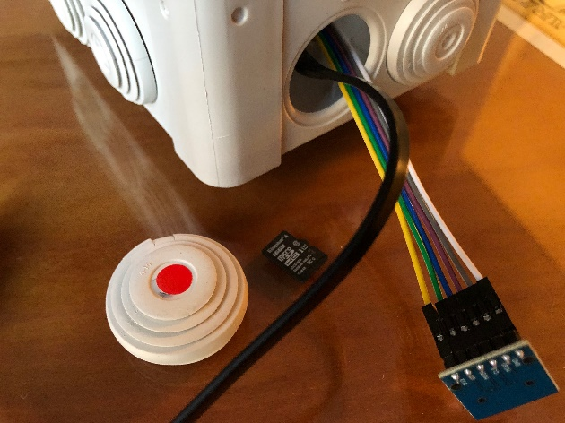

1. Uploading and visualising the data

*User creation and accessing the file manager*

* Go onto <http://app.open-seneca.org>
* Click on the link for registration in order to get a user
* Choose a username (special characters are not allowed)
* Once the registration is complete, you will be forwarded to the file manager
* Log in using your newly created user

*Uploading data and visualising*  
  
After entering the file manager, the interface below will be shown

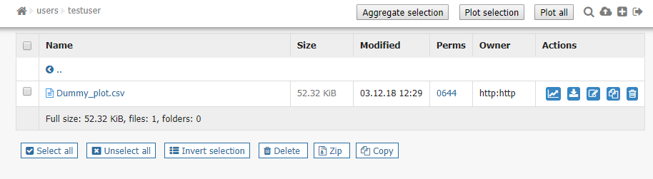

In the upper right corner, there are buttons (from right to left) to sign out, create a folder and upload data. Clicking the button to upload brings up the following panel:

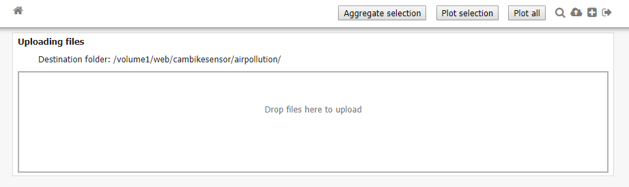

Clicking the panel allows selection of local files in a file dialogue for uploading. Alternatively, one or more files can be dragged from a folder on your PC and dropped into the panel to upload them.

In the file manager interface every file has an associated set of buttons:



These do the following (from right to left): plot the data from the file on a map (only works when GPS location is available), plot the data versus minutes in a graph, download the file, rename the file, copy the file and delete the file.

If a plot of multiple files is desired, the buttons in the top “Aggregate selection”, “Plot selection” and “Plot all” should be used. A selection is made by checking the boxes in the leftmost column of every file of interest, e.g. the following selection of three files:

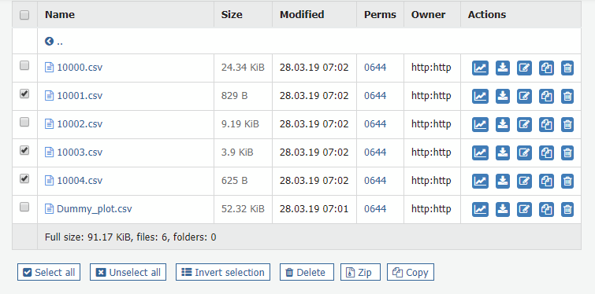

The “Plot selection” visualisation overlays the tracks of data on top of each other. This may be good to get an idea for how well tracks overlap as they will all be individually drawn, although the tracks may occlude each other. The “Aggregate selection” combines the data in the files to come up with an best estimate for the covered area – below is an example.

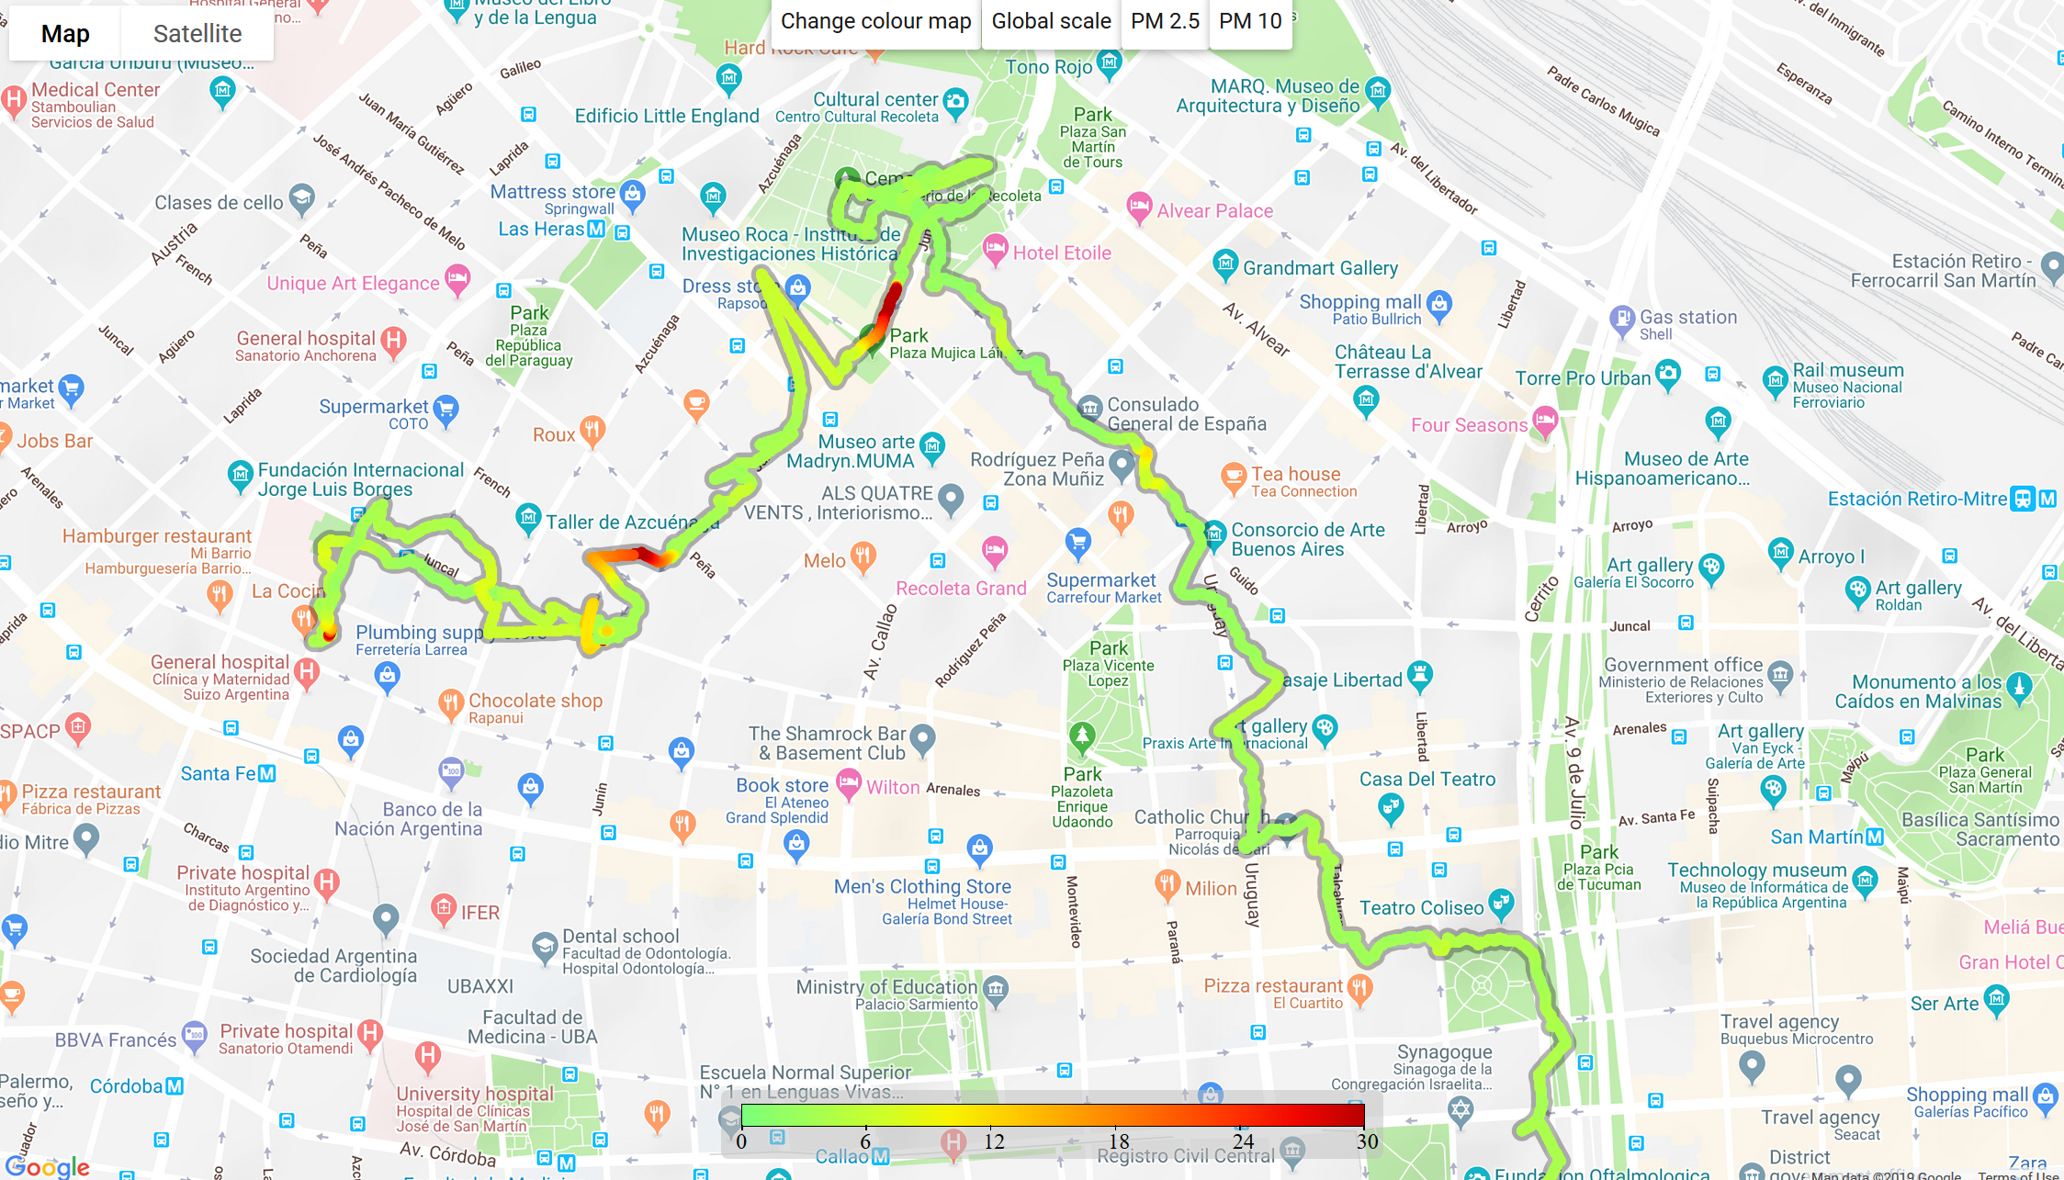

[www.open-seneca.org](http://www.open-seneca.org)