Gvideobrowser

A Linux Video Clip Aggregator.

This application solves the problem of having hundreds or thousands of videos stored on your PC in random folders, but never being able to locate and play the one you want at short notice.

With gvideobrowser you can have access to ALL your videos through ONE thumbnail matrix, yet be able to quickly locate and play any particular one by filtering the whole collection by entering one or more relevant keywords. E.g. if your entire family video collection contains some videos of your pet cats, you can simply type the word ‘cat’ do display a matrix of thumbnails for only videos with the word ‘cat’ in the title. Clicking on any thumbnail then plays that video using your preferred player. If you have several cats then simply enter keywords ‘cat, ginger’, or perhaps ‘cat, bambi’ to find videos for a specific cat.

Besides filtering on keywords in video titles, you may also filter on a separate suite of keywords that are stored separately from the titles.

In case your video collection contains ‘adult’ material, gvideobrowser also caters for classification of videos to facilitate child safety. By default and new video introduced to the program gets a ‘G’ (General Exhibition) rating, and only videos having this classification will be displayed. But you may optionally assign and optionally display ‘PG’, ‘R’, or ‘X’ ratings by using a password protected interface.

Gmusicbrowser can provide very fast access to any single video in a library of many thousands. Your original video files remain intact in their original folders. On first use of the program you may opt to use a menu item that finds and loads ALL video files on your machine, across multiple hard drives and USB drives, provided that these drives have first been “mounted”.

Individual videos take about one second of processing time to create the required thumbnails and add data to gvideobrowser’s database. Subsequent videos can be added to the library simply by dragging and dropping their files onto the main screen of the program.

Gmusicbrowser offers very fast startup by using a ‘lazy-loading’ technique. E.g. rather than attempting to import the entire library on startup, only the first page of 12 thumbnails gets loaded. Scrolling the display results in the next row (4) begin loaded. The database stores only the folder paths to each original video file and its associated thumbnail, never any actual images. The application also relies on an embedded SQLite 3 database that is managed by Synapse mORMot which stores everything as objects. This database gets automatically created on program startup and thereafter needs no maintenance apart from occasional backups.

Here is the main page showing the first 12 of 28 videos in a small test database…

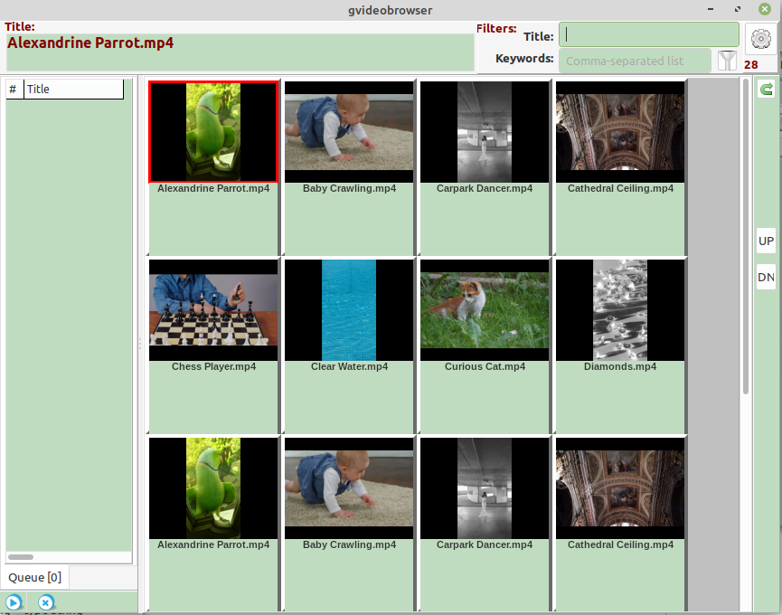
Note that the videos are each represented by a thumbnail with a filename title. Enough title space is available to cater for most videos that you may have downloaded from YouTube, etc.

The currently selected thumbnail is outlined in red and the selected title appears at the top of the window. Clicking this thumbnail instantly plays the underlying video through VLC or a similar video player. The player contains all the necessary controls. The 28 at the top right indicates that this small test database contains a total of only 28 videos. Only the first 12 videos are shown here but you can scroll to the remainder using the ‘UP/DN’ buttons.

There are 2 filter keyword boxes near the top right, one that can take a comma-separated list of keywords relating to the title, and one that relates to a set of keywords that can be assigned separately to each video.

Only ‘G-rated’ videos appear initially. Other classifications may be made visible by clicking the menu button at the top right which applies a number of options including classifications. Right-clicking any thumbnail also brings up a menu that allows classifications and other pre-video parameters to be set.

Here are the results on same database with a ‘water’ filter applied for all titles…
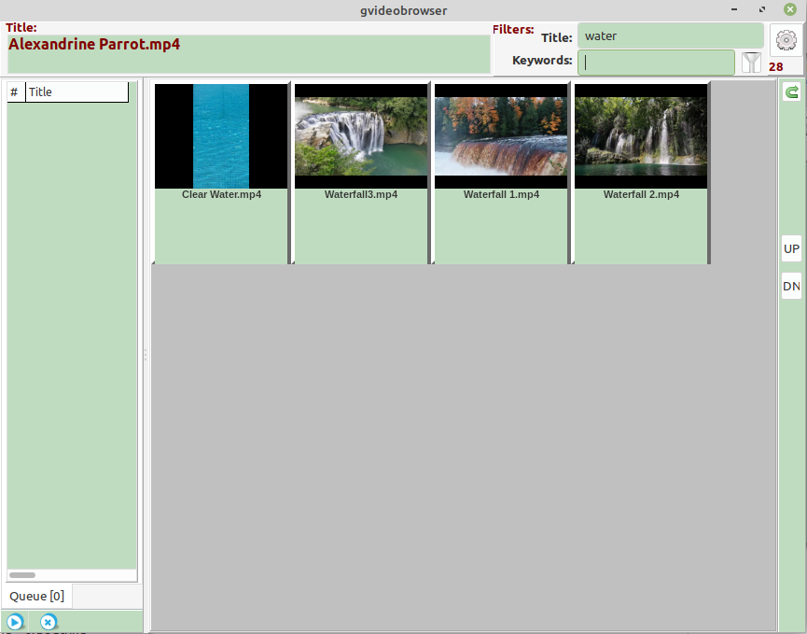
The panel on the left can be used to assemble separate videos into a playlist simply by dragging thumbnails onto this panel.

