GWM_V2MH
HDD_GWM_V2MH_RVC
Scope: HDD_GWM_V2MH
High Level Design Document of RVC

Document Status: | Draft
Revision: | 1.1
Date: | 31 August 2017
Author: | Wang, Xiaole
Department: | CPM GWM

History
Rev. | Status | Date | Author | Reviewer | Approver | Description of Change
0.5 | Draft |  |  |  |  | Initial Version
0.6 | Draft |  |  |  |  | Remove Svc
1.0 | Draft |  |  |  |  | - Carplay does not directly monitor the Rvc state;  - Add framework diagram for Rvc;  - Layer can be switched by HMI;  - Vehicle Info for Rvc can be provided unified interface by AMB;
1.1 | release |  |  |  |  | Released

Contents
1 General 5
1.1 Purpose 5
1.2 Validity 5
1.2.1 Intended Audience 5
1.3 Related Documents 6
1.4 Abbreviations 7
2 Decisions and Requirement Agreements 8
3 Architecture Model 9
3.1 Use Case Model 9
3.1.1 Description 9
3.1.2 Diagram 9
3.2 Domain Architecture Diagram 9
3.2.1 Description 10
3.2.2 Diagram 10
3.3 Application Architecture Diagram 10
3.3.1 Description 10
3.3.2 Diagram 11
3.4 Components Diagram 11
3.4.1 Internal Component 11
3.4.2 External Component 12
3.5 Interfaces Diagram 13
4 Dynamic Behavior 15
4.1 External Dependencies 15
4.1.1 Description 15
4.2 Startup / Shutdown 15
4.2.1 Description 15
4.3 Use Case Sequences 15
4.3.1 Use Case 1 <showFrame> 15
5 Test Environment 18
6 Traceability 19

General

Purpose
The purpose of this High Level Design (HLD) Document is to add the necessary detail to the current project description to represent a suitable model for coding. This document is also intended to help detect contradictions prior to coding, and can be used as a reference manual.
This document covers the basic design for ADAS Framework, including completed design for RVC and SVC.
When Car is switched to reverse gear, RVC is mainly responsible for displaying rear view video camera on display by interacting with other capture drivers/V4L2. Rear view camera should be displayed within 2 seconds of user activating the reverse gear even from cold/warm start of HU.

Validity

Intended Audience
- Software Architecture Team
- System Team
- ADAS Software development team
- HMI Team

Related Documents
Title | <Referenced Document Title>
Link | <Link to Referenced Document>
Abstract | <Long Document Description>
Release Info | Latest
Publication Date | Latest

Abbreviations
Item | Description
RVC | Rear View Camera
HMI | Human Machine Interface
CAN | Controller Area Network
V4L2 | Video4Linux
GPIO | General-purpose input/output

Decisions and Requirement Agreements

Architecture Model

Use Case Model

Description
Usage HMI Diagnostic CAN and EthernetApp can use Adas Service by CommonAPI.

Diagram
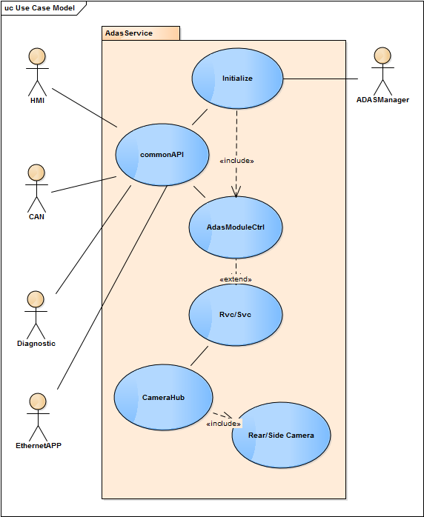

Domain Architecture Diagram
The domain architecture diagram shows the components relationships between the logical function within a domain and to interfaces of other domains.

Description
RVC camera application works based on vehicle gear signal (GPIO) system, based on GPIO status camera preview comes to display very early in the boot cycle. AdasPresCtrl will provide interface to HMI for Customer specific logic. In addition, AdasService support for camera diagnostics by Setting and Controlling. When Adas module status changed, AdasCore will broadcast the changed message for the domain who subscribe the message.

Diagram
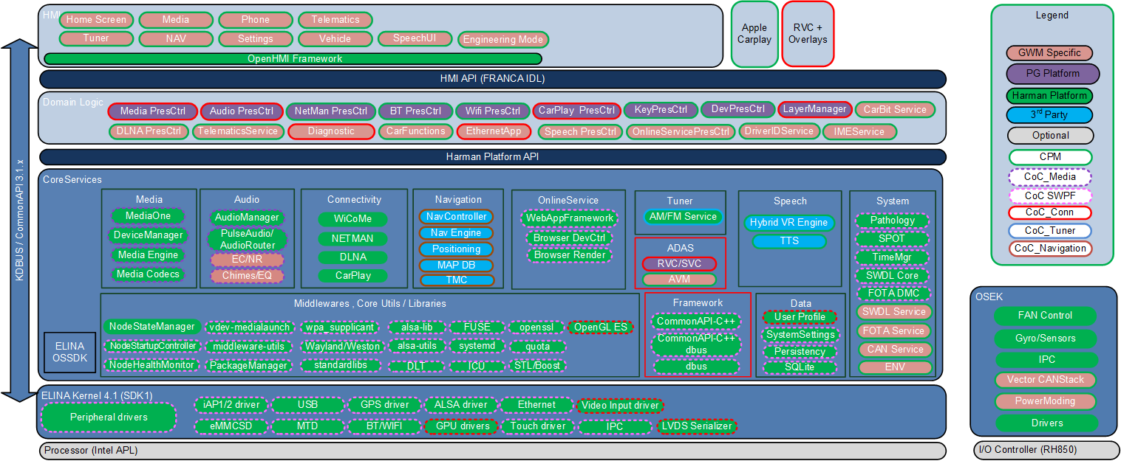

Application Architecture Diagram

Description
RVC application are working dependent on reverse gear signal. GPIO is responsible to get reverse gear signal GPIO status. If early RVC application gets the GPIO status (i.e. enable or disable) and then based on GPIO status RVC camera will lunch or splash screen.

System Diagram
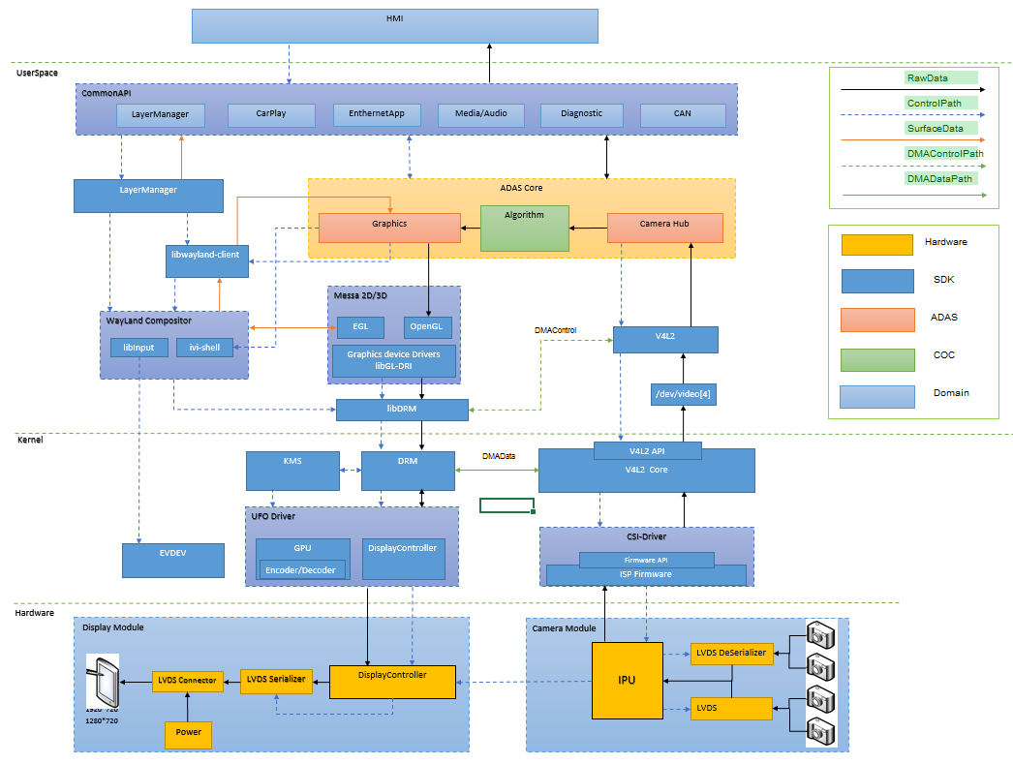

Rvc App Diagram
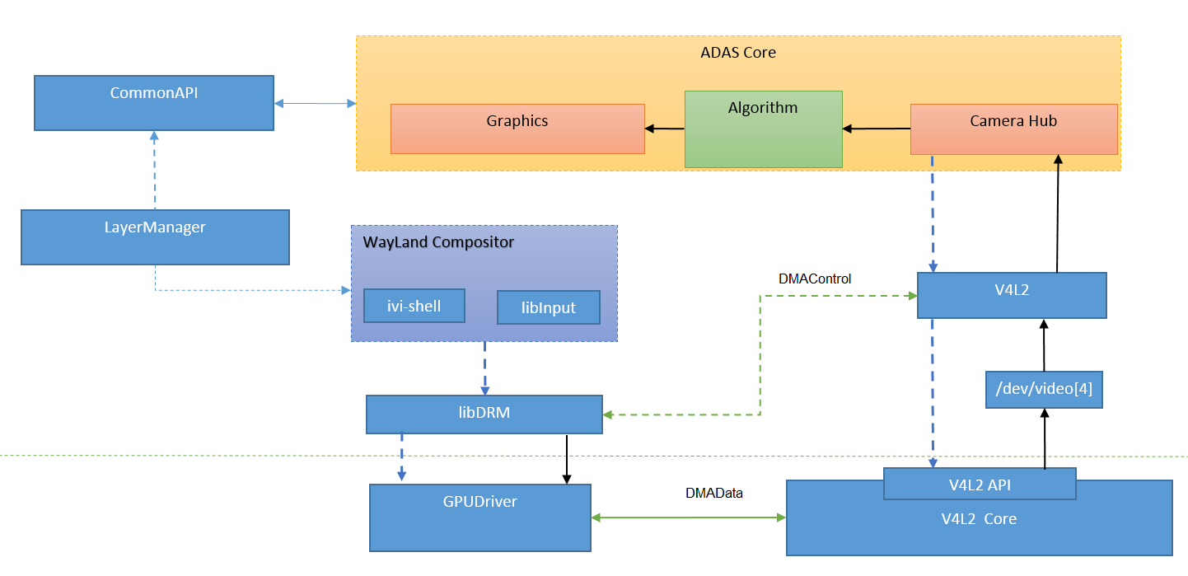

Components Diagram

Internal Component
Describe the composite component internal relationship as follow.

Description
There will be three subsystem in AdasService, include project, LibABase and LibAFoundation.
Project: Customer logic.
LibABase: Dispatch IPC Message to module; Manager internal module, include RVC, APA, PAS, AVM.
LibAFoundation: Include the base class library and interface, thread, timer, message, State Machine, Log.

Diagram
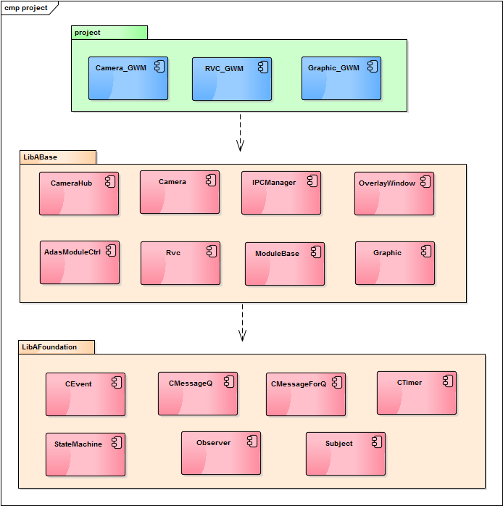

External Component
The chapter provides the component external context as follow.

Description
AdasPresCtrl will provide interface to HMI for Customer specific logic. In addition, AdasService support for camera diagnostics by Setting and Controlling. When Adas module status changed, AdasPresCtrl will broadcast the changed message to the domain who subscribe the message. Such as module state changed from RVC on to RVC off, RVC OFF message will be broadcast.

Diagram
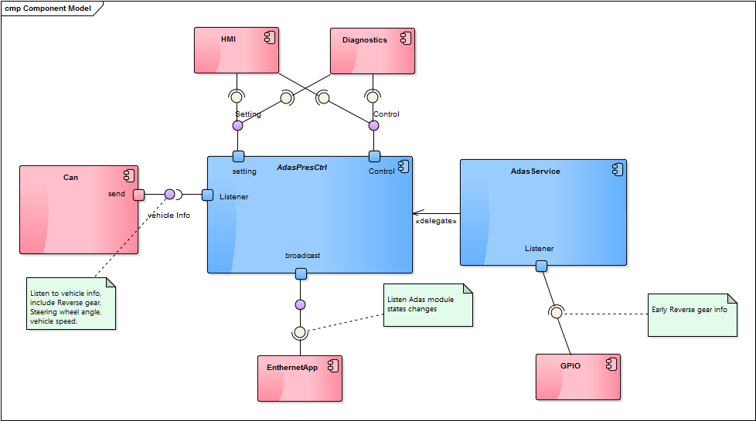

Interfaces Diagram
1. The FIDL file linkage path in the server is below.
https://stash1.harman.com/projects/GWM_V2MH/repos/contracts-gwm/browse/contracts-gwm-v2mh/packages/adas
2. Interface description.
Interface | description
getModuleState | Get Adas internal module state.  OFF = 0 //0x00 module view disable, eg: Rvc/Svc/Avm view is unshown.  ON = 1//0x01 module view enable, eg: Rvc/Svc/Avm view is showing.  UNAVAILABLE = 8 //0x08 module view disable, eg: Rvc/Svc/Avm module is unavailable.
broadcast aAdasModuleState | Broadcast adas module state who subscribe this message

Dynamic Behavior

External Dependencies

Description
Rvc/Svc screen showing dependent on display driver, and camera capture dependent on LVDS dirver.

Startup / Shutdown
Describe the main process or components startup / shutdown behaviour with lifecycle in your domain. What persistency data should recovery and store at the startup / shudown phase.

Description
Initrc will start up AdasService in early time. The RVC/SVC process has been in the background. If gear shift to ‘R’, will show RVC screen. When HUT receives gear shift from 'R' to others or Press SVC button, it requests SVC view activation. When Press SVC button again or speed greater than 15km/h, SVC view is deactivation.

Use Case Sequences
Describe the major and typical use case sequences

Use Case 1 <showFrame>

Description
GPIO: GPIO is responsible to get reverse gear signal GPIO status. Once early RVC application gets the GPIO status (i.e. enable or disable) and then based on GPIO status RVC camera will lunch or splash screen.
Graphics Buffer: Buffer allocation and deallocation are handle from graphics buffer based on capturing height & width resolution.
Display: It is responsible to show buffer frame and render to the display.

Diagram

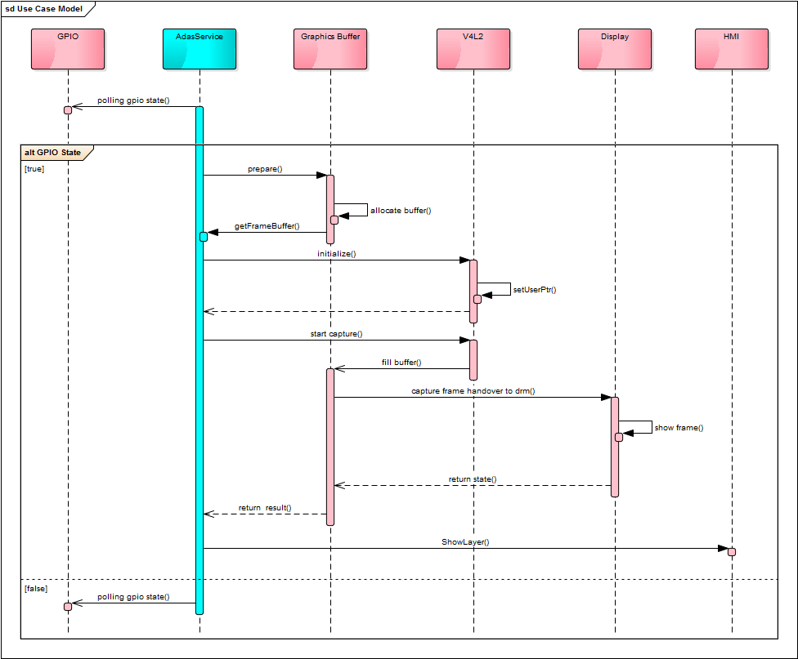

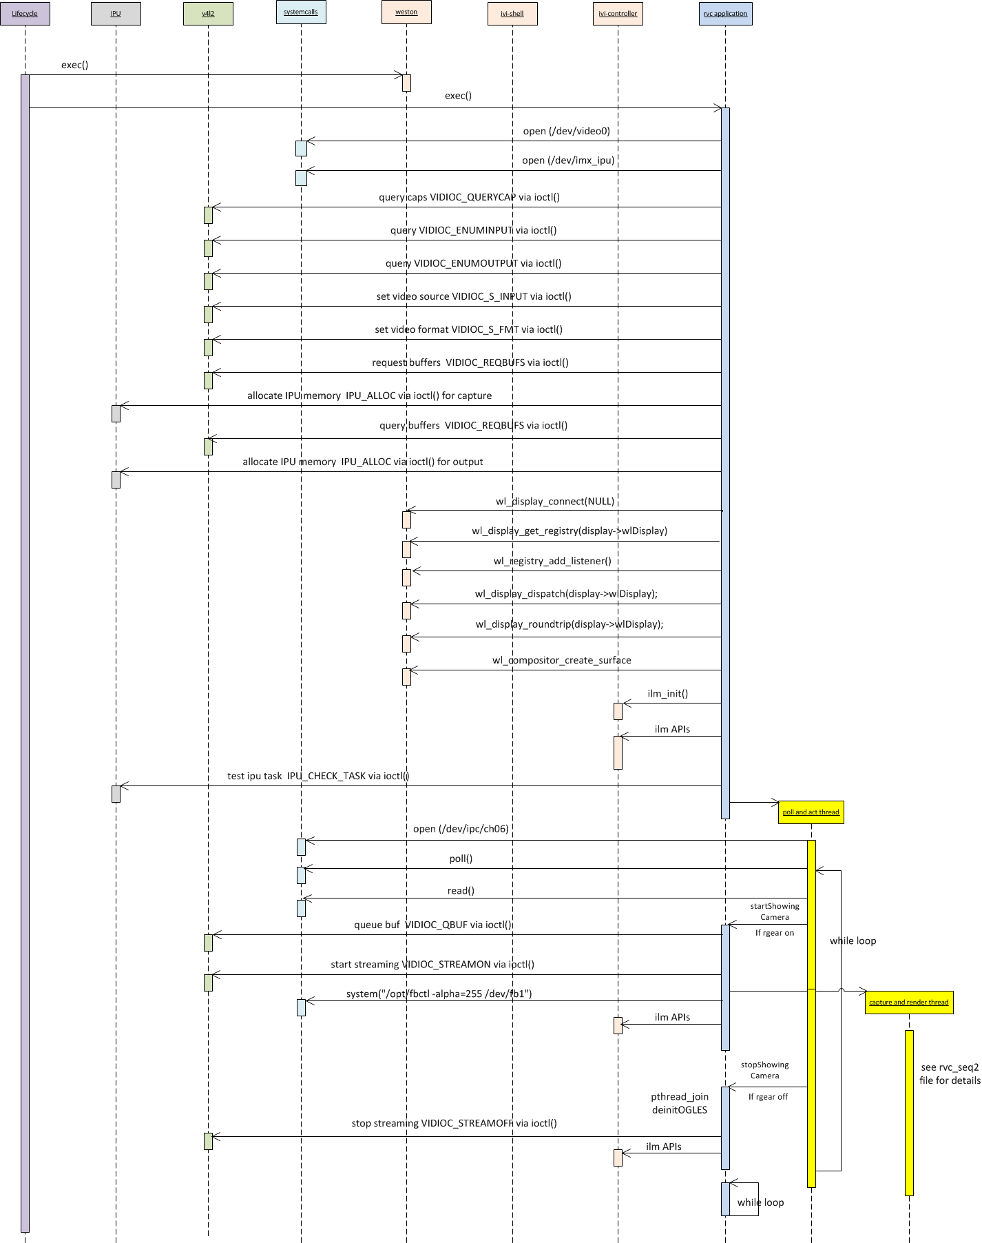

Test Environment

Traceability
TRS ID | TRS Description | Component Name
TRS-V2MH-ADAS-RVCSVC-142 | Video capture | AdasService
TRS-V2MH-ADAS-RVCSVC-143 | Video Display | AdasService
TRS-V2MH-ADAS-RVCSVC-144 | Reverse Gear info receive and handle | AdasService
TRS-V2MH-ADAS-RVCSVC-163 | Rvc service is unavailable | AdasPresctl
TRS-V2MH-ADAS-RVCSVC-174 | RVC layer z-order is top | AdasService
TRS-V2MH-ADAS-RVCSVC-170 | Popup & Notification handling on RVC | AdasService
TRS-V2MH-ADAS-RVCSVC-171 | Application switching on RVC | AdasService
TRS-V2MH-ADAS-RVCSVC-183 | Camera view display on screen by LVDS | AdasService
TRS-V2MH-ADAS-RVCSVC-180 | Raw image data format conversion and scaling | AdasService

