GWM_V2MH
HDD_GWM_V2MH_ ADAS_AVM_MOD
Scope: HDD_GWM_V2MH
High Level Design Document of ADAS_AVM_MOD

Document Status: | Draft
Revision: | 0.1
Date: | 31 August 2017
Author: | Lu Guofeng
Department: | CPM GWM

History
Rev. | Status | Date | Author | Reviewer | Approver | Description of Change
0.1 | Draft | 04/07/2017 | Lu Guofeng |  |  | Initial Version

Contents
1 General 5
1.1 Purpose 5
1.2 Validity 5
1.2.1 Intended Audience 5
1.3 Related Documents 6
1.4 Abbreviations 6
2 Decisions and Requirement Agreements 7
3 Architecture Model 8
3.1 Use Case Model 8
3.1.1 Description 8
3.1.2 Diagram 8
3.2 Domain Architecture Diagram 8
3.2.1 Description 8
3.2.2 Diagram 8
3.3 Application Architecture Diagram (Optional) 8
3.3.1 Description 8
3.3.2 Diagram 8
3.4 Hardware Assignment Diagram (Optional) 8
3.4.1 Description 8
3.4.2 Diagram 8
3.5 Components Diagram 9
3.5.1 <Component Name 1> 9
3.5.2 <Component Name 2> 9
3.6 Interfaces Diagram 10
4 Dynamic Behavior 11
4.1 External Dependencies 11
4.1.1 Description 11
4.1.2 Diagram 11
4.2 Startup / Shutdown 11
4.2.1 Description 11
4.2.2 Diagram 11
4.3 Use Case Sequences 11
4.3.1 Use Case 1 <name> 11
4.3.2 Use Case n <name> 11
5 Test Environment 12
6 Traceability 13

General

Purpose
This document describes High level design on AVM & MOD module design of ADAS domain. It contains description for following questions:
- Decomposition of sub-domain to components
- Description of methods and attributes, which are used in provided/used interfaces and purpose of use.
- List of handled use cases.

Validity

Intended Audience
Role | Name | E-Mail
Developer | Wang xiaole | <Xiaole.wang@harman.com>
Developer | Li hui | <Hui.li2@harman.com>
Architect | Chen huichao | < huichao.chen@harman.com>
Application FO | Guofeng Lu | <guofeng.lu@harman.com>

Related Documents
- GWM_Platform_Feature-Functionlist_infotainment_V1_0_20170512.xlsx
- 产品定义书-V2多媒体播放器总成中高配-1.21.pdf

Abbreviations
Item | Description
AVM | Around view module
MOD | Moving object deletion
FCTA | Front cross traffic assist
RCTA | Rear cross traffic assist
ADAS | Advanced driver assist system

Decisions and Requirement Agreements

Architecture Model

Use Case Model

Description
Client interaction with this domain/subdomain indicating major usages and handling failure situations.

Diagram
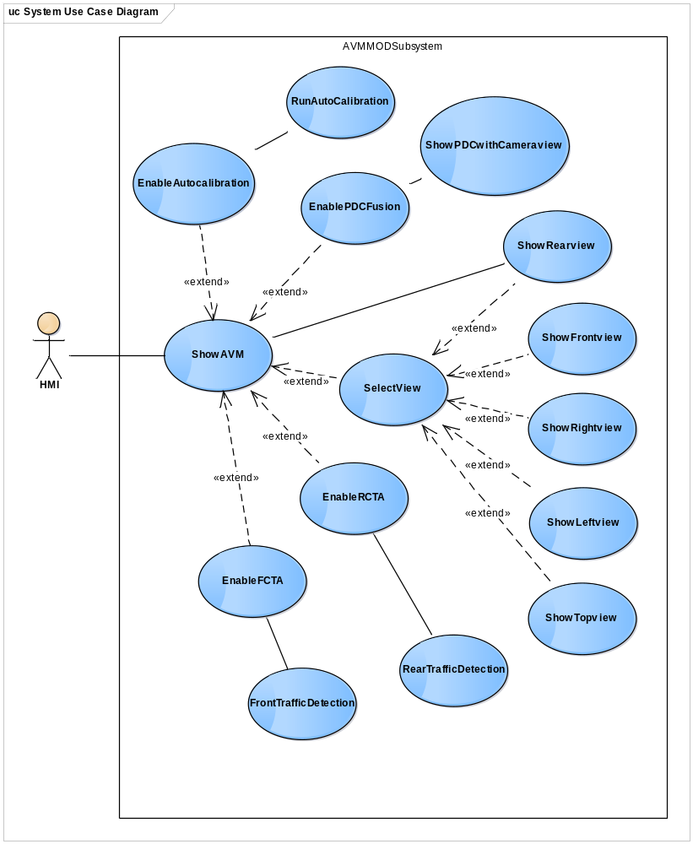

Domain Architecture Diagram
The domain architecture diagram shows the components relationships between the logical function within a domain and to interfaces of other domains.

Description
Two major layer would be implemented as GWMv2 ADAS presctrl:
- Project Presctrl layer: GWMv2 ADAS presctrl
- Common layer: ADAS Service(Framework)
The purpose of ADAS Service(Framework) is:
- Abase.so: provide baseline ADAS application including RVC, SVC, AVM, MOD, PDC, APA, etc…
- AGraphic.so: driver and graphic processing, including algorithm core for CoC team
- AFoundation.so: basic class and component to support application development
- CaseCleint.so: dedicate to support development use case management
The purpose of GWMv2 ADAS presctrl is:
- To implement GWMv2 project customer requirement.
For GWMv2 project, ADAS feature contains RVC, AVM, MOD, PDC, APA. All the feature is implemented as a subsystem and maintain a dedicated state machine. ADAS manager module and ADAS control module will schedule and dispatch all the request from system to ADAS subsystem.
The interaction between ADAS presctrl and other process is based on common API, including signals, method all and broadcast notification.

Diagram
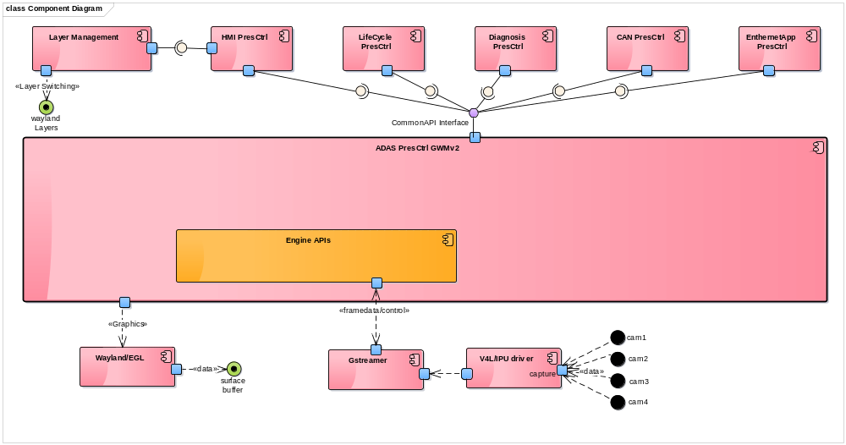

Components Diagram

AVM& MOD

Description
For GWMv2, a dedicated AVM& MOD subsystem will be implemented. This AVM&MOD module will be created by ADAS control module and scheduled by ADAS manager module.
All the system request of AVM&MOD feature will be dispatched to this subsystem. The sensor driver will be managed by engine directly and the graphics resources will be managed by display buffer manager module.

Diagram
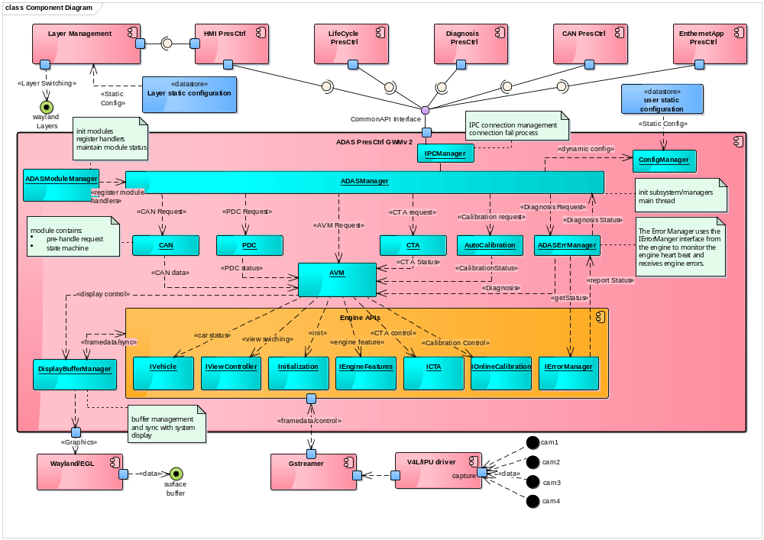

Interfaces Diagram

links of CDL & FIDL
https://stash1.harman.com/projects/GWM_V2MH/repos/contracts-gwm/browse/contracts-gwm-v2mh/packages/adas/ADAS.cdl
https://stash1.harman.com/projects/GWM_V2MH/repos/contracts-gwm/browse/contracts-gwm-v2mh/packages/adas/intf/ADAS.fidl
https://stash1.harman.com/projects/GWM_V2MH/repos/contracts-gwm/browse/contracts-gwm-v2mh/packages/adas/intf/ADASBaseType.fidl

Interface description table.
Type(fidl) | Name | Description
broadcast | bcAVMViewStatus | Report AVM static and dynamic status as:  AVM_NOT_CONFIGURED  AVM_TOP_VIEW  AVM_FRONT_VIEW  AVM_REAR_VIEW  AVM_RIGHT_VIEW  AVM_LEFT_VIEW  AVM_FRONT_RIGHT_VIEW  AVM_FRONT_LEFT_VIEW  AVM_REAR_RIGHT_VIEW  AVM_REAR_LEFT_VIEW  AVM_TOP_FRONT_VIEW  AVM_TOP_REAR_VIEW  AVM_TOP_RIGHT_VIEW  AVM_TOP_LEFT_VIEW  AVM_TOP_FRONT_RIGHT_VIEW  AVM_TOP_FRONT_LEFT_VIEW  AVM_TOP_REAR_RIGHT_VIEW  AVM_TOP_REAR_LEFT_VIEW  AVM_OFF_OVERSPEED  AVM_OFF  AVM_ERR
attribute | stAVMCamState | Report four AVM camera status as:  AVM_CAMERA_NOT_AVAILABLE  AVM_CAMERA_SIGNAL_GOOD  AVM_CAMERA_SIGNAL_LOST
attribute | stCTAStatus | Report RCTA and FCTA status as:  CTA_NOT_CONFIGURED  CTA_ON  CTA_OFF  CTA_ERR
attribute | enAutoCaliState | Report calibration status as:  AVM_AUTO_CALI_OFF  AVM_AUTO_CALI_NOTAVALIABLE  AVM_AUTO_CALI_RUNNING  AVM_AUTO_CALI_SUCCESS  AVM_AUTO_CALI_FAILED  AVM_AUTO_CALI_IDLE
method | SwitchAVMView | Switch AVM view mode to :  OFF  TOP_VIEW  FRONT_VIEW  REAR_VIEW  RIGHT_VIEW  LEFT_VIEW  FRONT_RIGHT_VIEW  FRONT_LEFT_VIEW  REAR_RIGHT_VIEW  REAR_LEFT_VIEW  TOP_REAR_VIEW  TOP_FRONT_VIEW  TOP_RIGHT_VIEW  TOP_LEFT_VIEW  TOP_FRONT_RIGHT_VIEW  TOP_FRONT_LEFT_VIEW  TOP_REAR_RIGHT_VIEW  TOP_REAR_LEFT_VIEW
method | SwitchGuideline | Switch AVM view mode to :  AVM_STATIC_GUIDELINOFF  AVM_STATIC_GUIDELINREAR  AVM_STATIC_GUIDELINFRONT  AVM_STATIC_GUIDELINFRONT_REAR  AVM_DYNAMIC_GUIDELINOFF  AVM_DYNAMIC_GUIDELLINREAR  AVM_DYNAMIC_GUIDELLINFRONT  AVM_DYNAMIC_GUIDELINFRONT_REAR
method | SwitchCTA | Switch CTA work mode to :  CTA_FRONT_ON  CTA_FRONT_OFF  CTA_REAR_ON  CTA_REAR_OFF
method | SwitchAutoCalibrationAuto | Switch calibration work automatically mode to ON and OFF
method | SwitchAutoCalibrationManually | Switch calibration work manually mode to ON and OFF

Dynamic Behavior

Startup / Shutdown
Describe the main process or components startup / shutdown behaviour with lifecycle in your domain. What persistency data should recovery and store at the startup / shudown phase.

Description

Diagram

Use Case Sequences
Describe the major and typical use case sequences

Manually enable/disable AVM view

Description
User request to show AVM view.

Diagram
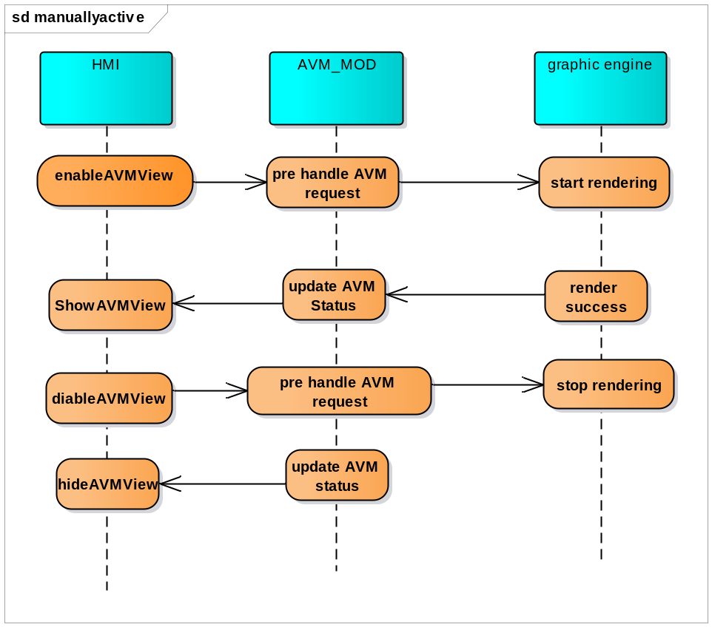

Automatically enable/disable AVM view

Description
System request to show AVM view.

Diagram
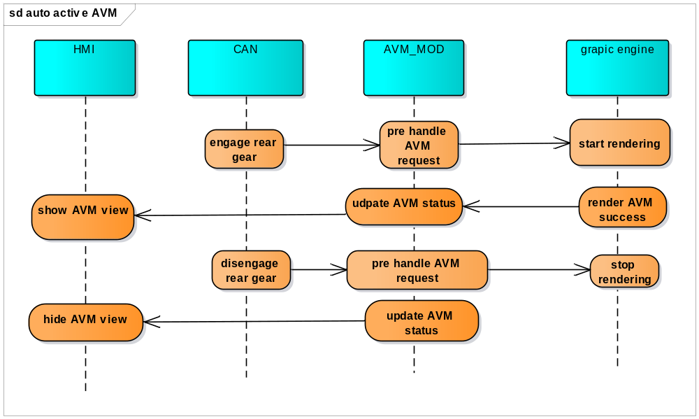

Manually enable/disable cross traffic assist

Description
User request to enable/disable cross traffic assist view.

Diagram
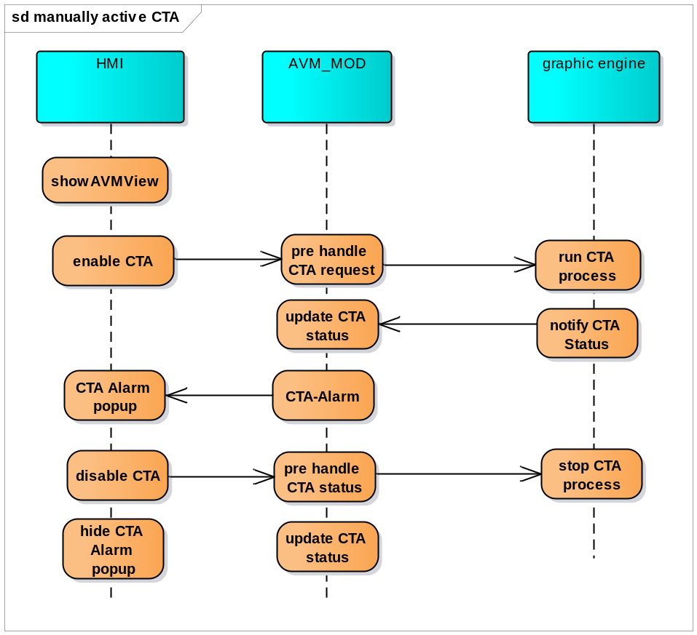

Automatically enable/disable cross traffic assist

Description
System request to enable/disable cross traffic assist view.

Diagram
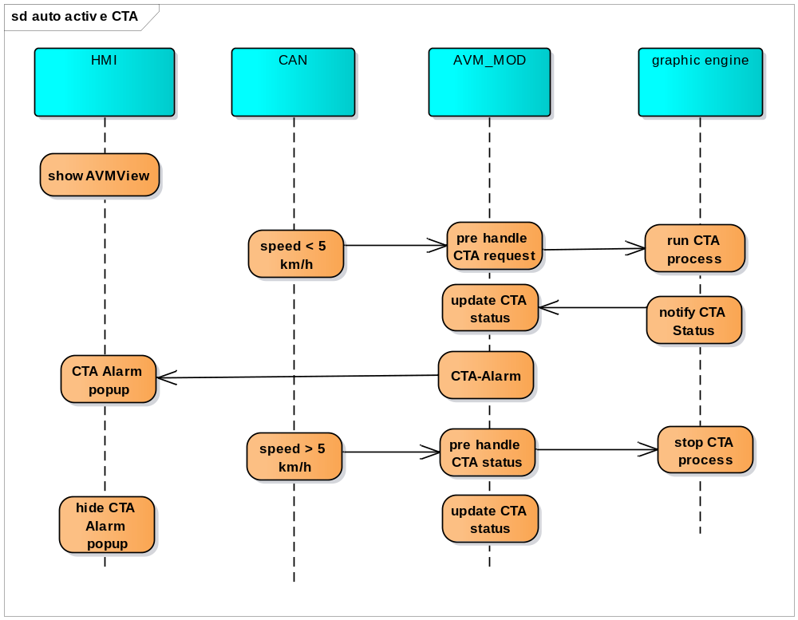

Manually enable/disable auto calibration

Description
User request to enable/disable auto calibration.

Diagram
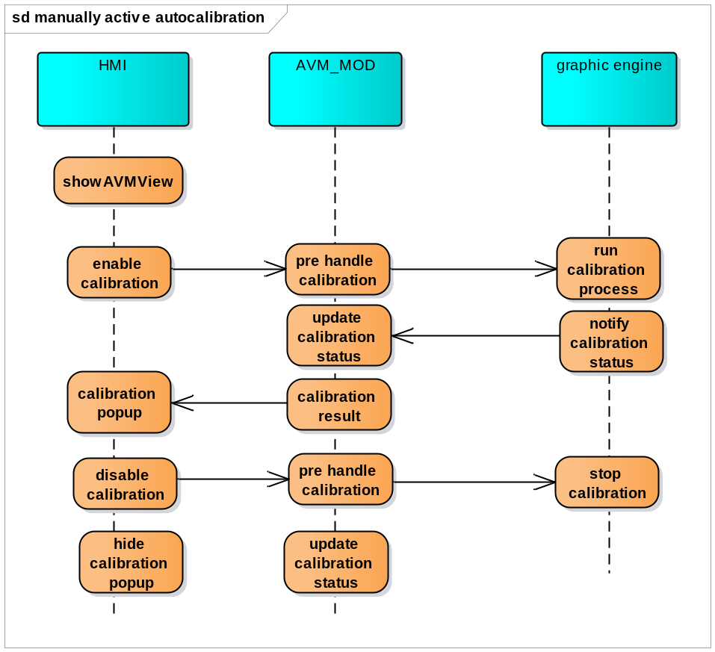

Automatically enable/disable auto calibration

Description
System request to enable/disable auto calibration.

Diagram
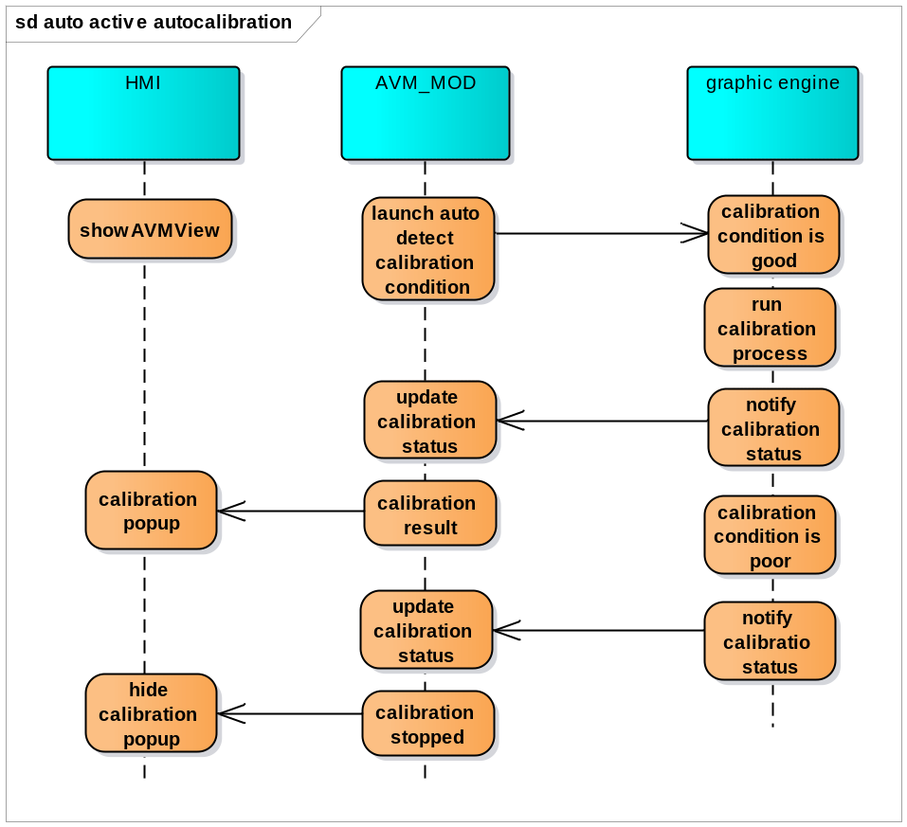

Test Environment

Traceability
TRS ID | TRS Description | Component Name | Section Number in this document
TRS-V2MH-ADAS_AVMMOD-34 | Activate around camera view by hard key
TRS-V2MH-ADAS_AVMMOD-76 | Activate around camera view by engaging rear gear
TRS-V2MH-ADAS_AVMMOD-35 | Deactivate around camera view by touch screen
TRS-V2MH-ADAS_AVMMOD-36 | Deactivate around camera view by hard key
TRS-V2MH-ADAS_AVMMOD-37 | Deactivate around camera view by disengaging rear gear
TRS-V2MH-ADAS_AVMMOD-38 | Deactivate around camera view by speed
TRS-V2MH-ADAS_AVMMOD-39 | Switching around camera view manually by touch screen
TRS-V2MH-ADAS_AVMMOD-40 | Switching around camera view automatically by steer wheel/radar/MOD
TRS-V2MH-ADAS_AVMMOD-41 | Mute Audio when around camera view is activated
TRS-V2MH-ADAS_AVMMOD-42 | Resume Audio when around camera view is deactivated
TRS-V2MH-ADAS_AVMMOD-43 | Pause media when around camera view is activated
TRS-V2MH-ADAS_AVMMOD-44 | Resume media when around camera view is activated
TRS-V2MH-ADAS_AVMMOD-45 | Keep playing BT phone when around camera view is activated
TRS-V2MH-ADAS_AVMMOD-46 | Show previous application when rear gear not engaged (exit from AVM)
TRS-V2MH-ADAS_AVMMOD-47 | Setting guide line displayed on around camera view
TRS-V2MH-ADAS_AVMMOD-48 | Displaying static guide line on around camera view
TRS-V2MH-ADAS_AVMMOD-49 | Displaying dynamic guide line on around camera view
TRS-V2MH-ADAS_AVMMOD-50 | Displaying distance block view (fusion with radar sensors) on around camera view
TRS-V2MH-ADAS_AVMMOD-51 | Displaying waring message on around camera view
TRS-V2MH-ADAS_AVMMOD-52 | Displaying system fault message on around camera view
TRS-V2MH-ADAS_AVMMOD-53 | Blocking Popup & Notification when around camera view is activated
TRS-V2MH-ADAS_AVMMOD-54 | Blocking Application switching when around camera view is activated
TRS-V2MH-ADAS_AVMMOD-55 | Displaying Door open state when around camera view is activated
TRS-V2MH-ADAS_AVMMOD-56 | Displaying trunk open state when around camera view is activated
TRS-V2MH-ADAS_AVMMOD-57 | Displaying outside mirror open state when around camera view is activated
TRS-V2MH-ADAS_AVMMOD-58 | Auto calibration of around view system
TRS-V2MH-ADAS_AVMMOD-59 | Diagnosis of around view system
TRS-V2MH-ADAS_AVMMOD-60 | Moving object detection by front view
TRS-V2MH-ADAS_AVMMOD-61 | Moving object detection by rear view
TRS-V2MH-ADAS_AVMMOD-62 | Detection range of MOD
TRS-V2MH-ADAS_AVMMOD-63 | Detection type of MOD
TRS-V2MH-ADAS_AVMMOD-64 | Detection size of MOD
TRS-V2MH-ADAS_AVMMOD-65 | Detection warning rate of MOD
TRS-V2MH-ADAS_AVMMOD-73 | Detection false positive rate of MOD
TRS-V2MH-ADAS_AVMMOD-74 | Detection speed of MOD
TRS-V2MH-ADAS_AVMMOD-67 | latency of displaying around camera view when camera system is ready
TRS-V2MH-ADAS_AVMMOD-68 | latency of displaying around camera view from a system cold start
TRS-V2MH-ADAS_AVMMOD-69 | stability of camera view

