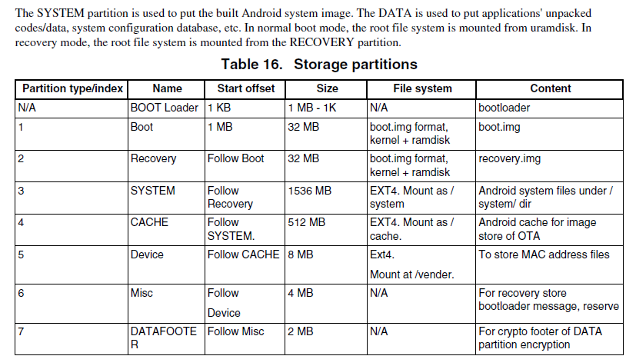

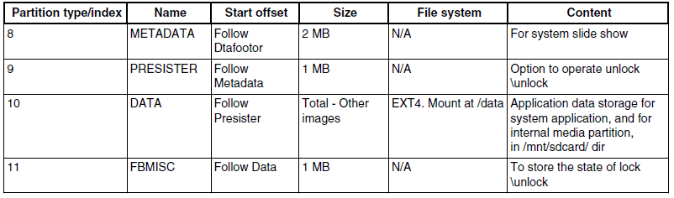

$ cd ~/myandroid/

$ sudo chmod +x ./device/fsl/common/tools/fsl-sdcard-partition.sh

$ sudo ./device/fsl/common/tools/fsl-sdcard-partition.sh -f <soc_name> /dev/sdX

# <soc_name> can be imx6q, imx6dl, imx6sl, imx6sx and imx7d.

• The minimum size of the SD card is 4 GB.

• /dev/sdX, the X is the disk index from 'a' to 'z'. That may be different on each

computer running Linux OS.

• Unmount all the SD card partitions before running the script.

• Put the related bootloader, boot image, system image, recovery image in your

current directory. This script requires to install the simg2img tool on the computer.

simg2img is a tool that converts the sparse system image to raw system image on

the Linux OS host computer. The android-tools-fsutils package includes the

simg2img command for Ubuntu Linux OS.

小结：从 fsl-sdcard-partition.sh 中提炼出烧写命令：

bootloader: u-boot-imx6q.imx node: /dev/sdc offset: 1

boot image_file: boot-imx6q.img

recovery image: recovery-imx6q.img

system image: system.img

dd if=${bootimage_file} of=${node}1 conv=fsync

------->dd if=boot-imx6q.img of=/dev/sdc1 conv=fsync

dd if=${recoveryimage_file} of=${node}2 conv=fsync

simg2img ${systemimage_file} ${systemimage_raw_file}

dd if=${systemimage_raw_file} of=${node}3 conv=fsync

rm ${systemimage_raw_file}

dd if=/dev/zero of=${node} bs=1k seek=${bootloader_offset} conv=fsync count=800

dd if=${bootloader_file} of=${node} bs=1k seek=${bootloader_offset} conv=fsync