IPD Media Player

Developed by Sebastien Scullion and Matthew Stinis
The purpose of our project is to execute a functional design of a professional Windows based media player, which will access an online repository of audio files. Users will also be able to add or remove albums to their media player application from the music database for easier playback, as well as edit metadata to files kept on their own machines.
Additionally, we plan to include an audio file converter; capable of converting WAVs to lossy formats like MP3s, and lossless formats like FLAC. The ability to read and rip content from physical formats like CDs, and add to the database of music, would also be ideal for users. There will also be full customization control on the app’s theme, where users can select whatever color schemes they desire.

Technologies used:

- WPF, C#
- SQL Database
Not covered in class:
- Audio file playback
- Interfacing disk-reader with an application
- User-customizable application characteristics

Mock-up

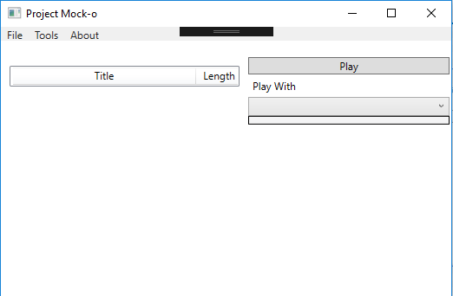

Above is a snap shot of a basic unrefined user interface for the application. The user can see a list of available media on the in the main area of the window. On the right the user can select play options and view the jewel case art.

The file menu will contain an exit option.

The Tools menu will contain the various feature available. These features will be access via custom windows.

The About will contain info about the developers and version.

Database

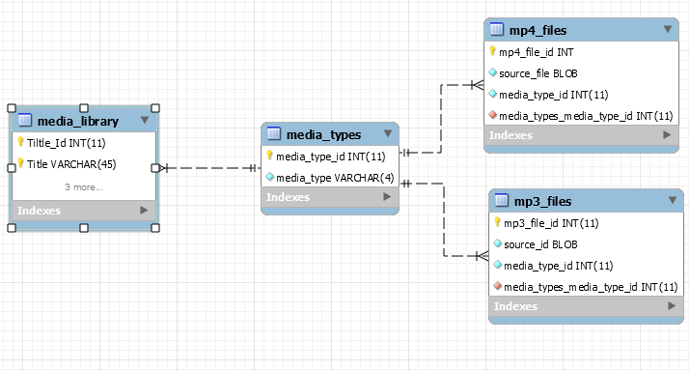

The above diagram illustrates the proposed tables for the media library.

