**Release V2.3 of the Rebel Alliance Mod.**

By NA8E, K4JK, PA3ANG, AE6RQ(tester), W2ROW bugfix + improved frequency display.

Rebel Alliance Mod V2.3 by Johan, PA3ANG. October 2014.

Almost a year ago a group of Rebel enthusiasts released version 1.1 of the Rebel Alliance Mod, a sketch for the Ardinuo / chipKIT UNO32 running inside a Ten-Tec QRP transceiver. This transceiver can be modified and all details are Open Source. The base configuration is a 20 / 40 meter CW receiver / transmitter and the factory delivered sketch (firmware) is pretty basic. Straight key input, frequency tuning and 3 selectable bandwidth.

Already before the release of the Rebel and directly thereafter new functionality was written to encompass a broader usage of the Rebel. An iambic keyer, several display options and memory transmitting.

Based on my own experiences and feedback from the Rebel user community, I rewrote the Rebel Alliance Mod version 1.1 to a more streamlined and clearer sketch.   
Major decision was to incorporate only one display type which is fast and cheap and has easy connectivity. The I2C type display’s and the 16x2 and 20x4 matrix display are to slow and too cumbersome in my opinion to use as are the OLED versions. The NOKIA5110 display however is a very good alternative and is easy and cheap to buy on eBay or in the regular internet stores.  
I found a better and more performant library for the NOKIA5110 with a choice of fonts and the ability to display ‘graphics’. In other words: do yourself a favor and buy a NOKIA5110 for $1,50 on eBay. Less wires, fast display and cheap

Next to the display change, I rewrote the CAT function. It’s now emulating the Elecraft K3 CAT commands and works with most of the know logging and remote command software. If no initial CAT command is received the USB/Serial streams status information which can be displayed using Serial terminal software on your PC such as SSH.

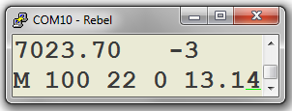

Frequency, RIT (or TX, CQCQCQ, TUNE)  
Filter, Step, WPM, Smeter, Voltage

The new version has also a tune function. Selecting U3 will result in a carrier transmission (max. 10 seconds) to enable antenna tuning. This is helpful if you have selected the Iambic keyer function on the Rebel.

**In summary the Rebel Alliance Mod V2.3 features:**

1. New improved NOKIA5110 display routines using a faster library and with better frequency visibility. The layout is different and the Rebel will start with the Ten-Tec logo!

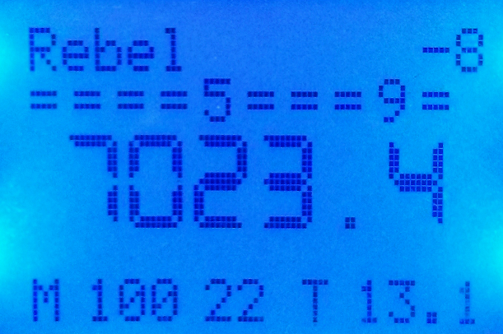

1. Improved CAT routines. Does work now with HRD (K3 compatible). Functions included are :

* VFO-A read and write
* Filter read and write
* S-Meter read
* Status (used in HRD not tested on other control software)
  + Model
  + Rebel Alliance Mod version
  + Keyer Speed in WPM
  + Step setting (100 Hz, 1K Hz, 10K Hz)
  + Voltage

Note: sometimes the Rebel goes into restart when connecting the CAT software. Just wait for a Rebel reboot and try again.

Note: The picture shows a ‘reconfigured’ HRD screen with Filter knobs and only 2 bands.

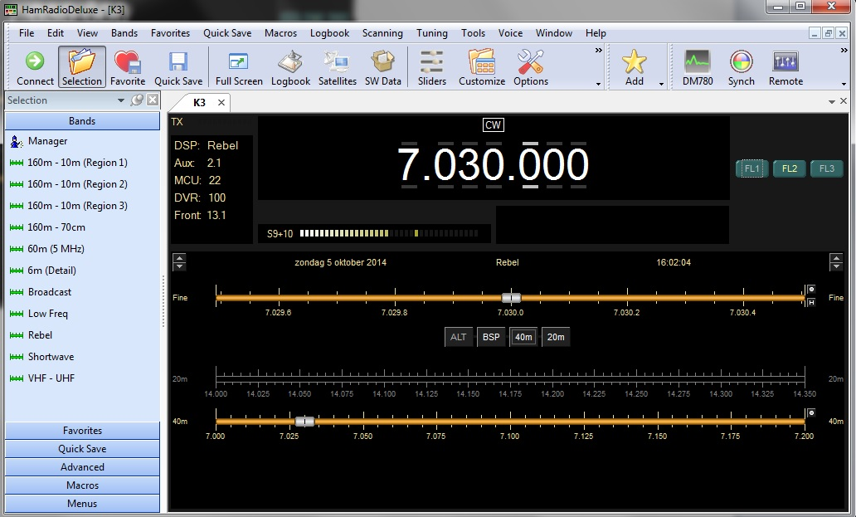

1. If no (initial) CAT commands is received, the USB/Serial port will act as a Terminal output giving the same info as displayed on the NOKIA5110. This info can be displayed using a simple terminal program on a PC, iPAD or smartphone.
2. New TUNE function (U3) to send a solid carrier. (max 10 seconds)
3. The sketch is streamlined with less #define FEATURE options and the iambic keyer has now also the Swap Paddle option working. Most of the functions are a fixed part of the sketch. The only exception is the BANDSWITCH function which is defined during compiling the source. The iambic keyer is either switched off by a program flag or by configuring the 3,5 mm jack (mono jack or middle pole to ground or one layer pressed on the keyer). Display and CAT / terminal are always on regardless of connectivity / usage.

**User settings in the sketch are:**

//------------------------------- SET OPTONAL FEATURES HERE -------------------------------------------------------------

int ST_key = 0; // Set this to 1 is you want to disable the keyer completely

int A7_adjust = 1; // Set this to 1 if you want to adjust the CW speed with pot A7, else the speed is

// controlled with function U1 DIT increase and DAH decrease speed.

#define FEATURE_BANDSWITCH

// Software based Band Switching. Press FUNCTION > 0.5 seconds ADDITIONAL HARDWARE

// Comment the line is you have no additional hardware added.

//------------------------------- SET OPTONAL FEATURES HERE -------------------------------------------------------------

**CQ message:**

//------------------------------- CHANGE CALLSIGN HERE -------------------------------------------------------------

#define CQ ("CQCQCQ DE PA3ANG PA3ANG PA3ANG K") // CQ text

//------------------------------- CHANGE CALLSIGN HERE -------------------------------------------------------------

Note: the CQ message and the frequency announce are now speed synchronized with the iambic keyer / A7. The beacon function is dropped, but you could use the CQ message as beacon. The pause time is 10 seconds between transmissions.

**Keyer settings:**

//------------------------------- CHANGE KEYER SETTINGS HERE -------------------------------------------------------------

#define PDLSWAP 0x00 // 0x00 for normal, 0x08 for swap

#define IAMBICB 0x10 // 0x00 for Iambic A, 0x10 for Iambic B

//------------------------------- CHANGE KEYER SETTINGS HERE -------------------------------------------------------------

**The fixed functions in V2.1 are:**

* Iambic Keyer with speed control on A7. The keyer can be switch off permanetly
* Frequency announce on press SELECT > 0.5 seconds
* CQ message on U2
* Tune carrier on U3
* NOKIA5110 display
* Terminal or CAT (K3 compatible) on USB/Serial

**Selectable feature in V2.3 is:**

* Band switch on press FUNCTION > 0.5 seconds with frequency memory. This function needs additional hardware and can be switched off

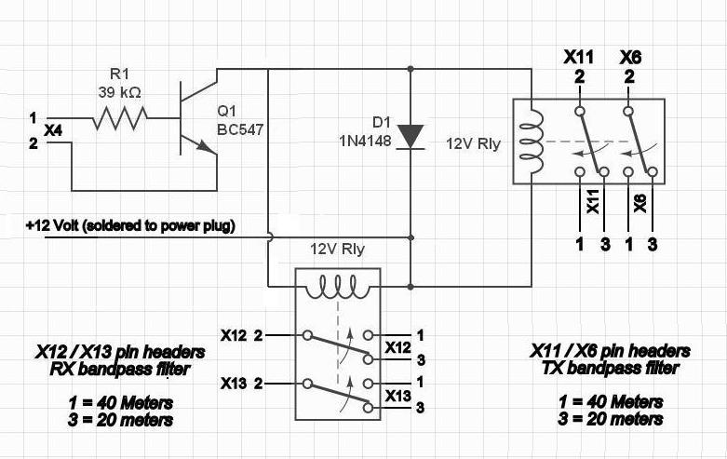

* Straight Key detection or flag imposed ST_key = 1
* U1 can be used as CW_speed control or pot A7

We also did some bug fixing based on the Yahoo TENTEC 506 Group conversations.

During the year I dropped the idea of having a CW decoder build in. To enable decoding, extra hardware is needed. Being mostly at home with a PC attached to the Rebel it's not worth the hassle.

The same goes for PSK31 and other digital modes. As Ten-Tec has recently announce the Patriot as their 2nd Open Source transceiver including not only CW but also Phone and Digital modes, I will refocus on the digital modes when the Patriot has arrived in my shack.

For more information on this project see:

<https://groups.yahoo.com/neo/groups/TenTec506Rebel/info>

<https://groups.yahoo.com/neo/groups/TenTec506Rebel/files/User%20Upload%20folder/Rebel%20Alliance%20Mod/>

The Rebel Alliance Mod sketch is built on a standard Rebel and the Rebel base sketch.

The iambic keyer originates from openqrp.org. The CQ generator from Steven T. Elliott and for the K3 CAT part the Rebel sketch from K1URC has been used.

Thanks to NA8E, K4JK, AE6RQ, K6HX, K1EL and W2ROW for helping to create the Rebel Alliance Mod code.