Water Level Sensor Test Report

*By: Bob Glicksman; 01/14/2017*

# Objective.

This report documents my analysis and test results for the Solu Water Level Sensor that I purchased at:

<https://www.amazon.com/Solu-Detection-Arduino-Sensitivity-Surface/dp/B00UJ0DVN4/ref=sr_1_5?ie=UTF8&qid=1484328763&sr=8-5&keywords=water+level+sensor+arduino>

# Analysis.

## Size.

The device is a lot smaller than I thought it was. Here is a photo of it next to a quarter.

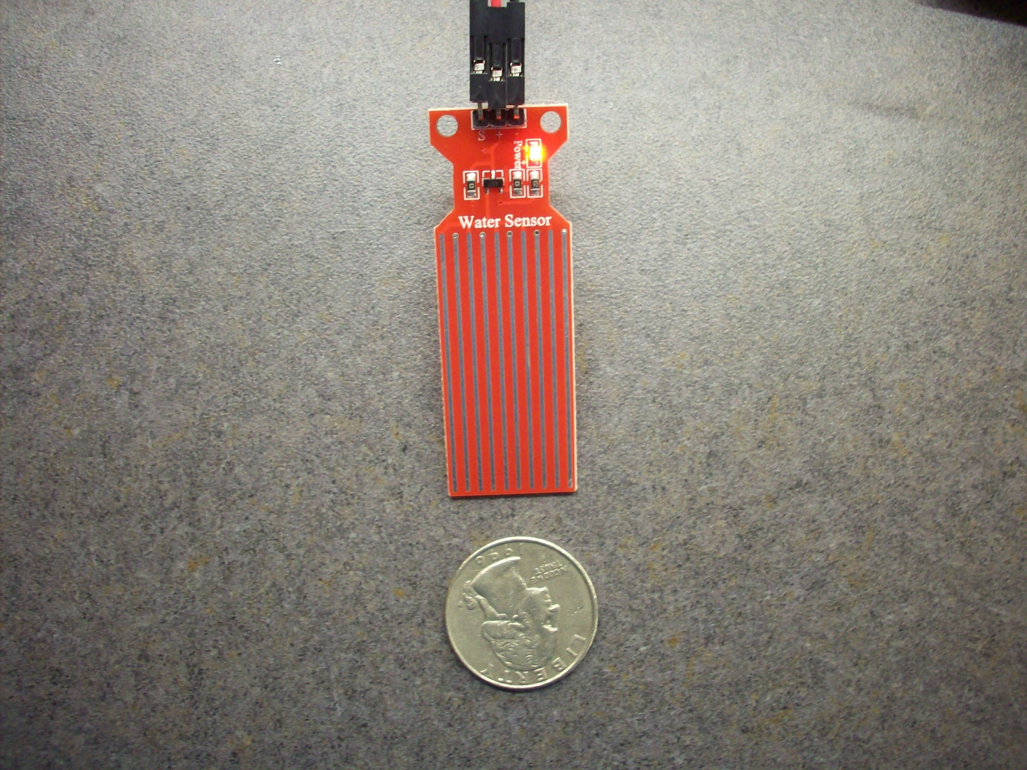

*Water Level Sensor Photo*.

A consequence of this small size it that it is probably not useful for detecting leaks via having drops of water from the leak fall on it. It is too small to situate under a potential leaky sink or washing machine, unless the leak location is already known. Therefore, it will need to be placed at least part way into a pool of water.

## Theory of Operation.

There is essentially no documentation on this sensor. Consequently, the first thing that I did was to trace out the circuit so that I could understand how it works. A schematic is shown below.

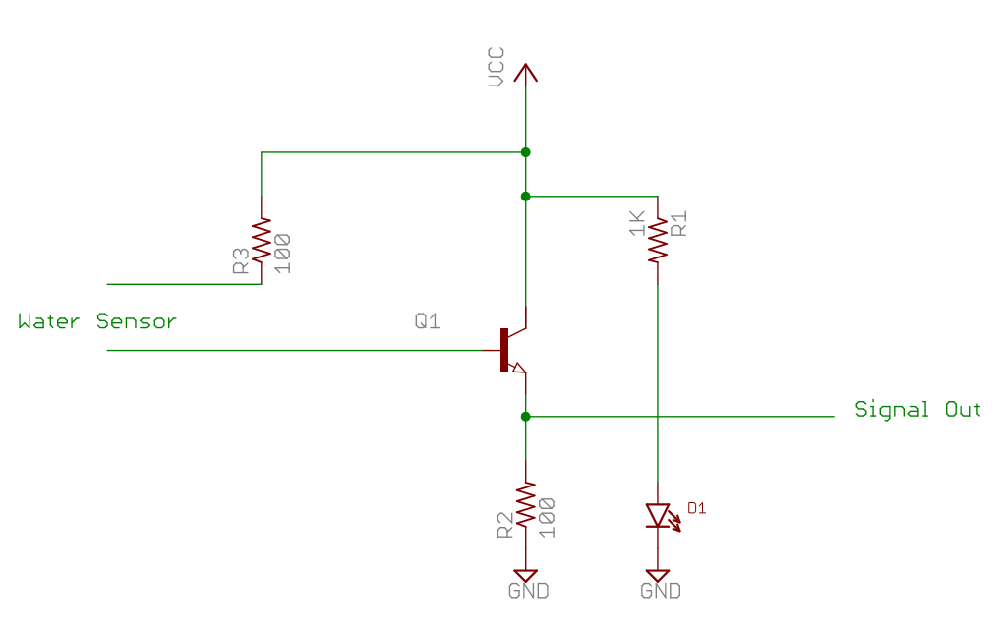

*Water Level Sensor Schematic.*

The sensor itself is just a grid of 10 closely spaced traces on one side of the board (the top of the board, where the circuitry is). Alternate traces connect to R3 and to the base of the transistor Q1. When the grid is dry, the circuit is open and the output voltage is zero. When the grid is wet, a voltage divider is formed by the grid resistance plus R3 and (Beta + 1) * R2. The transistor is a J3Y with a beta (DC current gain) of between 120 and 350, according to information that I pulled off of the Internet. Consequently, the wet sensor forms a voltage divider with an apparent resistance of 100 * (beta + 1) or say 20K in a typical case (series resistor R3 would be negligible here). Note, however, that the base/emitter junction of a silicon transistor drops about 0.7 volts, which effectively lowers Vcc by this amount when considering the voltage divider calculation for the output voltage. This value is not negligible, particularly if the supply voltage is 3 volts vs 5 volts.

The need to produce such a modest resistance when the sensor is wet underscores the need for the grid to have many parallel conductors. This is another reason why the sensor is probably not good for water drop detection, but needs to be at least partially immersed in water (to cover all grid conductors across, and then resistance is proportional to how far up the sensor the water level is).

# Testing.

I powered the sensor from a Arduino Uno, first using +5 volts and then using the +3.3 volt supply. I immersed the sensor in a dish of ordinary tap water and measured the voltage out from the sensor using a multimeter.

## 5 volt supply test results.

Dry sensor → 0 volts.

Sensor vertically in 1-2 mm of water → 2.2 volts

Sensor halfway immersed in water → 3.0 volts

Sensor fully immersed in water → 3.15 volts

## 3.3 volt supply test results.

Dry sensor → 0 volts.

Sensor vertically in 1-2 mm of water → 1.0 volts

Sensor halfway immersed in water → 1.77 volts

Sensor fully immersed in water → 1.78 volts

## 3.3 volt supply test results - RO filtered water.

Dry sensor → 0 volts.

Sensor vertically in 1-2 mm of water → 1.07 volts

Sensor halfway immersed in water → 1.47 volts

Sensor fully immersed in water → 1.61 volts

## Testing at an angle.

Using the 3.3 volt supply, I placed the sensor in water almost horizontally until the water level just covered about 1 mm of the sensor grid. The output voltage was about 1 volt. However, the depth of the water was about 3 mm owing to the thickness of the sensor board. Placing the sensor face down reduced this back to about 1 mm, but this same result was obtained with the sensor vertically in the water, as the conductor grid comes almost to the bottom of the sensor board.

## Drying.

After removing the sensor from water, some water clings to it and the output reduces slowly as water drains off. In order to get the sensor back to 0 volts output quickly, I had to dry it with a cloth.

# Conclusion.

The water level sensor can detect a puddle of water reliably, if the puddle is at least 1 mm high. The best orientation of the sensor is vertically. With a 3.3 volts supply, the output voltage jumps from 0 volts to about 1 volt or more quite suddenly as water just touches the bottom of the sensor grid. Drops of water on the surface of the sensor will also produce a measurable output, but this is not a reliable way to use the sensor. Therefore, this sensor is usable for detecting puddles of water about 1 mm or higher.