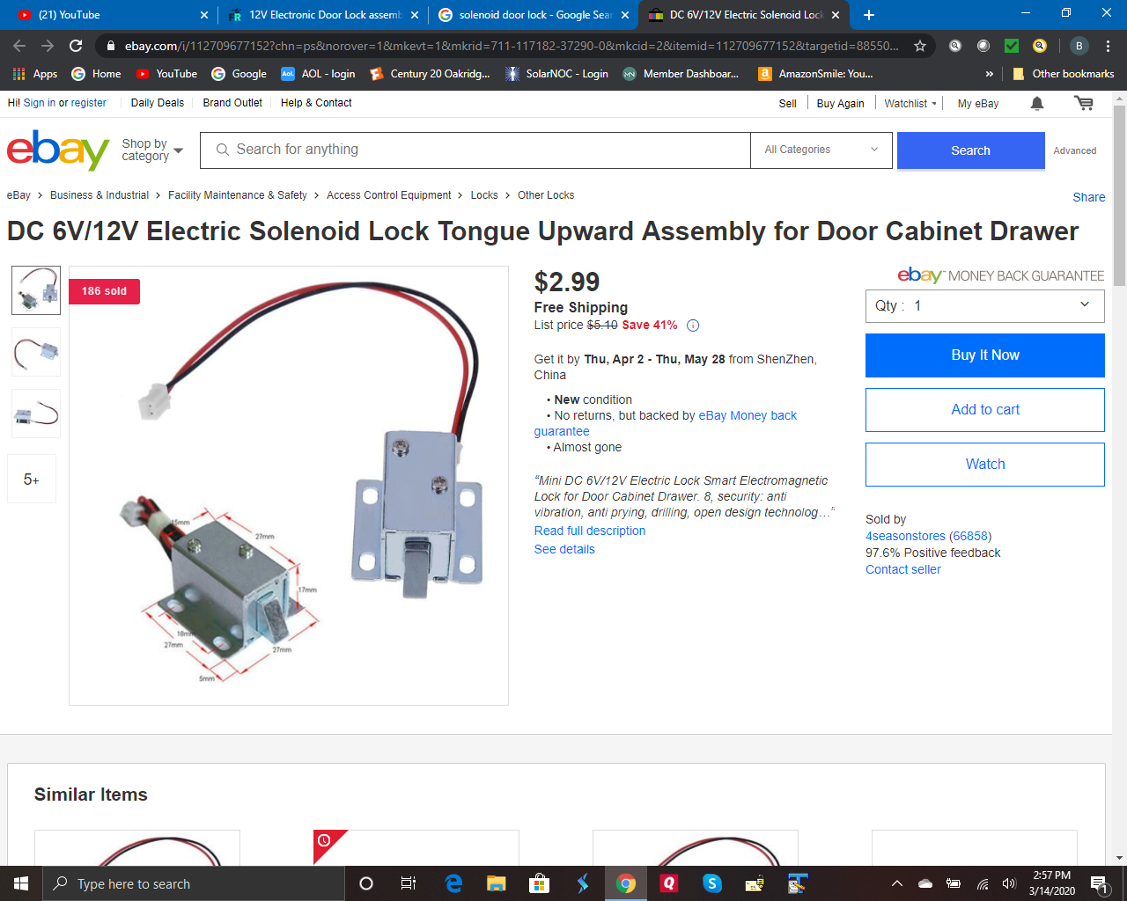

<https://www.ebay.com/i/112709677152?chn=ps&norover=1&mkevt=1&mkrid=711-117182-37290-0&mkcid=2&itemid=112709677152&targetid=885502524625&device=c&mktype=pla&googleloc=9032190&poi=&campaignid=9338046716&mkgroupid=94993973219&rlsatarget=aud-622524042958:pla-885502524625&abcId=1139336&merchantid=101710689&gclid=CjwKCAjwgbLzBRBsEiwAXVIygBxRx8xRO6CH4L0cl2Vwm1QEV0u_rfj4Pg1WhQrhx1CIRWOdBMulABoC0cEQAvD_BwE>