200% for tiny9.htm 8 pt font

For the reaction aA + bB → cC, we write

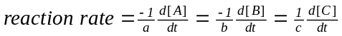

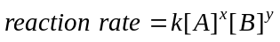

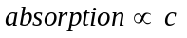

100% for beer-lambert law

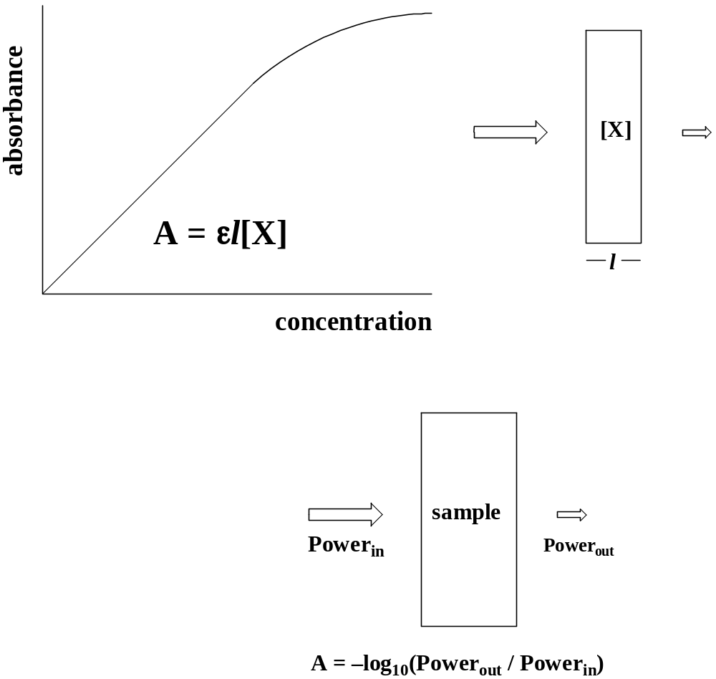
2A + B → 2C
reaction | [A]_{o} /M | [B]_{o} /M | d[C]/dt /(M/s)
#1 | 0.100 | 0.500 | 0.0044
#2 | 0.200 | 0.500 | 0.0088
#3 | 0.100 | 1.000 | 0.0176
