200% for tiny9.htm 8 pt font

For the reaction aA + bB → cC, we write

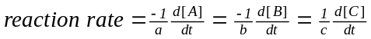

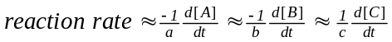

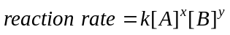

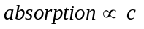

100% for beer-lambert law

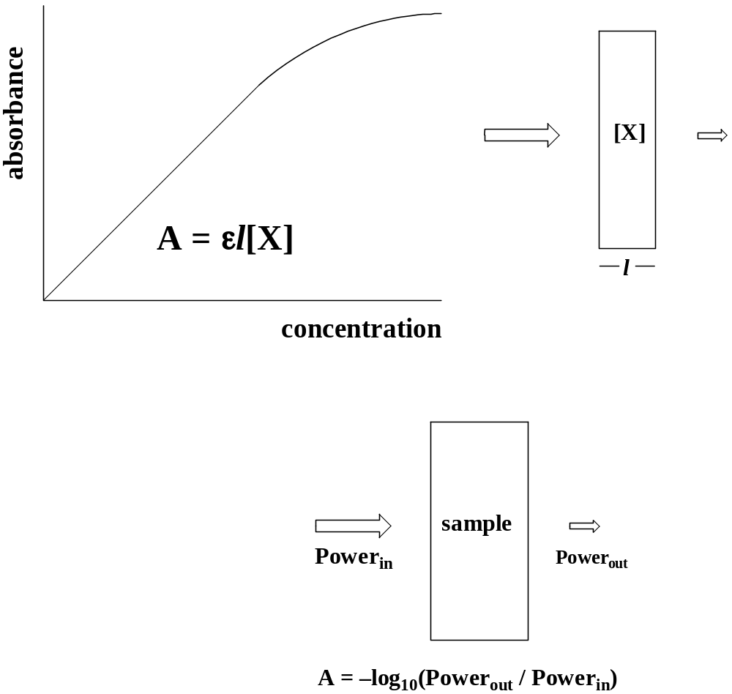
2A + B → 2C
reaction | [A]_{o} /M | [B]_{o} /M | d[C]/dt /(M/s)
#1 | 0.100 | 0.500 | 0.0044
#2 | 0.200 | 0.500 | 0.0088
#3 | 0.100 | 1.000 | 0.0176
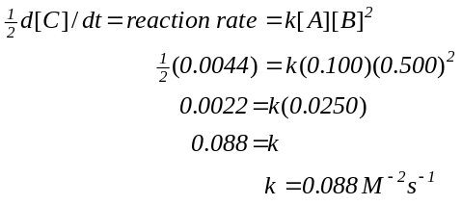

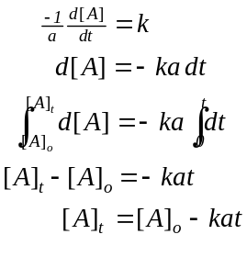
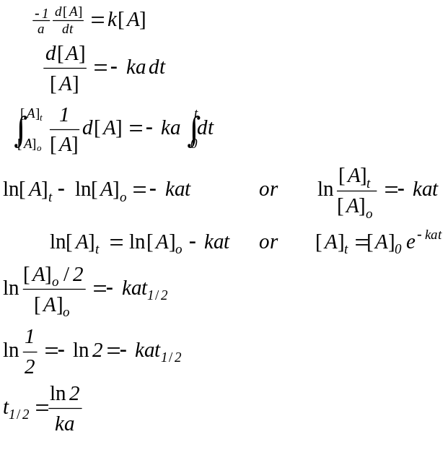

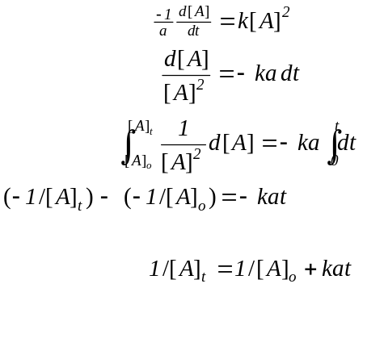

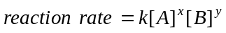

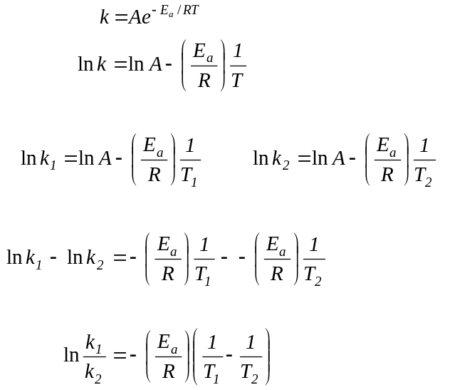

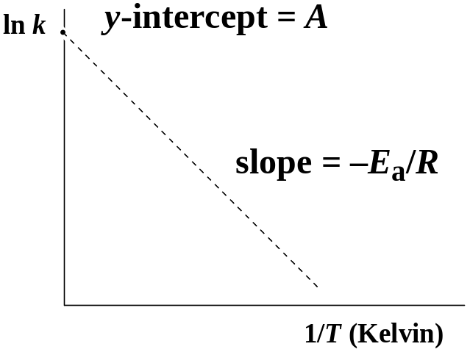

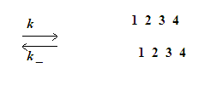

A 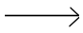 B
reaction rate = k[A]
A B + C

A + A B
reaction rate = k[A]²
A + A B + C

A + B C
reaction rate = k[A][B]
A + B C + D

NO + Cl₂ NOCl + Cl

NO + Cl NOCl

overall equation:

2NO + Cl₂ 2NOCl

proposed mechanism:

NO₂ + NO₂ NO₃ + NO

NO₃ + CO CO₂ + NO₂

overall equation:

NO₂ + CO CO₂ + NO

reaction rate = k₁[NO₂]²

k₁[NO₂]² = k_{–1} [NO][NO₃]

k₁[NO₂]²
________ = [NO₃]
k_{–1} [NO]

reaction rate = k₂[NO₃][CO]

k₁ [NO₂]²
= _________ k₂[CO]
k_{–1} [NO]

k₁k₂[NO₂]²
= _________ [CO]
k_{–1} [NO]

Cl₂ Cl + Cl

NO + Cl NOCl

NO + Cl NOCl

overall equation:

2NO + Cl₂ 2NOCl

proposed mechanism:

O₃ O₂ + O

O + O₃ O₂ + O₂

overall equation:

2O₃ 3O₂

reaction rate =k₂[O][O₃]

k_{–1} [O][O₂] = k₁ [O₃]

[O₃]
[O] =k₁/k_{–1}_______
[O₂]
proposed mechanism:

O₃ O₂ + O

O + O₃ O₂ + O₂

overall equation:

2O₃ 3O₂

reaction rate =k₂[O][O₃]

reaction rate = (k₁k₂/k_{–1})[O₃]²[O2] ^{–1}

rate =

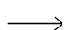

proposed catalysis mechanism:

A + X I

I B + X

overall equation:

A B

reaction rate =k₁[A][X]

enzyme-catalyzed mechanism:

A + E AE

AE B + E

overall equation:

A B

reaction rate k₂[AE]

