**PatientCare Installation Instructions**

**Android – (From the Android Play store)**

These instructions are how to install the PatientCare application on your Android smartphone from the Android play store.

1. Find the PatientCare app by searching the play store for “parc midas patinetcare” in the app section of google play. (**Important:** Make sure ‘patientcare’ is one word)
2. Select the “PARC Midas+ PatientCare” app for downloading, and follow the normal app installation steps for your phone.

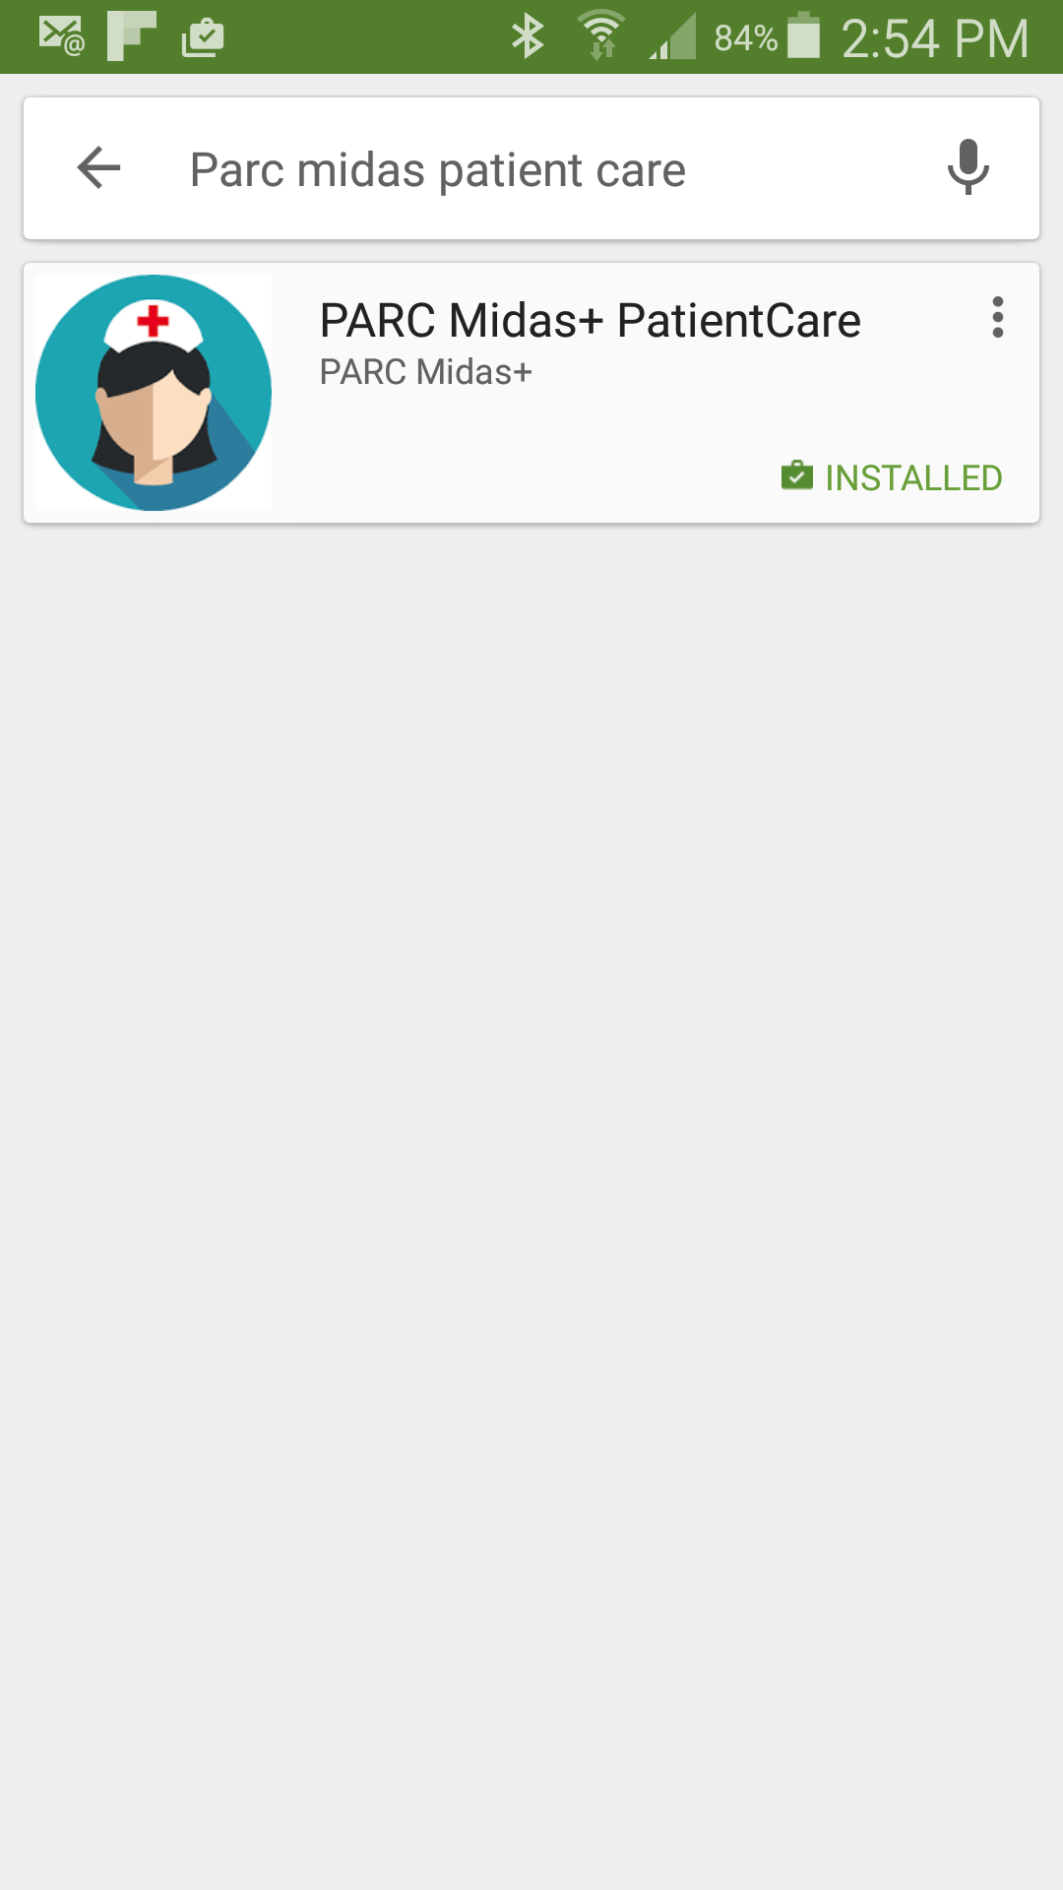

1. Once installed, you are ready to do a test run by entering the userid ‘demouser’ to see how the application works.

**IOS**

The Parc/Midas+ PatientCare application can also be downloaded from the iTunes store. Search for ‘parc midas plus patientcare’, and it will find our PatientCare app. Perform the normal iTunes download and install by pressing the ‘Get’ and then ‘Install’ buttons.

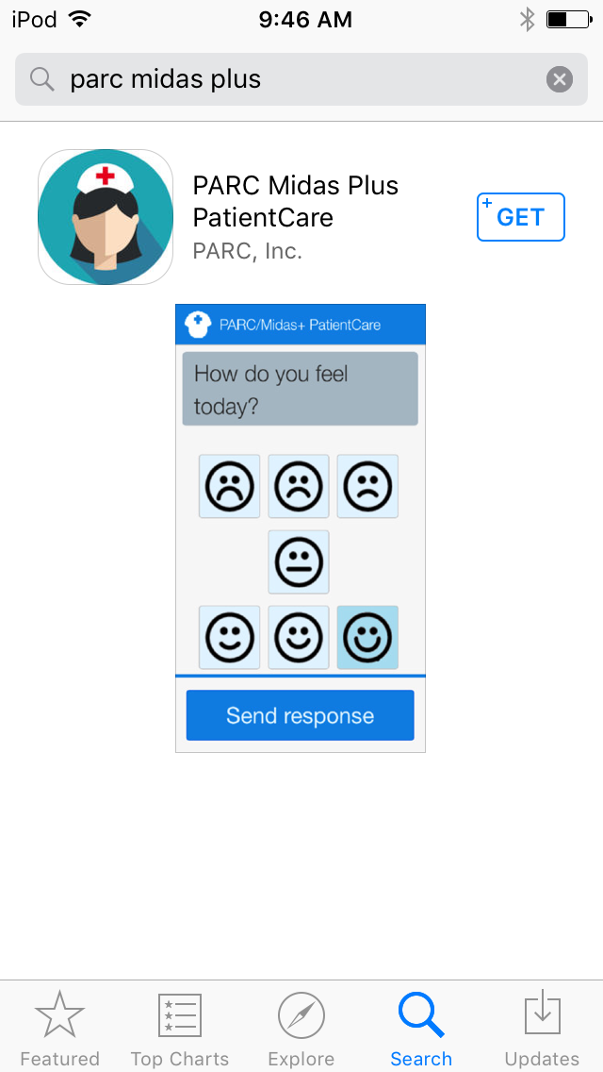

Be sure to allow notifications to be delivered when you start the application the first time.

Once installed, you are ready to do a test run by entering the userid ‘demouser’ to see how the application works.

**Running the application**

Go to your phone’s application list and run the PatientCare application. The icon will look like the image below.



The application will start, and ask your permission to be in the study, and receive notifications. You have to select the “I agree” selection (by scrolling down in some cases), and then the “Send response” button.

Once you have agreed, you will be asked to enter your patient ID. At this time it might be useful to practice responding to questions and check your connection to the system. If you enter the “demouser” as your patient ID, you can practice answering some sample questions to see how the application works. Once you are done, the app is reset, and you can then enter your real patient ID.

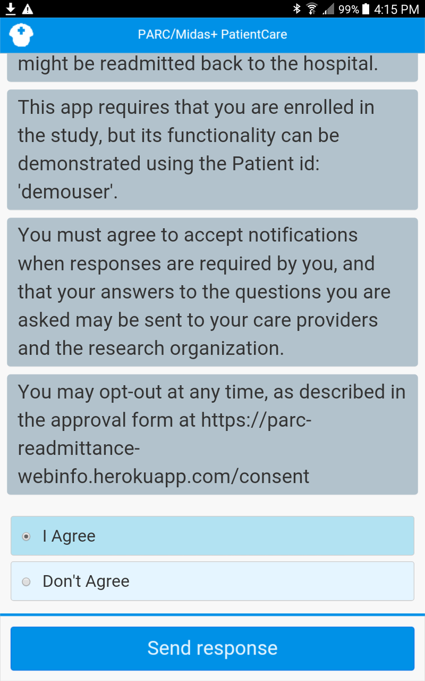

Your discharge nurse will then give you your patient ID, or she can enter this for you. This will register your phone with the study, and provide a few more sample questions for you to answer.

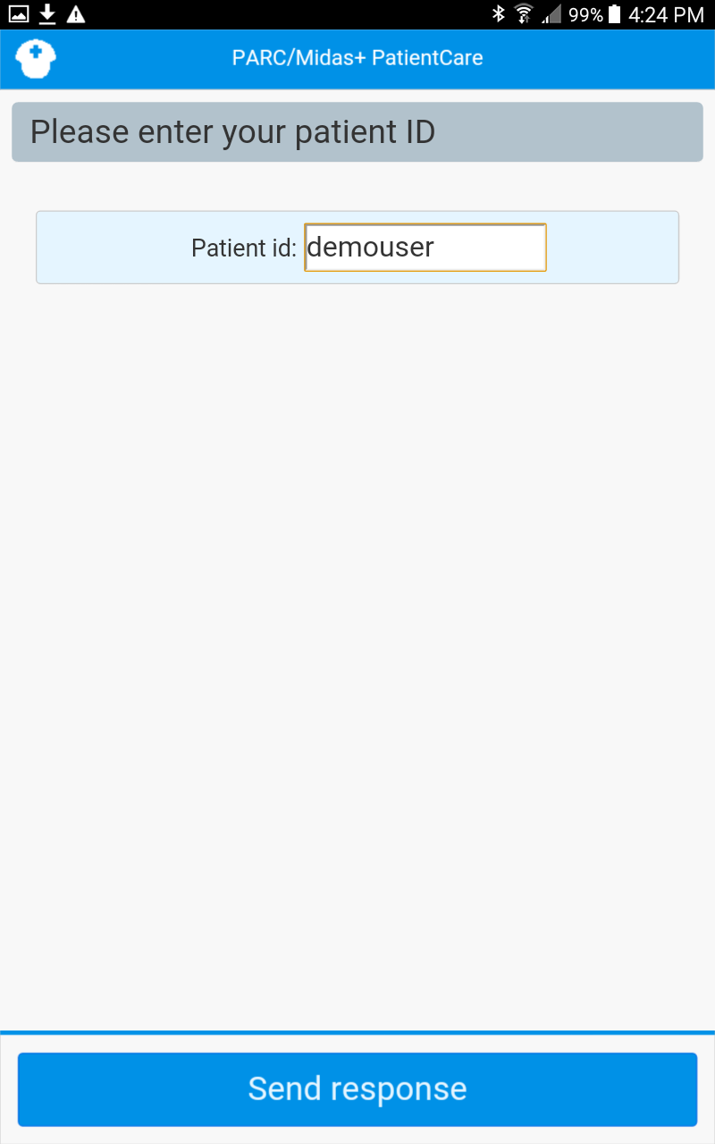After that, you are ready. Each day that questions are available, the system will send

out a notification to you indicating that some questions are ready. The questions that you receive will depend on what day it is and how you answered previous questions.

**Selecting your start time**

It is possible to select what time you want PatientCare to start asking you questions in the morning. To select the question start time (the default is 7:00 am), you need to get to the settings menu. To reach the settings menu, tap on the nurse icon at the top left corner of the screen. This brings up the menu below

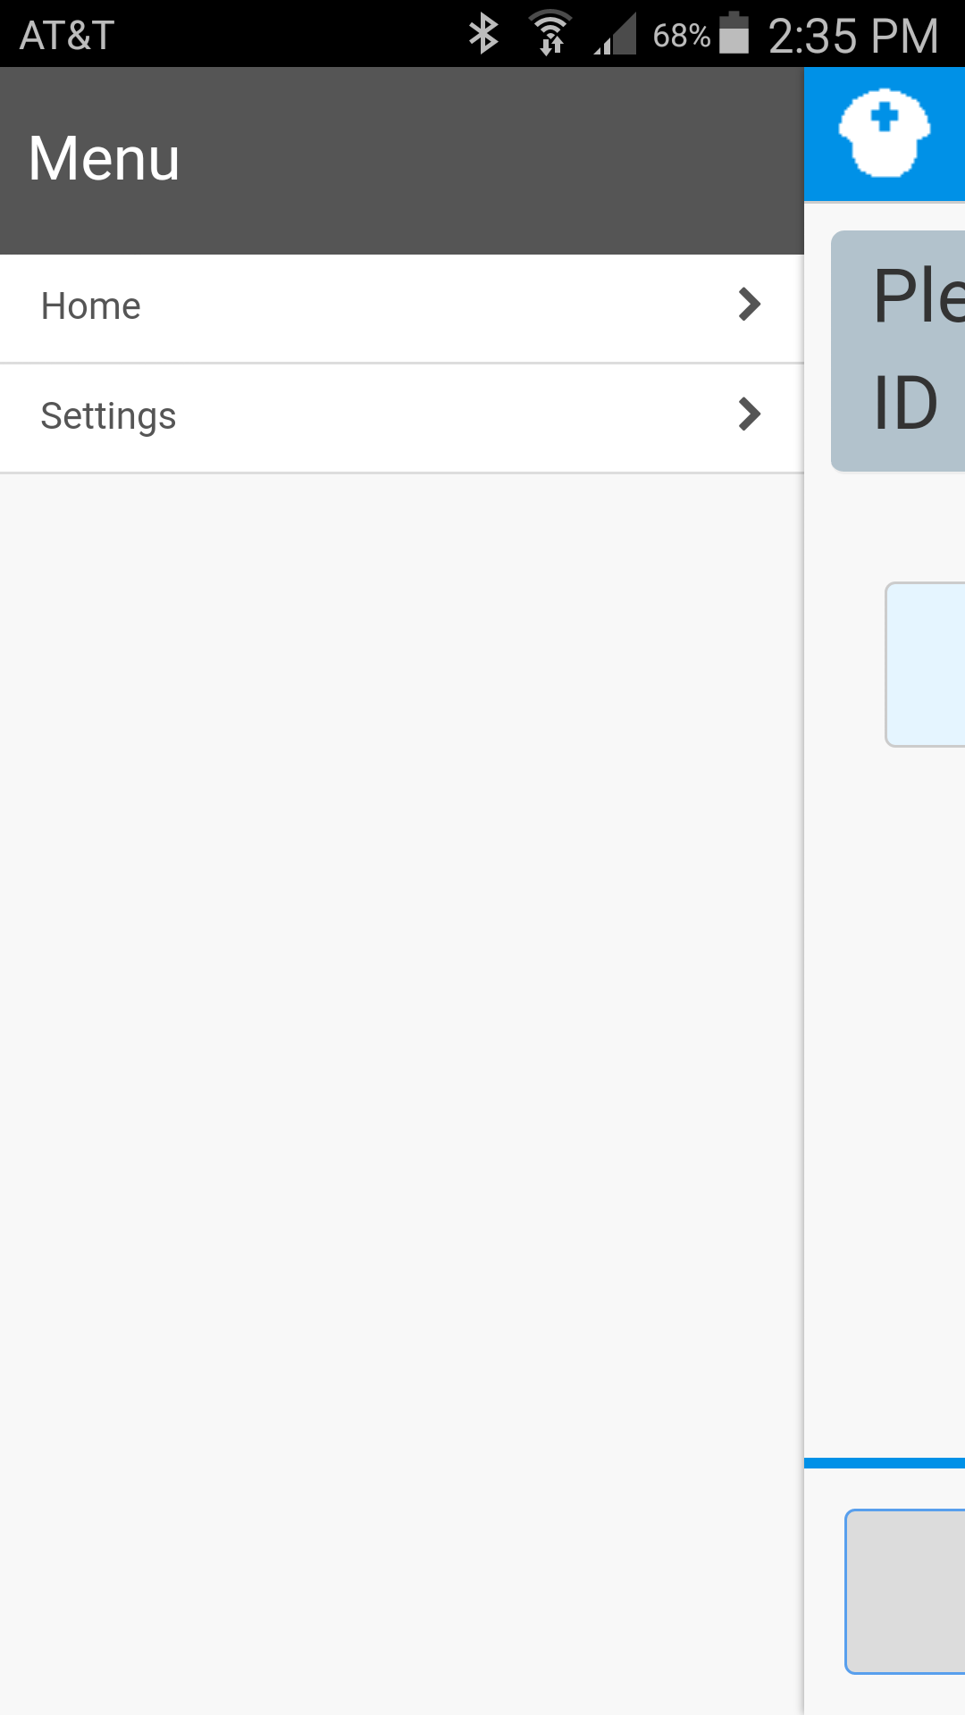

From the menu, select settings to get to your settings choices. Right now, your only selections is to choose the starting time for questions to be sent to you. After you make your time selection, repeat the process (press the nurse icon, then select Home) to get back to the main application page.

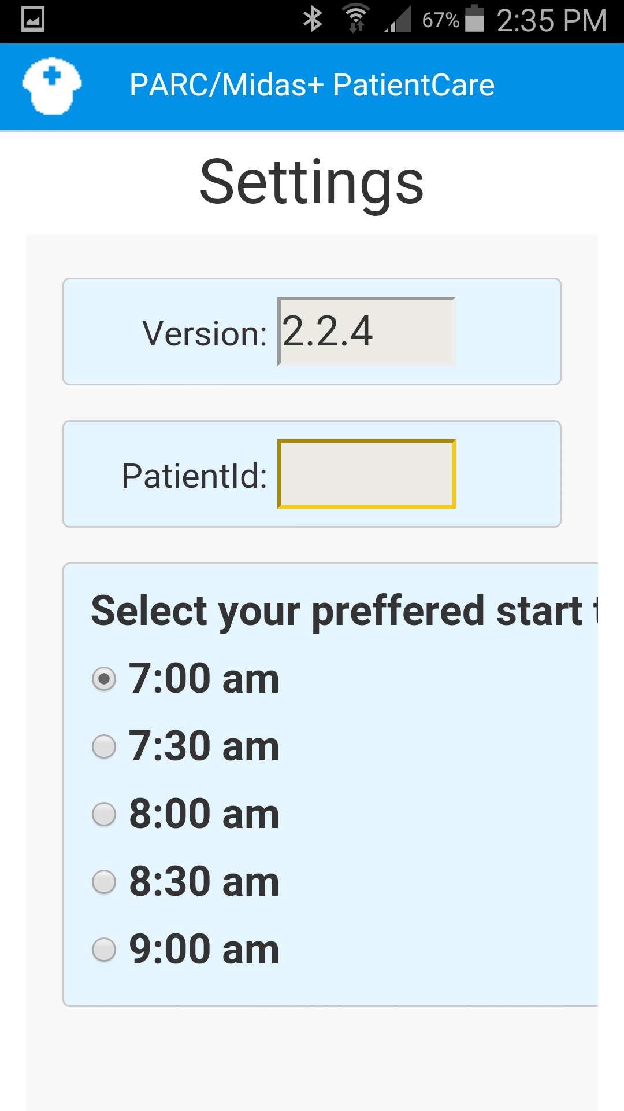

This document is available at:

<https://parc-readmittance-webinfo.herokuapp.com>