 Translated from French to English - www.onlinedoctranslator.com
Index

⚠️ WARNING 2
✅ Frequently Asked Questions about the Hack 3
❓What are the different boot modes? 5
🛒 Install games via Tinfoil easily 7
🛒 Add a Tinfoil shop 8
💻 Install games easily with DBI 10
💻 Install a game via PC with NUT Server 10
💻 Install a game via PC with Goldleaf and Quark 12
❓FAQ 12
❓Update your console 14
💾 Save your games with JKSV + Transfer to PC 16
✅ Some useful sites 19

⚠️ WARNING
Using a modded console to play copies of games may violate Nintendo's terms of service and infringe copyright law. So use them ethically and don't hesitate to buy official Nintendo games to compensate the creators of these games.
It's important to regularly back up your games when you own a modded console, since the entire operating system uses the SD card and not the console's internal memory. It therefore wears out more quickly, which in the long run can lead to the death of the SD card. Once the SD card is dead, it's impossible to recover your saves. So use a quality SD card to avoid unpleasant surprises.

Contact me if you have any concerns or if this guide is incomplete, incomplete, or simply incorrect.

✅ Frequently Asked Questions about the Hack
Can I still play online after hacking my console?
Yes, but only for games you own, and only in the console's normal mode. The hack only allows you to launch an additional cracked mode, independent of the normal mode.
Can I get banned for playing pirated games on EmuMMC?
No, the risk is zero.
What is my console at risk of?
If the chip doesn't hold, it suddenly stops booting completely, or the hack just won't launch. Otherwise, installing a chip is harmless to the console and will not destroy it.
How long does installation take?
Between 1h30 and 3h per console, depending on my availability and the amount of software to be installed.
How much will the hack cost me?
Cost table (per console):
In blue are the options you can take, and in red what is necessary. NOTE: for the setup and the games, it is necessary to have a MicroSD card, whether it is yours or mine it comes to the same.
What experience do you have with hacking?
I'm a community profiteer, I didn't develop the hack myself and I'm putting my microsoldering skills to good use for people. I have about twenty consoles ofmodded passives, and I haven't had any failures so far.
Do I risk bricking my console with the hack?
Yes, it's a possibility, but the installation itself won't be the cause. If you try to overclock the console, that's the main risk of bricking. Stay conservative and you'll be fine.
Does hacking allow you to cheat on games?
Yes

What is your availability?
Weekends and some weekdays, to be seen on a case-by-case basis.
Do you have any consoles I can buy directly?
Yes I have Nintendo Switch Litehacked that I sell for 140-160€ each.
Can you give me a guarantee that I will get a working console back?
Yes, if you want to have a warranty, you can select what you want in the options. 15€ extra forthe switch lite and the normal one, and 20€ extra for an Oled switch.
What are the penalties for downloading pirated content if the police come to my house?
Under Belgian copyright law, hackers face a fine of between €550 and €550,000 and/or a prison sentence of between three months and three years. (Source: Belga)

❓What are the different boot modes?
- There are several boot modes, all of which are more or less important. It's crucial to know what I'm talking about to understand the rest of the guide.
- EmuMMC mode is a virtual console whose internal memory is located on the SD card. It allows you to simulate a fake console in order to go unnoticed by Nintendo servers and thus avoid a ban.
- SysMMC (Semi-stock) mode is the mode that uses the console's internal memory, which means that this is data that Nintendo's servers can access, and if they detect illegal content, they can ban you.
- These two modes are two systems isolated from each other. You can transfer save data from one system to the other, but it's generally not very useful. Therefore, it's normal that if you make progress on a game on SysMMC, the progress will not be reflected on your save on EmuMMC.
- On the other hand, the Operating System is not managed by this, and that is why there is a third option: CFW (sysmmc) which allows the user to enter the internal memory of the console (Sysmmc) and be able to use personalized programs (like Tinfoil to "Dump" its games (recover the game in the form of ROM that can be re-downloaded later)). But this startup mode is rather risky, because a false move (you install a game that you do not have on SysMMC) can make the console banned from Nintendo servers. This can very quickly become problematic, because without Internet access, because of the virtual game card system, it is more complicated to play games that are nevertheless installed on the console in standard mode.
- The base console operating system is called NX OS. The custom firmware that allows you to launch custom applications is called Atmosphere and is made up of several layers, each with a specific role (for example, making the console incognito, starting games, etc.).
- It's important not to confuse operating system with firmware. Firmware refers to Atmosphere, and operating system refers to NX OS. The two are independent, but it's necessary to update both at the same time, and start by updating Atmosphere first before NX OS.

🕹️ Start the console in modded mode (EmuMMC)
- Turn on the consolevia a jig + RCM loader or via an injector dongle, if you don't have a chip. Turn on the console normally if you have a chip. (NOTE: Booting can take up to 25 seconds, so be a little patient, and don't press the POWER button repeatedly)
- If a menu appears, Choose the "EmuMMC" (system memory emulation) option from the Hekate menu ( Launch -> EmuMMC ).
  - ✅ This starts a separate system, which does not touch your official system, avoids banning.
- Once booted, you will see the classic Switch interface, with modified applications.

🕹️ Start the console in standard mode (Stock)
- Turn on the consoleby pressing the Volume + button and the Volume – button at the same time, and keep them pressed during the entire console boot process.

🕹️ Start the console in Hekate mode
- Turn on the consolewith the power button, and at the same time press the "Volume -" button, after a few seconds the Hekate menu should appear

🎮 Understanding Modified Apps
- Photos= Apps menu (via "Album" on the Switch).
- Daybreak= Manual firmware update (only if necessary).
- To view your screenshots, hold R on the right Joy-Con while opening the Album app.

🛒 Install games via Tinfoil easily
Step 1: Open Tinfoil
- Launch Tinfoil from the Tinfoil game (starting may take a little while, between 1 and 5 minutes depending on the network connection).
As long as it says "Loading -something-", it's fine. At startup there may be a popup "would you like to install this game cartridge", which you can ignore ("cancel"), it's only to install the cartridges you have.
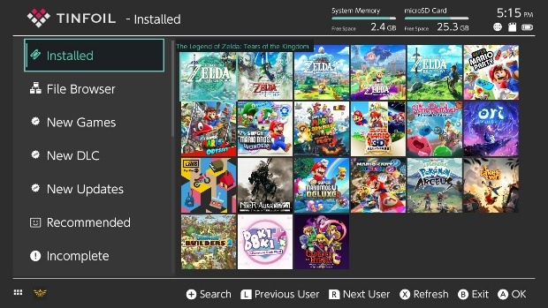
- If Tinfoil does not start:
  - Make sure USBFS is enabled (from Tinfoil options).
  - Update Tinfoil via a homebrew shop or manually.
Step 2: Browse and search for a game
- Go to "New Games" or "Browse". If the "New Games" tab is not visible, contact me, this means that either you are offline or the virtual shop has disappeared.
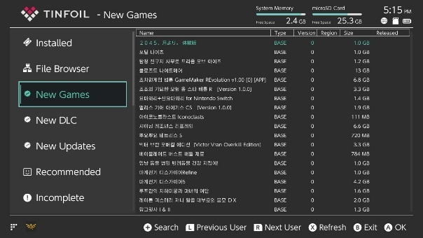
- Press "+" to search.
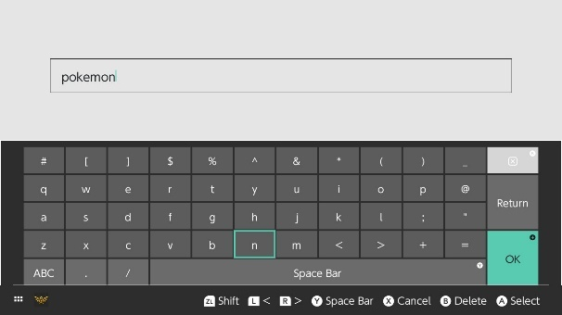
- Select a game from the list.
- Press "Install" and choose where to install (SD or NAND). It is possible to install the latest version and all-in-one DLCs if you enable the necessary options on this page
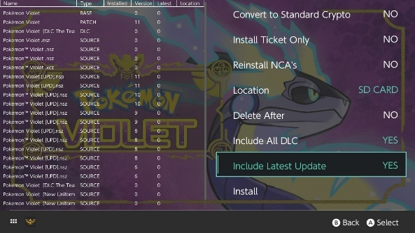
- If you want to update your games, it's no longer possible to do it with just the traditional "update" option; you'll also need to use Tinfoil. To do this, simply go to the "New Updates" tab and click the x button to install everything.
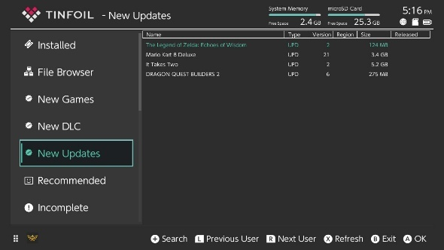
✅ Your games will be installed automatically.

🛒 Add a Tinfoil shop
Since shops open and close regularly, it's quite possible that you won't find what you're looking for or that the game you want to download is too large. Therefore, it's a good idea to regularly search for shops you like. This repository has an automatically updated list:https://github.com/melogabriel/tinfoil-shopsSimply enter the following information and the functional shops will be added automatically:
Protocol: https
Host: opennx.github.io
Path: tinfoil.json
Title: Open NX

- Go to the File browser tab
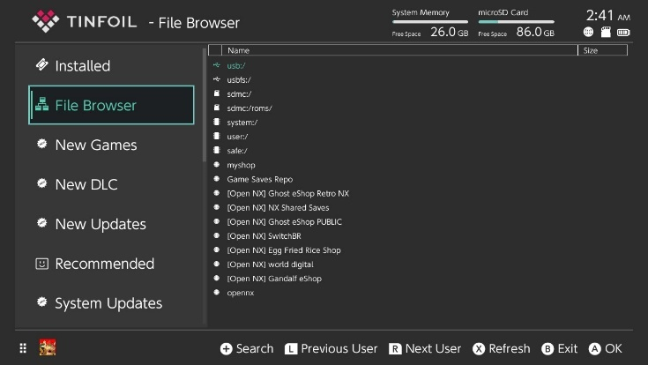
Once that's done, press "A" then "-"
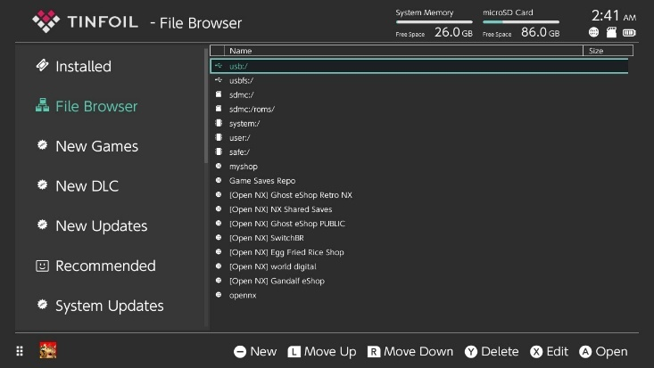
You will then enter this menu:
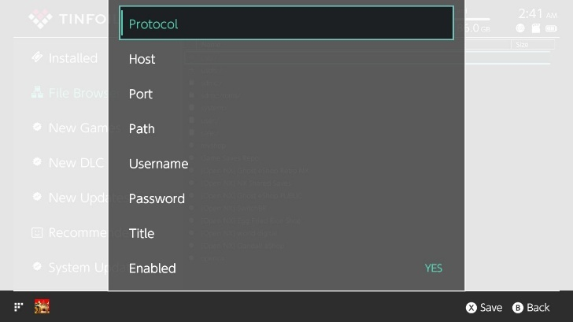

- Complete the fields with the information provided. It's intuitive, you have to press A on the field you want to modify, or use the console's touchscreen.
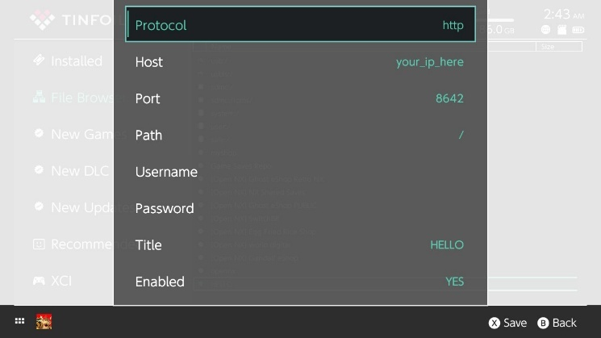
- Press X to save, and wait for the loading to finish.

💻Install games easily with DBI and a computer/phone

- Launch the DBI program on the console
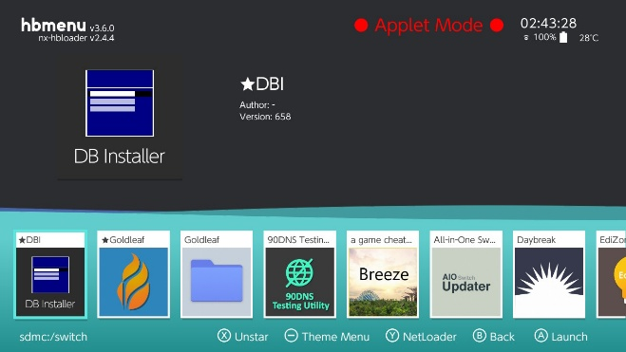
- Select the option with the acronym MTP in it (Media Transfer Protocol)
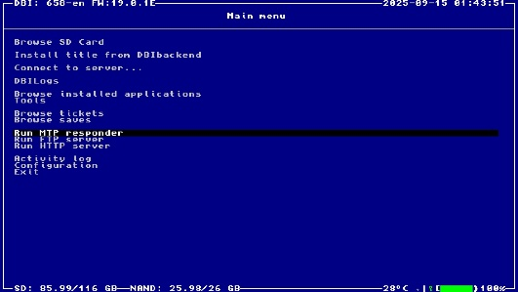
- Select option 5: SD card install
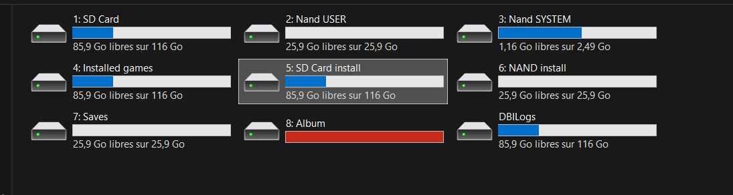
- Drag the NSP, XCI, or NSZ format ROM into the folder and wait for the transfer to complete. The game should now be installed.
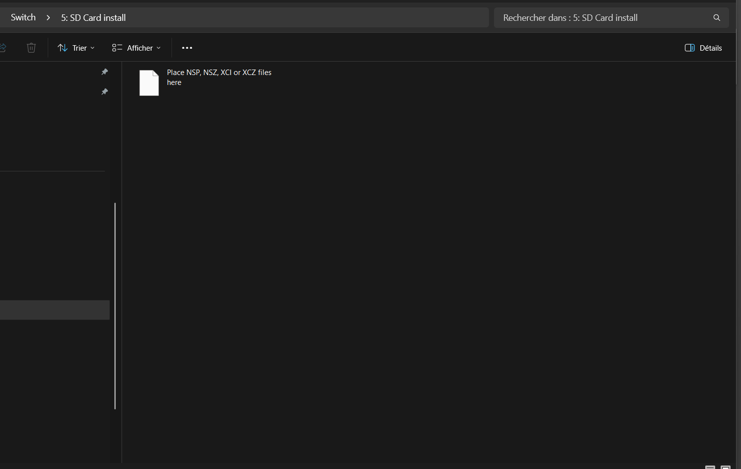

💻 Install a game via PC with NUT Server

⚠️ Warning: This method is riskier (more detectable) because you are not protected by the switch's incognito mode. It is recommended to use a VPN on your computer if you are installing illegal ROMs from the Internet

Step 1: Prepare the game on your computer
- Download a ROM in .nsp or .xci format from the Internet.
  - Google Keywords: <game name> Nintendo Switch NSP or <game name> Nintendo Switch XCI
- If you have a .zip or .rar, unzip it:
  - .zip → right click → Extract all
  - .rar → use 7-Zip or WinRAR

Step 2: Install NUT (the USB server for Tinfoil)
- Download NUT here:
🔗https://github.com/blawar/nut
(direct links) nut.exe:
https://github.com/blawar/nut/releases/download/v3.3/nut.exe
- Install the necessary drivers:
On Windows, run the install_driver.exe file:
https://github.com/blawar/nut/releases/download/v3.3/tinfoil_driver.exe
- Launch nut.exe or usb_install_pc.py depending on your system (usb_install_pc.py for MacOS).

Step 3: Place the games in the NUT folder
- By default, place your .nsp or .xci files in the folder:
nut/xci/
or else
nut/nsp/
or configure a path in config.json.
- In the NUT interface, check that the game appears in the list.

Step 4: Connect the Switch to the PC
- Connect your Switch to your PC via USB-C cable.
- Launch Tinfoil → go to "File Browser" > "USBFS"
- Select the game → Install.
📦 Automatic installation → restart to play.

💻 Install a game via PC with Goldleaf and Quark
https://github.com/XorTroll/Goldleaf/releases/tag/1.1.0
Follow the tutorial:
https://www.youtube.com/watch?v=NO09e0cbRH4
Zadig tool from the video:
https://zadig.akeo.ie/
Install Java (if not already installed):
https://adoptium.net/fr/temurin/releases/?os=any&arch=any&version=11

❓FAQ
Q: Can I get banned?
A: In EmuMMC mode, if you do not voluntarily disable 90DNS DNS and remove incognito mode, you cannot get banned.
Q: Can I play online with games installed via Tinfoil?
A: No, the console will fail to connect to the servers and you will get a connection error. However, games that you actually own can be used online if you launch your console with the "sysMMC" option. Some games that do not go through Nintendo services can sometimes work (e.g. Fortnite, Rocket League, etc. which sometimes work independently of Nintendo servers)
Q: Can I go back?
A: Yes, by rebooting without mod, you are on the original console (SysNAND), provided you have not modified it.
Q: What is “Applet Mode”?
A: This is a mode that is started not as the console's main program, but runs alongside a game. To exit "applet mode," simply launch a game while holding down the "R" button. This will open the application selection menu. From there, you will launch all applications in normal mode, not in "applet" mode.
Q: My SD card is too small? How do I use a bigger one?
A: Put your new SD card into your computer and format it in Fat32 format (not NTFS or exFAT). Then, copy all the files from your existing SD card to your new SD card and you're done.
Q: When I start up I get the message "No SD Card" with a winged raspberry symbol?
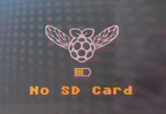
A: Your SD card is dead or at least no longer detected. You need to replace it. This means that all your backups are lost. This is why it is very useful to make backups with JKSV regularly. To initialize a new SD card, download the latest release of HATS:https://www.sthetix.info/hats/releases/
and extract everything to your new SD card

Q: My console automatically starts normally and I no longer have the Hekate menu/ My console does not start at all
A: There was a problem with the Picofly chip, which prevents the hack from being injected into the console and therefore prevents the console from starting in its modded version. Contact me again or go to a repairer capable of installing a Picofly chip. My installation offers a 1-year free warranty regarding the installation of the chip that did not hold. So come see me! (Your game data is not lost, don't worry)

Q: I installed a game but the console detects the file as corrupted or displays an error saying that the game cannot be launched after an update.
A: When updating the console's firmware, not all patches required to run games are installed, and patches may be missing. To fix this, the easiest way is to download the latest release from this site:https://www.sthetix.info/hats/releases/ , extract the .zip file, and put all the folders from the archive on the console's SD card.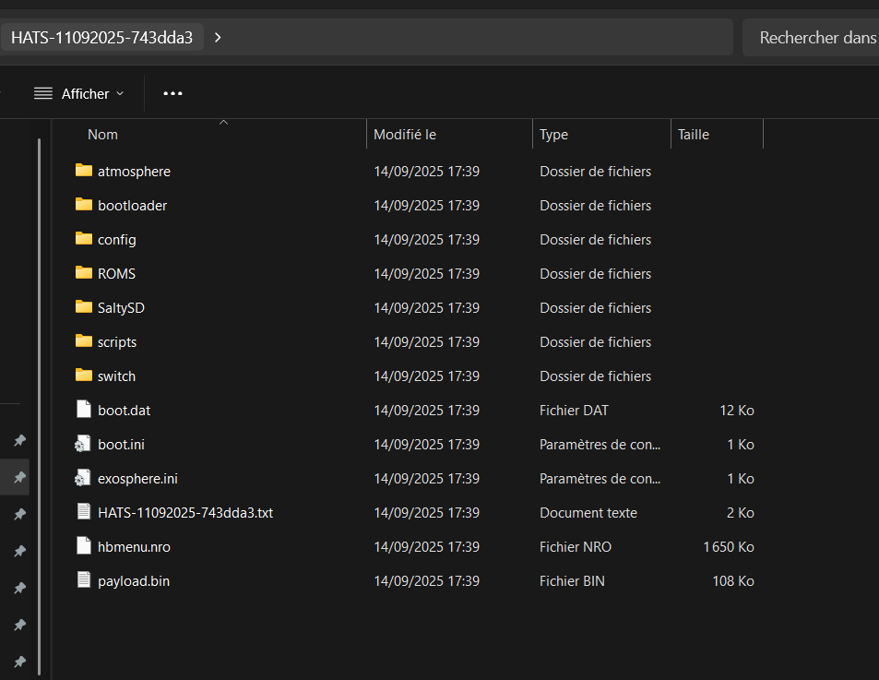
Here you can see the different folders of the HATS pack. You need to copy everything to the console's SD card.

❓Update your console
⚠️Important: Do not attempt to update unless necessary. If you want to update your console to the latest version, you can, but this may break compatibility with some games.

🧰Step 1: Open All-In-One Switch Updater
- Start your console in EmuMMC
- Go to the Album (or "Photos") menu
- Launch All-In-One Switch Updater (if you don't have it, install it via Homebrew App Store)
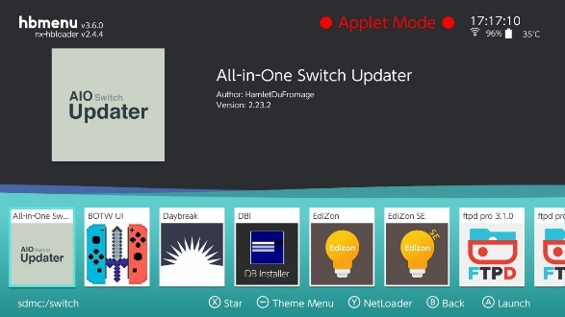

📦Step 2: Update Atmosphere
- In AIO Updater, select "Update Atmosphere"
- Press A to download the latest version
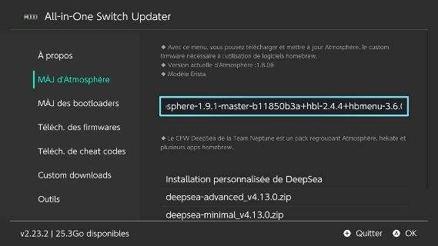
- The program automatically unzips and replaces old files
✅Atmosphere is nowhasday.

🛠️Step 3: Update Hekate
- From the main menu, choose "Update bootloaders"
- Press A to start the download
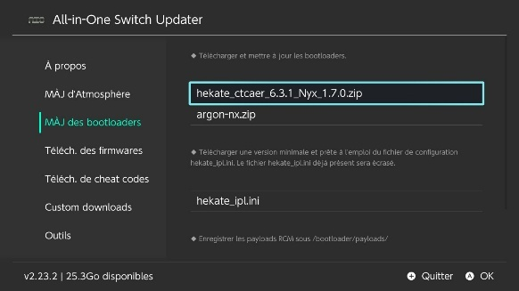
- The files will be automatically copied to /bootloader
✅Hekate is nowhasday.

🔧Step 4: Update Firmware (via Daybreak)
⚠️Never use betshasNintendo official days
- In AIO Updater, choose "Download Firmware"
- Select the desired version (take the most recent one supported by Atmosphère)
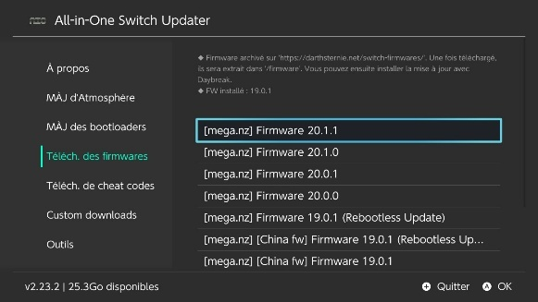
- Select "Download to SD Card"
📂This downloads a zip to /firmware.

🧪Step 5: Install the firmware with Daybreak
- Go back to the homebrew menu and launch Daybreak
- Choose the folder /firmware/<version>
- Select "Install (FAT32 + exFAT support)"
- Confirm → firmware installation
- When it's finished, choose "Reboot" and reboot into EmuMMC
✅Your firmware is now updatedhasday in all securite.

🚨Safety Tips
- ❌NEVER update via the internet or the official Switch menu
- ✅Always wait for Atmosphere supports the desired firmware version
- 🧯Keep a backup of your NAND before any major update

💾 Save your games with JKSV + Transfer to PC
✅What you need
- A console modified with Atmosphere
- JKSVinstalled (via Homebrew App Store)
- A USB-C ↔ USB cable for transfer
- A USB file manager, such as USB File Transfer (integrated into Tinfoil or other)

🧱Part 1 – Saving your games with JKSV
📥Step 1: Open JKSV
- Start your console in EmuMMC
- Go to Album to access homebrews
- JKSV Lance
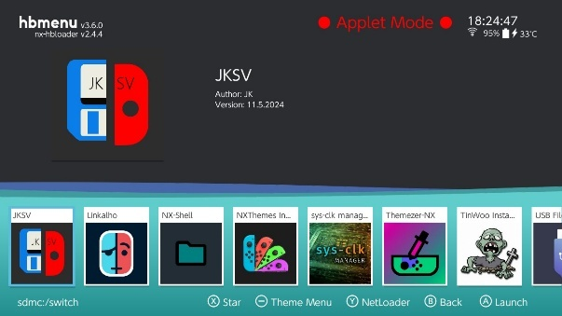

💾Step 2: Save a game
- JKSV shows you a list of user profiles → select your account
- A list of games with save data is displayed
- Select the game you want to save
- Press A → then choose "New Backup" to create a backup 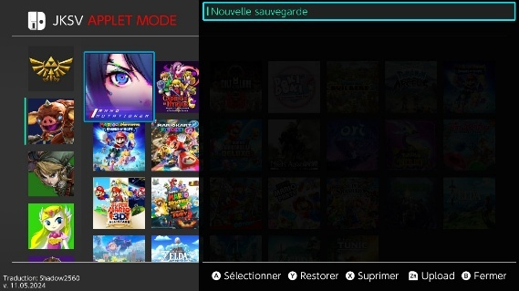
- You can give a name to the save (eg. before_final_boss) The save is now in your SD, in
/JKSV/<Profile Name>/<Game Name>/<Save Name>
- ✅Repeat for each game you want to save.

🔄Part 2 – Transferring Backups to Your Computer
📲Option 1: Transfer via USB File Transfer (from Tinfoil)
If you want to avoid removing your SD card
- Connect your Switch to your PC via USB-C
- Launch Tinfoil → go to the "File Browser" menu
- Choose "USBFS" as the source (make sure the USB server is active)
- Navigate your computer through the folders to:
/switch/JKSV/
- From your computer, you can copy the backup folders to a secure location

💽Option 2: Remove the SD card
- Turn off your console
- Remove the microSD card and insert it into your PC
- Navigate to: /switch/JKSV/
- Copy the entire folder or only the desired games

♻️Restore a backup with JKSV (optional)
- JKSV Revival
- Select your profile and your game
- Press Y to restore the desired backup

✅Advice
- 📂Make regular backups before modifying a game or updating it.
- 📅Rename your saves with a date or event (eg: before_new_zone)
- 🛟Always keep a copy on your PC or a cloud (Google Drive, etc.)

✅ Some useful game ROM sites
Functional on 09/15/2025. Not guaranteed for the future:
https://switchroms.io/
https://romslab.com/
https://romsim.com/
https://nxbrew.net/
https://switchrom.net/
https://nswpedia.com/
https://nsw2u.com/
https://www.switchgamesmall.icu/
https://eggnsemulator.com/nintendo-switch-roms/
It is recommended that you use ad blockers when visiting these sites. Here's an explanation of what an ad blocker is:
https://www.futura-sciences.com/tech/questions-reponses/internet-fonctionne-bloqueur-publicite-15738/

