 Translated from French to English - www.onlinedoctranslator.com
Index

⚠️ WARNING 2
✅Frequently Asked Questions about Hacking 3
❓What are the different boot modes? 5
⬇️ 💻 Install games easily with the APP INSTALLER and a computer 7
⬇️ 💻 Easily install games with DBI and a computer. 8
⬇️ Install games via Tinfoil 10
⬇️ Add a Tinfoil shop 12
⬇️ 💻 Install a game via a PC with NUT Server 13
⬇️ 💻 Install a game via a PC with Goldleaf and Quark 13
🤖 Start Android 13
💾Back up your games with JKSV + Transfer to PC 13
✅Some useful game ROM sites 13
✅Overclock your switch (Overclock) 14
❓FAQ 15
❓Update your console 18
❓Startup problems. 18

⚠️ WARNING
Using a modded console to play pirated games may violate Nintendo's terms of service and infringe copyright law. Therefore, use them ethically and consider purchasing official Nintendo games to support the creators. Pirating creative content is unethical and punishable by law.
It's important to back up your games regularly when you own a modded console, since the entire operating system uses the SD card and not the console's internal memory. This means the SD card wears out more quickly, which can eventually lead to its failure. Once the SD card is dead, it's impossible to recover your save data. So, use a high-quality SD card to avoid any unpleasant surprises.

Contact me if you have any problems or if this guide is incomplete, incomplete, or simply incorrect.
If you do not purchase the warranty, I cannot repair any problems that may arise with your console in the future.

✅Frequently Asked Questions about Hacking
Can I still play online after hacking my console?
Yes, but only for games you own, and only in the console's normal mode. The hack only allows you to launch an additional, cracked mode, independent of the normal mode.
Can I get banned if I play pirated games on EmuMMC?
No, the risk is zero.
Can I get banned if I play pirated games on SysMMC?
Yes. However, it's difficult to install them on SysMMC in the first place, so the risk isn't great.

What risks do I face for my console?
If the chip doesn't hold, the console might suddenly stop booting altogether, or the hack might simply fail to launch. Otherwise, installing a chip is harmless to the console and won't destroy it.If you're worried that this might happen, don't hesitate to take out a warranty with it.
How long does the installation take?
Between 1.5 and 3 hours per console, depending on my availability and the amount of software to install.
How much will the hack cost me?
Refer to the fair price calculatorhereUpdated with the latest data.
What experience do you have with hacking?
I'm a community beneficiary; I didn't develop the hack myself, and I'm simply sharing my microsoldering skills with others. I have aI've tried around forty passive modded consoles, and I haven't had any failures so far.
Is there a risk of bricking my console with this hack?
Yes, that's a possibility, but the installation itself won't be the cause. If you try to overclock the console, that's the main risk of bricking it. Stick to conservative settings and everything will be fine.Bricking your console remains very difficult, and I haven't known anyone who hasn't had this problem.
Does hacking allow cheating in games?
Yes

What are your availabilities?
Weekends and some weekdays, to be seen on a case-by-case basis.For more information, visitthis websiteto view available time slots
Do you have any consoles that I can buy directly?
Yes, I have hacked Nintendo Switch Lite consoles that I sell for 1€50-170 each. I also have hacked Nintendo Switch OLED consoles with or without accessories.
Can you give me a guarantee that I will get a working console back?
Yes, if you want a guarantee, you can select what you want from the options.Simply select the "Warranty" option in the choices on the price selector.
What are the penalties for downloading pirated content if the police come to my home?
Under Belgian copyright law, computer pirates risk a fine ranging from €550 to €550,000 and/or a prison sentence of 3 months to 3 years. (source: belga)However, this type of sanction for pirated game installations has never happened before, and it is unlikely that it ever will.

❓What are the different boot modes?
- There are several boot modes, each with varying degrees of importance. Understanding what I'm talking about is crucial to understanding the rest of this guide.
- EmuMMC mode is a virtual console whose internal memory is stored on the SD card. It allows you to simulate a fake console in order to go undetected by Nintendo's servers, and thus avoid a ban.
- SysMMC (Semi-stock) mode is the mode that uses the console's internal memory, which means that this is data that Nintendo's servers can access, and if they detect illegal content, they can ban you.
- These two modes are two separate systems. You can transfer save data from one system to the other, but it's generally not very useful. Therefore, it's normal that if you make progress in a game on SysMMC, that progress won't be reflected in your save on EmuMMC.
- However, the operating system isn't managed by this, which is why there's a third option: CFW (sysmmc), which allows the user to access the console's internal memory (Sysmmc) and use custom programs (like Tinfoil to "dump" games—retrieving the game as a ROM that can then be redownloaded). But this boot method is rather risky, because a mistake (installing a game you don't own on SysMMC) can get the console banned from Nintendo's servers. This can quickly become problematic because, without internet access, due to the virtual game card system, it's more difficult to play games that are installed on the console in standard mode.
- The base console's operating system is called NX OS. The custom firmware that allows you to run custom applications is called Atmosphere and is composed of several layers, each with a specific role (for example, making the console incognito, launching games, etc.).
- It's important not to confuse the operating system and the firmware. Firmware refers to Atmosphere, while the operating system refers to NX OS. They are independent, but it's necessary to update both simultaneously, starting with Atmosphere before NX OS.

🕹️ Start the console in modded mode (EmuMMC)
- Turn on the consolevia a jig + RCM loader or via an injector dongle, if you don't have a modchip. Turn on the console normally if you have a modchip. (NOTE: startup may take up to 25 seconds, so please be patient and do not repeatedly press the POWER button.)
- If a menu appearsChoose the option that contains the word "EmuMMC" (system memory emulation) in the Hekate menu (Launch -> EmuMMC).
  - ✅ This starts a separate system, which does not affect your official system, avoiding a ban.
- Once started, you will see the classic Switch interface, with modified applications.

🕹️ Start the console in standard (Stock) mode
- Turn on the consolePress and hold the Volume + and Volume – buttons simultaneously until you see the “Nintendo” logo on the screen (holding them down longer will put the console into recovery mode).

🕹️ Start the console in Hekate mode
- Turn on the consolePress and hold the power button, and simultaneously press the "Volume -" button. After a few seconds, the Hekate menu should appear.

🎮 Understanding Modified Applications
- Photos= Application menu (via "Album" on the Switch).
- Daybreak= Manual firmware update (only if necessary).
- To view your screenshots, hold R on the right Joy-Con while opening the "Album" app.

💻!! Before installing games !!

Below you will find a multitude of methods for installing games, updates, and game backups on your console. This guide is intended for restoring game ROM backups that you have created. It may also work for game ROMs that you have downloaded from the internet, BUT that is piracy, so this guide is purely for educational purposes and not an encouragement to pirate copyrighted content.
There are two ways to download games: directly from the console or via a computer. The console-only method is unreliable and extremely slow, so be prepared to use a computer if you need larger games.
TinfoilOption to install games directly from your console OR via a computer: Advantages: A fairly effective multi-functional tool. Doesn't necessarily require a PC. Disadvantages: Quite cumbersome and slow to use. Also, not very reliable.
GoldleafRequires a computer. Advantages: Lightweight tool that also allows you to manage games installed on the console and files on the SD card. Disadvantages: Requires a computer to install games, and it's impossible to install a game queue.
DBI/ App installerAll-in-one tool (my favorite because it's extremely useful). Advantages: Does everything, including making coffee. Easy bulk USB installation (several tens of gigabytes of games at once), fast and minimalist. Very simple to use. Disadvantages: Unintuitive and not very aesthetically pleasing interface. Requires a computer.

⬇️💻Install games easily with the APP INSTALLER and a computer

- You may not have the application installed, as it's a shortcut to DBI that only I use. If you don't have it on your console, install it.nsp followingon your console using one of the following methods.
- Launch the game "APP INSTALLER-RUN MTP RESPONDER" from the home screen (with a download icon)
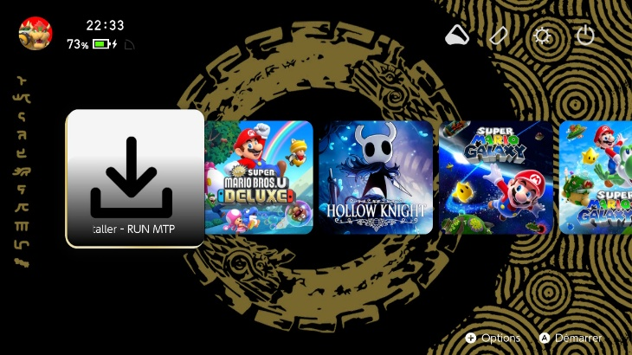
- Select the option with the acronym MTP in it (Media Transfer Protocol)
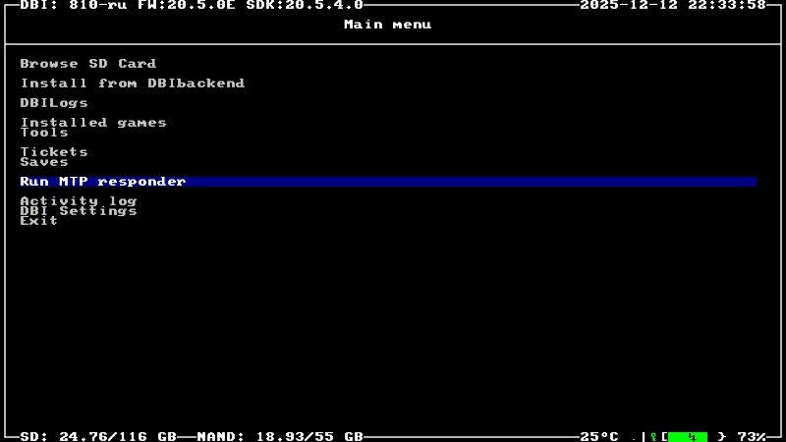
- Connect the console to your computer via USB-C (note that the cable must be capable of transferring data. A USB-C to USB-C cable will not work. USB-A to USB-C cables are recommended).

- Select option 5: SD card install (or NAND install if SD card install is full)
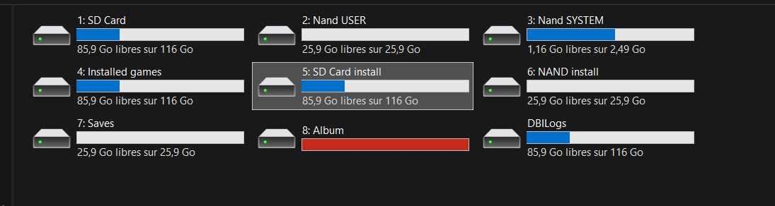
- Drag and drop the ROM file (NSP, XCI, or NSZ format) into the folder and wait for the transfer to complete. The game should then be installed. (A folder containing multiple NSP files will also work, as long as it's not compressed.)
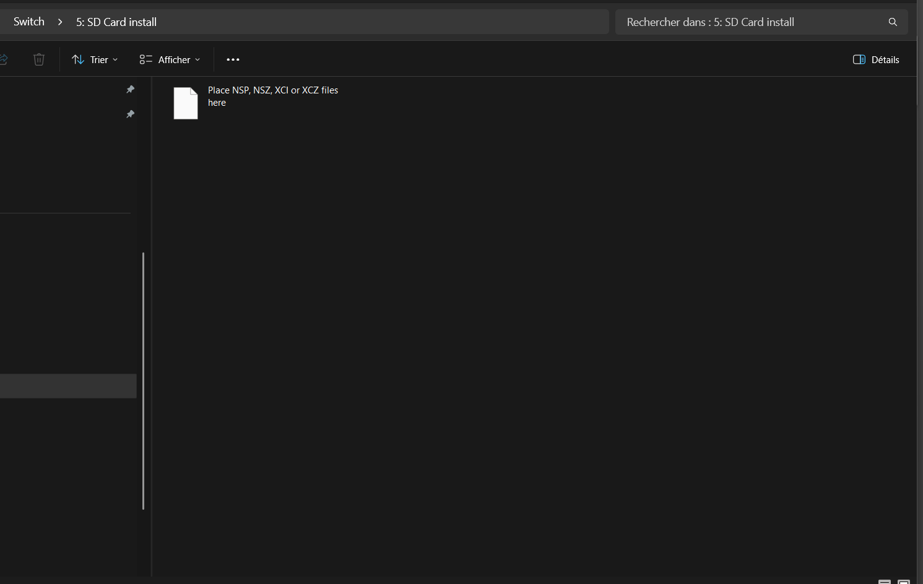

NOTES: You may encounter an error during installation. Here is the most frequent one.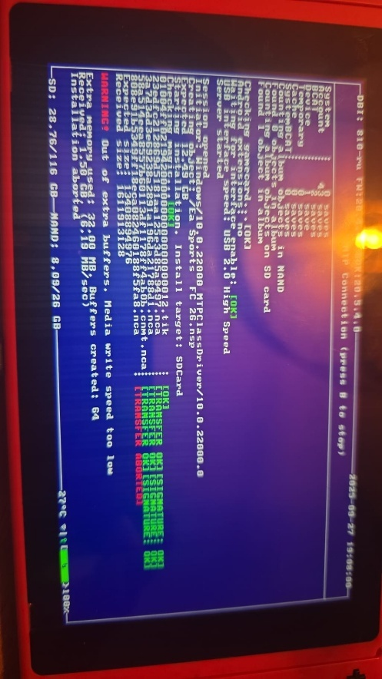
Out of extra buffers. Media write speed too low.
This means the microSD card is too full for the file transfer to take place. Try freeing up space on the microSD card before trying again.

⬇️ 💻Install games easily with DBI and a computer.

- Launch the DBI program on the console (from the homebrew menu, i.e., the photo gallery)
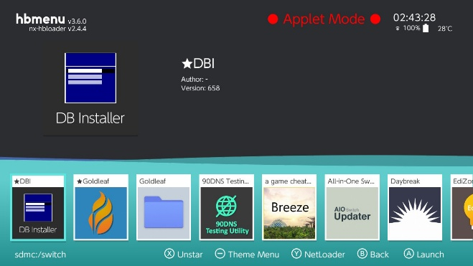
- Select the option with the acronym MTP (Media Transfer Protocol) in it. Then connect the console to a computer with a USB-A to USB-C cable (make sure this cable is capable of data transfer; some cables only support charging).
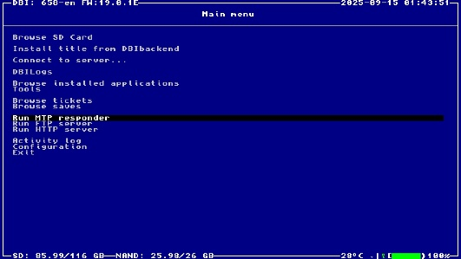
- Select option 5: SD card install

- Drag the ROM file (NSP, XCI, or NSZ format) into the folder and wait for the transfer to complete. The game should then be installed.


NOTES: You may encounter an error during installation. Here is the most frequent one.
Out of extra buffers. Media write speed too low.
This means the file transfer was too slow and the computer refused to continue. Changing the USB-C cable might fix the problem, but most of the time, simply launching DBI in "Non-applet mode" (see the section on "Applet mode") is sufficient.

⬇️ Install games via Tinfoil
Step 1: Open Tinfoil
- Launch Tinfoil from the Tinfoil game (startup may take some time, between 1 and 5 minutes depending on the network connection).
As long as it says "Loading -something-", it's fine. At startup, there may be a popup asking "Would you like to install this game cartridge?", which you can ignore ("cancel"), it's only for installing cartridges you already own.
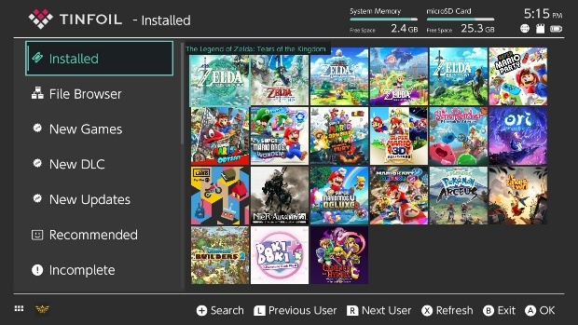
- If Tinfoil does not start:
  - Make sure that USBFS is enabled (from the Tinfoil options).
  - Update Tinfoil via a homebrew shop or manually.
Step 2: Browse and search for a game
- Go to "New Games" or "Browse". If the "New Games" tab is not visible, contact me; it means that either you are offline or the virtual shop has disappeared.
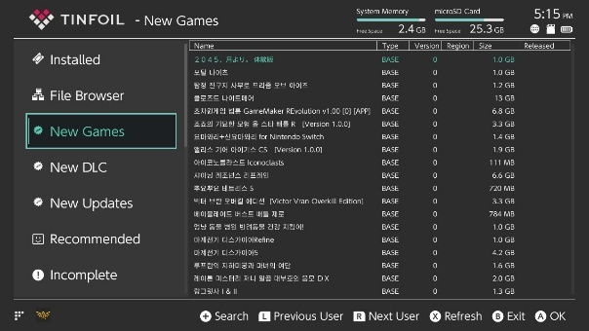
- Press "+" to perform a search.
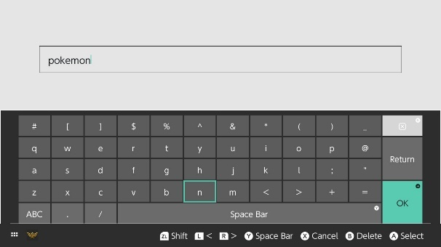
- Select a game from the list.
- Tap "Install" and choose where to install (SD or NAND). You can install the latest version and all-in-one DLC if you enable the necessary options on this page.
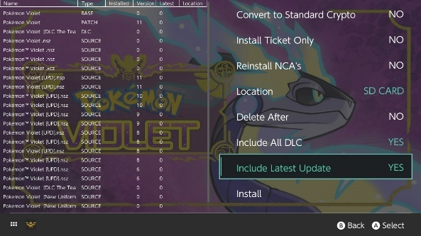
- If you want to update your games, it's no longer possible using just the traditional "update" button; you also need to use Tinfoil. To do this, simply go to the "New updates" tab and click the "x" button to install everything.
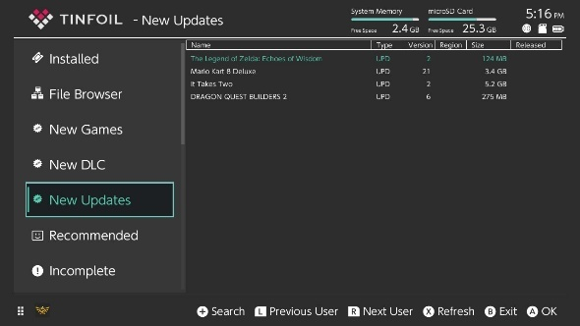
✅ Your games will be installed automatically.

⬇️ Add a Tinfoil shop
Since shops open and close regularly, you might not find what you're looking for, or the game you want to download might be too large. Therefore, it's a good practice to regularly search for shops that interest you. This repository has an automatically updated list:https://github.com/melogabriel/tinfoil-shopsSimply enter the following information and the functional shops will be added automatically:
Protocol: https
Host: opennx.github.io
Path: tinfoil.json
Title: Open NX

- Go to the File browser tab
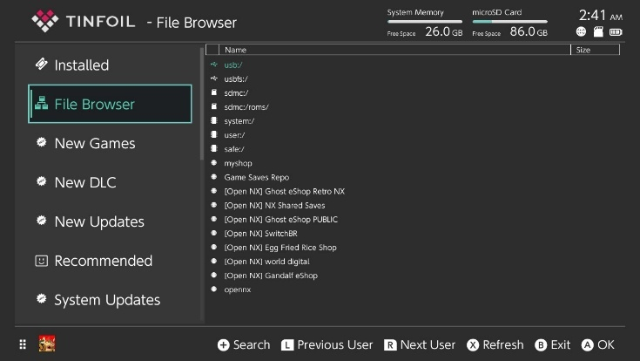
Once that's done, press "A" then "-"
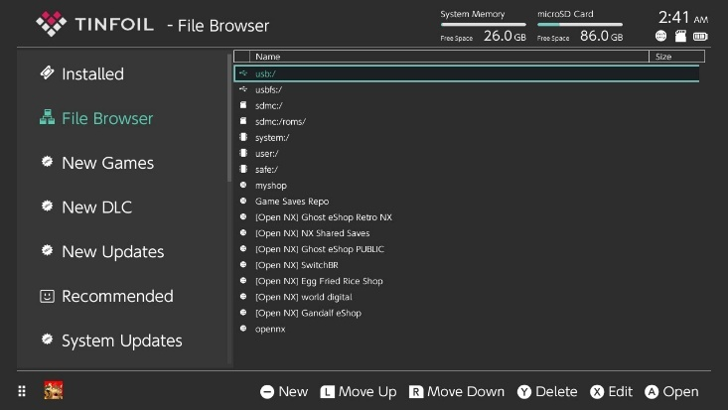
You will then enter this menu:
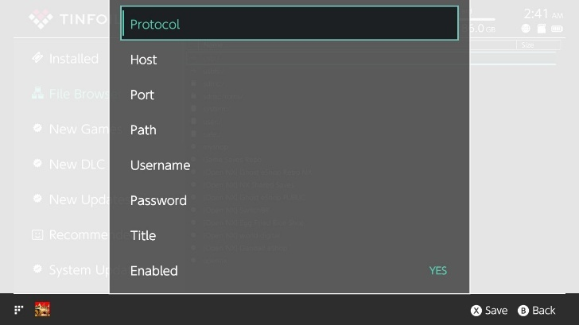

- Complete the fields with the information provided. It's intuitive; just press A on the field you want to modify, or use the console's touchscreen.
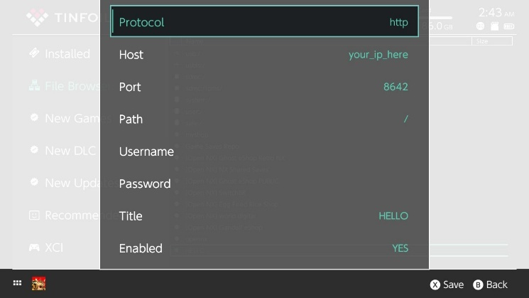
- Press X to save, and wait for the loading to finish.

⬇️💻Installing a game via a PC with NUT Server
Step 1: Prepare the game on your computer
- Download a ROM in .nsp or .xci format from the Internet.
  - Google keywords: <game name> Nintendo Switch NSP or <game name> Nintendo Switch XCI
- If you have a .zip or .rar file, extract it:
  - .zip → right-click → Extract all
  - .rar → use 7-Zip or WinRAR

Step 2: Install NUT (the USB server for Tinfoil)
- Download NUT here:
🔗https://github.com/blawar/nut
(direct links) nut.exe:
https://github.com/blawar/nut/releases/download/v3.3/nut.exe
- Install the necessary drivers:
On Windows, run the install_driver.exe file:
https://github.com/blawar/nut/releases/download/v3.3/tinfoil_driver.exe
- Launch nut.exe or usb_install_pc.py depending on your system (usb_install_pc.py for MacOS).

Step 3: Place the games in the NUT folder
- By default, place your .nsp or .xci files in the :nut/xci/ folder
or
nut/nsp/
or configure a path in config.json.
- In the NUT interface, check that the game appears in the list.

Step 4: Connect the Switch to the PC
- Connect your Switch to the PC via USB-C cable.
- Launch Tinfoil → go to "File Browser" > "USBFS"
- Select the game → Install.
📦 Automatic installation → restart to play.

⬇️💻Installing a game via a PC with Goldleaf and Quark
https://github.com/XorTroll/Goldleaf/releases/tag/1.1.0
Follow the tutorial:
https://www.youtube.com/watch?v=NO09e0cbRH4
Zadig tool from the video:
https://zadig.akeo.ie/
Install Java (if not already installed):
https://adoptium.net/fr/temurin/releases/?os=any&arch=any&version=11

🤖 Start Android
Step 1: Launch the console in Hekate mode
Start the "More configs" option. You will find the lineage option there. Select this boot mode and wait a few minutes.
[This section is incomplete regarding file transfer to the console's Android system.]

IMPORTANT :If your console can boot into Android, simply transferring files to expand your storage with a new SD card won't be enough. You'll need third-party software to clone the SD card, then write it to another card and extend the partitions as needed.

💾Back up your games with JKSV + Transfer to PC
✅What we need
- JKSVinstalled (via Homebrew App Store, if not already done)
- A USB-C to USB-A (standard USB) cable for transfer

🧱Part 1 – Backing up your games with JKSV
📥Step 1: Open JKSV
- Start the console in EmuMMC
- Go to Album to access homebrew applications
- Launch JKSV
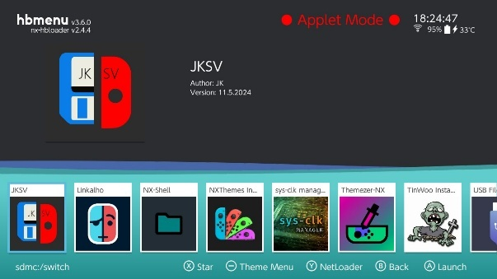

💾Step 2: Saving a game
- JKSV displays a list of user profiles → select your account
- A list of games with save data is displayed.
- Select the game you want to save
- Press A → then select "New Backup" to create a backup 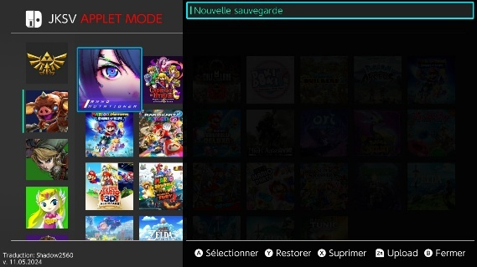
- You can name the save file (e.g., before_final_boss). The save file is now on your microSD card, in
/JKSV/<Profile Name>/<Game Name>/<Save Name>
- ✅ Repeat for each game you want to save.(NOTE: It is possible to save everything at once by selecting the profile picture and pressing Y, then following the on-screen instructions)

🔄Part 2 – Transferring backups to your computer
📲Option 1: Transfer via USB File Transfer (from Tinfoil)
If you want to avoid removing your SD card
- Connect your Switch to your PC via USB-C
- Launch Tinfoil → go to the "File Browser" menu
- Choose "USBFS" as the source (make sure the USB server is active)
- Navigate through the folders on your computer until you find: /switch/JKSV/
- From your computer, you can copy the backup folders to a secure location.

💽Option 2: Remove the SD card
- Turn off your console
- Remove the microSD card and insert it into your PC
- Navigate to: /switch/JKSV/
- Copy the entire folder or only the games you want.

♻️Restore a backup using JKSV (optional)
- JKSV Relaunch
- Select your profile and your game
- Press Y to restore the desired backup.

✅Advice
- 📂Make regular backups before modifying a game or performing an update.
- 📅Rename your save files with a date or event (e.g., before_new_zone)
- 🛟Always keep a copy on your PC or in the cloud (Google Drive, etc.).

✅Some useful game ROM sites
Operational on 12/12/2025. Not guaranteed for the future:
https://romshq.com/
https://romslab.com/
https://switchroms.io/
https://apkmara.com/roms/switch-roms/
https://www.yggtorrent.top/
https://romsim.com/
https://nxbrew.net/
https://switchrom.net/
https://nswpedia.com/
https://www.switchgamesmall.icu/
https://eggnsemulator.com/nintendo-switch-roms/
It is recommended (even necessary) to use ad blockers when visiting these sites. Here's an explanation of what an ad blocker is:
https://www.futura-sciences.com/tech/questions-reponses/internet-fonctionne-bloqueur-publicite-15738/

⚡Overclock your switch (Overclock)
If you find your console's performance lacking, you can overclock the processor and memory for improved gaming performance. By default, the console is underclocked to prevent overheating and maintain good battery life.
To do this, you need access to Ultrahand. Ultrahand is an interface that appears on the screen when you press the following key combination: L + D-pad down + press the right joystick. The Ultrahand menu will appear. Then simply follow these steps:
    - 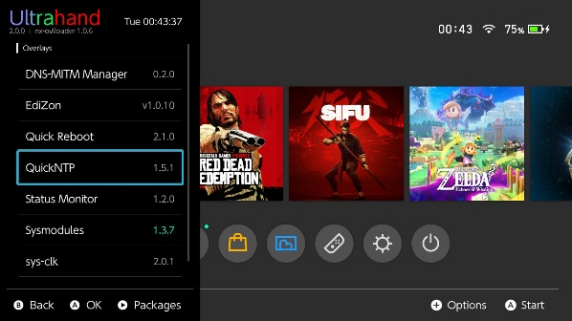
    - 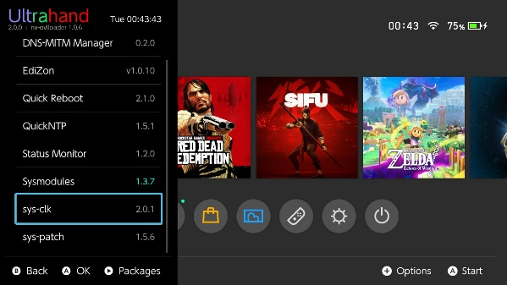
    - 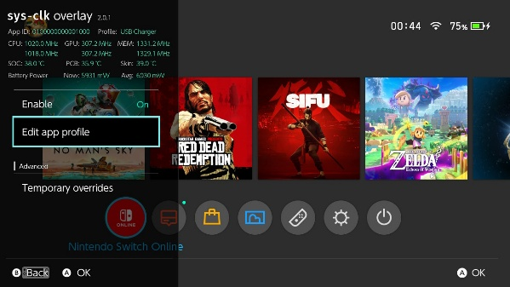
    - 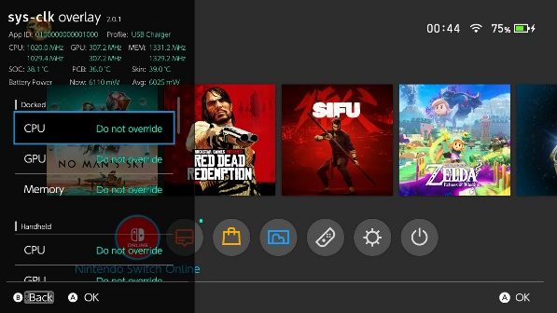
    - 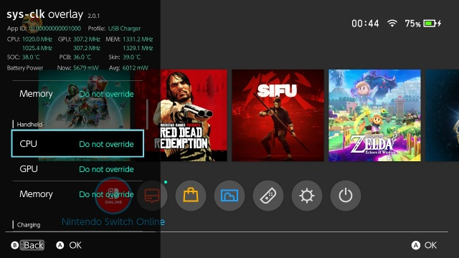
    - 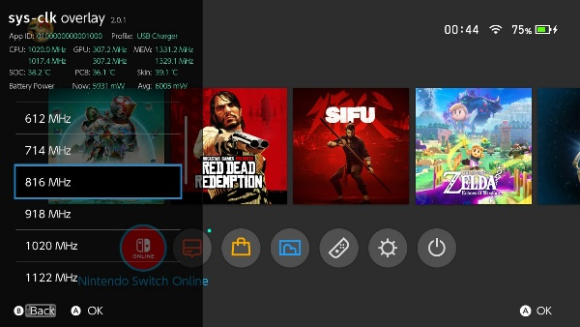
Here you can select the default frequency based on the game mode and certain settings. Feel free to watch YouTube videos for optimal values.
NOTE: If you brick your console due to overclocking, I cannot be held responsible and the warranty will not apply. I can help you resolve the issue, but I am under no obligation to do so.

❓FAQ
Q: Can I get banned?
A: In EmuMMC mode, if you do not intentionally disable 90DNS and remove incognito mode, you cannot get banned.
Q: Can I play online with games installed via Tinfoil?
A: No, the console will fail to connect to the servers and you will get a connection error. However, games you actually own can be used online if you launch your console with the "sysMMC" option. Some games that don't use Nintendo services may sometimes work (e.g., Fortnite, Rocket League, etc., which sometimes work independently of Nintendo's servers).
Q: Can I go back?
A: Yes, by restarting without mods, you are on the original console (SysNAND), provided you have not modified it.
Q: What is "Applet Mode"?
A: This is a mode that isn't started as the console's main program, but runs alongside a game. To exit "applet mode," simply launch a game while holding down the "R" button. This will open the application selection menu. From there, you can launch all applications in normal mode, not in "applet" mode.
Q: My SD card is too small? How do I use a larger one?
A: Insert your new SD card into your computer and format it as FAT32 (not NTFS or exFAT). Then, copy all the files from your existing SD card to your new SD card, and you're done. NOTE: This method does not apply if you can run Android on the console. For more information about Android, see the "Starting Android" section of the tutorial.
Q: When I start up, I get the message "No SD Card" with a winged raspberry symbol?
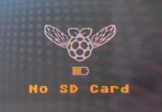
A: Your SD card is dead or at least no longer detected. You need to replace it. This means all your save files are lost. That's why it's very useful to back up your files regularly with JKSV. To initialize a new SD card, download the latest release of HATS:https://www.sthetix.info/hats/releases/
and extract everything onto your new SD card

Q: My console starts up normally on its own, but I no longer have the Hekate menu/My console won't start at all
A: There was a problem with the Picofly chip, which prevents the hack from being injected into the console and therefore prevents the console from booting in its modded version. Contact me again or go see a repairer who can install a Picofly chip. My installation comes with a free 1-year warranty for the chip installation that didn't work. Come see me! (Your game data is not lost, don't worry)

Q: I installed a game but the console detects the file as corrupted or displays an error saying that it is impossible to launch the game following an update.
A: When you update the console's firmware, not all patches required to run games are installed, and some patches may be missing. To fix this, the easiest method is to download the latest release from this website:https://www.sthetix.info/hats/releases/ Extract the .zip file, and put all the folders from the archive onto the console's SD card.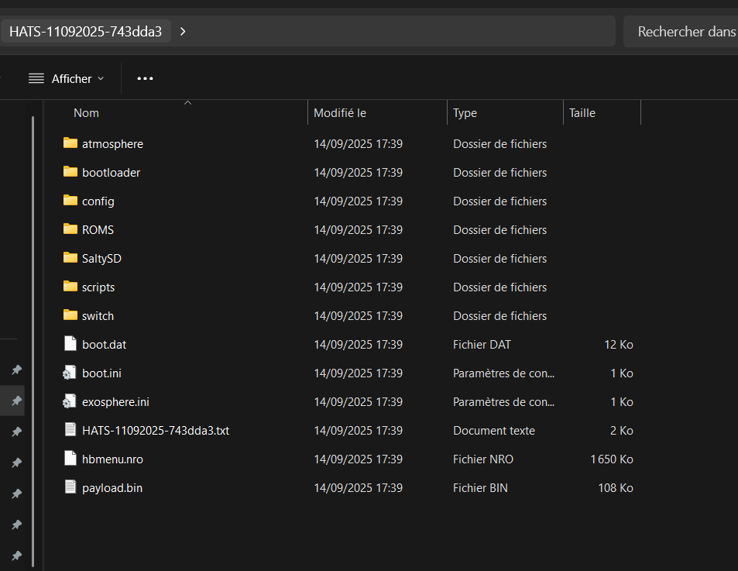
Here you can see the different folders of the HATS pack. You need to copy everything to the console's SD card.
Q: I installed a game, but the console says I need the software to play it.
A: That's normal, it's a problem with the latest versions of the console. You need to follow the last step of the console update.

❓Update your console
⚠️Important: Do not attempt to update unless necessary. If you wish to update the console to the latest version, you can, but this may break compatibility with some games.

🧰Step 1: Open All-In-One Switch Updater
- Start your console in EmuMMC
- Go to the Album (or "Photos") menu
- Launch All-In-One Switch Updater (if you don't have it, install it via the Homebrew App Store)
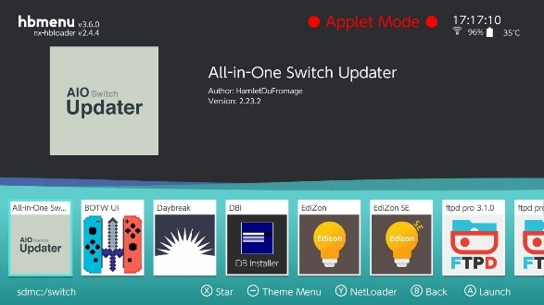

📦Step 2: Update Atmosphere
- In AIO Updater, select "Update Atmosphere"
- Press A to download the latest version
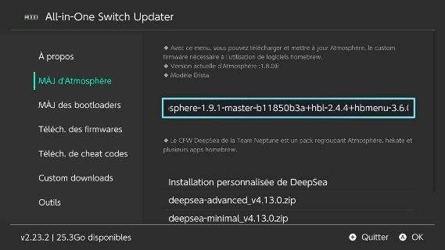
- The program automatically decompresses and replaces the old files.
✅Atmosphere is nowhasday.

🛠️Step 3: Update Hekate
- From the main menu, select "Bootloader Update"
- Press A to start the download
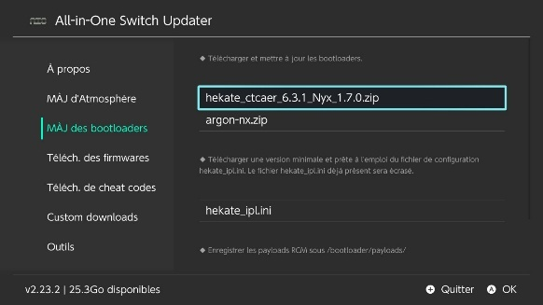
- The files will be automatically copied to /bootloader
✅Hekate is nowhasday.

🔧Step 4: Update the firmware (via Daybreak)
- In AIO Updater, select "Download Firmware"
- Select the desired version (choose the most recent one supported by Atmosphere)
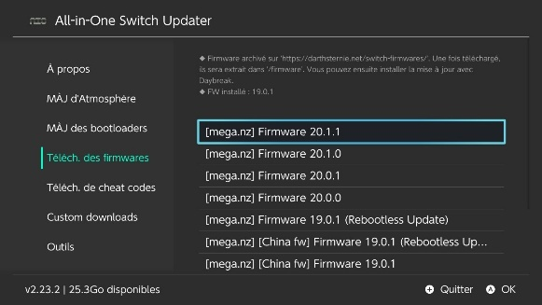
- Select "Download to SD Card"
📂This downloads a zip file to /firmware.

🧪Step 5: Install the sigpatches and syspatches
Simply download the latest release from this website:https://www.sthetix.info/hats/releases/ Extract the .zip file, and put all the folders from the archive onto the console's SD card.
Here you can see the different folders of the HATS pack. You need to copy everything to the console's SD card. Then restart the console to proceed to the final step.

🧪Step 6: Install the operating system with Daybreak
- Return to the homebrew menu and launch Daybreak
- Choose the /firmware/<version> folder
- Select "Install (FAT32 + exFAT support)"
- Confirm → firmware installation
- When it's finished, select "Reboot" and restart in EmuMMC.
✅The operating system is now installedhasday in all securite.

🚨Safety tips
- ❌NEVER update via the internet or the official Switch menu (it won't work)
- ✅Always wait for Atmosphere supports the desired operating system version
- 🧯Keep a backup of your NAND before any major update (if you're unsure, copy all the files on your SD card).

❓Startup problems.
If the console won't start at all, try contacting me if you're unsure how the hack works. If you have some experience in this area, feel free to try fixing the problem yourself. Here's a checklist of things to try in this order.
Symptom: The console starts without the Hekate menu, and without the games I downloaded.
- Chip problem. The console has suffered a shock or excessive vibration that has unsoldered the hack chip. SOLUTION: Return to the repair shop
Symptom: Black screen with no response
- Remove the SD card, and try to start the console without the SD card.
  - The console won't start at all. Try charging the console for an hour. If it still doesn't start after an hour, there's a problem with the hacking chip. You'll need a repair technician to fix the problem. NOTE: It's possible that after a full charge the console will restart in normal mode; this sometimes happens. Wait until the battery is charged to at least 20%, turn the console off completely, and then turn it back on.
  - The console starts without an SD card on a screen displaying "No sd card found": the hack chip still works, the problem is with the firmware on the SD card.
    - Reinsert the SD card and boot the console in Hekate mode (for this, see the section "What are the different boot modes")
    - If the console boots Hekate, try launching EmuMMC from Launch -> EmuMMC (far right). Wait a few minutes. If this fails, refer to the "Install the HATS pack" section; it's very likely that the console has corrupted its "Atmosphere" folder.

