1.) What characteristics are needed in a secure hash function?

The results of the function should be seemingly random to an outside observer, and this randomness should be evenly distributed across the entire input. (pseudorandom)

The output size should be fixed, while taking variable input.

It should not be feasible to find 2 messages with the same hash (collision resistant).

It should be easy to create a hash using the message, but unfeasible to generate a message using the hash. (efficiency, one-way)

2.) The high-speed transport protocol XTP (Xpress Transfer Protocol) uses a 32-bit
checksum function defined as the concatenation of two 16-bit functions: XOR and
RXOR, defined in Section 11.4 as “two simple hash functions” and illustrated in
Figure 11.4.

a. Will this checksum detect all errors caused by an odd number of error bits?
Explain.

Yes, because a flipped bit will always result in an error in an XOR.

b. Will this checksum detect all errors caused by an even number of error bits? If
not, characterize the error patterns that will cause the checksum to fail.

No, if two flipped bits are both XOR'd and RXOR'd with each other (if they are in the same column AND the same diagonal path), they could negate each other and result in a correct hash.

c. Comment on the effectiveness of this function for use as a hash function for
authentication.

The chances of errors appearing in the bits that would cause an undetectable error are small, and XOR and rotation are simple and fast. Depending on the actual odds of just the right bits being flipped causing an undetectable error this might be a good function.

3.) What changes in HMAC are required in order to replace one underlying hash function with another?

None, the hash function in HMAC can be switched out at will as it is otherwise disconnected from the rest of the function.

4.) List two disputes that can arise in the context of message authentication.

a.) An authentication code could be attached to a false message other than the message it was originally attached to, by the receiver.

b.) The sender could claim they never sent the message, as there is no proof that (a) did not occur.

5.) In what order should the signature function and the confidentiality function be
applied to a message, and why?

The signature should be calculated first, so the plaintext and signature can be stored for use in dispute resolution.

6.) With DSS, because the value of k is generated for each signature, even if the same
message is signed twice on different occasions, the signatures will differ. This is not
true of RSA signatures. What is the practical implication of this difference?

In DSS, the time of sending is indicated by the change in signature, for use in dispute resolution about who sent what when.

7.) Find at least one intermediate certificate authority’s certificate and one trusted root certificate authority’s certificate on your computer (in the browser). Print screen shots of both the general and detailed tabs for each certificate. On Explorer, it’s under Tools, Internet Options, Content.

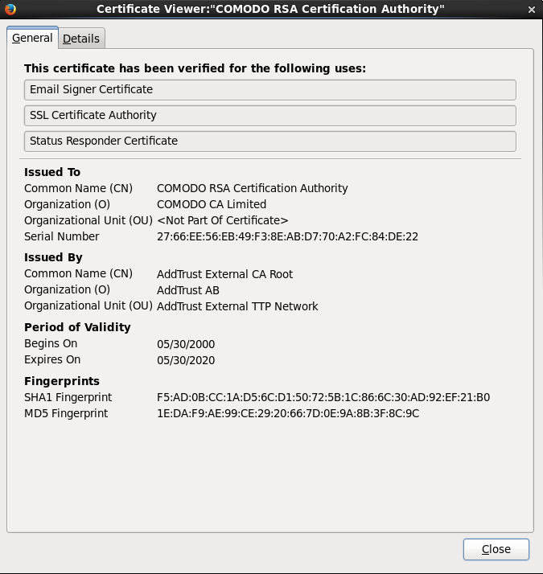

Certificate Authority

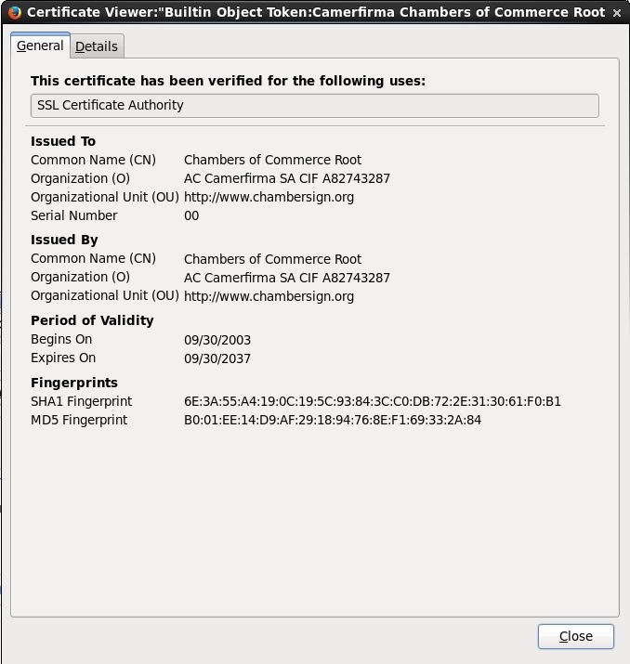

Root Certificate

8.) (5th ed. Page 441, Problem 14.1) One local area network vendor provides a key distribution facility as illustrated in Figure 14.17 (below).
  - Describe the scheme.
  - Compare this scheme to Figure 14.3 (below). What are the pros and cons?

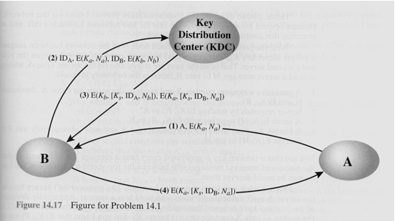

a.) A sends a message to B along with their identity. B requests a shares their key and A's key encrypted with a nonce with the KDC, requesting a session key to communicate with A. The KDC confirms B's identity, sends back key. B sends back the the session key provided by the KDC to A.

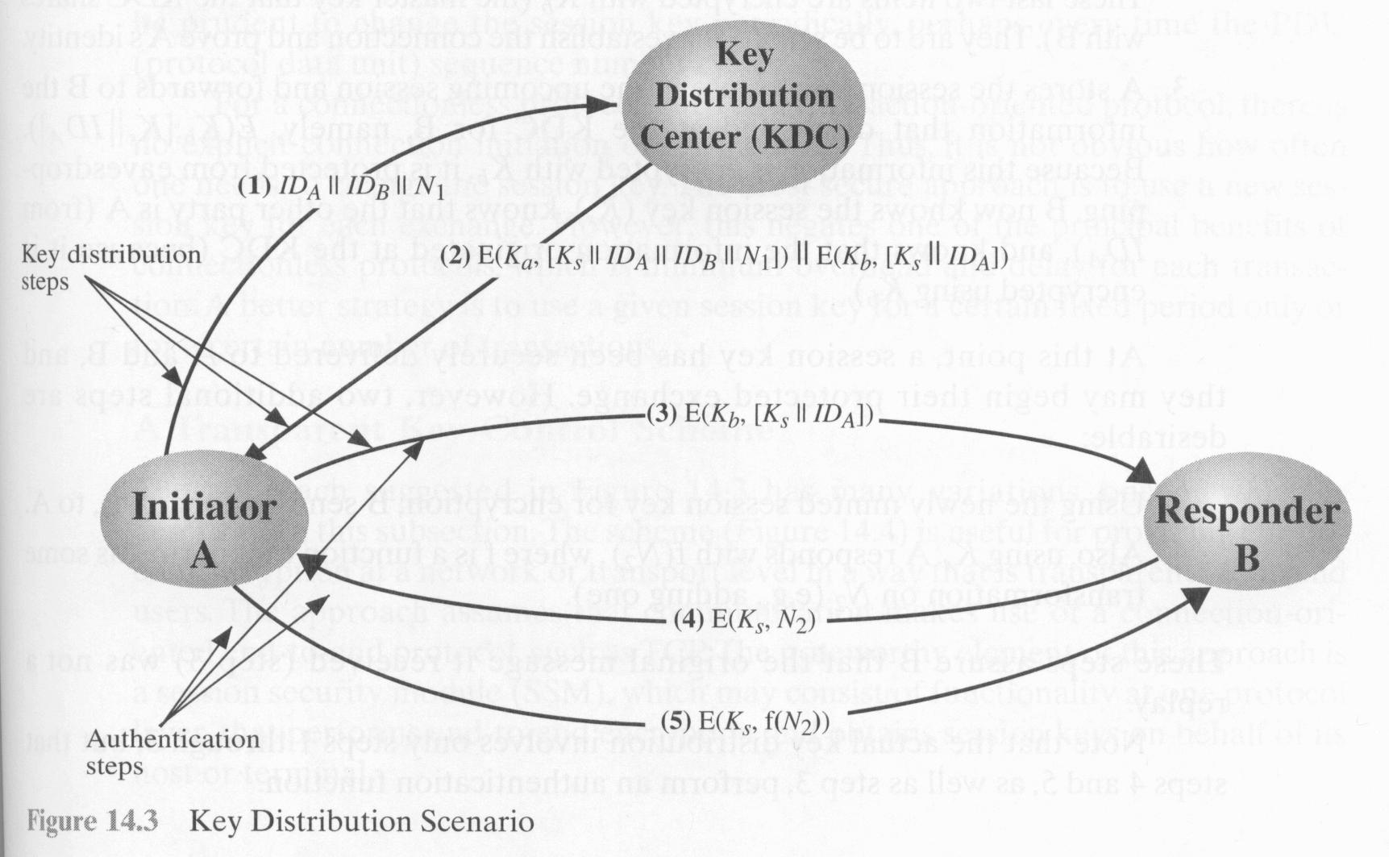

b.) A requests a session key from the KDC instead of B. A gets a session key back from the KDC, along with their original message so they can confirm it hasn't been changed. A sends the encrypted key to B encrypted with B's private key. Once B has confirmed steps 1 and 2 happened it sends a encrypted nonce to A as confirmation. A replies to confirm it received confirmation.
The 2nd one seems more secure, as it never shares their private key with the other party, even encrypted.

9.) (5th ed. Page 443, Problem 14.6)

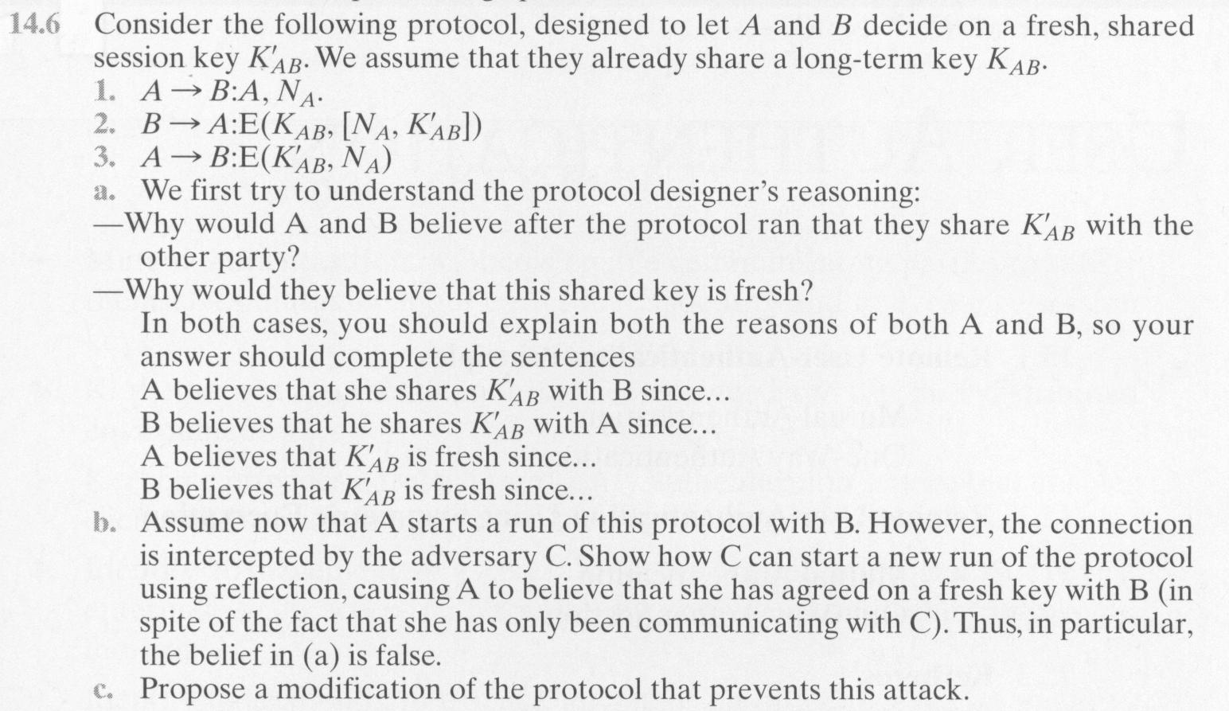

a.) Because A has KAB, they can separate it from from the encrypted (Kab, [Na, K'ab]) By sending the encrypted message in 3 back to B, they confirm that they were able to decrypt and separate the key from the original message.

b.)

C intercepts (1)
C -> B: A, Na
B -> C: E(Kab, [Na, K'ab])
C-> A: E(Kab, [Na, K'ab])
A -> C: E(K'ab, Na)
C -> B: E(K'ab, Na)

C has just tricked B into thinking they are A.

c.) Have confirmation of the challenge being passed be sent between (2) and (3), perhaps by having (1) challenge just be a nonce and sending back the nonce along with their ID.

